RationSeva – Online Ration Card Services Portal
Change Management Process
Handling state eligibility-rule changes after go-live
Case Study No. 142 | District Supply Office | Version 1.0 | Oct 2026

1. Why This Process Is Needed
The state is expected to change eligibility rules within the year. This risk has P = 0.5, I = 7 and exposure 3.5 (ranked #2). Uncontrolled edits would break the eligibility checks and the audit trail.

2. Roles
Role | Who | Responsibility
Requester | State Dept. / DSO staff | Raises a change request (CR) with a copy of the GO
Change Coordinator | Project Manager | Logs the CR, tracks it to closure
Impact Analyst | Business Analyst + Tech Lead | Assesses scope, time, cost and quality
Decision Owner | District Supply Officer | Approves, rejects or defers the change
Implementer | Admin (config) / Developer (code) | Applies the change as a new rule version
Verifier | Tester + 1 Officer | Runs regression tests and signs off

3. Change Categories
Type | Example | Path | Target time
A – Configuration | Change income limit or document list | Fast track: Admin creates a new rule version | <= 1 working day
B – Logic | New condition or new field | Full process + code release | <= 10 working days
C – New service | New request type | Treated as a new project or phase | Planned release

4. Six-Step Procedure
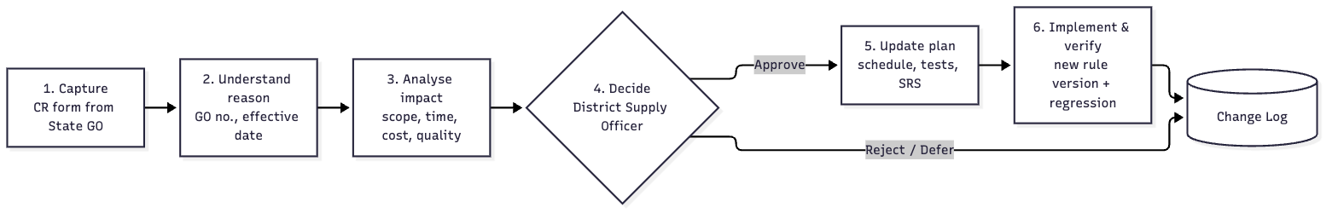
Figure 1: Rule-change process
Step | What happens | Output
1. Capture | Requester fills in the CR form (GO no., rule, old/new value, effective date) | CR-ID in change log
2. Understand reason | Coordinator confirms the legal source and urgency with the State Dept. | Reason + priority
3. Analyse impact | Assess Scope (screens, rules), Time (days), Cost (effort), Quality (tests to rerun) | Impact sheet
4. Decide | District Supply Officer approves, rejects or defers | Decision + date
5. Update plan | Update the SRS rule table, schedule, test cases and traceability matrix | Updated baseline
6. Implement & verify | New rule version with effective date; rerun decision-table and BVA tests; officer sign-off; SMS/notice to staff | Rule vX.Y live, CR closed

Note: Requests already submitted are evaluated under the rule version that was active on the submission date. This is fair to applicants and keeps the audit trail intact.

5. Change Log
CR | Date | Change & reason | Impact (S / T / C / Q) | Decision | Implemented & verified | Status
CR-001 | 05-Jan-27 | PHH income limit ₹1,00,000 → ₹1,20,000 (State GO 12/2027) | S: 1 rule value; T: 0.5 d; C: ~0.5 person-day; Q: rerun TC-06, TC-12 at new boundary | Approved – DSO, 06-Jan | Rules v1.1, effective 01-Feb; tests passed 07-Jan | Closed
CR-002 | 20-Feb-27 | Aadhaar of new member mandatory for Add Member (anti-fraud GO) | S: +1 field, +1 condition; T: 3 d; C: ~3 person-days; Q: update DT-2, TC-07 | Approved – DSO, 22-Feb | Release 1.2 on 02-Mar; regression passed | Closed
CR-003 | 10-Mar-27 | Add 'Card Surrender' request type | S: new service; T: ~10 d; C: high; Q: new test suite | Deferred to Phase 2 | – | Deferred

