RationSeva – Online Ration Card Services Portal
Statement of Work (SOW) & Project Plan
Contractual Scope, Detailed WBS, CPM Schedule Analysis, Resource Allocation & Governance
Case Study No. 142 | District Supply Office | Version 1.0 | Oct 2026

1. Project Identification & Contractual Overview
Project Charter: This Statement of Work (SOW) defines the formal agreement between the District Supply Office (Client / Sponsor) and the Technical Solutions Partner (Contractor) for the turnkey design, development, verification, deployment, and operationalization of the RationSeva Online Ration Card Services Portal.
Project Parameter | Contract Specification
Project Title | RationSeva – Online Ration Card Services Portal
Sponsoring Authority | District Supply Office (DSO), District Collectorate
Contract Type | Fixed Duration, Milestone-Billed Turnkey Software Delivery
Total Schedule Duration | 44 Working Days (from Project Inception to Production Go-Live)
Target Production Environment | State Data Centre (SDC) Cloud Infrastructure
Governing Standards | IEEE 830-1998 (SRS), ISO/IEC 25010 Quality Model, IT Act 2000

2. Scope of Work & Deliverables Package (D1 to D6)
The Contractor is contractually committed to delivering six comprehensive work packages, tied to formal milestone checkpoints:
Deliverable ID | Deliverable Name | Milestone | Delivery Format | Acceptance Verification Standard
D1 | Requirements & Business Blueprint Package | M1 (Day 6) | IEEE 830 SRS, BRD, Traceability Matrix | Formal sponsor sign-off; 100% FR-to-test mapping
D2 | Eligibility Rules Engine & Data Architecture | M2 (Day 31) | Config schema, rule evaluation service, DB scripts | Passing 100% boundary and decision-table test specs
D3 | Citizen Portal & Officer Workflow Application | M2 (Day 31) | Deployable web application + SMS gateway hook | Passes end-to-end multi-role functional tests
D4 | Quality Assurance & Test Evidence Package | M3 (Day 39) | Test execution logs, BVA/Decision tables, DRE report | DRE >= 85%; zero open Severity-1 / Severity-2 defects
D5 | Operational Readiness & Training Enablement | M4 (Day 44) | Bilingual quick-guides, 2h staff training delivery | 100% target staff trained; SUS usability score >= 70
D6 | Production Deployment & Go-Live Certificate | M4 (Day 44) | SDC production release, operational baseline | Signed Go-Live acceptance certificate from DSO

3. Detailed Work Breakdown Structure (WBS)
The project scope is hierarchically decomposed into seven primary Level-1 work packages, partitioned down to verifiable operational tasks:
WBS Code | Work Package / Task Name | Input Artifacts | Core Activities | Tangible Deliverable
1.0 | Requirements Engineering | Forms, staff interviews | Elicit citizen/staff needs; define 11 FRs & 6 NFRs | Signed SRS v1.0 & BRD v1.0
1.1 | Stakeholder Elicitation | Citizen/staff questionnaires | Conduct 23 interviews; analyze paper forms | Field interview findings report
1.2 | Specification & Traceability | Elicitation data | Author IEEE 830 SRS, MoSCoW priorities, NFRs | Baselined SRS & Traceability Matrix
2.0 | Service Rules Engine | State food policy circulars | Model 5 request types; build versioned rule schema | Rule Engine module & test harness
2.1 | Rule Schema & Versioning | NFSA guidelines | Design table schema for income, quota, and doc list | Data dictionary & migration DDL
2.2 | Evaluation Service APIs | Rule schema | Develop stateless evaluate() service with effective dates | REST rule evaluation endpoints
3.0 | Application Portal Development | SRS FR-01, 02, 03, 05 | Build citizen self-service screens & file upload | Tested citizen web portal
3.1 | Auth & OTP Subsystem | Telecom SMS API | Implement mobile OTP generation and session management | Login & authentication module
3.2 | 5-Service Application Wizard | SRS FR-02 | Multi-step form with live client-side validation | Application intake wizard
3.3 | Document Upload Engine | SRS FR-03 | File type/size validator (PDF/JPG <= 2MB) | Document ingestion subsystem
4.0 | Officer Approval Workflow | SRS FR-07, NFR-02 | Develop FIFO work queue and decision actions | Officer approval dashboard
4.1 | Review Queue with SLA | SRS FR-07 | Build queue sorted oldest-first with >15d SLA alerts | FIFO review queue screen
4.2 | Adjudication & Remarks Engine | SRS FR-07 | Approve/Reject/Return with mandatory rejection remarks | Decision modal & handlers
4.3 | Immutable Audit Subsystem | NFR-02 | Log every status and rule alteration with timestamp | Audit trail database & viewer
5.0 | Status Tracking & SMS Gateway | SRS FR-06, FR-08 | State machine transition events & SMS dispatch | SMS notification subsystem
5.1 | Status State Machine | UML State Diagram | Implement transitions: Submitted->Verified->Approved/etc | State machine logic
5.2 | SMS Gateway Integration | Gateway credentials | Template management; asynchronous dispatch (<60s) | Notification worker service
6.0 | Testing & Quality Assurance | SRS, Test Plan | Black-box BVA, decision tables, UAT with 30 users | Comprehensive Test Report
6.1 | System & Boundary Testing | BVA/EP test cases | Execute TC-01 to TC-20 across all boundary limits | System test execution log
6.2 | User Acceptance Testing (UAT) | Test scenarios | Conduct formal UAT with 10 staff and 20 citizens | Signed UAT test report
7.0 | Deployment & Staff Enablement | D3, D4, D5 | Host on SDC; conduct 2h hands-on training for staff | Trained staff & Go-Live
7.1 | SDC Infrastructure Setup | SDC cloud VM | Configure web/db servers, SSL certificate, firewall | Production environment
7.2 | Staff Training & Cutover | Bilingual user guides | Train staff with low computer skills; verify SUS >= 70 | Go-Live Certificate

4. Schedule Analysis – Critical Path Method (CPM) & Float
Project schedule parameters derived from given task durations and strict dependency logic:
ID | Task Description | Dur (d) | Predecessors | ES | EF | LS | LF | Total Float | Free Float | Critical?
A | Requirements Engineering | 6 | None (-) | 0 | 6 | 0 | 6 | 0 | 0 | YES (Critical)
B | Service rules for 5 request types | 8 | A | 6 | 14 | 6 | 14 | 0 | 0 | YES (Critical)
C | Application portal | 14 | A | 6 | 20 | 17 | 31 | 11 | 11 | NO (Float = 11d)
D | Officer approval workflow | 12 | B | 14 | 26 | 14 | 26 | 0 | 0 | YES (Critical)
E | Status & SMS | 5 | D | 26 | 31 | 26 | 31 | 0 | 0 | YES (Critical)
F | Testing | 8 | C, E | 31 | 39 | 31 | 39 | 0 | 0 | YES (Critical)
G | Staff training | 5 | F | 39 | 44 | 39 | 44 | 0 | 0 | YES (Critical)

4.1 Mathematical Walkthrough of Forward & Backward Pass
- Forward Pass (Early Dates): ES(A) = 0 -> EF(A) = 0 + 6 = 6. ES(B) = EF(A) = 6 -> EF(B) = 6 + 8 = 14. ES(C) = EF(A) = 6 -> EF(C) = 6 + 14 = 20. ES(D) = EF(B) = 14 -> EF(D) = 14 + 12 = 26. ES(E) = EF(D) = 26 -> EF(E) = 26 + 5 = 31. Task F requires both C and E; ES(F) = max(EF(C), EF(E)) = max(20, 31) = 31 -> EF(F) = 31 + 8 = 39. ES(G) = EF(F) = 39 -> EF(G) = 39 + 5 = 44.
- Backward Pass (Late Dates): Target project duration = 44 days. LF(G) = 44 -> LS(G) = 44 - 5 = 39. LF(F) = LS(G) = 39 -> LS(F) = 39 - 8 = 31. Task F succeeds both C and E; hence LF(C) = LS(F) = 31 -> LS(C) = 31 - 14 = 17. LF(E) = LS(F) = 31 -> LS(E) = 31 - 5 = 26. LF(D) = LS(E) = 26 -> LS(D) = 26 - 12 = 14. LF(B) = LS(D) = 14 -> LS(B) = 14 - 8 = 6. Task A precedes B and C; LF(A) = min(LS(B), LS(C)) = min(6, 17) = 6 -> LS(A) = 6 - 6 = 0.
- Critical Path Identification: The critical path is defined by zero float (Total Float = LS - ES = 0): Path A -> B -> D -> E -> F -> G. Total duration = 6 + 8 + 12 + 5 + 8 + 5 = 44 Working Days.
- Float Analysis of Task C (Application Portal): Total Float = LS(C) - ES(C) = 17 - 6 = 11 days. Free Float = min(ES of successors) - EF(C) = ES(F) - EF(C) = 31 - 20 = 11 days. Task C can be delayed by up to 11 days without delaying Task F or extending the 44-day project deadline.
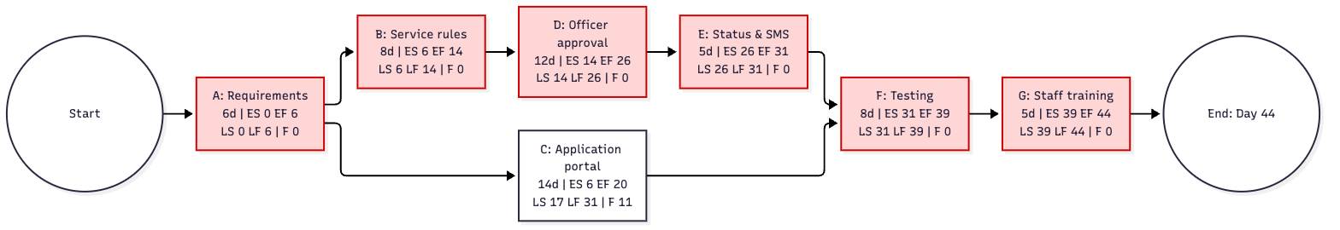
Figure 1: Project Network Diagram (Critical Path highlighted in Red)

4.2 Milestones & Contractual Gates
Four mandatory contractual milestones serve as zero-duration formal gates:
Milestone | Day | Formal Gate Criteria | Required Sign-Off Authority
M1 – Requirements Sign-Off | Day 6 | SRS v1.0 and BRD v1.0 approved; traceability matrix baseline locked | District Supply Officer & Lead BA
M2 – System Build Complete | Day 31 | All 11 FRs coded; Portal (C) and Status/SMS (E) successfully integrated | Technical Delivery Lead
M3 – UAT Acceptance | Day 39 | All Must-have test cases pass; DRE >= 85%; zero open Sev-1/2 bugs | Lead QA & Staff Representative
M4 – Production Go-Live | Day 44 | All DSO staff completed 2h training; SDC cutover complete; portal live | District Collector / DSO Sponsor

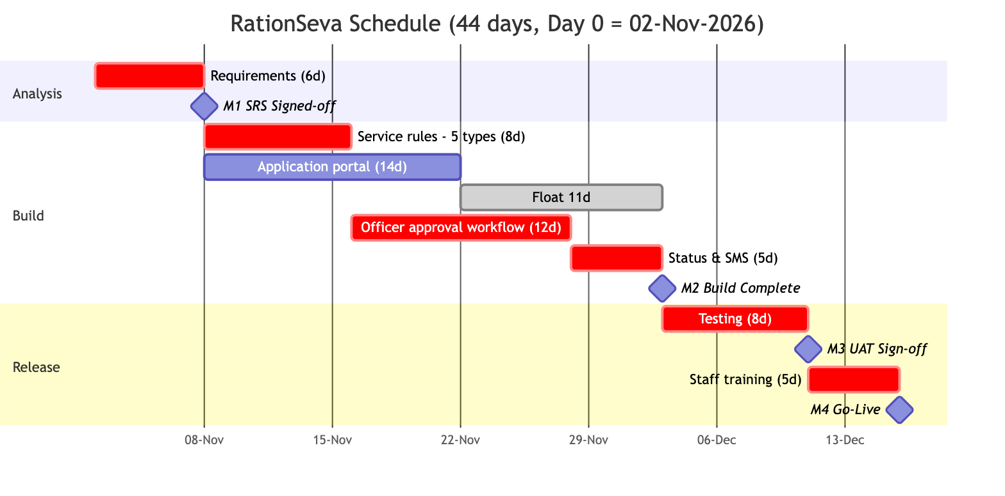
Figure 2: Milestone Gantt Chart (Red = Critical Tasks, Grey = Float)

5. Human Resource Allocation & Resource Leveling Strategy
To guarantee project execution within 44 days, human resources are allocated based on critical-path prioritization:
Role | Headcount | Core Task Assignments | Total Person-Days | Key Responsibilities
Project Manager (PM) | 1 | All (A–G), Change Management | 22 (0.5 FTE) | Schedule tracking, risk management, milestone gates
Lead Business Analyst | 1 | A (Req), B (Rules), G (Training) | 19 (1.0 FTE) | Requirements elicitation, rule specification, staff training
Full-Stack Developer 1 (Lead) | 1 | B (Rules), D (Officer Approval) | 20 (1.0 FTE) | Rule engine architecture, approval state machine
Full-Stack Developer 2 | 1 | C (Portal), D/E Support | 22 (1.0 FTE) | Citizen portal wizard, document upload, then assists D & E
Integration Developer | 1 | E (SMS), System Integration | 16 (1.0 FTE) | SMS gateway integration, audit log, build pipeline
QA / Test Engineer | 1 | Test design (d14–30), F (Testing) | 24 (1.0 FTE) | BVA/decision table tests, defect logging, DRE metrics

Note: Resource Leveling Insight: Developer 2 completes Task C (Application Portal) on Day 20. Because Task C has 11 days of float, Developer 2 is redeployed to assist Developer 1 on Task D (Officer Approval) and Task E (Status & SMS) from Day 20 to 31. This injects 11 person-days of additional development capacity directly into the critical path, mitigating schedule risk.

6. Project Governance, Cadence & Escalation Protocol
A three-tier governance model ensures continuous oversight and rapid issue resolution:
Governance Meeting | Frequency | Participants | Primary Objective
Daily Scrum / Standup | Daily (15 min) | Project Team (PM, Devs, QA, BA) | Track daily progress, identify blockers, verify critical path
Weekly Progress Review | Weekly (60 min) | PM, Lead BA, Supply Officers | Review milestone burn-down, review open defects and risks
Milestone Gate Sign-off | Milestones M1–M4 | DSO Sponsor, District Collectorate, PM | Formal acceptance sign-off and authorization to proceed

Issue Escalation Hierarchy:
- Tier 1 (Technical / Task Variance <= 1 day): Handled by Contractor Lead Developer & Lead BA within 4 working hours.
- Tier 2 (Schedule Variance > 1 day or Cross-Module Dependency): Escalated to Project Manager; corrective action plan formulated within 24 hours.
- Tier 3 (Scope Dispute, Policy Contradiction, or Budget Impact): Referred directly to District Supply Officer (Sponsor); binding decision within 48 hours.

7. Quality Assurance Standards & Acceptance Criteria
- Functional Completeness: 100% of Must-have Functional Requirements (FR-01 through FR-09) pass verification against their mapped test cases (TC-01 through TC-18).
- Defect Removal Efficiency (DRE): System testing must achieve DRE >= 85% prior to go-live sign-off, calculated as DRE = E / (E + D).
- Defect Severity Thresholds: Zero open Severity-1 (Blocker) and Severity-2 (Critical) defects at the conclusion of Milestone M3 (UAT Sign-off).
- Non-Functional Target Verification: System availability >= 99.5%, 100% audit logging, sub-3s response time, and SUS usability score >= 70 verified in formal UAT.

8. Change Control & Scope Amendment Protocol
Any proposed amendment to requirements, service rules, schedule, or architecture must comply with the formal 6-step Change Management Process (Capture -> Understand -> Impact Analysis -> Decide -> Update Plan -> Implement & Verify). The District Supply Officer holds sole statutory approval authority for changes impacting scope or legal compliance.

9. Post-Go-Live Warranty & SLA Support
The Contractor provides a 90-calendar-day warranty period commencing immediately following Milestone M4 (Go-Live). Support SLAs:
Severity Level | Definition | Response Time | Resolution Time Target
Severity 1 (Critical) | Portal down, citizen login disabled, SMS gateway failure | <= 30 minutes | <= 4 hours
Severity 2 (High) | Eligibility rule miscalculation, document upload error | <= 2 hours | <= 12 hours
Severity 3 (Medium) | UI visual defect, non-critical report generation slow | <= 4 hours | <= 48 hours
Severity 4 (Low) | Minor text typo, documentation clarification | <= 8 hours | Next scheduled release patch

10. Contractual Authorization & Signatures
For and on Behalf of Client (DSO) | For and on Behalf of Contractor
Name: Shri R. K. Sharma  Title: District Supply Officer (Sponsor)  Date: ________________________  Signature: ___________________ | Name: Lead Delivery Partner  Title: Engagement Director  Date: ________________________  Signature: ___________________

