Assignment 2

**Computer Network**

**Name of the student: Swaraj Phand**

**Roll No. 7**

**PRN- 12211292**

**Class- TY – D -B1**

**Div: C Batch: 3**

**Date of performance: 24/01/2024**

**Setting Up a Small Wired and Wireless Network**

**The setup will involve using devices such as a Hub, Switch, or Access Point. The steps include installing LAN cards, preparing cables, configuring an access point, assigning IP addresses, and using basic network commands for testing.**

**1. Equipment and Preparation**

**LAN Cards: Ensure that all computers are equipped with LAN (Local Area Network) cards for wired connections.**

**Cables: Prepare or purchase the necessary Ethernet cables (Cat 5e or Cat 6 recommended).**

**Hub/Switch/Access Point: Select the appropriate networking device to connect all computers.**

**2. Cable Preparation and Installation**

**Twisted Pair Cables: Use twisted pair cables (Cat 5e or Cat 6) to connect the computers to the hub, switch, or access point.**

**Crimping: If preparing cables yourself, crimp the RJ45 connectors to the twisted pair cables using a crimping tool. Follow the T568A or T568B wiring standard for proper pin alignment.**

**3. Network Setup**

**Wired Network:**

**Connect each computer to the hub or switch using the prepared twisted pair cables.**

**Wireless Network:**

**Configure the access point with a unique SSID (network name) and security settings (e.g., WPA2).**

**Connect the computers wirelessly by searching for the SSID and entering the security key.**

**UTP categories:**

Category 1 - Voice only (Telephone)

Category 2 - Data to 4 Mbps (Localtalk)

Category 3 - Data to 10Mbps (Ethernet)

Category 4 - Data to 20Mbps (Token ring)

Category 5 - Data to 100Mbps (Fast Ethernet)

Category 5e - Data to 1000Mbps (Gigabit Ethernet)

Category 6 - Data to 2500Mbps (Gigabit Ethernet)

**Color Coding of Twisted Pair cable –**

The color code for twisted pair cables, particularly for Ethernet cables, is used to ensure consistency and proper connections when terminating the cable's connectors (such as RJ-45 connectors) on both ends. In an Ethernet cable, there are four twisted pairs of wires, and each wire within a pair is assigned a specific color.

**The color code is typically as follows:**

Pair 1 - (White with Blue / Blue)

Pair 2 - (White with Orange / Orange)

Pair 3 - (White with Green / Green)

Pair 4 - (White with Brown / Brown)

When crimping connectors onto the ends of twisted pair cables, it's crucial to follow the color code and pinout scheme accurately. Mistakes in wiring can lead to connectivity issues or complete failure of data transmission.

The color code and standards for twisted pair cables are essential for maintaining a structured cabling system, especially in networking and telecommunications environments. Adhering to these standards helps ensure reliable data transmission, reduces the risk of errors, and simplifies troubleshooting and maintenance.

**Networking Commands**

**1. ipconfig**

It is used to manage and troubleshoot network configurations. It provides information on IP addresses, subnet masks, default gateways, DNS settings, and MAC addresses of network interfaces. It provides a quick and convenient way to gather network configuration information.

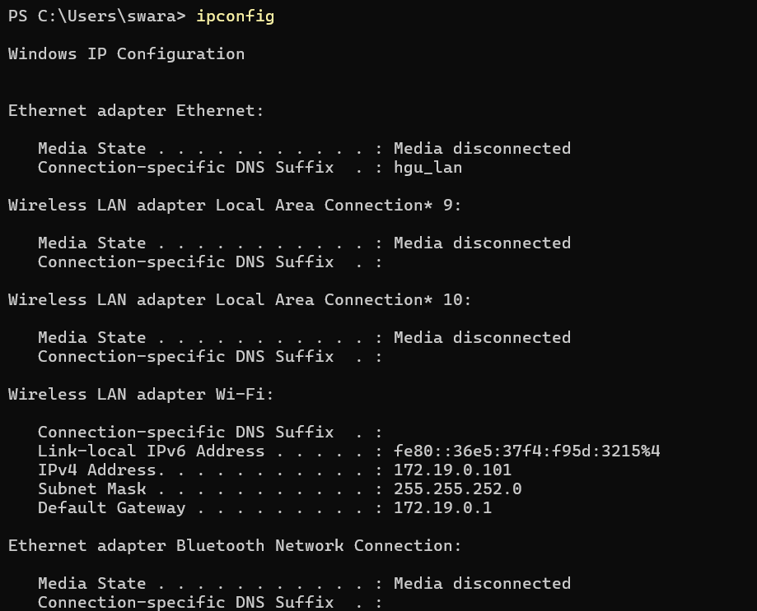

**2. ping**

It is used to test network connectivity, measure response time, determine packet loss. When we specify the IP address or domain name, it sends request to that address and displays all information. There are different options available with ‘ping’ command. When we execute ping command with IP address, information about packets sent and received, round-trip time (in milliseconds) is displayed.

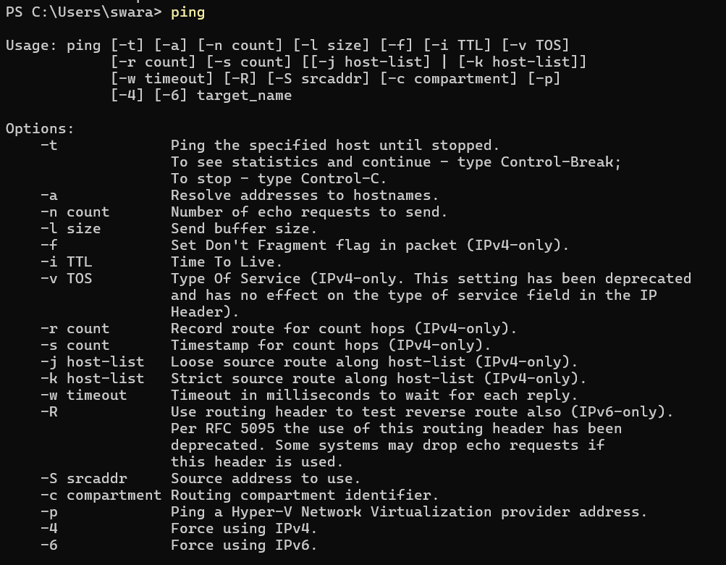

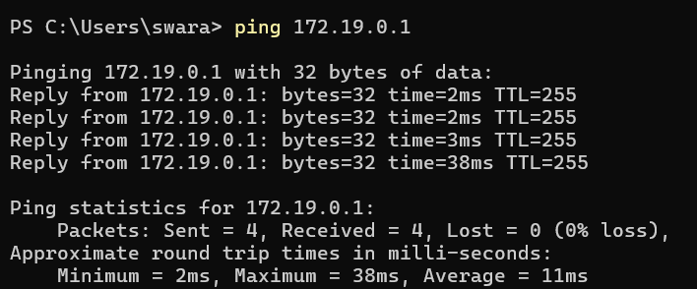

**3. Tracert**

It is used to diagnose connection problem between source and destination. When we enter the IP address or domain name, a list of hops is displayed that the packets traverse along with the round-trip time (in milliseconds) for reaching that hop and IP addresses. Tracert -h can be used to specify the number of hops.

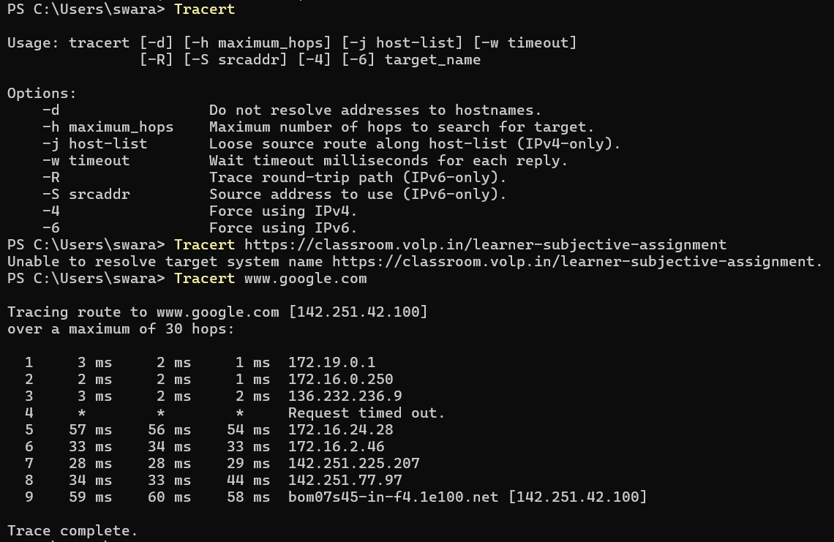

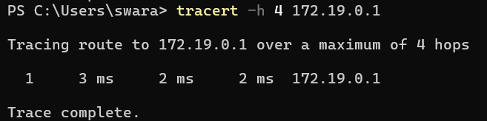

**4. arp**

The arp (Address Resolution Protocol) command is used to map an IP (Internet Protocol) address to a corresponding MAC (Media Access Control) address in a local network. There are different options available in arp command. The arp – a is used to display the ARP table for a particular IP address. The arp command is primarily used for troubleshooting network connectivity issues.

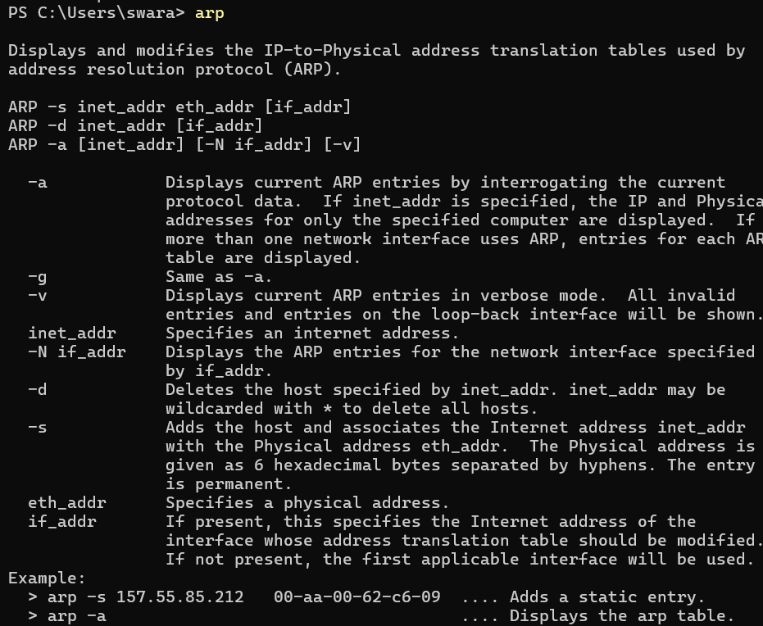

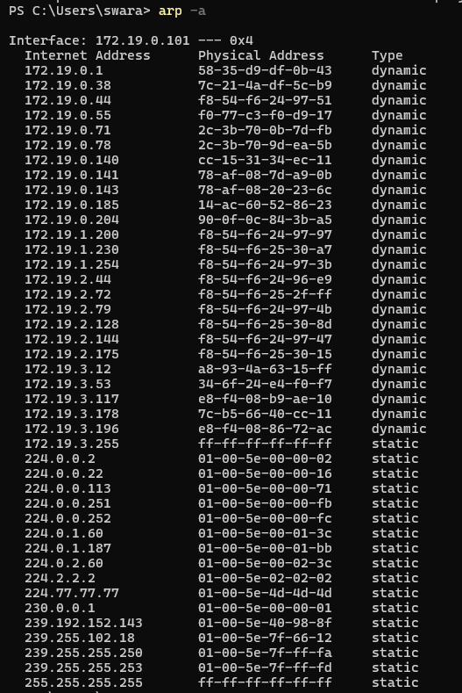

**5. Netstat**

The netstat command is used to display various network-related information. When executed, the netstat command retrieves and displays a list of active network connections, including the protocol used (TCP or UDP), source and destination IP addresses, status of each connection. The netstat -a is used to display the information for our computer system. The netstat -e is used to check the packets sent and received. The netstat -r is used to display network destination, netmask and other information.

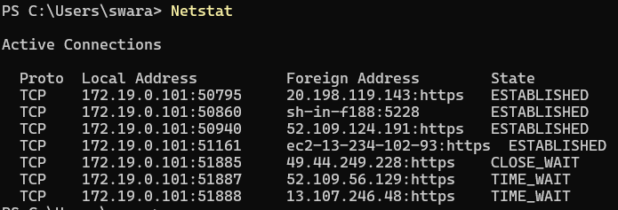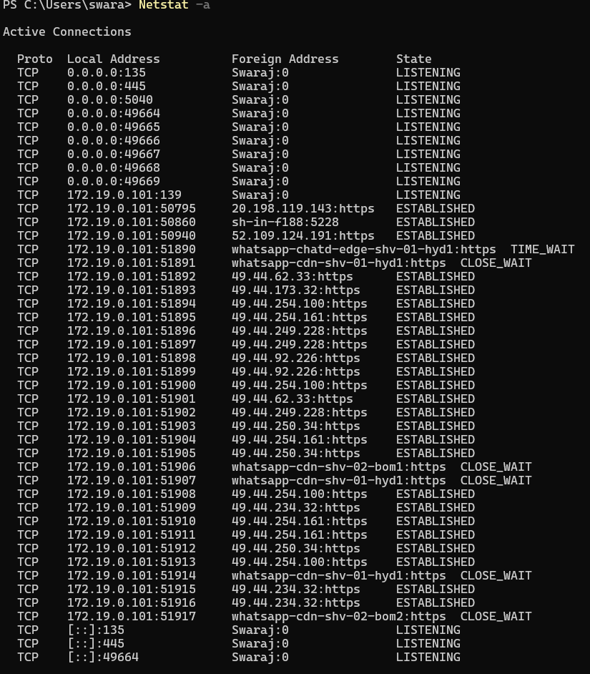 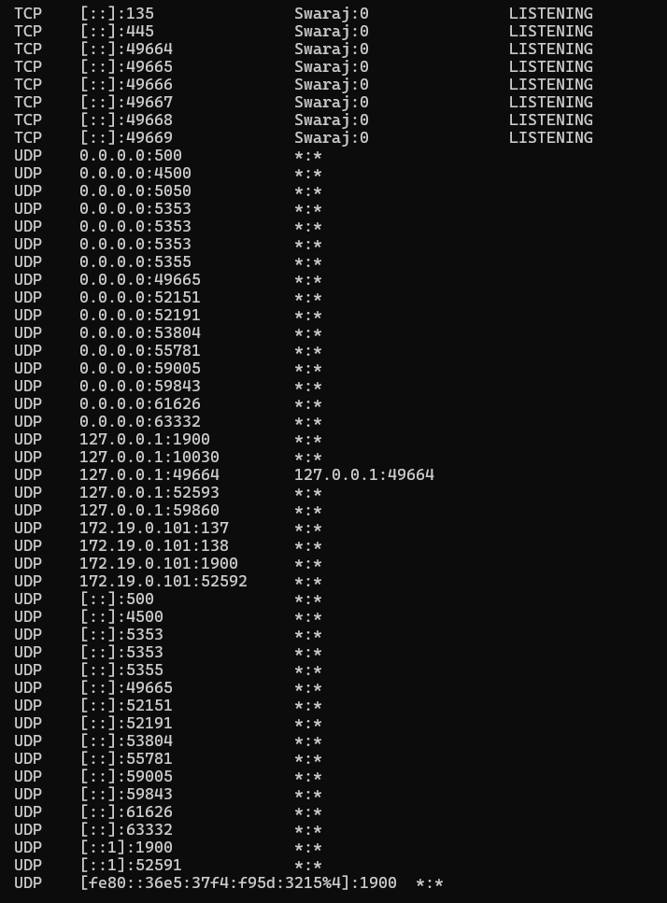

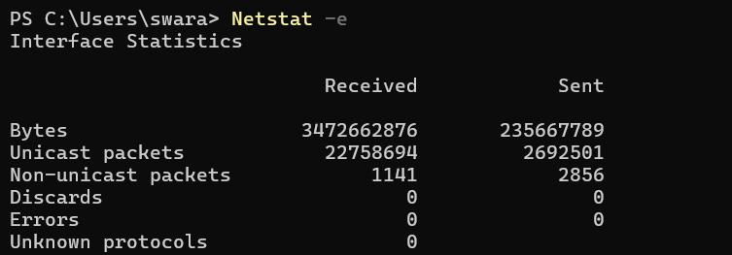 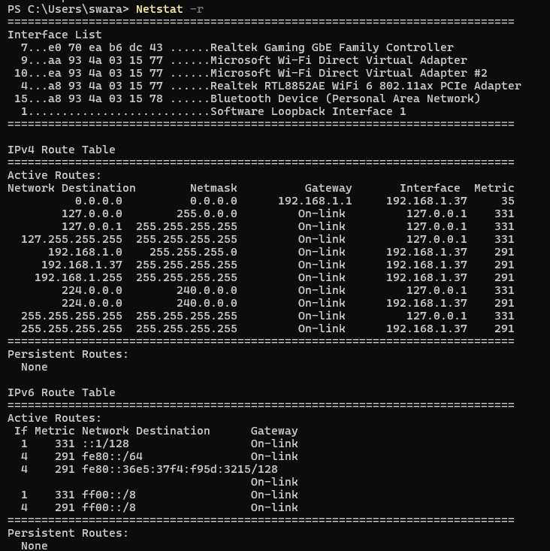  **6. pathping**

The pathping command is used to troubleshoot network issues. It combines features of both tracert and ping commands. When executed, it displays the IP addresses of each hop along with the round-trip time (RTT) for reaching that hop. Pathping provides more detailed information compared to tracert or ping alone. It computes the data for 25 seconds.

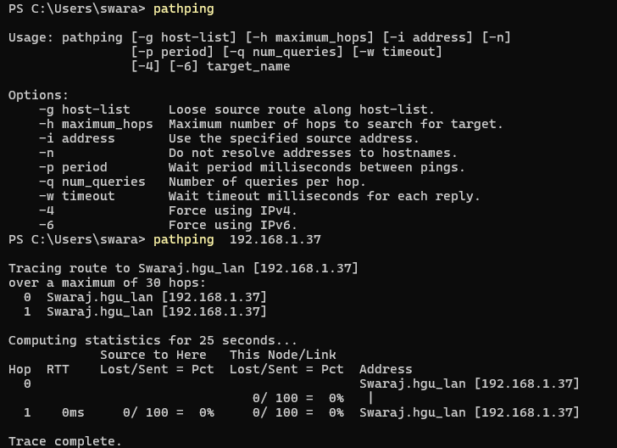

**7. nslookup**

The nslookup command is used to display the IP address if we know the DNS (Domain Name System) information about a given domain name or vice versa. When we enter the domain name, the IP address of that particular domain is displayed. The nslookup command is useful for troubleshooting DNS-related issues.

