Practical No 2
🔹 a) Create, Drop, Alter Database & Table
CREATE DATABASE flights_info;
SHOW DATABASES;
USE flights_info;
-- Create Table
CREATE TABLE flights (
flight_id INT,
flight_date STRING,
carrier STRING,
origin STRING,
destination STRING,
dep_delay INT,
arr_delay INT
)
ROW FORMAT DELIMITED
FIELDS TERMINATED BY ','
STORED AS TEXTFILE;
-- Drop Table
DROP TABLE flights;
-- Alter Table
ALTER TABLE flights ADD COLUMNS (flight_duration INT);

🔹 b) External Table
CREATE EXTERNAL TABLE external_airports (
airport_code STRING,
airport_name STRING,
city STRING,
state STRING
)
ROW FORMAT DELIMITED
FIELDS TERMINATED BY ','
STORED AS TEXTFILE;

🔹 c) Load, Insert, Join
-- Insert
INSERT INTO flights VALUES
(1001, '2008-01-01', 'AA', 'JFK', 'LAX', 10, 5);
-- Load Data
LOAD DATA LOCAL INPATH '/home/pl/Desktop/external_airport.txt'
INTO TABLE external_airports;
-- Join
SELECT f.flight_id, a.airport_name
FROM flights f
JOIN external_airports a
ON f.origin = a.airport_code;

🔹 d) Create Index (Correct Table)
CREATE INDEX idx_flight_origin
ON TABLE flights (origin)
AS 'COMPACT'
WITH DEFERRED REBUILD;
ALTER INDEX idx_flight_origin ON flights REBUILD;

🔹 e) Average Departure Delay Per Day (IMPORTANT)
SELECT flight_date,
AVG(dep_delay) AS avg_departure_delay
FROM flights
WHERE flight_date LIKE '2008%'
GROUP BY flight_date;

Assignment no:-8

import pandas as pd
import matplotlib.pyplot as plt
import seaborn as sns

df = pd.read_csv("forestfires.csv")

# 1. Bar Graph - Avg Temperature per Month
avg_temp = df.groupby('month')['temp'].mean()
avg_temp.plot(kind='bar')
plt.title("Average Temperature per Month")
plt.xlabel("Month")
plt.ylabel("Temperature")
plt.show()

# 2. Box Plot - Fire Area Distribution
sns.boxplot(x='month', y='area', data=df)
plt.title("Fire Area Distribution per Month")
plt.show()

CREATE DATABASE forestdb;
USE forestdb;

CREATE TABLE forestfires (
X INT,
Y INT,
month STRING,
day STRING,
FFMC FLOAT,
DMC FLOAT,
DC FLOAT,
ISI FLOAT,
temp FLOAT,
RH FLOAT,
wind FLOAT,
rain FLOAT,
area FLOAT
)
ROW FORMAT SERDE 'org.apache.hadoop.hive.serde2.OpenCSVSerde'
WITH SERDEPROPERTIES (
"separatorChar" = ",",
"quoteChar" = "\""
)
STORED AS TEXTFILE
TBLPROPERTIES ("skip.header.line.count"="1");
LOAD DATA INPATH '/input/forestfires.csv'
INTO TABLE forestfires;
SELECT month, SUM(area)
FROM forestfires
GROUP BY month;
SELECT month, COUNT(*)
FROM forestfires
GROUP BY month;
SELECT month, AVG(temp) AS avg_temp
FROM forestfires
GROUP BY month
ORDER BY avg_temp DESC;

GNU nano 6.2 mapper.py
#!/usr/bin/env python3
import sys

for line in sys.stdin:
line = line.strip()
data = line.split(",")

# skip header
if data[0] == "X":
continue

try:
temp = float(data[8]) # example column
print(f"{data[2]}\t{temp}")
except:
continue

#!/usr/bin/env python3
import sys

current_key = None
total = 0
count = 0

for line in sys.stdin:
key, value = line.strip().split("\t")
value = float(value)

if key == current_key:
total += value
count += 1
else:
if current_key:
print(f"{current_key}\t{total/count}")
current_key = key
total = value
count = 1

if current_key:
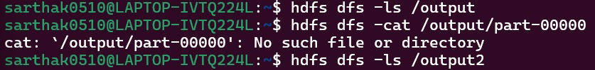
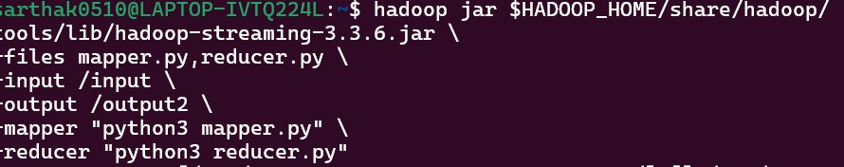
print(f"{current_key}\t{total/count}")

📌 Step 1: Start Hadoop
start-dfs.sh
start-yarn.sh

📌 Step 2: Create HDFS folder
hdfs dfs -mkdir /input

📌 Step 3: Upload dataset
hdfs dfs -put forestfires.csv /input
📌 Step 6: Give permission
chmod +x mapper.py reducer.py

📌 Step 7: Run MapReduce Job
hadoop jar /usr/lib/hadoop-mapreduce/hadoop-streaming.jar \
-input /input \
-output /output \
-mapper "python3 mapper.py" \
-reducer "python3 reducer.py"

📌 Step 8: View Output
hdfs dfs -cat /output/part-00000
👉 Output = Average temperature per month

