TASK 01

TRF-CS{C0NGR4TU14TI0NS_0N_Y0UR_FIRST_F14G}

TASK 02

TRF-CS privacy

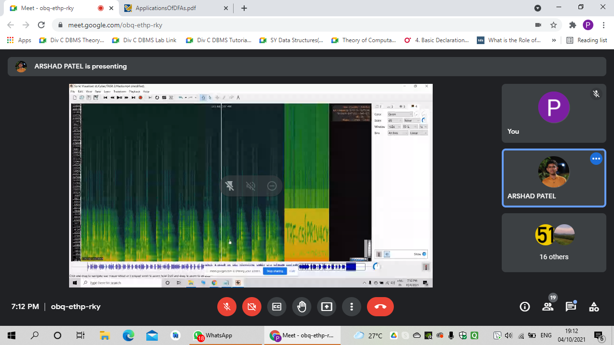

TASK 03 Turing machine

Ans: SOYOUHAVEWHATITTAKES

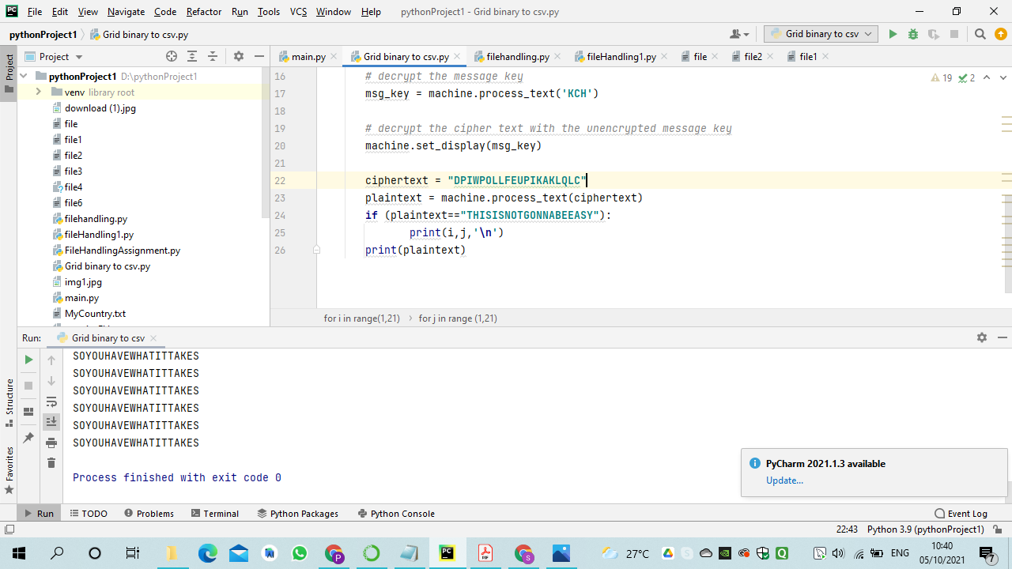

Task 4

Ans: TRFISLOVE

