1.Branch Instruction Verification
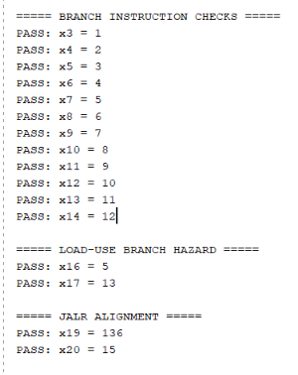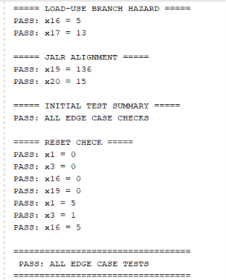
>>CORRESPONDING INSTRUCTION CODE:
00500093
00500113
FFF00793
09100913
00102023
00002803
00180263
00D00893
00208263
00F08263
00F09263
00209263
0017C263
00F0C263
00F0D263
0017D263
00F0E263
0017E263
0017F263
00F0F263
00100193
00200213
00300293
00400313
00500393
00600413
00700493
00800513
00900593
00A00613
00B00693
00C00713
00000013
000909E7
00000013
00000013
00F00A13

2.Branch Hazard, JALR and Reset Verification
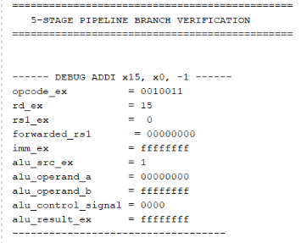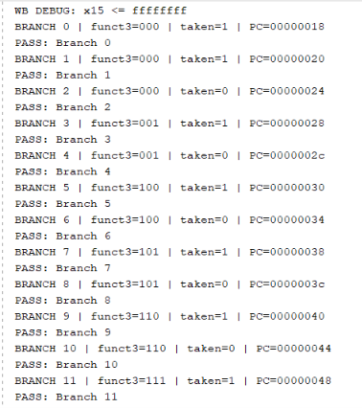
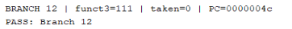
>>CORRESPONDING INSTRUCTION CODE:
00500093
00500113
FFF00793
09100913
00102023
00002803
00180263
00D00893
00208263
00F08263
00F09263
00209263
0017C263
00F0C263
00F0D263
0017D263
00F0E263
0017E263
0017F263
00F0F263
00100193
00200213
00300293
00400313
00500393
00600413
00700493
00800513
00900593
00A00613
00B00693
00C00713
00000013
000909E7
00000013
00000013
00F00A13

3.Load/Store and Load-Use Hazard Verification

02A00093
00102023
00002103
00110193
00000013
00000013
00000013
00000013
00000013
00000013
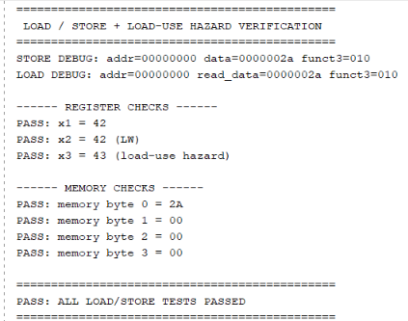

4 .ALU Data Forwarding Verification
00A00093
00508113
00310193
00700213
00900293
00520333
001303B3
00000013
00000013
00000013
00000013
00000013
00000013
00000013
00000013
00000013
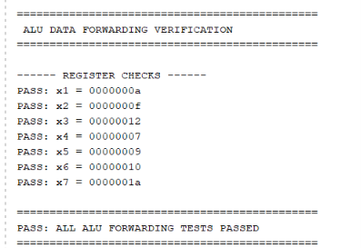
5.Load/Store Edge Case Verification

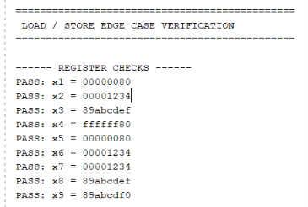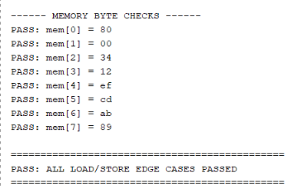
08000093
00001137
23410113
89ABD1B7
DEF18193
00100023
00201123
00000013
00000013
00000013
00302223
00000203
00004283
00201303
00205383
00402403
00140493
00000013
00000013
00000013
00000013
00000013

6.Pipeline Integration Verification
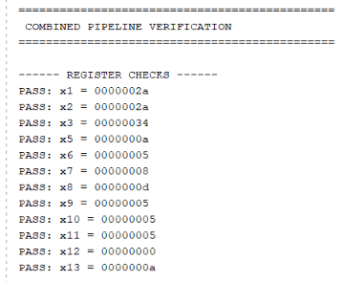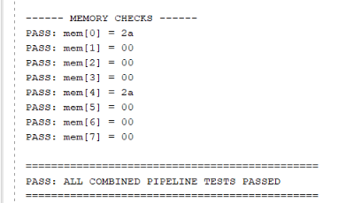
00002083
00102223
00402103
00A00293
005101B3
00500313
00330393
00638433
407404B3
00500513
00500593
00B50463
06300613
00A00693
00000013
00000013
00000013
00000013
00000013
00000013
7.Reset and x0 Register Verification

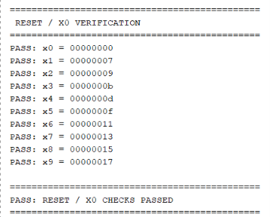
00500013
00700093
00900113
00B00193
00D00213
00F00293
01100313
01300393
01500413
01700493

