 We've all learned about the BODMAS rule in school, but have you ever wondered why we only use BODMAS specifically? Why not BOMASD or DOBASM? What is its mathematical significance? This article explores the importance of the BODMAS rule.

* **WHAT IS BODMAS RULE?**

Achilles Reselfelt is a mathematician who invented BODMAS.BODMAS rule is a mathematical acronym for the mathematical terms used to solve basic mathematical expressions. 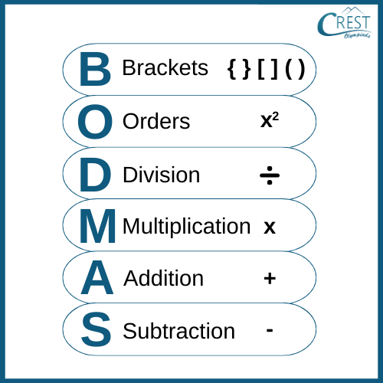

As we have SI units in Physics so that everybody has the same measurement similarly, Before standardized rules like BODMAS, different people might interpret mathematical expressions differently, leading to inconsistent and incorrect results. The BODMAS principle provides a universal standard that ensures everyone evaluates expressions the same way.

Mathematical expressions can become complex, involving multiple operations. Without a clear order of operations, it's challenging to determine which operations to perform first.

Examples related to the BODMAS rule

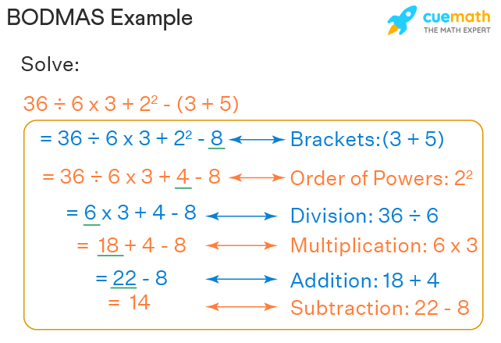

Certainly! Consider the expression:

12−3×2212 - 3 \times 2^212−3×22

Let's see what happens when we don't apply the BODMAS rule versus when we do:

### Without Applying BODMAS:

1. Perform Addition/Subtraction and Multiplication from Left to Right:
   * First, handle subtraction and multiplication sequentially: 12−312 - 312−3 then multiply by 222^222.
   * Subtract first: 12−3=912 - 3 = 912−3=9.
   * Then calculate 22=42^2 = 422=4, and multiply: 9×4=369 \times 4 = 369×4=36.
   * Result: 36.

### With Applying BODMAS:

* Apply the BODMAS Rule:
  + Brackets: There are none.
  + Orders: Calculate the exponent first: 22=42^2 = 422=4.
  + Division and Multiplication: Next, perform multiplication: 3×4=123 \times 4 = 123×4=12.
  + Addition and Subtraction: Finally, subtract: 12−12=012 - 12 = 012−12=0.
  + Result: 0.
  + **BODMAS AND GROUP THEORY**

Associative Property: One of the axioms of a group is that its operation must be associative. This means that for any elements aaa, bbb, and ccc in the group, (a∗b)∗c=a∗(b∗c)(a * b) * c = a * (b * c)(a∗b)∗c=a∗(b∗c). The BODMAS rule respects associativity by ensuring that operations within brackets are evaluated first. This reflects the concept of associativity in group theory, where the grouping of operations does not change the result.

* **BODMAS RULE AND CALCULATOR**

As a student of mathematics, it is really important to know how to write the equation in the calculator as the calculator does not follow the BODMAS rule many a time we tend to solve the equations slowly and gradually by dividing them into many parts Eg: 5/2+3 will give in two steps 5/2 and after getting the answer of this we will proceed to add the 3.

Another way out is that we can input the equation by putting in some brackets in the calculations itself so that the calculator will give us output in a particular manner. Eg: the above equation will be given as (5/2)+3 this will give a better output.

We can also make use of the bodmas calculator to get the correct answer in the regular scenario but from the examination point of view, the other two practices are better than this one.