**Bold Text Bold Text**

Normal text Normal Text

|  |  |  |
| --- | --- | --- |
| **Table** | **Table** |  |
| 1 | 3 | 5 |
| 2 | 4 | 6 |

There is an equation in this question $y=mx+c$.

|  |
| --- |
| Red Text |

Text

|  |
| --- |
| Red Text |

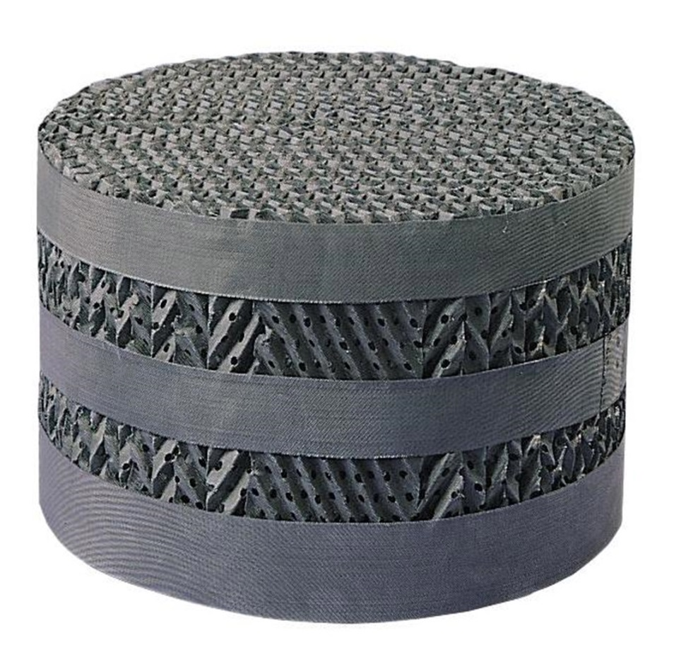

Text

|  |
| --- |
| Red Text |