**RECORD YOUR RESPONSE IN THE SPACE PROVIDED UNDER EACH SUBQUESTION**

**AQ4: Molecular Diffusion: 10 Marks**

Water is kept at the bottom of a narrow tube at a constant temperature of 20 °C. The total pressure of dry air above the tube is 1.01325 × 105 Pa and the temperature is 20 °C. Water evaporates and diffuses through the air in the tube (see Figure AQ4). The diffusivity of water vapour in air at 350 K and 1 atm pressure is 2.50 × 10-5 . The vapour pressure of water at 20 °C is 17.54 mm Hg. Calculate the time in hours, required to evaporate 1 g of water at steady state (assuming that the reduction in water level is negligible).

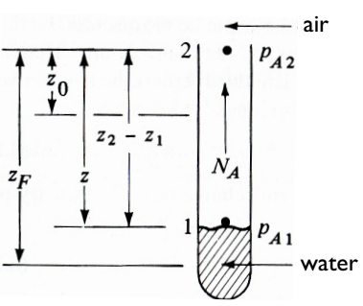

1

2

20 cm

2 cm

**Figure AQ4**

|  |
| --- |
| Response: |

**END OF QUESTION AQ4 (Go to next page)**