**RECORD YOUR RESPONSE IN THE SPACE PROVIDED UNDER EACH SUBQUESTION**

**AQ6: Liquid-liquid Extraction (LLE): 20 Marks**

A chemical plant produces wastewater solution that contains 48 wt% acetone at a mass flow rate of 100 kg/h. Acetone is extracted using pure trichloroethane. A continuous counter-current multistage extraction process is employed to produce a final raffinate containing 10 wt% acetone. The phase diagram for this ternary system (Water-Acetone-Trichloroethane) is given below at the temperature and pressure at which the extraction is conducted.

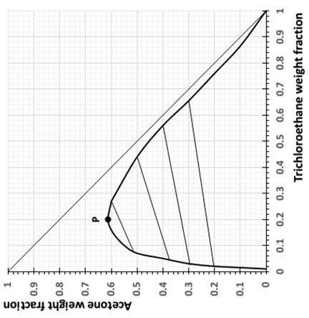

**Figure AQ6**

a) Label directly on the diagram by inserting text boxes on Figure AQ 6, the extract and the raffinate side of the equilibrium plot. **2 Marks**

|  |
| --- |
| Response: |

b) Find the maximum acetone composition of the extract ($y_{1, max}$) **2 Marks**

|  |
| --- |
| Response: |

c) Determine the maximum acetone composition of the mixture. **2 Marks**

|  |
| --- |
| Response: |

d) What would be the minimum Trichloroethane flow rate? **2 Marks**

|  |
| --- |
| Response: |

e) Estimate the actual solvent flow rate for which the final extract has an acetic composition of 0.4. **2 Marks**

|  |
| --- |
| Response: |

f) What would be the final extract and raffinate flow rates? **2 Marks**

|  |
| --- |
| Response: |

g) Determine the raffinate composition of Stage 1. **2 Marks**

|  |
| --- |
| Response: |

h) In your own words write the procedure to determine the number of equilibrium stages required to achieve the desired separation (150 words limit). **6 Marks**

|  |
| --- |
| Response: |

**END OF QUESTION AQ6 (Go to next page)**