**RECORD YOUR RESPONSE IN THE SPACE PROVIDED UNDER EACH SUBQUESTION**

**BQ2: Distillation: 10 Marks**

Fig. BQ2 provides an equilibrium data for the methanol-water distillation system and a solution to a methanol-water distillation problem using McCabe-Thiele method. Answer the following questions based on Fig. BQ2 –

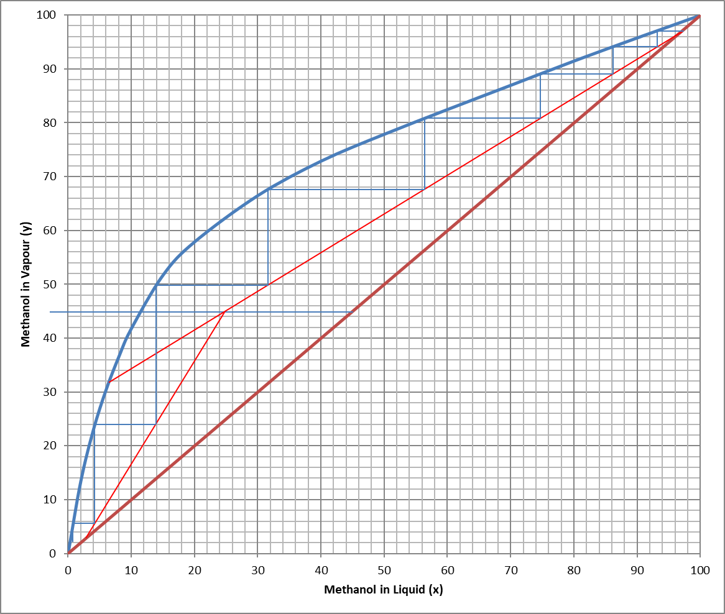

**Figure BQ2**

a) Determine the vapour fraction in the feed. In addition, briefly explain the significance of the feed condition on the operation of the distillation column (maximum 100 words). **2 Marks**

|  |
| --- |
| Response: |

b) Determine the approximate composition of water in the vapour and liquid phases leaving the feed stage. **2 Marks**

|  |
| --- |
| Response: |

c) Determine the approximate compositions of methanol in the vapour and liquid phases entering stage 4. **2 Marks**

|  |
| --- |
| Response: |

d) Determine the relative volatility of methanol at stage 5. **2 Marks**

|  |
| --- |
| Response: |

e) To estimate the minimum number of equilibrium stages, the rectifying (enriching) and stripping operating lines coincides with the $x=y$ line. Using theoretical and analytical reasoning, briefly describe the reasons for this condition of the operating lines. **2 Marks**

|  |
| --- |
| Response: |

**END OF QUESTION BQ2 (Go to next page)**