**RECORD YOUR RESPONSE IN THE SPACE PROVIDED UNDER EACH SUBQUESTION**

**BQ4: Molecular Diffusion: 10 Marks**

Butanol is kept at the bottom of a narrow tube at a constant temperature of 25 °C. The total pressure of dry air above the tube is 1.01325 × 105 Pa and its temperature is 25 °C. Butanol evaporates and diffuses through the air in the tube (see Figure BQ4). The diffusivity of butanol in air at 273 K and 1 atm pressure is 6.94 × 10-6 . The vapour pressure of butanol at 25 °C is 6.79 mm Hg. Determine the time in hour required to evaporate 1 g of butanol at steady state. Note that the amount of butanol in the tube is sufficient and the reduction in butanol level upon the mass loss of 1 g can be assumed negligible.

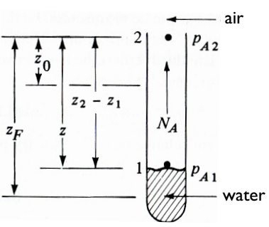

1

2

18 cm

1.8 cm

Butanol

**Figure BQ4**

|  |
| --- |
| Response: |

**END OF QUESTION BQ4 (Go to next page)**