**RECORD YOUR RESPONSE IN THE SPACE PROVIDED UNDER EACH SUBQUESTION**

**BQ5: Adsorption: 20 Marks**

Water vapour is to be removed from nitrogen gas in a packed bed with a cross-sectional area of 1 m2 and a height of 0.5 m at 28 °C using 4A molecular sieves. The bulk density of the packed bed is 712.8 kg/m3. The initial water concentration in the packed bed is 0.02 kg water/kg solid and the mass velocity of the inlet gas is 4200 kg/m2.h. The inlet water concentration is Co = 926 x 10-6 kg water/kg nitrogen. The breakthrough graph is given in Figure BQ5, and it is assumed to be symmetric. The break point concentration is set at C/Co = 0.01.

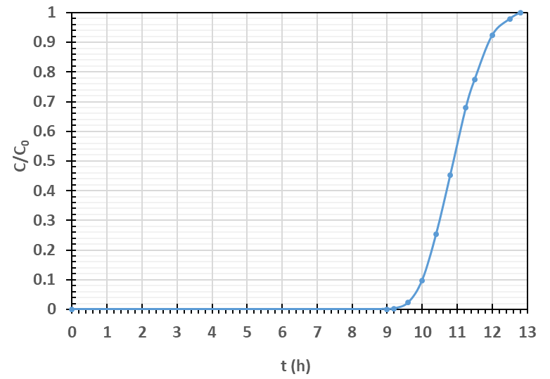

**Figure BQ5**

a) Determine the break-point time in hours. **2 Marks**

|  |
| --- |
| Response: |

b) Determine the fraction of the total capacity used at the break point. **8 Marks**

|  |
| --- |
| Response: |

c) Determine the length of the unused bed (cm). **2 Marks**

|  |
| --- |
| Response: |

d) Calculate the saturation loading capacity of the solid. **5 Marks**

|  |
| --- |
| Response: |

e) We are supposed to scale up the bed to 3 m in height. Determine the new break-point time. **3 Marks**

|  |
| --- |
| Response: |

**END OF QUESTION BQ5 (Go to next page)**