**RECORD YOUR RESPONSE IN THE SPACE PROVIDED UNDER EACH SUBQUESTION**

**BQ6: Liquid-liquid Extraction (LLE):**   **20 Marks**

Toluene is to be extracted from heptane, using sulpholane as a solvent in a multi-stage equilibrium counter-current liquid-liquid extraction (LLE) process at 25°C and 1 atm. The miscibility phase boundary is shown in Fig. BQ6, where the terminal conditions for the LLE process are also included. Note that the symbol $L_{0}$ refers to the fresh feed, $L_{N}$ is the final raffinate and $V_{N+1}$ is sulpholane flow in.

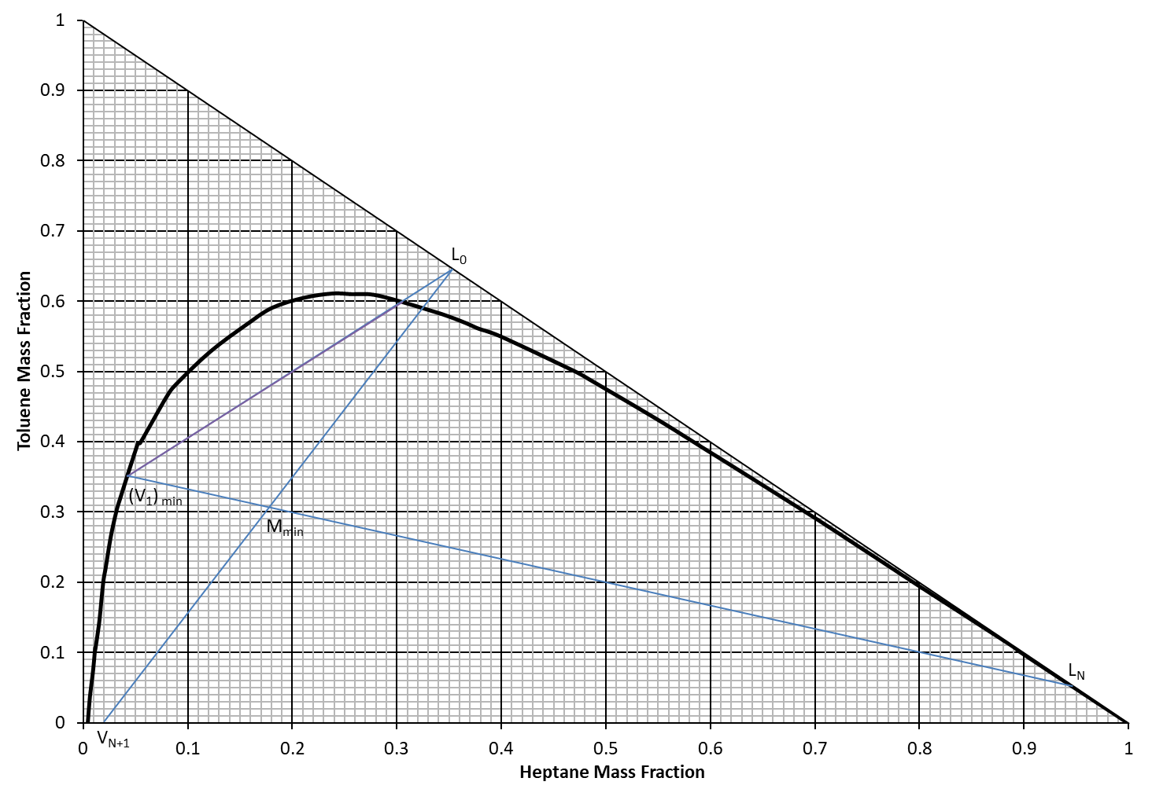

**Figure BQ6**

a) Determine the feed composition for all three components. **2 Marks**

|  |
| --- |
| Response: |

b) Label the raffinate and extract layers on the equilibrium plot (by adding text box). Discuss the partitioning of the solute composition in raffinate and extract layers, and also discuss which phase will be more enriched in toluene. (150 words max). **2 Marks**

|  |
| --- |
| Response: |

c) Determine the minimum solvent flow rate on the basis of 100 kg/h of feed. **3 Marks**

|  |
| --- |
| Response: |

d) For an actual solvent flow rate times is twice larger than the minimum value, calculate all the terminal flow values and their compositions. **5 Marks**

|  |
| --- |
| Response: |

e) Discuss the relative miscibility (i.e. partial miscible/completely miscible) of binary pairs of the three components in this question. **2 Marks**

|  |
| --- |
| Response: |

f) In your own words, write down the key steps to determine the number of equilibrium stages required to achieve the desired separation (200 words max). **6 Marks**

|  |
| --- |
| Response: |

**END OF QUESTION BQ6 (Go to next page)**