

[COMPANY NAME]
BRAND GUIDELINES
Version 0.1 — Working Draft — July 2026

About This Document
This is a working draft brand system built around a radial "millstone" mark — a circular, spoked motif chosen to be distinctive, scalable to a single-color favicon, and easy to reproduce on signage, print, and screen. Every placeholder in brackets — [COMPANY NAME], [Tagline Placeholder], contact details — should be replaced once the real name and copy are finalized; nothing here is final until you sign off on a primary mark.
This draft carries over the exact color palette and typography already established for the presentation template and icon library, so all brand materials stay visually consistent across decks, documents, and this identity system.

Color Palette
Two coordinated palettes — one tuned for light/white backgrounds, one for dark navy backgrounds — carried directly from the presentation template and icon library already in use.

Light Theme
Swatch | Name | Hex | Usage
 | Background | #FFFFFF | Page and slide background, white space
 | Navy (primary) | #16233F | Primary mark color, headings, body text on light backgrounds
 | Slate (secondary) | #4F6079 | Secondary text, captions, supporting graphics
 | Gold (accent) | #C89B3C | Single accent — taglines, dividers, callouts. Use sparingly.

Dark Theme
Swatch | Name | Hex | Usage
 | Background | #10162B | Dark working background
 | Navy block | #0B1022 | Deep panel fills, bookend/cover slides
 | Slate (mark on dark) | #8DA0C2 | Primary mark color and body text on dark backgrounds
 | Gold (accent) | #D4AF5A | Same role as light theme — single accent, brightened for contrast on navy
Rule of thumb: gold is a single accent, never a dominant fill. Navy/slate carry the weight of the mark and text; gold marks taglines, dividers, and the one thing on a page you want the eye drawn to.

Typography
Both fonts ship standard with Microsoft Office, so text renders identically on any machine without installing anything.

Cambria — Headings & Wordmark
The quick brown fox jumps over the lazy dog
ABCDEFGHIJKLM · abcdefghijklm · 0123456789

Calibri — Body & Captions
The quick brown fox jumps over the lazy dog
ABCDEFGHIJKLM · abcdefghijklm · 0123456789
Note on this draft's preview images: the logo concept renders and mockups on the following pages were generated in an environment without Cambria/Calibri installed, so their wordmark text is drawn in metric-compatible substitutes (Liberation Serif/Sans). The actual .docx and .pptx source files below correctly reference Cambria/Calibri and will render properly in Word/PowerPoint.

Primary Mark & Usage Rules
The recommended starting point is Concept 2 (page 6) — an 8-sector combination lockup — for general use: business cards, letterhead, email signatures, and slide decks. Concept 3 (10 sectors, fine grooves) is built as a standalone icon for favicons and app icons where a finer, more literal stone texture reads well at small size. Review all six on the following pages and tell me which to carry forward — the rest are provided as alternates or for A/B use across sub-brands or product lines.

Clear Space
Keep clear space around the mark equal to at least the radius of its outer rim circle on all sides — no text, edges, or other graphics inside that margin.

Minimum Size
- Digital: no smaller than 24px for the icon-only mark (favicon-safe).
- Print: no smaller than 0.4in / 10mm for the icon-only mark; 1.25in wide for the combination lockup.

Do
- Use the mark at 100% opacity in navy (light backgrounds) or slate (dark backgrounds).
- Use the single gold accent only for the center spindle-hole ring or a supporting rule/divider — never as the dominant groove color.
- Scale the mark proportionally in both directions.

Don't
- Don't recolor the grooves in multiple colors at once, add drop shadows/bevels, or stretch the mark disproportionately.
- Don't place the navy mark on a busy photo background without a solid color plate behind it.
- Don't rotate the mark — its sector angles are fixed per concept.

Six Logo Concepts
The mark is a plain circular disc face divided into equal sectors by straight radiating grooves, with shorter secondary grooves fanning within each sector and a small center spindle hole — the actual structure of a dressed millstone face, not a pointed star or compass. Each concept varies sector count and groove density, from a fine, dense, literal texture close to your reference photo down to a clean, minimal mark; each is shown on both a light and a dark background to confirm it holds up in both contexts.

Concept 1 — Icon-first, 6 sectors / 3 secondary grooves (clean, moderate detail)
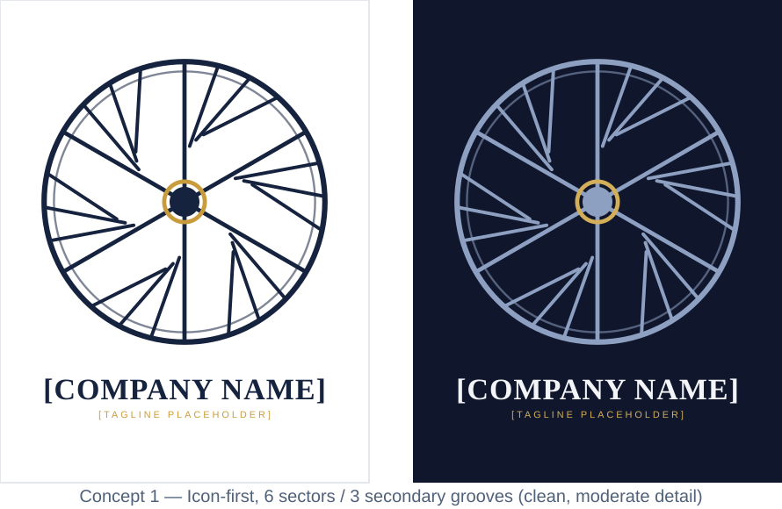

Concept 2 — Combination lockup, 8 sectors / 2 secondary grooves — recommended primary
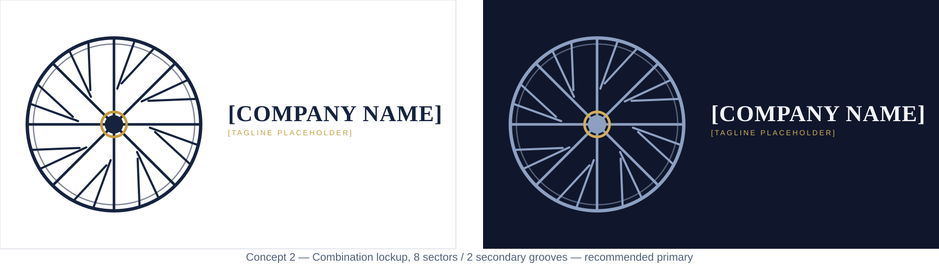

Concept 3 — Icon-first, 10 sectors / 2 secondary grooves (fine, dense texture)
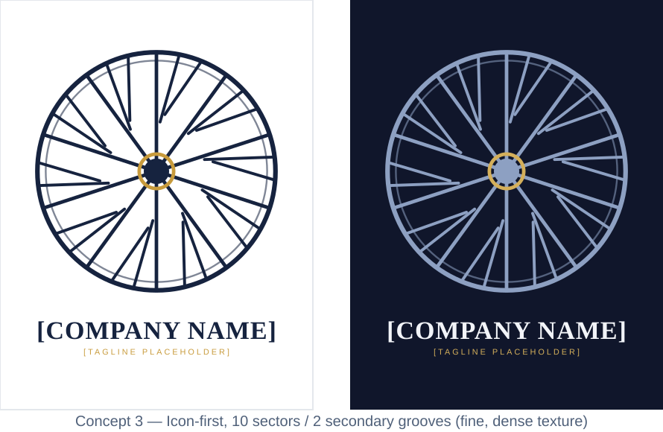

Concept 4 — Icon-first stacked, 7 sectors / 3 secondary grooves
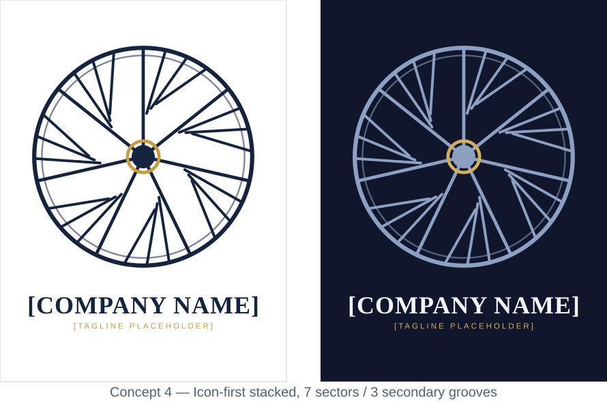

Concept 5 — Combination lockup, 6 sectors / 1 secondary groove (minimal)
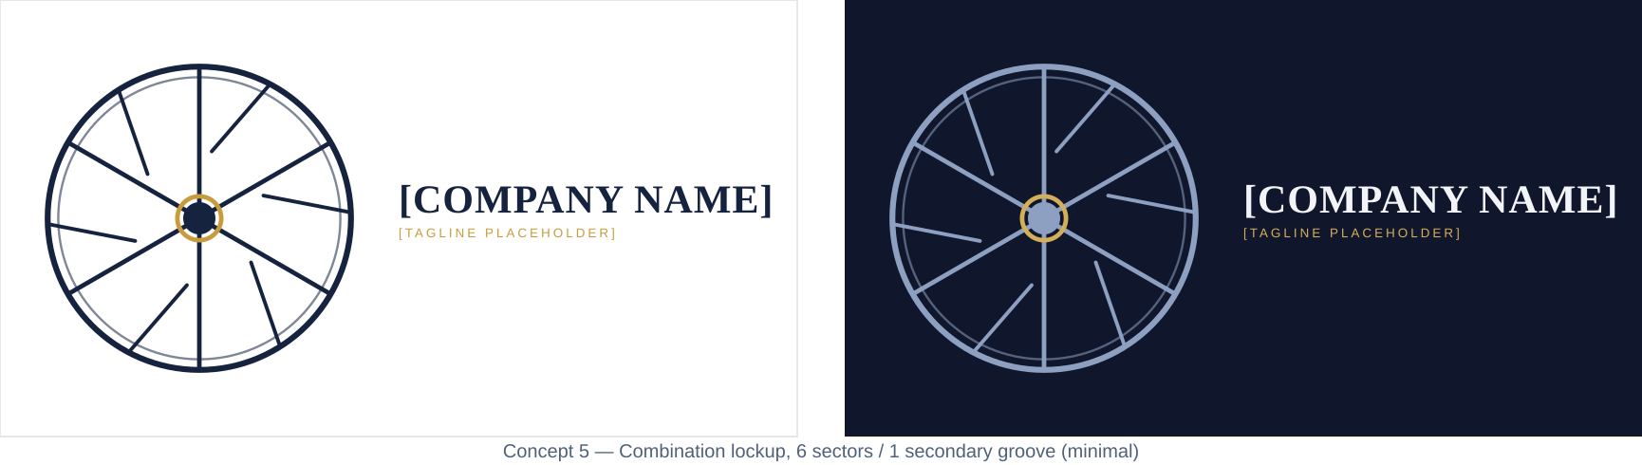

Concept 6 — Icon-first, 9 sectors / 4 secondary grooves (densest, most literal)
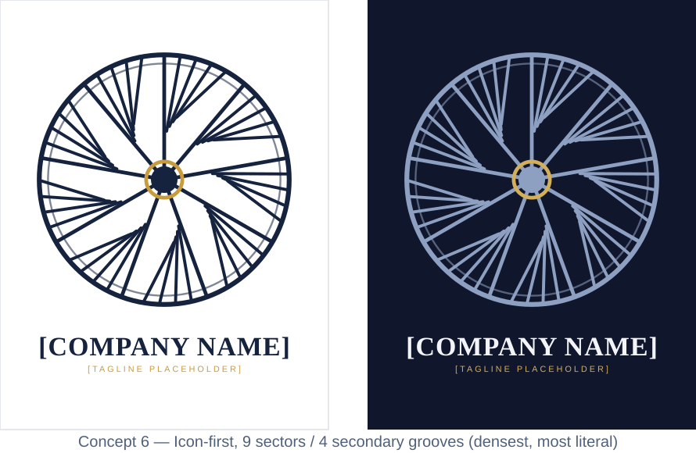

Letterhead
A ready-to-use Word letterhead is provided as a separate file, Letterhead-Template.docx, built on Concept 2. Preview:
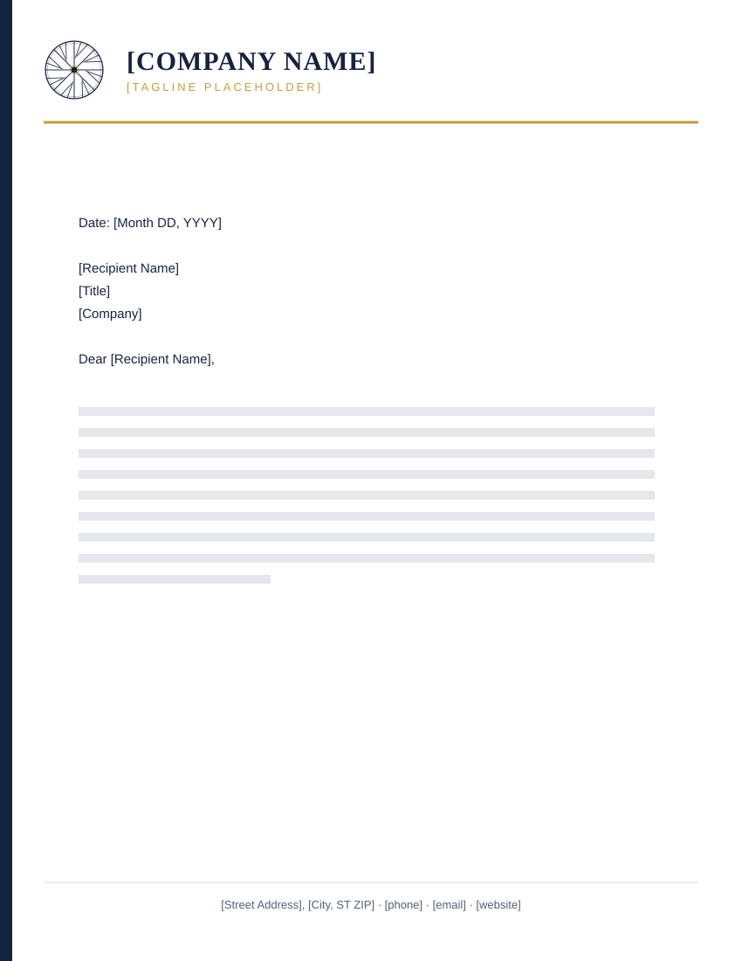

Business Card
Standard US business card size (3.5in × 2in). Front carries the full lockup on navy; back is light with contact details and a small icon-only mark.
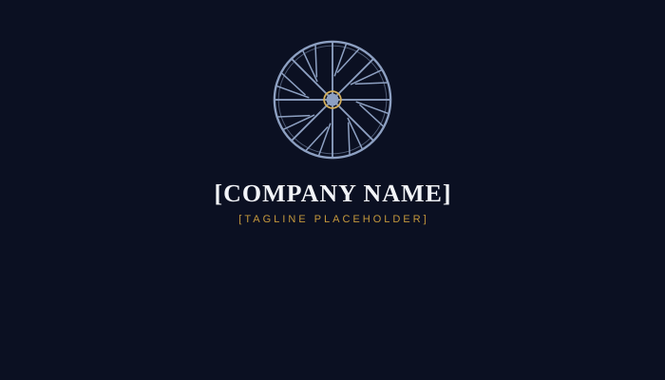
Front
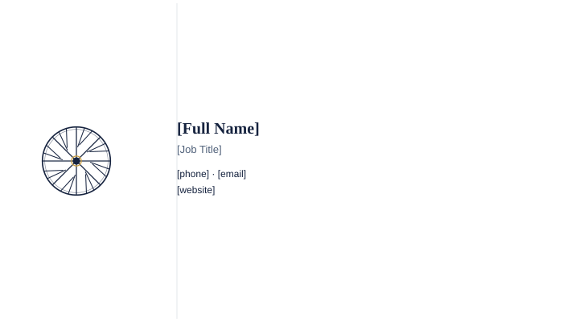
Back

Open Questions / Next Steps
- Confirm the real company name and tagline (or confirm to keep working in placeholder form a while longer).
- Pick a primary mark from the 6 concepts — or ask for a 7th blending elements of two.
- Confirm the monogram initial if a monogram concept (3 or 6) is the direction.
- Any existing sub-brand, product line, or division that also needs a lockup variant?
- Once a name is locked, this document and the letterhead/business-card files can be regenerated end-to-end with the real name, tagline, and contact details filled in — no manual re-typing needed.

