**Impact of ESG rated holdings on Fund flows and Fund returns: The case of New Zealand**

**Abstract**

This research paper investigates the impact of ESG rated holdings on fund flows and fund returns in New Zealand mutual funds. Utilizing historical monthly data at the holdings and fund level, the study finds that fund flows related to ESG-rated holdings positively impact the overall fund flows, and the decomposed returns from ESG holdings make a substantial contribution to the fund returns. Additionally, an examination of the expected return of ESG-rated holdings reveals that these expected returns surpass the actual fund returns during the sample period. By categorizing funds with a portfolio allocation of at least 50% in ESG-rated holdings as Sustainable funds, the research evaluates the fund returns of these categorized funds. The results indicate that Sustainable funds demonstrate better performance compared to the total funds analysed, spanning open-end funds, KiwiSaver funds, and pension funds.

**Keywords:** ESG, SRI, investor learning, fund flows, Portfolio Holdings, Fund performance.

**Introduction**

ESG gained prominence in the investment and fund management industry with the release of the influential report by the United Nations in 2004[1]. Over the past two decades, climate change, social and governance have emerged as a critical issue for investors. Last year the Government made it mandatory for 200 large institutions covered by the Financial Markets Conduct (FMC) Act to start making climate-related disclosures for financial years commencing in 2023, earliest starting in 2024. ESG has increasingly gained prominence in the financial landscape, shaping investment trends and market dynamics. According to a report from Morgan Stanley in August 2023, sustainable funds have outperformed traditional funds in terms of both flows and returns during the first half of the year.

Sustainable investment has witnessed significant expansion in flows, with global assets under management in responsible investments rising by 15% from 2018 to 2020, to a total of US$35.3 trillion representing 36% of all professionally managed assets as of the beginning of 2020, according to the Global Sustainable Investment Alliance (2021) (Tang, Frijns, Gilbert & Scott). Simultaneously there has been several studies done assessing the performance of sustainable mutual funds. Hartzmark, & Sussman (2019) show that investors value sustainability but do not find evidence that funds with high sustainability ratings rewards investors. In 2022 study, Fang & Parida (2022) find out that active sustainable funds create more value for the investors and Morningstar rated five - globe funds attract more investments or suffer less outflow than one - globe fund. Both the previous two papers find out contradicting results in terms of fund returns but the consistent results in the funds flow. The inflow in capital of ESG funds trigger a phenomenon which is described by Van der Beck (2021). The researcher argued that the returns to ESG investing are driven by price impact from flows towards ESG funds, showing that every dollar flowing towards ESG stocks increases their aggregate market value by $0.7 and in the absence of flows, ESG funds would have not outperformed the markets.

The favourable trends in international financial markets towards sustainable funds and the growing body of literature on ESG funds was the motivation behind this study. The aim is to explore how ESG rated holdings influence fund flows and fund returns within the New Zealand mutual fund industry. It is curious to know if ESG rated holdings or stocks in the portfolio can affect fund flows and fund returns. I chose New Zealand managed funds industry for this analysis because managed investment funds account for roughly 85% of all equity investments in the New Zealand financial market (Ali et al., 2022). In the study I separated fund returns and fund flows into those resulting from ESG rated holdings and from non-ESG rated holdings. Next, I compare the ESG holdings fund flows and decomposed ESG holdings fund returns with overall fund returns to calculate the contribution of these holdings in the fund returns and fund flows. The overall analysis helped in understanding the positive role played by ESG ratings of the holdings in mutual fund portfolio.

The empirical findings of the study are as follows. The proportion of ESG rated holdings by portfolio weights have increased consistently for the sample time period irrespective of the fund return volatility. Simultaneously the allocation to ESG rated equity holdings have also consistently increased over non ESG rated equity holdings. The decomposed returns of ESG rated holdings contributes a significant part to fund returns. ESG rated stocks contribute $0.655 (or 65.50%) for every dollar earned in fund returns. The expected return of ESG rated holdings outperform the overall fund returns. Combined flows to ESG rated holdings is higher than fund flows. From every dollar invested as fund flow $0.64671 (or 64.671%) goes to ESG rated holdings basket. This study expands on the existing literature by investigating metrics of fund flows, fund returns, and fund return volatility at holdings level and funds level generated by ESG ratings of holdings.

**Literature Review.**

From the previous literature on fund flows we know that investment flows of managed funds are often considered as an indicator of investor sentiment (Ali, Badshah, Demirer, & Hegde (2023)). In 2022 report Mckinsey provided evidence of rising fund flows in ESG funds. Inflows in ESG funds grew from $5 billion in 2018 to nearly $70 billion in 2021. Even the rate of new investments has been on decline in 2022 these funds gain $87 billion of new net money in first quarter of 2022 and $33 billion in second quarter. The report found out that rate of decline of net inflows in these funds was less than rate of decline of the broader market.

In 2016 March, when Morningstar first published Sustainability ratings for more than 20,000 mutual funds money shifted hands as fund flows from low Sustainability ratings funds to high sustainability ratings funds but do not find evidence supporting a rational belief that more sustainable perform better (Hartzmark & Sussman (2019)). In 2022, Fang & Parida (2022) presented evidence that funds with Morningstar five globe ratings attract more (or lose less) investments than one – globe funds. Also, the return of five globe funds is higher than one – globe funds post pandemic. The paper also gave an important finding that investors invest more in five – globe funds during pandemic which gives credence that investor’s attitude towards sustainable investing might has changed as they prioritize sustainable investments. The findings are in line with Mckinsey report insight. In another study (Omura et al., 2020) researcher found out that the outperformance of Socially responsible investing (SRI) index increased during pandemic globally however ESG ETFs did not outperform the benchmarks during the period. Study also states that European equity investors sought out Socially responsible companies during pandemic for wealth protection.

In the study done by Van der Beck (2021,2), the researcher estimated the market ability to accommodate the demand for ESG stocks generated by ESG funds, given by the elasticity of substitution between ESG and other stocks. The researcher estimated an annual flow – driven ESG returns of 2.07%. He claimed that ESG funds would not have performed in the absence of flows. This study is one of its kind which studied the liquidity profile and associated returns with the liquidity profile of underlying holdings of a ESG fund portfolio. In 2022 study done by Sim & Kim (2022) for Korean mutual funds, the study was done at holdings based ESG scores, flows and performance and found that flow performance relationship of ESG funds is not different from that of non – ESG funds however, the flow performance sensitivity weakens for higher for funds with higher ESG scores. This paper further contributes to the emerging literature and analyse the contribution of ESG rated holdings in fund flows and fund returns. An emerging literature on ESG funds is the issue of window dressing. In the paper, Tang, Frijns, Gilbert & Scott discussed about window dressing in RIFs (Responsible investment funds). The author states that investor who judge fund manager by portfolio holdings, gives an incentive to fund managers to manipulate their holdings near the reporting dates to give investors a more favourable impression to avoid fund outflows and attract fund flows. The researcher states the case of ESG performance window dressing in which fund manager switch holdings with regard to ESG aspects near reporting date. Window dressing has the potential to adversely affect fund value, fund flow and fund returns through an unnecessary churning of portfolio (Agarwal, Gay & Ling (2014)).

**Data and Methodology**

The dataset was compiled from two primary sources. Information was gathered from Morningstar for 1258 funds and from Refinitiv for 815 funds for fund level and holdings level respectively for the sample period 2000 to 2022. The comprehensive dataset encompasses percent holdings, detail holding type, holdings name, SecID, ISIN, ESG scores, ESG controversy score, monthly returns at holdings level and fund variables at fund level – monthly fund returns, monthly net assets, monthly fund size, monthly fund Star rating and yearly expense ratio and turnover ratio for the fund month holding period. All the variables’ calculations are at monthly level, providing a time-series perspective for the analysis. Among the 825 funds at the holdings level, there are 388 open-end funds, 268 KiwiSaver funds, and 159 pension funds.

Various filters were applied to this database to facilitate the exploration of ESG-related metrics. These included the construction of ESG holdings weight and ratios for portfolio, fund flows at the fund level, decomposed ESG holdings fund flows, fund returns, decomposed ESG fund returns. At stock level, average ESG holding returns at the fund level and stock level is done.

To calculate the number of stocks with ESG ratings I isolated data of equity holdings with ESG ratings and calculated the following ratio.

$ESG equity holdings ratio=\frac{Total ESG equity holdings}{Total equity holdings}$

Calculated the fund flow for each fund for each month and year as per data available in Morningstar at fund level as per (Ali, Badshah, Demirer, & Hegde, 2022)(2)

$$Fund flow =\frac{\left\{TNA\left(at t month\right)-TNA\left(at \left(t-1\right)month\right)*\left(1+r\right)\right\}}{TNA at \left(t-1\right)month}$$

To calculate the decomposed return for total ESG rated holdings $Decomposed return for total ESG holdings=∑(Portfolio weight per ESG holdings*Fundreturns)$

Next calculated total ESG holdings monthly fund flow. The decomposed fund returns of ESG holdings returns is used. The variables created for this calculation is sum of capital invested in ESG stocks as per portfolio weight for per holdings which is taken as TNA. $$Fund flow =\frac{\left\{TNA\left(at t month\right)-TNA\left(at \left(t-1\right)month\right)*\left(1+R\right)\right\}}{TNA at \left(t-1\right)month}$$

$$Capital Invested per holding=Portfolio weight per holding*TNA$$

$$Weighted return per ESG holdings=portfolio weight per holding*monthlyreturns per holding$$

$$Fund flow per ESG holdings=\frac{\left\{Capital invested\left(at t\right)-Capital invested\left(t-1\right)*\left(1+R\right)\right\}}{Capital invested(t-1)}$$

where R is weighted return per stock. We computed the total weight of ESG holdings and the total capital invested in ESG holdings by summing the relevant variables as calculated above. To calculate expected ESG holdings return,

$$Sum ESG holdings return expected=∑(portfolio weight*monthlyreturns)$$

The following two variables are created for a deeper analysis of holdings data trends. Average ESG holding return expectedis the mean expected return from an individual ESG holding within the portfolio

$$Avg Return ESG holding=avg(portfolio weight*monthlyreturns)$$

Average decomposed ESG holding return is the mean return attributed by an individual ESG holding to the fund returns

$$Avg decomposed ESG holding=avg(portfolio weight*fundreturns)$$

**Discussion of findings and Implications**

Over the period from 2000 to 2022, it is observed that fund flows, portfolio weights and related returns for ESG-rated holdings have steadily increased in an upward trend. The proportion of ESG holdings in terms of portfolio weight has consistently risen over the years, and have mean of 56.03% for the sample time period (figure 2 & 3). Further examination focused on the proportion of ESG-rated equity allocation out of the total equity allocation. The mean for this variable is 0.764, which suggests that, on average, out of 10 stocks purchased from fund houses, approximately seven and a half have ESG ratings in Refinitiv for the studied time period (figure 2).

[Insert Table 1 – Panel A]

Next, we computed decomposed holdings return and expected holdings returns for fund based on identified portfolio weights of ESG holdings, fund returns and monthly returns of holdings, resulting in a mean returns decomposition of 0.357%. Notably, the return generated by ESG-rated holdings contributed 65.50%, calculated as (0.357/0.545) *100 to the overall fund returns, while the average ESG holdings portfolio weight was 56.028%. In summary, with an average weight of 56.028%, ESG-rated holdings significantly contributed, making up 65.50% of the fund returns during the study period.

The decomposed contribution of ESG holdings to fund returns varies across fund types. Specifically, for Open-end funds, this contribution stands at 74.115% [(0.398/0.537) * 100], for KiwiSaver funds it is 59.122% [(0.256/0.433) * 100], and for pension funds, it is 59.154% [(0.378/0.639) * 100]. Notably, ESG-rated holdings exhibit the highest contribution to returns in Open-end funds.

[Insert Table 2 – Panel A, Panel B, Panel C]

Following the computation of decomposed returns, the subsequent inquiry centred on the anticipated returns from ESG-rated holdings. The calculated mean expected returns for these holdings, which depend on their monthly returns, amount to 0.795% (Figure 4). By comparing the mean expected returns with mean portfolio weights, we infer that a 56.028% portfolio weight generated an expected return of 0.795%, amounting to a decomposed fund return contribution of 0.357% while the mean total fund returns stand at 0.545% for the sample period.

[Insert Table 1 – Panel A]

The data reveals that the ESG rated holdings basket has been beneficial for investors over the analysed period, with expected returns outperforming total fund returns by 31.44%, calculated as [{(0.795-0.545)/0.545} * 100]. The variance between ESG holdings' decomposed returns and expected returns suggests that ESG investing has mitigated the impact of unfavourable investments within the portfolios or the timing of investor entries into these holdings could be poor.

[Insert Table 2 – Panel A, Panel B, Panel C]

The performance of ESG holdings' decomposed returns, relative to fund returns, exhibits variation among different fund types. Specifically, for Open-end funds, this outperformance registers at 57.914%, calculated as [{(0.848-0.537)/0.537} * 100], for KiwiSaver funds, it is 57.505%, calculated as [{(0.682-0.433)/0.433} * 100], and for pension funds, it is 31.611%, calculated as [{(0.841-0.639)/0.639} * 100]. Notably, the expected return contribution of ESG-rated holdings remains nearly equivalent for open-end funds and KiwiSaver funds, portraying a positive contribution in the dataset. This nuanced analysis underscores the varied impact of ESG considerations on different fund categories.

After conducting the previously mentioned analysis, which emphasized the superior performance of ESG holdings in terms of returns, the subsequent investigation focuses on the inflow of capital. Following the analysis, we computed both the fund flow for ESG-rated holdings and the total fund flow. Subsequently, calculated the ratio of ESG-rated holdings fund flow to the total fund flow. This ratio serves to provide a more insightful perspective on the breakdown of fund flows, indicating the proportion allocated to ESG-rated holdings for every dollar invested as fund flow. The objective of these calculations is to examine the allocation of funds to ESG-rated holdings, particularly in light of the basket's notable outperformance in returns and the capital inflows available as Fund flows. The ratio variable mean stands at 0.646, indicating that 64.671% of the total fund flow in the dataset is directed towards ESG-rated holdings (Figure 5).

Based on the aforementioned analysis, it is evident that the basket of ESG-rated holdings experiences more favourable capital inflows compared to their counterparts. A holding's return is an output of various factors, with two key inputs being the money flow into the security and the fundamentals of the security. The observed outperformance could be attributed to either or both of these factors. These findings could contribute to the phenomena observed by researcher Van der Beck (2021).

Upon delving deeper into our analysis, we examined the expected return and decomposed return of individual holdings identified as ESG rated. Notably, we observed disparities between the mean and median values in these datasets [Insert Table 1 – Panel A]. For the expected return of a holding, the mean stands at 0.023, while the median is 0.003. Simultaneously, the mode of the dataset, without winsorization, is -0.002. In the case of the decomposed return for a single holding identified as ESG rated, the mean is 0.013, and the median is 0.001. Distribution graphs for both variables were plotted, revealing a distinct presence of outliers (Figure 6). These findings strongly indicate that certain holdings have exhibited exceptional performance compared to their peer group. Consequently, it is crucial for investors to exercise due diligence before including a holding in their portfolio, as not all or majority of the holdings within the ESG rated baskets demonstrate good performance in terms of returns. Interestingly the variation in mean and median for open end funds is highest and lowest for KiwiSaver funds. The observed disparities highlight the need for a nuanced approach to ESG investing, emphasizing thorough analysis, risk management, and ongoing monitoring to optimize portfolio performance.

In our analysis of volatility, we computed the 12-month running volatility of fund returns (Figure 7). The results reveal that the influence of volatility on both total fund flows and fund returns is more pronounced compared to its impact on ESG fund flows and fund returns. While decomposed fund returns are factor of total fund returns, variations among the variables in light of volatility can still be observed. Considering the mean portfolio weight of 56.03%, it suggests that more than half of the portfolio, by weight, is comparatively less volatile than the total fund portfolio at certain instances in the timeline.

After performing the aforementioned calculations, we classify the data into funds as sustainable funds where ESG holdings weight is more than 50%. When we compare the returns of sustainable funds with the overall analysed funds for the studied time period, we determine the excess returns provided by sustainable funds in each category. The excess returns, relative to the fund returns in the total funds analysis, are 16.40% for total funds analysis [(0.635% - 0.545%)/ (0.545%)], 27.19% for open-end funds [(0.683% - 0.537%)/ (0.537%)], 6.46% for KiwiSaver funds [(0.461% - 0.433%)/ (0.433%)], and 21.44% for pension funds [(0.776% - 0.639%)/ (0.639%)]. We observed that excess returns are consistently positive across all categories, suggesting a favourable trend in the returns of sustainable funds compared to total funds. This implies that investors should carefully assess the performance of sustainable funds during the specified time period and consider prioritizing them over total funds based on the positive trend in returns.

**Conclusion**

This study examines the impact of ESG and non-ESG holdings on fund flows and fund returns. The analysed data reveals that ESG holdings not only attract higher fund flows but also contribute more significantly to fund returns. A more in-depth analysis involved calculating the expected returns of ESG holdings, which were found to be greater than the overall fund returns. Therefore, the market equilibrium in this scenario aligns with both higher fund flows and higher returns. The results for fund flows are in line with study done by Sim & Kim (2022) and Fang & Parida (2022).

Upon further exploration of the data, a detailed analysis of the expected return by an ESG-rated holding was conducted. Notably, the data revealed discrepancies between the mean and median, along with the presence of outliers, underscoring the importance of investor due diligence before engaging with the ESG basket. A 12-month running volatility results indicated that ESG-rated holdings fund flows remain unaffected.

The analysis of portfolio weights for ESG holdings within the fund revealed a consistent upward trend, with a year-on-year increase in portfolio weights for ESG-rated holdings. Notably, the data underscores a substantial preference for ESG ratings in equity allocation, indicating a prevalent market theme. Classifying funds as sustainable funds and comparing them with total funds we were able to see a clear trend in the market where investors of sustainable funds are rewarded more than the investors of total analysed funds. The study contributes to the literature of ESG funds flows and performance analysis. As ESG rated holdings are playing a crucial role in fund flows and fund returns more study needs to be undertaken to study the liquidity and returns profile of the fund’s portfolio.

**References**

1. Ali, S., Badshah, I., Demirer, R., & Hegde, P. (2023). Economic policy uncertainty and fund flow performance sensitivity: Evidence from New Zealand. *International Review of Finance*. [Economic policy uncertainty and fund flow performance sensitivity: Evidence from New Zealand - Ali - 2023 - International Review of Finance - Wiley Online Library](https://onlinelibrary.wiley.com/doi/10.1111/irfi.12407)
2. <https://www.morganstanley.com/ideas/sustainable-funds-performance-2023>
3. <https://www.todayesg.com/origin-of-esg-global-compact-who-cares-wins/>
4. <https://www.sustainabilityinbusiness.org/blogs/who-cares-wins-the-report-that-started-esg>
5. Bali, T. G., & Weigert, F. (2023). Hedge funds and the positive idiosyncratic volatility effect. *Georgetown McDonough School of Business Research Paper*, (3292347). <http://dx.doi.org/10.2139/ssrn.3292347>
6. Edmans, A. (2023). The end of ESG. *Financial Management*, *52*(1),3-17. <http://dx.doi.org/10.2139/ssrn.4221990>
7. Tang, H., Frijns, B., Gilbert, A., & Scott, A. Window Dressing among Responsible Investment Funds <https://acfr.aut.ac.nz/__data/assets/pdf_file/0009/689247/Window-Dressing-among-Responsible-Investment-Funds_Manuscript-NZFM.pdf>
8. Ali, S., Badshah, I., Demirer, R., & Hegde, P. (2022). Economic policy uncertainty and institutional investment returns: The case of New Zealand. *Pacific-Basin Finance Journal*, *74*, 101797.<https://www.sciencedirect.com/science/article/pii/S0927538X22000920?via%3Dihub>
9. Fang, F., & Parida, S. (2022). Sustainable mutual fund performance and flow in the recent years through the COVID-19 pandemic. *International Review of Financial Analysis*, *84*, 102387.[10.1016/j.irfa.2022.102387](https://doi.org/10.1016/j.irfa.2022.102387)
10. McKinsey (2022, August 10). *ESG Is Essential for Companies to Maintain Their Social License | McKinsey*. Mckinsey. <https://www.mckinsey.com/capabilities/sustainability/our-insights/does-esg-really-matter-and-why>
11. Sim, M., & Kim, H. E. (2022). ESG Fund Labels Matter: Portfolio Holdings, Flows, and Performance. *한국증권학회지*, *51*(4), 447-471. <https://doi.org/10.26845/kjfs.2022.08.51.4.447>
12. Van der Beck, P. (2021). Flow-driven ESG returns. *Swiss Finance Institute Research Paper*, (21-71). <https://papers.ssrn.com/sol3/Papers.cfm?abstract_id=3929359>
13. Mandatory climate-related disclosures. (2021, December 1). Ministry for the Environment. https://environment.govt.nz/what-government-is-doing/areas-of-work/climate-change/mandatory-climate-related-financial-disclosures/
14. Omura, A., Roca, E., & Nakai, M. (2021). Does responsible investing pay during economic downturns: Evidence from the COVID-19 pandemic. *Finance Research Letters*, *42*, 101914. <https://doi.org/10.1016/j.frl.2020.101914>
15. Sustainable mutual fund performance and flow in the recent years through the COVID-19 pandemic. *International Review of Financial Analysis*, *84*, 102387. <https://doi.org/10.1016/j.irfa.2022.102387>
16. Sustainability ratings methodology 2021 – Morningstar
17. Hartzmark, S. M., & Sussman, A. B. (2019). Do investors value sustainability? A natural experiment examining ranking and fund flows. The Journal of Finance, 74(6), 2789-2837. **<https://doi.org/10.1111/jofi.12841>**
18. Agarwal, V., Gay, G. D., & Ling, L. (2014). Window dressing in mutual funds. *The Review of Financial Studies*, *27*(11), 3133-3170. <https://doi.org/10.1093/rfs/hhu045>
19. Who Cares Wins report ->

<https://www.unepfi.org/fileadmin/events/2004/stocks/who_cares_wins_global_compact_2004.pdf>

**Table 1. Summary Statistics**

This table presents summary statistics for the key variables examined in the study. In Panel A, the summary statistics are computed for all funds and months throughout the sample period. The table provides an overview of the funds analysed during this period, encompassing return variables and fund flow variables that have been constructed for the study.

**Panel A: Funds studied, Returns and Fund flows characteristics – Overall Funds**

|  |  |  |  |  |
| --- | --- | --- | --- | --- |
| **Variables** | **Mean** | **Median** | **Min** | **Max** |
| Funds across the sample every month | 211 | 264 | 1 | 614 |
| Surviving funds | 210 | 263 | 1 | 610 |
| Ratio ESG holdings to total holdings - Equity | 0.764 | 0.839 | 0.069 | 1.000 |
| Fund Flow (%) | 2.659 | 0.430 | -39.860 | 117.740 |
| ESG Fund Flow (%) | 6.917 | 1.103 | -2233.860 | 316.596 |
| Fund returns (%) | 0.545 | 0.760 | -21.440 | 20.180 |
| ESG holdings returns expected (%) | 0.795 | 0.651 | -7.648 | 8.652 |
| Decomposed return for total ESG holdings (%) | 0.357 | 0.098 | -10.581 | 11.041 |
| Total weight ESG holdings (%) | 56.028 | 59.315 | 0.110 | 99.640 |
| Average ESG holding return expected (%) | 0.023 | 0.003 | -0.282 | 0.361 |
| Average decomposed ESG holding return (%) | 0.013 | 0.001 | -0.434 | 0.484 |
| Fund returns Rolling Volatility (12 month) (%) | 4.722 | 4.227 | 2.098 | 11.572 |

The provided table presents data on fund returns and fund flows related to ESG rated holdings within the fund. Additionally, it includes overall fund returns and fund flows, serving as a basis for comparative analysis.

**Table 2 – Summary Statistics**

This table offers summary statistics for the primary variable constructed in the study, calculated across all funds and months within the specified sample period. The comprehensive dataset of 815 funds is categorized into three distinct groups: Open-end funds, KiwiSaver funds, and Pension funds. Panel A of Table 2 outlines the summary statistics for Open-end funds, Panel B covers the variables constructed for KiwiSaver funds, and Panel C in Table 3 provides summary statistics for pension funds. The table delves into an examination of the funds throughout the sample period, encompassing the constructed return and fund flow variables, based on their respective categorizations.

**Panel A: Funds studied, Returns and Fund flows characteristics – Open end Funds**

|  |  |  |  |  |
| --- | --- | --- | --- | --- |
| **Variables** | **Mean** | **Median** | **Min** | **Max** |
| Funds across the sample every month | 95 | 112 | 1 | 289 |
| Ratio ESG holdings to total holdings - Equity | 0.729 | 0.815 | 0.022 | 1.000 |
| Fund flow (%) | 2.079 | 0.180 | -42.290 | 110.880 |
| ESG Fund flow (%) | 6.074 | 1.035 | -91.798 | 233.082 |
| Fund returns (%) | 0.537 | 0.750 | -58.370 | 43.830 |
| ESG holdings returns expected (%) | 0.848 | 0.661 | -8.285 | 9.745 |
| Decomposed return for all ESG holdings (%) | 0.398 | 0.089 | -11.281 | 11.366 |
| Total weight ESG holdings (%) | 57.073 | 63.590 | 0.068 | 99.810 |
| Average ESG holding return expected (%) | 0.031 | 0.007 | -0.356 | 0.466 |
| Average decomposed ESG holding return (%) | 0.0177 | 0.0016 | -0.4970 | 0.5515 |
| Fund returns Rolling Volatility (12 month) (%) | 4.805 | 4.283 | 2.149 | 11.743 |

The above table presents data for Open end funds on fund returns and fund flows related to ESG rated holdings within the fund. Additionally, it includes overall fund returns and fund flows for open end funds, serving as a basis for comparative analysis.

**Panel B: Funds studied, Returns and Fund flows characteristics – KiwiSaver Funds**

|  |  |  |  |  |
| --- | --- | --- | --- | --- |
| **Variables** | **Mean** | **Median** | **Min** | **Max** |
| Funds across the sample every month | 58 | 67 | 0 | 242 |
| Ratio ESG holdings to total holdings - Equity | 0.791 | 0.844 | 0.224 | 1.000 |
| Fund flow (%) | 5.637 | 1.340 | -19.450 | 202.190 |
| ESG Fund flow (%) | 9.192 | 2.045 | -49.972 | 214.953 |
| Fund returns (%) | 0.433 | 0.600 | -39.430 | 25.800 |
| ESG holdings returns expected (%) | 0.682 | 0.539 | -6.139 | 7.586 |
| Decomposed return for all ESG holdings (%) | 0.256 | 0.126 | -8.877 | 9.810 |
| Total weight ESG holdings (%) | 49.298 | 47.110 | 0.260 | 97.980 |
| Average ESG holding return expected (%) | 0.012 | 0.002 | -0.175 | 0.262 |
| Average decomposed ESG holding return (%) | 0.004 | 0.001 | -0.235 | 0.266 |
| Fund returns Rolling Volatility (12 month) (%) | 4.622 | 4.186 | 2.370 | 11.002 |

The above table presents data for KiwiSaver funds on fund returns and fund flows related to ESG rated holdings within the fund. Additionally, it includes overall fund returns and fund flows for KiwiSaver funds, serving as a basis for comparative analysis.

**Panel C: Funds studied, Returns and Fund flows characteristics – Pension Funds**

|  |  |  |  |  |
| --- | --- | --- | --- | --- |
| **Variables** | **Mean** | **Median** | **Min** | **Max** |
| Funds across the sample every month | 24 | 35 | 0 | 59 |
| Ratio ESG holdings to total holdings - Equity | 0.814 | 0.881 | 0.294 | 1.000 |
| Fund flow (%) | 0.613 | -0.150 | -31.980 | 53.100 |
| ESG Fund flow (%) | 1.509 | -0.490 | -67.060 | 104.360 |
| Fund returns (%) | 0.639 | 0.850 | -29.110 | 93.850 |
| ESG holdings returns expected (%) | 0.841 | 0.894 | -8.344 | 8.199 |
| Decomposed return ESG holdings (%) | 0.378 | 0.060 | -10.976 | 11.696 |
| Total weight ESG holdings (%) | 62.834 | 70.560 | 0.290 | 99.980 |
| Average ESG holding return expected (%) | 0.018 | 0.003 | -0.229 | 0.260 |
| Average decomposed ESG holding return (%) | 0.008 | 0.001 | 0.008 | 0.474 |
| Fund returns Rolling Volatility (12 month) (%) | 4.637 | 4.182 | 1.936 | 11.467 |

The above table presents data for KiwiSaver funds on fund returns and fund flows related to ESG rated holdings within the fund. Additionally, it includes overall fund returns and fund flows for KiwiSaver funds, serving as a basis for comparative analysis.

**Table 3: Sustainable funds comparison**

This table presents a comparative analysis of returns and capital flows variables based on a comprehensive dataset of 815 funds. Additionally, we have specifically identified funds within the dataset that possess an ESG-rated holdings portfolio weight exceeding 50%. The study involves a comparison of the returns and flows characteristics of these identified funds with the overall returns and flows profile of all funds in the dataset.

**Panel A: Overall dataset, Fund returns and Fund flows comparison.**

|  |  |  |  |  |
| --- | --- | --- | --- | --- |
| **Fund types** | **Total Funds** | | **Funds with ESG exposure by weight >50%** | |
| **Variables** | **Mean** | **Median** | **Mean** | **Median** |
| Total funds across sample every month | 211 | 264 | 52 | 49 |
| Fund returns (%) | 0.545 | 0.760 | 0.635 | 0.870 |
| Decomposed return ESG holdings (%) | 0.357 | 0.098 | 0.531 | 0.654 |
| Fund flow (%) | 2.659 | 0.430 | 1.769 | 0.480 |
| ESG Fund flow (%) | 6.917 | 1.103 | 4.028 | 0.642 |

From above table, we analysed that fund with ESG exposure exceeding 50% show a higher mean in terms of fund returns and decomposed returns for ESG holdings but exhibit lower mean values for total fund flow and ESG-specific fund flow compared to the overall dataset.

**Table 4: Sustainable funds comparison**

This table presents a comparative analysis of returns and capital flows variables based on a comprehensive dataset of 815 funds, which is classified into three main groups: Open-end funds, KiwiSaver funds, and Pension funds. Additionally, we have specifically identified funds within the dataset that possess an ESG-rated holdings portfolio weight exceeding 50%. The study involves a comparison of the returns and flows characteristics of these identified funds with the overall returns and flows profile of all funds in the dataset.

**Panel A: Open end funds dataset, Fund returns and Fund flows comparison.**

|  |  |  |  |  |
| --- | --- | --- | --- | --- |
| **Fund types** | **Total Funds** | | **Funds with ESG exposure by weight >50%** | |
| **Variables** | **Mean** | **Median** | **Mean** | **Median** |
| Total funds across sample every month | 95 | 112 | 36 | 33 |
| Fund returns (%) | 0.537 | 0.750 | 0.683 | 0.900 |
| Decomposed return ESG holdings (%) | 0.398 | 0.089 | 0.578 | 0.697 |
| Fund flow (%) | 2.079 | 0.180 | 1.857 | 0.300 |
| ESG Fund flow (%) | 6.074 | 1.035 | 3.508 | 0.520 |

From above table, we analysed that fund with ESG exposure exceeding 50% generally show a higher mean in terms of fund returns and decomposed returns for ESG holdings but exhibit lower mean values for total fund flow and ESG-specific fund flow compared to the overall dataset.

**Panel B: KiwiSaver funds dataset, Fund returns and Fund flows comparison.**

|  |  |  |  |  |
| --- | --- | --- | --- | --- |
| **Fund types** | **Total Funds** | | **Funds with ESG exposure by weight >50%** | |
| **Variables** | **Mean** | **Median** | **Mean** | **Median** |
| Total funds across sample every month | 58 | 67 | 13 | 14 |
| Fund returns (%) | 0.433 | 0.600 | 0.461 | 0.760 |
| Decomposed return ESG holdings (%) | 0.256 | 0.126 | 0.379 | 0.567 |
| Fund flow (%) | 5.637 | 1.340 | 1.689 | 0.750 |
| ESG Fund flow (%) | 9.192 | 2.045 | 7.007 | 1.303 |

From above table of KiwiSaver dataset, we analysed funds with ESG exposure exceeding 50% show higher mean values for fund returns and decomposed returns for ESG holdings, but exhibit notably lower mean values for both total fund flow and ESG-specific fund flow compared to the overall dataset.

**Panel C: Pension funds dataset, Fund returns and Fund flows comparison.**

|  |  |  |  |  |
| --- | --- | --- | --- | --- |
| **Fund types** | **Total Funds** | | **Funds with ESG exposure by weight >50%** | |
| **Variables** | **Mean** | **Median** | **Mean** | **Median** |
| Total funds across sample every month | 24 | 35 | 7 | 7 |
| Fund returns (%) | 0.639 | 0.850 | 0.776 | 1.010 |
| Decomposed return ESG holdings (%) | 0.378 | 0.060 | 0.525 | 0.775 |
| Fund flow (%) | 0.613 | -0.150 | 0.416 | 0.095 |
| ESG Fund flow (%) | 1.509 | -0.490 | 1.768 | -0.578 |

From above table of Pension fund dataset, Funds with ESG exposure exceeding 50% generally show higher mean values for fund returns, decomposed returns for ESG holdings, and ESG-specific fund flow compared to the overall dataset. However, these funds exhibit a lower mean value for total fund flow.

**Figure 1** – TNA of dataset with 12 month running volatility.

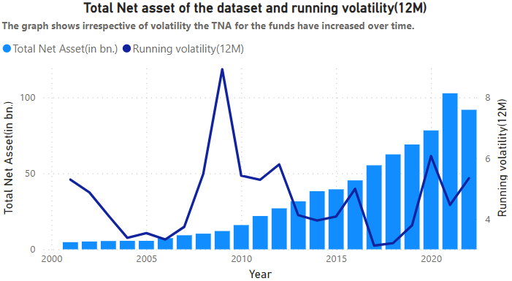

**Figure 2** – First graphs show ratio of ESG rated equity holdings to total equity holdings over the sample period. Second graph shows ESG rated holdings portfolio weights in time series. The dotted lines are the trendlines which are upward trending.

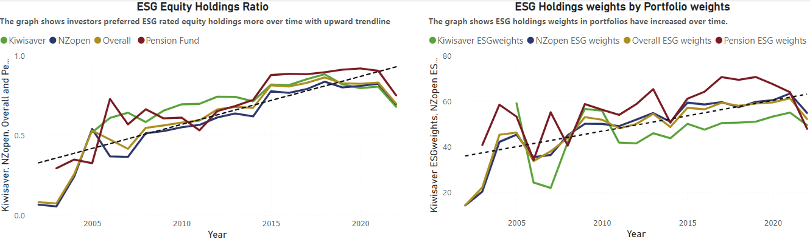

**Figure 3** – The graph shows mean weightage of ESG rated holdings against the portfolio weight which is taken 100% to understand the ESG rated weightage in time series. The dotted line is the trendline.

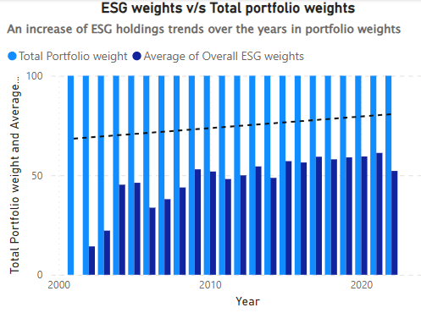

**Figure 4** – The graph shows decomposed ESG returns contribution to Fund returns in the timeline with 12 month running volatility. Second graph is time series analysis of decomposed ESG returns, expected ESG returns and fund returns with 12 month running volatility.

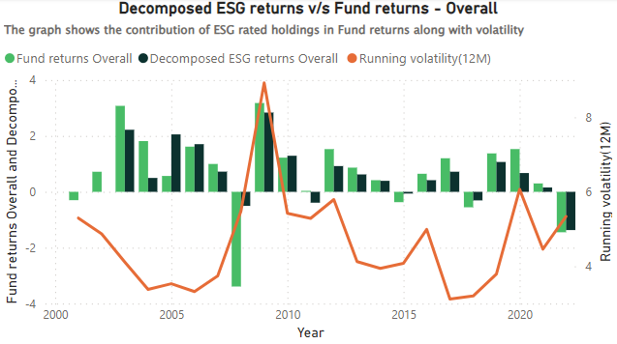 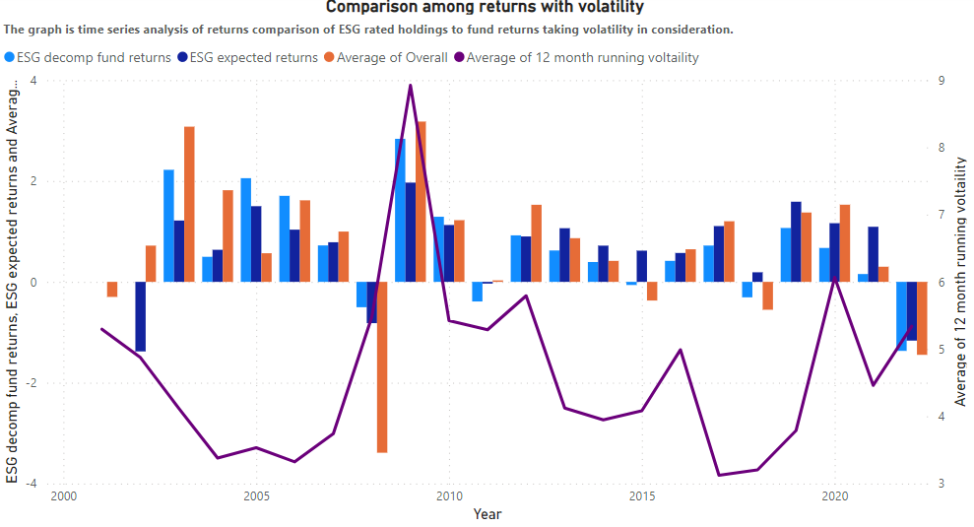

**Figure 5** – First graph shows ESG fund flow ratio against total fund flow ratio(assumed as 100$). The graph gives a metric where an investor can deduce out of every 100 dollars of fund flow what is the proportin which have gone to ESG rated holdings. Second graph is fund flow breakdown considering fund returns and 12 month running volatility.

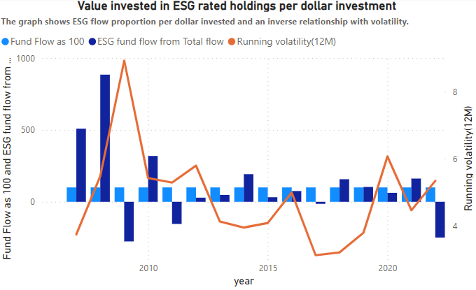 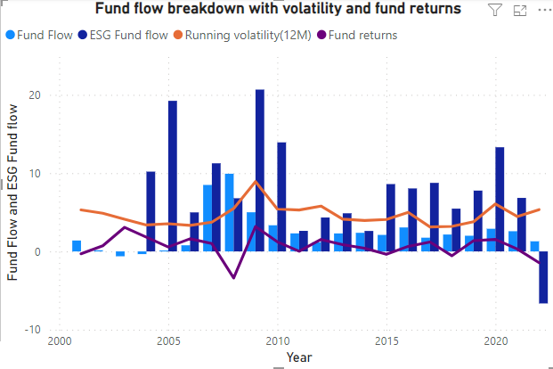

**Figure 6 –** The figure shows distribution graph of average expected return given by a ESG holding. The second distribution graph is of avergae decomposed return contributed by ESG holdings. Both the graph shows presence of outliers in the data in the time series analysed.

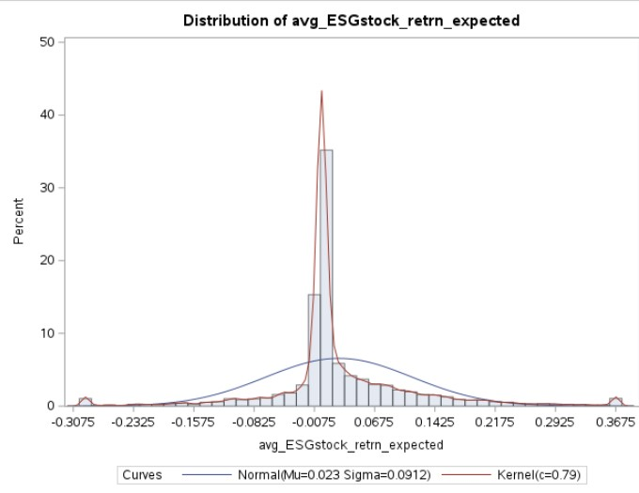 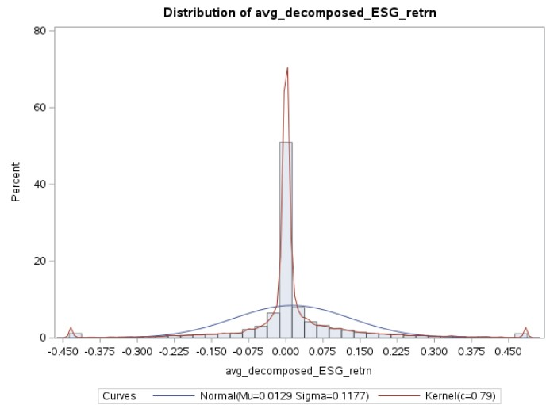

**Figure 7 –** The figure shows the impact of 12 month running returns volatility in the variables.

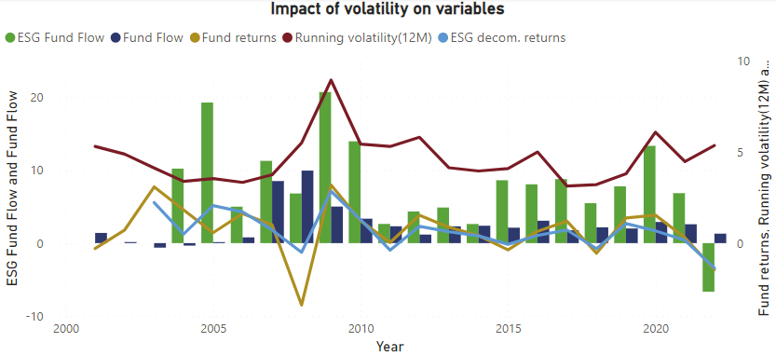

1. The report "Who Cares Wins," a joint effort by eighteen financial institutions spanning nine countries, suggested the incorporation of ESG considerations in sectors of analysis, asset management, and brokerage practices within the financial industry. <https://www.todayesg.com/origin-of-esg-global-compact-who-cares-wins/>

   https://www.sustainabilityinbusiness.org/blogs/who-cares-wins-the-report-that-started-esg