Data Governance Report

Executive Summary
This scan identified unmasked personal data in customer tables, posing a high compliance risk under DPDP. Immediate remediation is required before further data usage.

Risk Overview
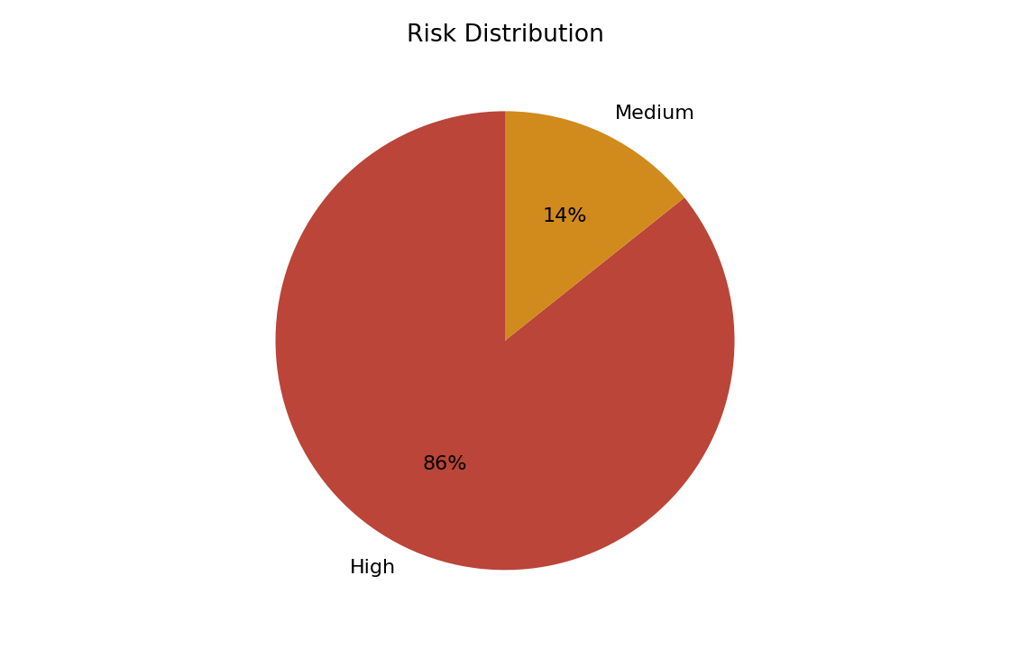
- High severity quality issue in dpdp_poor_quality.customer_imports: city has 66.67% null values
- Increase sample coverage and resolve profiling limitations
- High severity quality issue in dpdp_poor_quality.customer_imports: email contains invalid email formats
- High severity quality issue in dpdp_poor_quality.payment_imports: customer_email contains invalid email formats
- High severity quality issue in dpdp_poor_quality.payment_imports: amount contains negative values

PII Exposure
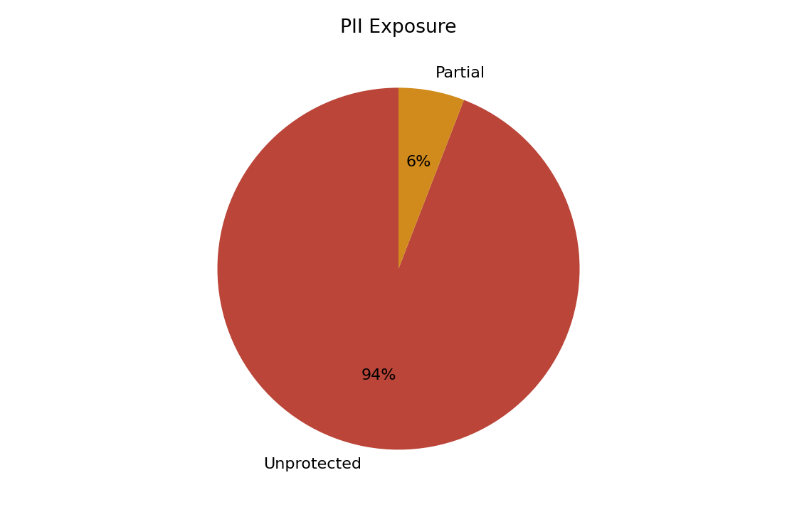
- dpdp_clean.customers.full_name: Unprotected sensitive data
- dpdp_clean.customers.email: Unprotected sensitive data
- dpdp_masked.masked_customers.display_name: Unprotected sensitive data
- dpdp_masked.masked_customers.masked_email: Unprotected sensitive data
- dpdp_masked.masked_customers.masked_phone: Partially protected sensitive data

Data Quality
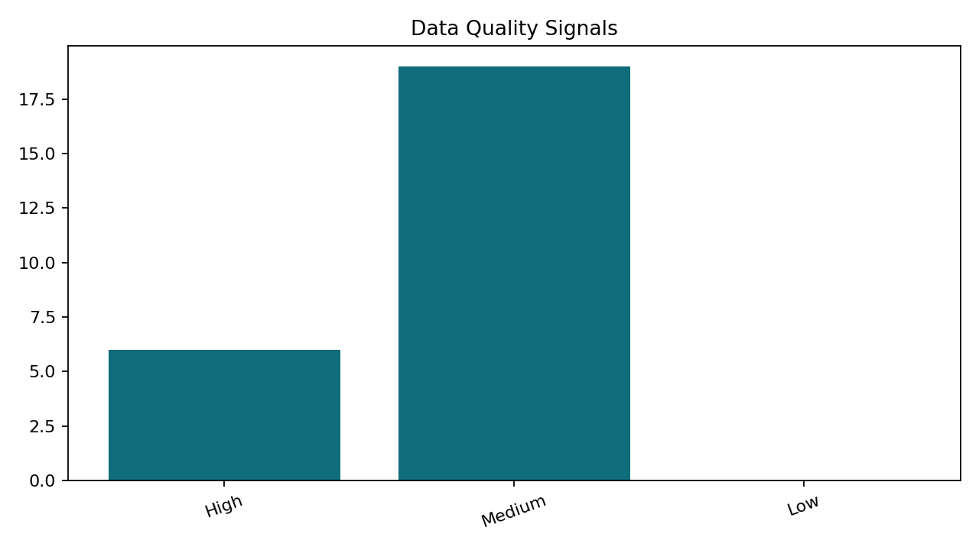
Profiled 13 table(s). Data quality score is 96.68.

AI Insights
- Apply masking or tokenization to protect sensitive data
- Increase sample coverage and resolve profiling limitations
- 22 high-severity RAID risks were identified, indicating elevated governance exposure.
- Inferred relationships across 22 column pair(s) suggest shared identifiers that should be validated for lineage and access control.

Recommendations
- Increase sample coverage and resolve profiling limitations
- Apply masking or tokenization to protect sensitive data
- Review completeness rules and upstream capture for dpdp_poor_quality.customer_imports.full_name.
- Review completeness rules and upstream capture for dpdp_poor_quality.customer_imports.email.
- Review completeness rules and upstream capture for dpdp_poor_quality.customer_imports.phone_number.

