Data Governance Report

Executive Summary
This scan identified unmasked personal data in customer tables, posing a high compliance risk under DPDP. Immediate remediation is required before further data usage.

Risk Overview
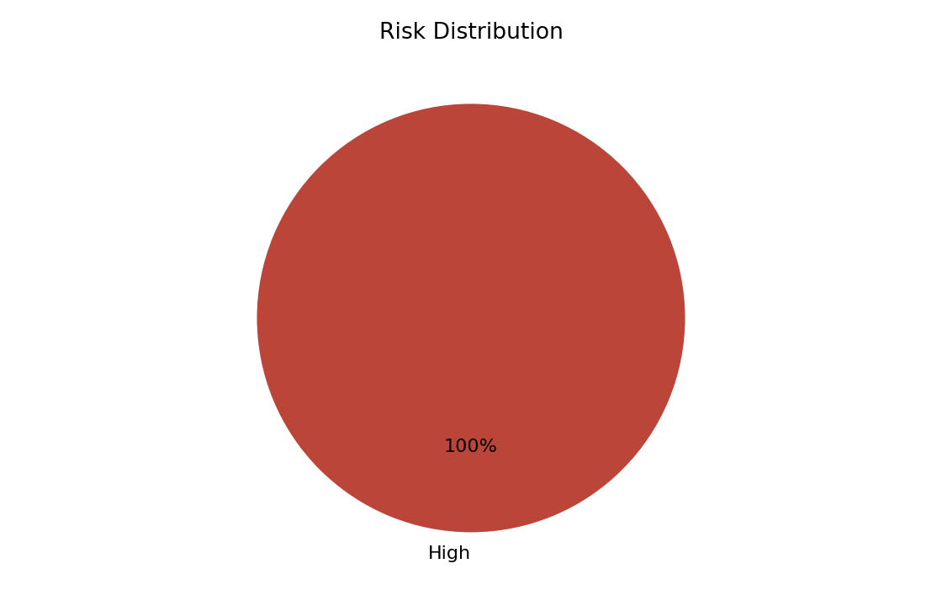
- Apply masking or tokenization to protect sensitive data

PII Exposure
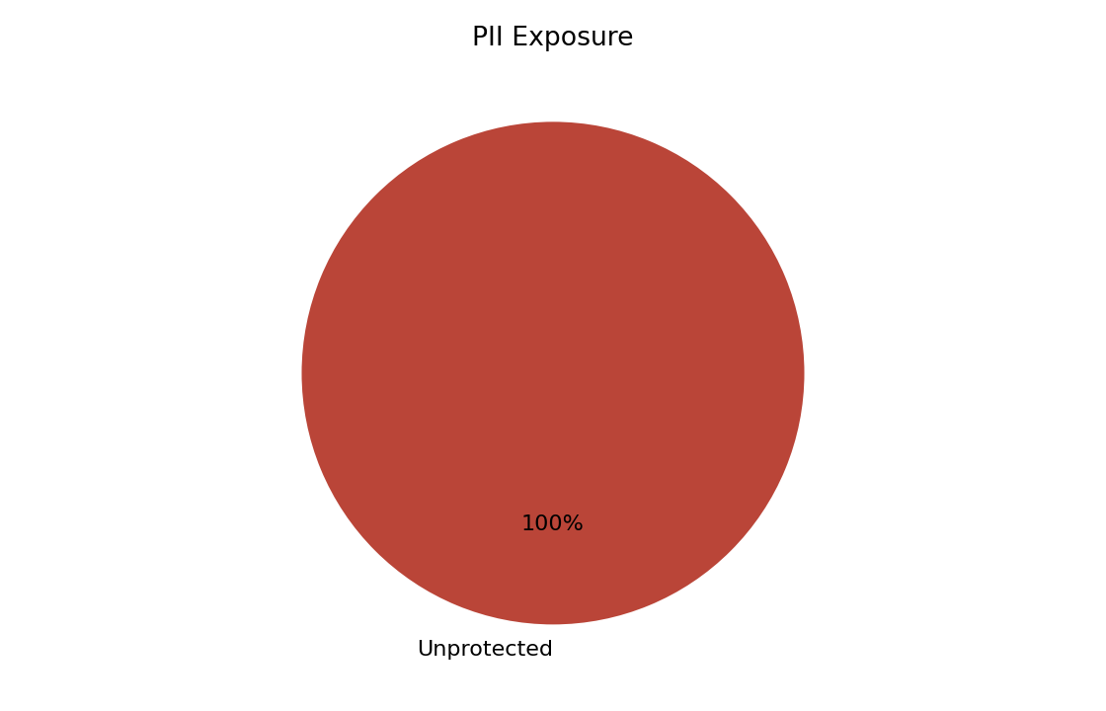
- public.customers.customer_name: Unprotected sensitive data
- public.customers.email: Unprotected sensitive data

Data Quality
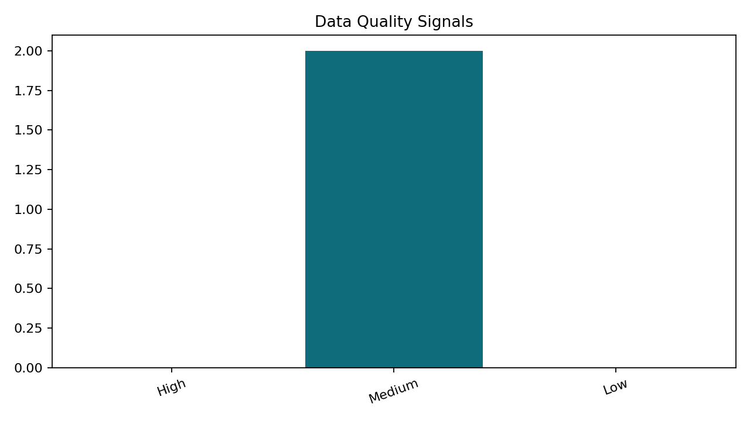
Profiled 2 table(s). Data quality score is 100.0.

AI Insights
- Apply masking or tokenization to protect sensitive data
- Increase sample coverage and resolve profiling limitations
- Inferred relationships across 1 column pair(s) suggest shared identifiers that should be validated for lineage and access control.

Recommendations
- Increase sample coverage and resolve profiling limitations
- Apply masking or tokenization to protect sensitive data

