**Aim:** Implementation of Sequential circuit (4-counter) on Zynq board.

**Counter:** Counter is a digital device and the output of the counter includes a predefined state based on the clock pulse applications. The output of the counter can be used to count the number of pulses. Generally, counters consist of a flip-flop arrangement which can be synchronous counter or asynchronous counter.

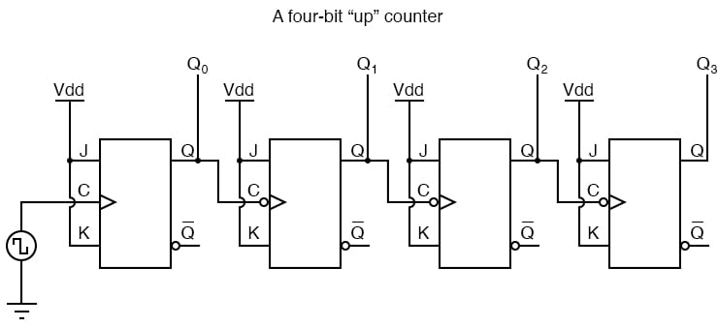

**Code**

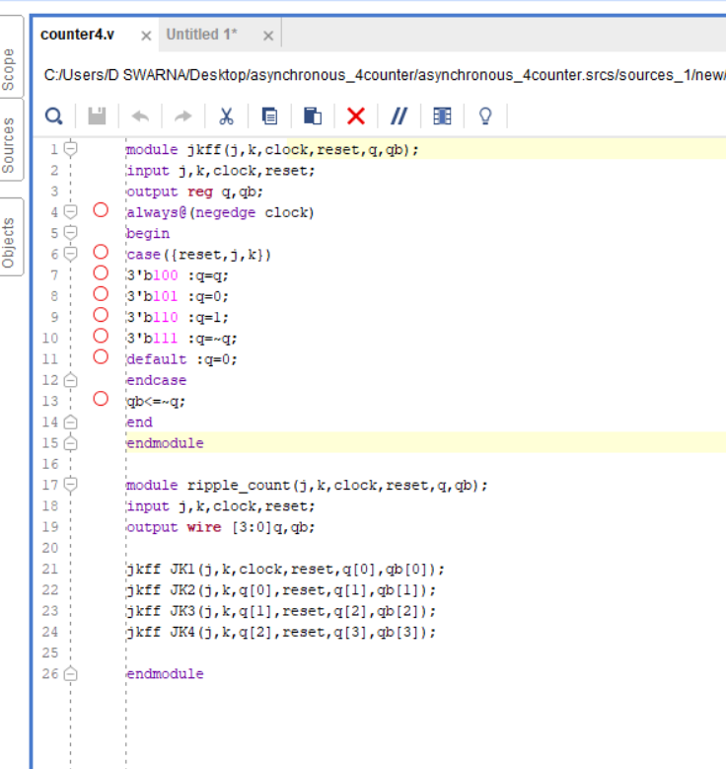

**Simulation Results**

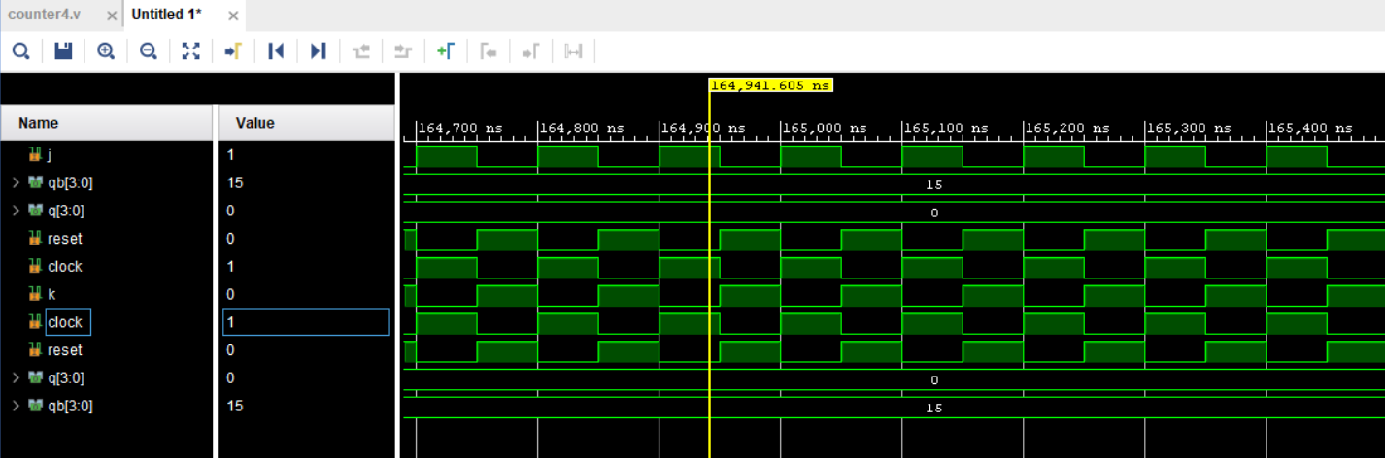

🡪 In design below, synchronous clock and reset are applied to the circuit by right click->add ip-> clocking wizard and right click->add ip-> processing system reset.

**Block Design**

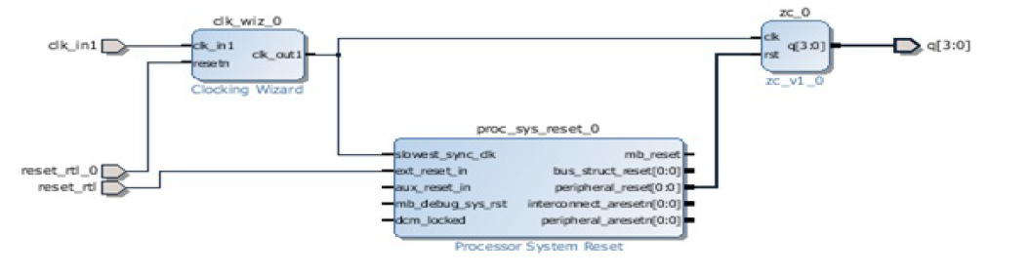

🡪The procedure is as similar as the combinational circuit implementation except adding IPs for synchronous clock and reset.

🡪 The procedure is as similar as the combinational circuit implementation except adding IPs for synchronous clock and reset.

🡪Also inputs of an ip that are not required can be removed and frequency can be adjusted within the specified range in the customize block settings which will appear by selecting ip->right click->customize block.

**Implementation Output:** When rst=1 then the counter startscounting from 0 to 15 (0000 to 1111).

**Case-1:** rst=0

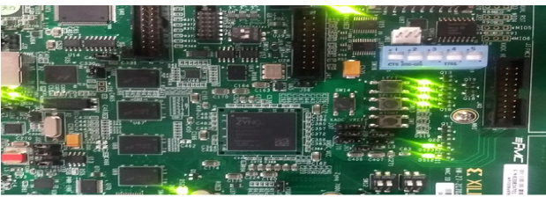

**Case-2:** rst=1

