**Bug/Issue:** [Legend is not present in the generated image if I use “tight” for bbox_inches #10194](https://github.com/matplotlib/matplotlib/issues/10194)

**Code Reproduction for Bug:** /bug_snippets/bbox_tight_missing_legend.py

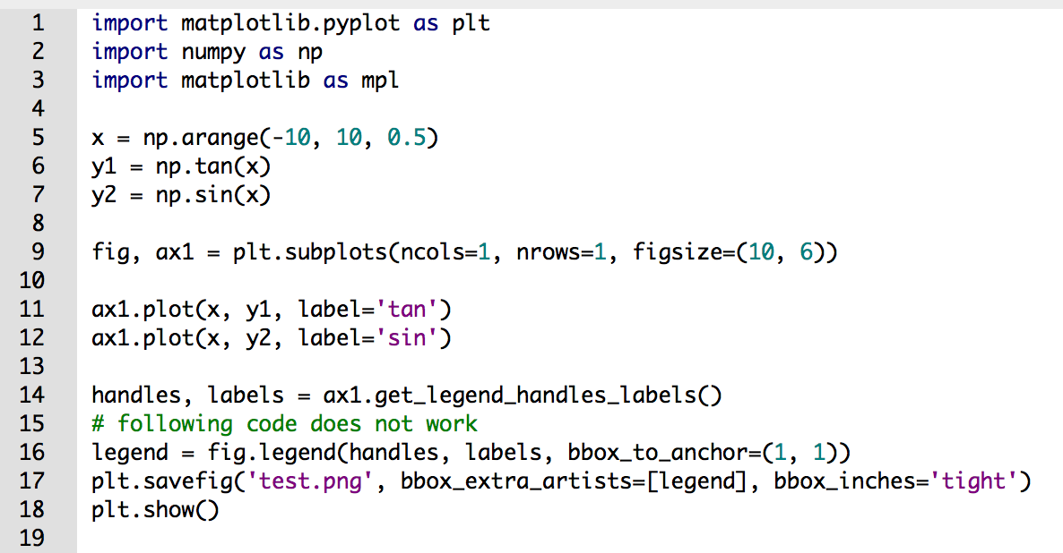

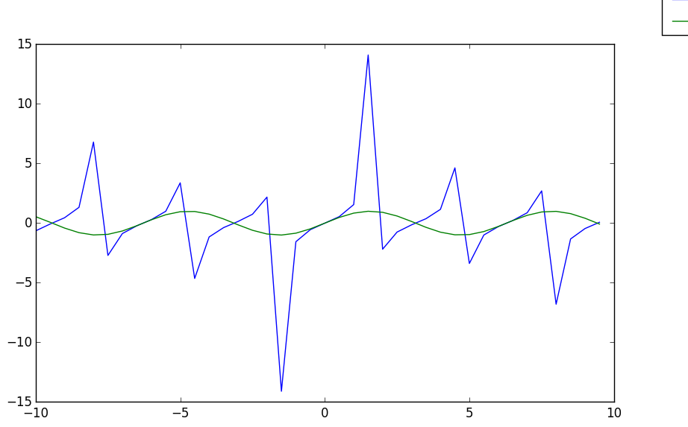

**Description:**

As shown in the image above, when bbox_anchor is used along with the “tight” property of bbox_inches, the created legend gets cut off in the outputted file. The “tight” property enables users to condense the size of the outputted figure but in the process of condensing the image, the figure’s legend is omitted. This rendering is inconsistent when you use the loc property instead of bbox_anchor. If the loc property is used, the legend is not omitted in the outputted file, and a detailed figure is produced. This deduction helps us isolate the error specifically to the bbox_anchor property of a legend.

**Approach to Solution:**

Coming up with an elegant solution will require a little bit of effort, as we will be required to look over several files within the code base. We will first need to figure out how the bbox module works with the legend module, and then figure out a clever way to attach the legend to the plot. Right now there is a disconnect between bbox and legend, so to determine this connection and to fix the bug it will require about 8-10 hours of work, with testing taking another 2-3 hours.

The steps needed to fix the issue are as follows:

1. Understand the connection between legend, axis, bbox
2. Find way to detect legend properties from axes, axis without changing drastic changes such as adding new arguments to existing methods
3. Account for legend size and location within bbox calculations
4. Ensure that changes do not affect larger codebase

Relevant files are:

backend_bases.py

figure.py

transforms.py

tight_bbox.py

legend.py

The files that will be affected are those listed above. Everything else should be unaffected due to bbox and legend being isolated components of a figure. Regardless, the only code affected will be those that handle the creation of a legend and alignment of the legend on the outputted file.