**Bug/Issue:** [Minor ticks on log-scale colorbar are not cleared #8358](https://github.com/matplotlib/matplotlib/issues/8358)

**Code Reproduction for Bug:** /bug_snippets/log_scale.py

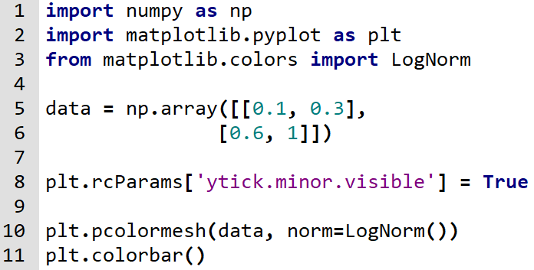

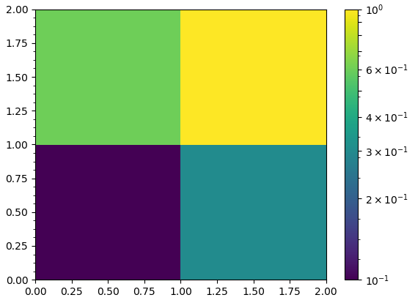

**Description:**

When plotting a quadrilateral mesh using pcolor or pcolormesh with a logarithmic colorbar scale, if the minor ticks on the colorbar are enabled, some undesired linear scale minor ticks will be displayed in addition to the desired logarithmic scale ticks.

In more detail, when the Axes object is created, it calls cla() to clear the current axes. However, when the xtick.minor.visible and/or ytick.minor.visible dictionary entries in rcParams are set to true, that method updates the minor locator to AutoMinorLocator, which is an undesired result.

**Approach to Solution:**

Given that this issue is very specific; caused by enabling the minor ticks, and using a logarithmic scale on a colorbar, it will be a very difficult task to fix this bug such that it doesn’t create other issues. Although the source of the bug begins in axes/_base.py (lines 1050-1054), we believe that changing any line of code in cla() may break other code that may depend on it. So we will have to devote a lot of time to examining the consequences of potential fixes. Because of the nature of this bug, we estimate that it will take around 12 hours to fix, and another 4 hours dedicated to testing and validation and ensuring code consistency with matplotlib.

The steps needed to fix the issue are as follows:

1. Take a more in-depth look at the relevant methods and try to understand the design decisions behind the code responsible for the bug.
2. Determine ways to prevent AutoMinorLocator ticks from appearing on logarithmic scales.
3. Study the effects of these methods and how they interact with other parts of the code.
4. Decide which solution creates the least impact outside of fixing the bug and is the most consistent with matplotlib standards and implement it.