SMART HEALTHCARE SYSTEM – DIAGRAMS

Chapter 4: Overall System Architecture
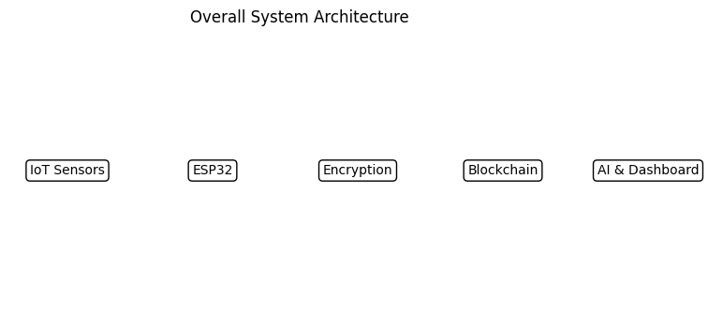

Chapter 5: Layered Architecture
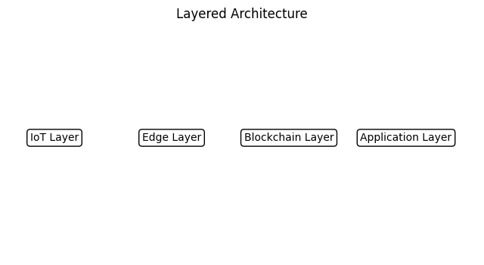

Chapter 5: Data Flow Diagram (Level 0)
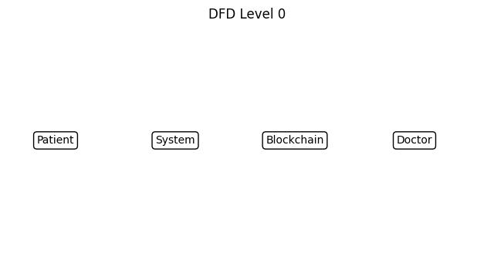

Chapter 9: CNN-LSTM Intrusion Detection Model
