CYBERSECURITY &
ETHICAL HACKING INTERNSHIP

Task 1 – Foundations of Cybersecurity & Lab Setup

Submitted by:
Swarnabha Sharma
Cybersecurity & Ethical Hacking Intern
ApexPlanet Software Pvt. Ltd.

Duration: Days 1–12 | March 2025
Status: Complete ✅

⚠️ Disclaimer: All activities documented in this report were performed exclusively in a controlled, isolated virtual lab environment for educational purposes only. No real-world systems or networks were targeted at any time.

1. Introduction
This report documents the work completed during Task 1 of the Cybersecurity & Ethical Hacking Internship at ApexPlanet Software Pvt. Ltd. The primary goal of this task was to build a solid theoretical foundation in cybersecurity concepts and to establish a functional, isolated virtual lab environment suitable for practicing ethical hacking techniques safely.

Over the course of Days 1–12, I studied core cybersecurity principles, explored networking and cryptography fundamentals, set up attacker and target virtual machines, and familiarized myself with industry-standard security tools. This document reflects both the knowledge gained and the practical steps taken to build and validate the lab.

2. Objectives
The task was structured around the following learning objectives:

- Understand and apply the CIA Triad (Confidentiality, Integrity, Availability)
- Identify common cyber threat categories and their mitigations
- Learn core networking concepts including the OSI and TCP/IP models
- Understand symmetric and asymmetric cryptography and hashing
- Set up an isolated virtual lab using VirtualBox, Kali Linux, and Metasploitable2
- Practice Linux command-line fundamentals
- Explore and run basic scans with tools: Nmap, Wireshark, and Burp Suite

3. Cybersecurity Fundamentals

3.1 The CIA Triad
The CIA Triad is the foundational model underpinning all information security practices. It defines three core properties that any secure system must maintain:

Principle | Definition | Implementation Examples | Key Threats
Confidentiality | Only authorized parties can access sensitive data | Encryption, access controls, MFA, hashing passwords with salts | Data breaches, unauthorized disclosure, espionage
Integrity | Data remains accurate, complete, and unmodified | SHA-256 hashing, digital signatures, checksums | Tampering, SQL injection, man-in-the-middle attacks
Availability | Authorized users can access systems and data when needed | Redundancy, load balancing, DDoS protection, backups | DDoS attacks, ransomware, hardware failures

3.2 Common Cyber Threats
During this task, I studied several major threat categories that ethical hackers must understand in order to defend against them:

Threat | Description | Mitigation
Phishing | Social engineering via fraudulent emails to steal credentials or install malware | User training, email filtering, MFA
Malware | Malicious software including viruses, trojans, worms, and ransomware | Antivirus, sandboxing, code analysis
DDoS | Flooding a target with traffic to deny legitimate users access | Traffic filtering, rate limiting, CDN
SQL Injection | Inserting malicious SQL into input fields to compromise databases | Prepared statements, input validation
Brute Force | Systematically trying password combinations to gain unauthorized access | Strong passwords, account lockout, MFA
Ransomware | Encrypts victim data and demands payment for decryption key | Offline backups, network segmentation, IR plan

3.3 Attack Vectors
Attack vectors are the paths or methods adversaries use to gain unauthorized access. The following were studied during this task:

- Social Engineering – Manipulating people into revealing sensitive information (phishing, pretexting, baiting)
- Network Attacks – Exploiting network protocols (Man-in-the-Middle, ARP spoofing, DNS poisoning)
- Wireless Attacks – Exploiting Wi-Fi vulnerabilities (WEP/WPA cracking, rogue access points, eavesdropping)
- Insider Threats – Malicious or negligent actions by authorized internal users
- Physical Attacks – Gaining physical access to systems (dumpster diving, tailgating, shoulder surfing)

4. Lab Environment Setup

4.1 Architecture Overview
A fully isolated virtual lab was constructed using VirtualBox as the hypervisor. All machines communicate only through a Host-Only Adapter, ensuring no internet-facing exposure of vulnerable systems. The architecture is illustrated below:

HOST MACHINE (Windows/Linux/macOS)
└── VirtualBox Hypervisor
└── Host-Only Network: 192.168.56.0/24 (Isolated)
├── Kali Linux (Attacker) → 192.168.56.102
└── Metasploitable2 (Target) → 192.168.56.101
└── DVWA (Vulnerable Web App)

4.2 Virtual Machine Specifications

Component | Attacker Machine | Target Machine
OS | Kali Linux (latest) | Metasploitable2
RAM | 2–4 GB | 1–2 GB
Disk | 20–30 GB | 10 GB
Network | Host-Only Adapter | Host-Only Adapter (DHCP)
IP Address | 192.168.56.102 | 192.168.56.101
Purpose | Penetration testing and attack simulation | Intentionally vulnerable target for practice
Default Credentials | kali / kali (changeable) | msfadmin / msfadmin

Kali Linux (Attacker Machine) – ifconfig Output
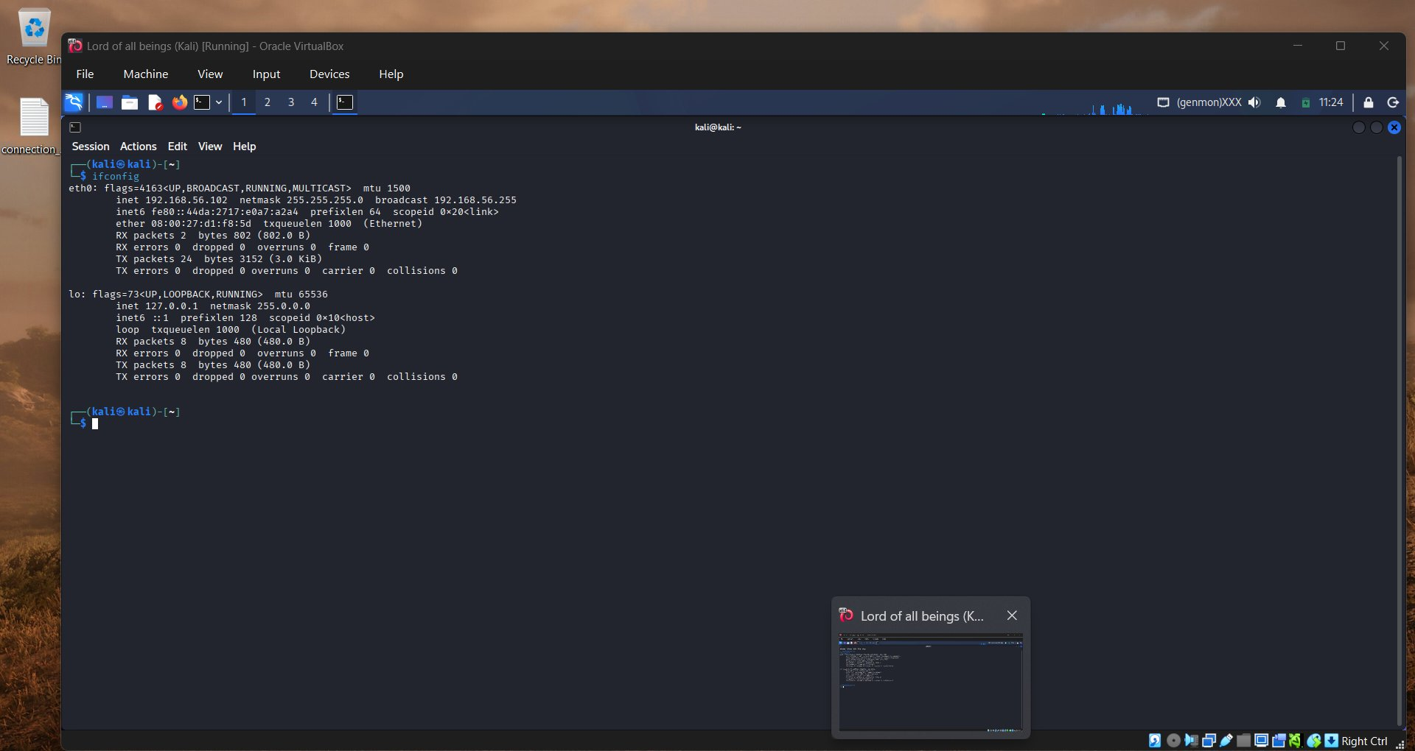
Figure 1: Kali Linux running in VirtualBox — eth0 assigned 192.168.56.102

Metasploitable2 (Target Machine) – ifconfig Output
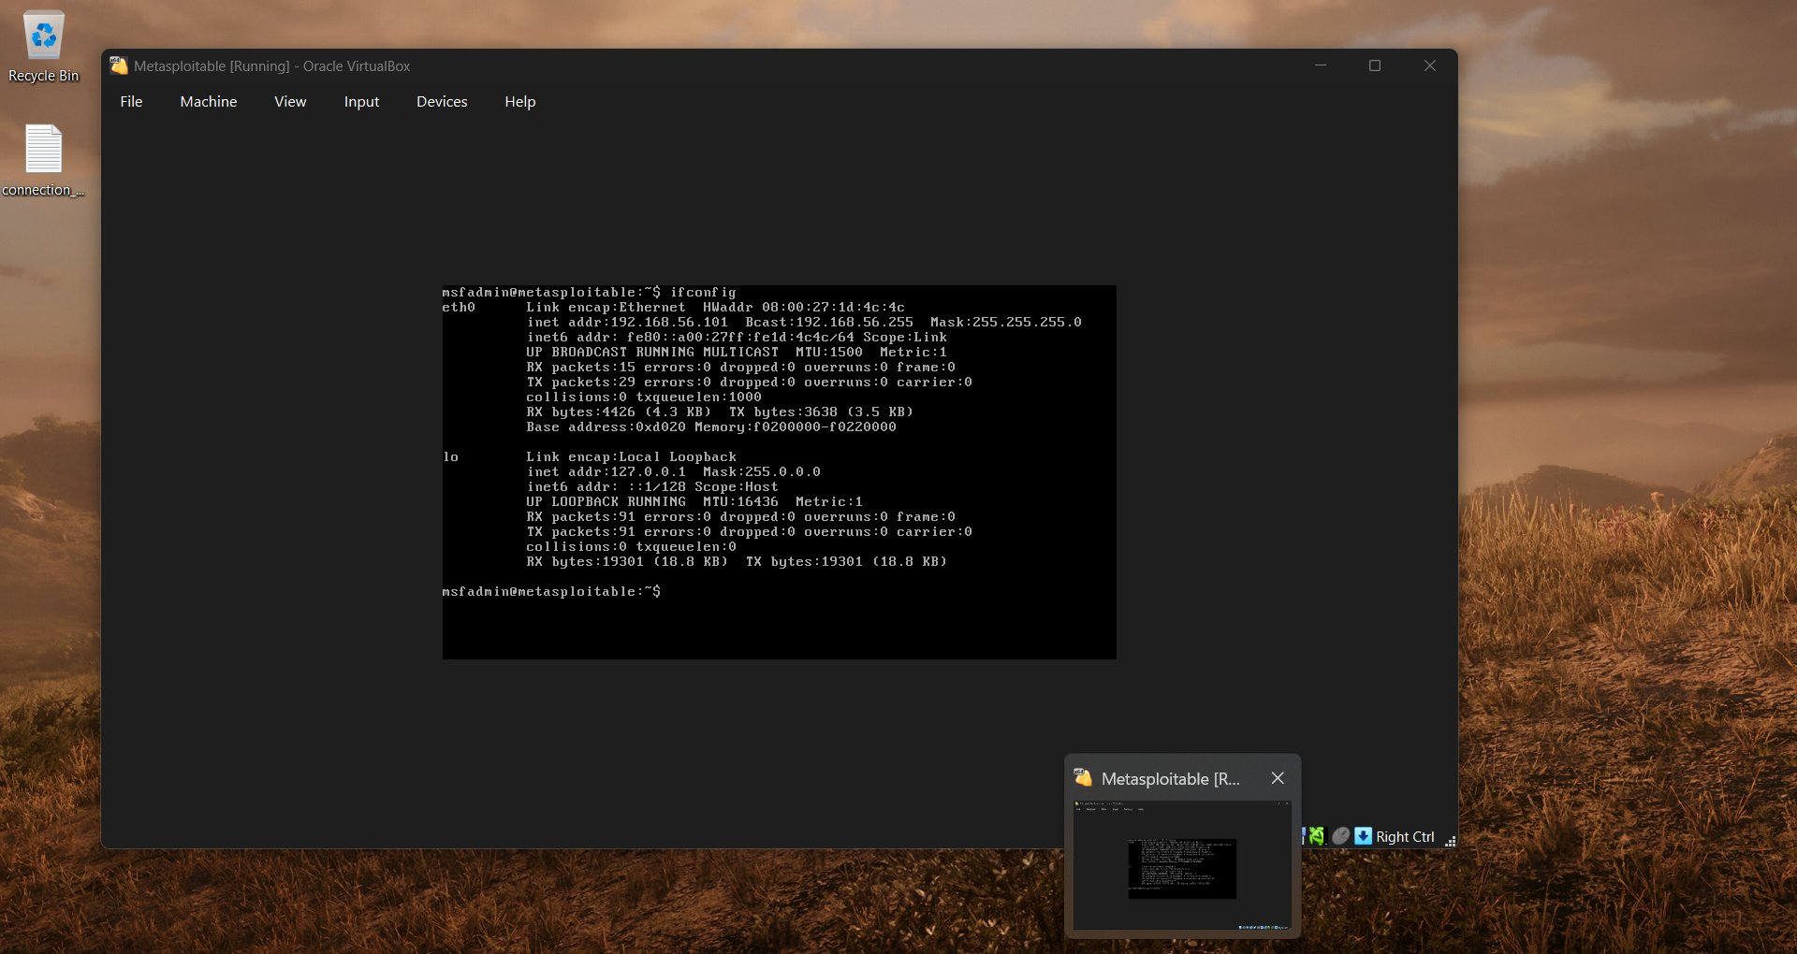
Figure 2: Metasploitable2 running in VirtualBox — eth0 assigned 192.168.56.101

4.3 Network Validation
After configuring both machines on the Host-Only Adapter, connectivity was verified using a ping test from Kali Linux to the Metasploitable2 target:

# Ping test from Kali Linux to verify lab connectivity
ping 192.168.56.101

PING 192.168.56.101 (192.168.56.101) 56(84) bytes of data.
64 bytes from 192.168.56.101: icmp_seq=1 ttl=64 time=0.512 ms
64 bytes from 192.168.56.101: icmp_seq=2 ttl=64 time=0.487 ms
64 bytes from 192.168.56.101: icmp_seq=3 ttl=64 time=0.501 ms

Successful ICMP replies confirmed that both VMs were correctly networked and communicating within the isolated environment.

4.4 Security Considerations
The following precautions were observed throughout the lab setup:

- Complete Isolation: Host-Only adapter ensures no VM has external internet access
- Snapshot Management: Snapshots taken before any major changes to allow rollback
- No Public Exposure: Vulnerable VMs were never bridged or NAT-ed to the internet
- Audit Logging: All commands and activities documented for traceability

5. Linux Fundamentals
Kali Linux serves as the primary platform for all penetration testing activities. The following Linux commands and concepts were practiced during this task:

5.1 File System Navigation

pwd # Print current working directory
ls -la # List all files with permissions and hidden files
cd /path/to/directory # Navigate to absolute path
cd ~ # Return to home directory
mkdir pentest_lab # Create a new directory
touch notes.txt # Create an empty file
cat /etc/passwd # Display file contents
tail -n 20 /var/log/syslog # Show last 20 lines of a log file

5.2 File Permissions
Understanding Linux permissions is critical for both system administration and privilege escalation during penetration testing:

chmod 644 file.txt # rw-r--r-- (owner read/write, others read)
chmod 755 script.sh # rwxr-xr-x (owner execute, others read/execute)
chmod 700 private.key # rwx------ (owner only – private keys)
chown user:group file # Change file owner and group

Permission | Octal | Meaning | Common Use Case
rw-r--r-- | 644 | Owner read/write; others read-only | Standard text/config files
rwxr-xr-x | 755 | Owner full; others read & execute | Scripts and binaries
rwx------ | 700 | Owner full; no access for others | Private keys, sensitive files
rwxrwxrwx | 777 | Everyone full access | Not recommended – avoid

5.3 Networking Commands

ifconfig # Display network interfaces and IP addresses
ip a # Modern alternative to ifconfig
ping 192.168.56.101 # Test ICMP connectivity to target
netstat -tuln # Show listening ports and active connections
ss -tuln # Modern alternative to netstat

6. Networking Concepts

6.1 OSI Model
The OSI (Open Systems Interconnection) model is a conceptual framework for understanding how data travels across a network. Each layer has specific responsibilities:

Layer | Name | Function | Protocols/Examples
7 | Application | User-facing services and interfaces | HTTP, HTTPS, DNS, FTP, SMTP
6 | Presentation | Data formatting, encryption, compression | SSL/TLS, JPEG, ASCII
5 | Session | Manages sessions between applications | NetBIOS, RPC, PPTP
4 | Transport | End-to-end data delivery and error checking | TCP, UDP
3 | Network | Logical addressing and routing | IP, ICMP, ARP, OSPF
2 | Data Link | Physical addressing and frame delivery | Ethernet, MAC, Wi-Fi
1 | Physical | Raw bit transmission over physical media | Cables, hubs, repeaters

6.2 Key Protocols

Protocol | Port | Purpose
HTTP | 80 | Web traffic – plaintext (vulnerable to interception)
HTTPS | 443 | Encrypted web traffic via TLS
SSH | 22 | Secure remote shell access
FTP | 20–21 | File transfer (plaintext – insecure)
DNS | 53 | Domain name to IP resolution
SMTP | 25 | Email transmission
SMB | 445 | Windows file sharing (commonly exploited)
RDP | 3389 | Remote Desktop Protocol (Windows)
MySQL | 3306 | Database access (targeted in Metasploitable)

7. Cryptography Basics

7.1 Symmetric Encryption
Symmetric encryption uses a single shared key for both encryption and decryption. It is fast and suitable for encrypting large amounts of data, but requires a secure key exchange mechanism.

- AES (Advanced Encryption Standard) – Industry standard; key sizes: 128, 192, 256 bits
- DES (Data Encryption Standard) – Legacy standard; 56-bit key; now considered insecure

7.2 Asymmetric Encryption
Asymmetric encryption uses a mathematically linked key pair: a public key (shared openly) and a private key (kept secret). Data encrypted with the public key can only be decrypted with the private key.

- RSA – Widely used for secure key exchange and digital signatures
- ECDSA – Elliptic Curve variant; smaller keys with equivalent security to RSA
- Used in: HTTPS (TLS handshake), SSH, email signing (PGP)

7.3 Hashing
Hash functions produce a fixed-length fingerprint of any input. They are one-way operations — the original input cannot be recovered from the hash. This makes them ideal for password storage and data integrity verification.

Algorithm | Output Size | Status | Common Use
MD5 | 128-bit (32 hex chars) | Broken – collision vulnerable | Legacy checksums (not for security)
SHA-1 | 160-bit (40 hex chars) | Deprecated | Legacy digital signatures
SHA-256 | 256-bit (64 hex chars) | Current standard | Password hashing, file integrity, TLS
bcrypt | 60 chars | Recommended | Password storage (includes salt + cost factor)

8. Security Tools Explored

8.1 Nmap – Network Scanner
Nmap (Network Mapper) is the primary tool for host discovery, port scanning, and service fingerprinting. The following scans were run against the Metasploitable2 target:

# Basic TCP port scan
nmap 192.168.56.101

# Service version and OS detection
nmap -sV -O 192.168.56.101

# Aggressive scan: versions, OS, scripts, traceroute
nmap -A -T4 192.168.56.101

# Scan all 65535 ports with version detection
nmap -sV -p- 192.168.56.101

# Run NSE vulnerability scripts
nmap --script vuln 192.168.56.101

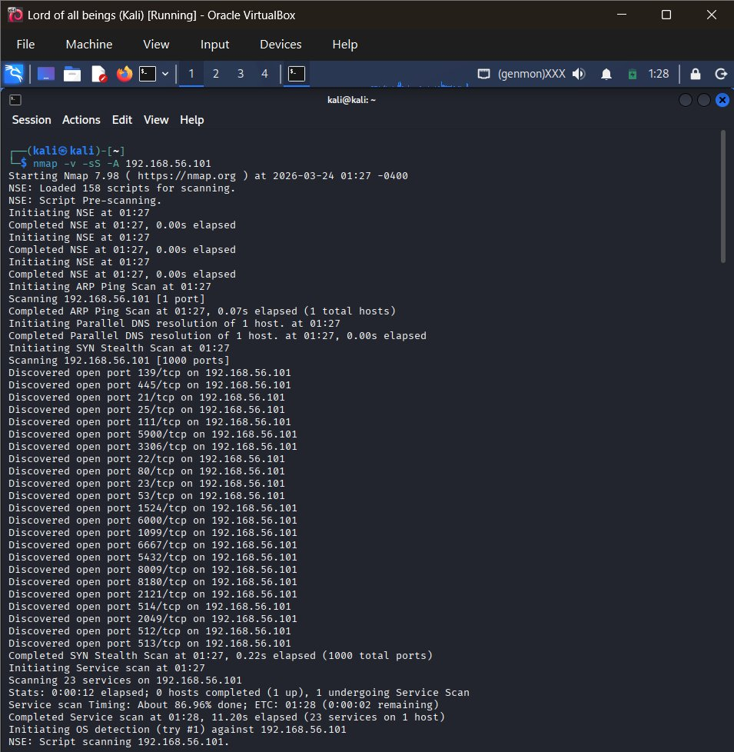
Figure 3: Nmap aggressive scan (nmap -v -sS -A) against Metasploitable2 — discovering open ports in real time
The aggressive scan revealed that Metasploitable2 had a large number of open ports including FTP (21), SSH (22), Telnet (23), SMTP (25), HTTP (80), MySQL (3306), VNC (5900), and many others — confirming its intentionally vulnerable nature and providing a clear attack surface for future tasks.

8.2 Wireshark – Packet Analyzer
Wireshark was used to capture and inspect live network traffic between Kali Linux and the target machine. Key display filters used during this task:

# Filter HTTP traffic
http

# Filter by source IP
ip.src == 192.168.56.102

# Filter TCP SYN packets (connection initiation)
tcp.flags.syn==1 && tcp.flags.ack==0

# Filter ICMP (ping) traffic
icmp

# Filter DNS queries
udp.port == 53

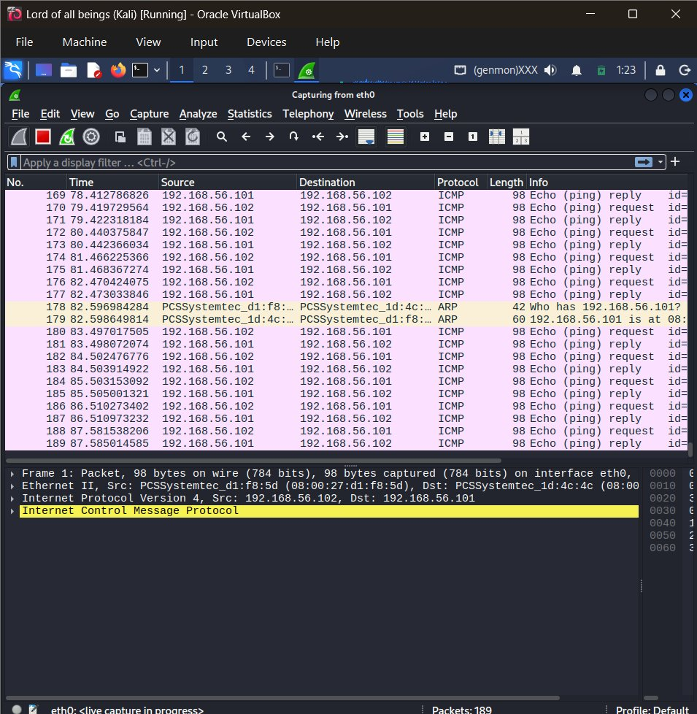
Figure 4: Wireshark capturing live ICMP ping traffic between Kali (192.168.56.102) and Metasploitable2 (192.168.56.101), with ARP resolution visible
The capture clearly shows the ICMP echo request/reply exchange between both VMs, confirming live network connectivity. The highlighted ARP entry (row 178–179) shows the address resolution process — Kali querying 'Who has 192.168.56.101?' and receiving the MAC address in response. This is a textbook example of how Layer 2 (Data Link) and Layer 3 (Network) protocols interact.

8.3 Burp Suite – Web Proxy
Burp Suite Community Edition was configured as an intercepting proxy for HTTP/HTTPS traffic analysis. The basic setup involved:

- Launching Burp Suite and enabling the proxy listener on 127.0.0.1:8080
- Configuring the browser to route traffic through the Burp proxy
- Intercepting and inspecting HTTP requests and responses in the Proxy tab
- Forwarding modified requests using the Repeater module

This tool will be used extensively in Task 3 (Web Application Security) for SQL injection testing, XSS exploration, and CSRF analysis.

8.4 Tool Summary

Tool | Category | Primary Use in This Task
Nmap | Network Scanner | Port scanning, service detection, OS fingerprinting
Wireshark | Packet Analyzer | Capturing TCP/ICMP traffic, protocol inspection
Burp Suite | Web Proxy | HTTP interception and request modification
Netcat | Network Utility | Testing port connectivity, banner grabbing
ifconfig / ip | System Tool | Network interface configuration and inspection
ping | Connectivity | Verifying host reachability in the lab

9. Key Learnings & Reflections

9.1 What I Learned
Task 1 was a broad but essential foundation-building exercise. Some of the most valuable insights included:

- The CIA Triad is not just a theoretical model — it directly informs real-world security decisions, from how passwords are stored to how services are architected for resilience.
- Setting up an isolated lab taught me the importance of network segmentation. The same principle that keeps my Metasploitable2 VM isolated is how organizations protect sensitive servers from general network traffic.
- Running Nmap for the first time against Metasploitable2 was eye-opening — the number of open, vulnerable services on a default installation highlights how important hardening and patch management are.
- Wireshark made networking concepts tangible. Seeing the actual bytes of a TCP handshake or a DNS query in real-time is far more effective than reading about it in a textbook.
- Linux permissions and command-line fluency are not optional for an ethical hacker — they underpin almost every task performed during penetration testing.

9.2 Challenges Encountered

- Initial VirtualBox network configuration required multiple attempts to ensure both VMs were on the same Host-Only subnet and could communicate
- Understanding the difference between Wireshark capture filters (applied before capture) and display filters (applied after) took some hands-on experimentation
- Distinguishing between symmetric, asymmetric, and hashing use cases required working through real examples to understand when each is appropriate

10. Conclusion
Task 1 successfully delivered on its objectives. A fully functional, isolated ethical hacking lab has been established, and a solid theoretical grounding in cybersecurity fundamentals has been built. The combination of conceptual study and hands-on lab work has prepared a strong foundation for the subsequent tasks.

The virtual lab environment created during this task will serve as the platform for all future activities — including network vulnerability scanning (Task 2), web application security testing (Task 3), exploitation techniques (Task 4), and the final capstone project (Task 5).

The most important takeaway from this task is that cybersecurity is best learned by doing. Every command run, every packet captured, and every configuration adjusted deepens understanding in a way that reading alone cannot achieve.

11. Upcoming Tasks Overview

Task | Topic | Timeline | Status
Task 1 | Foundations & Environment Setup | Days 1–12 | Complete ✅
Task 2 | Network Security & Scanning | Days 13–24 | Upcoming
Task 3 | Web Application Security | Days 25–36 | Upcoming
Task 4 | Exploitation & System Security | Days 37–48 | Upcoming
Task 5 | Capstone Project & Incident Response | Days 49–60 | Upcoming

――― End of Task 1 Report ―――

