SECURITY TESTING REPORT
Web Application Vulnerability Assessment

Prepared by: Swarnabha Sharma
Date: 20 April 2026
Project: DVWA (Damn Vulnerable Web Application) Security Testing
Report Status: Final

1. EXECUTIVE SUMMARY
This report documents the security testing performed on the Damn Vulnerable Web Application (DVWA) during the internship period. The testing focused on identifying critical web application vulnerabilities including SQL Injection (SQLi), Cross-Site Scripting (XSS), and Cross-Site Request Forgery (CSRF). The purpose was to demonstrate practical understanding of common web security flaws and their exploitation.

2. TESTING METHODOLOGY

2.1 Testing Environment
- Target Application: DVWA (Damn Vulnerable Web Application)
- Testing Tool: Manual testing with browser-based tools
- Security Level: Low (for demonstration purposes)

2.2 Testing Approach
- Black-box testing approach
- Manual payload injection
- Verification of vulnerability exploitation

3. VULNERABILITY FINDINGS

3.1 SQL INJECTION (SQLi)

Vulnerability Details
Vulnerability Type | SQL Injection
Severity | CRITICAL
CWE Reference | CWE-89
OWASP Top 10 | A03:2021 – Injection
Test Payload | 1' OR '1'='1

Description
SQL Injection is a code injection technique where an attacker can inject malicious SQL statements into entry fields for execution by the backend database. The tested payload "1' OR '1'='1" is a classic boolean-based SQL injection attack that exploits vulnerabilities in user input validation.

Impact
- Unauthorized data access
- Data manipulation or deletion
- Potential database server compromise
- Information disclosure

Proof of Concept
The payload "1' OR '1'='1" was successfully injected into the vulnerable input field, resulting in boolean-based data extraction from the database.
Screenshot: dvwa sqli.png
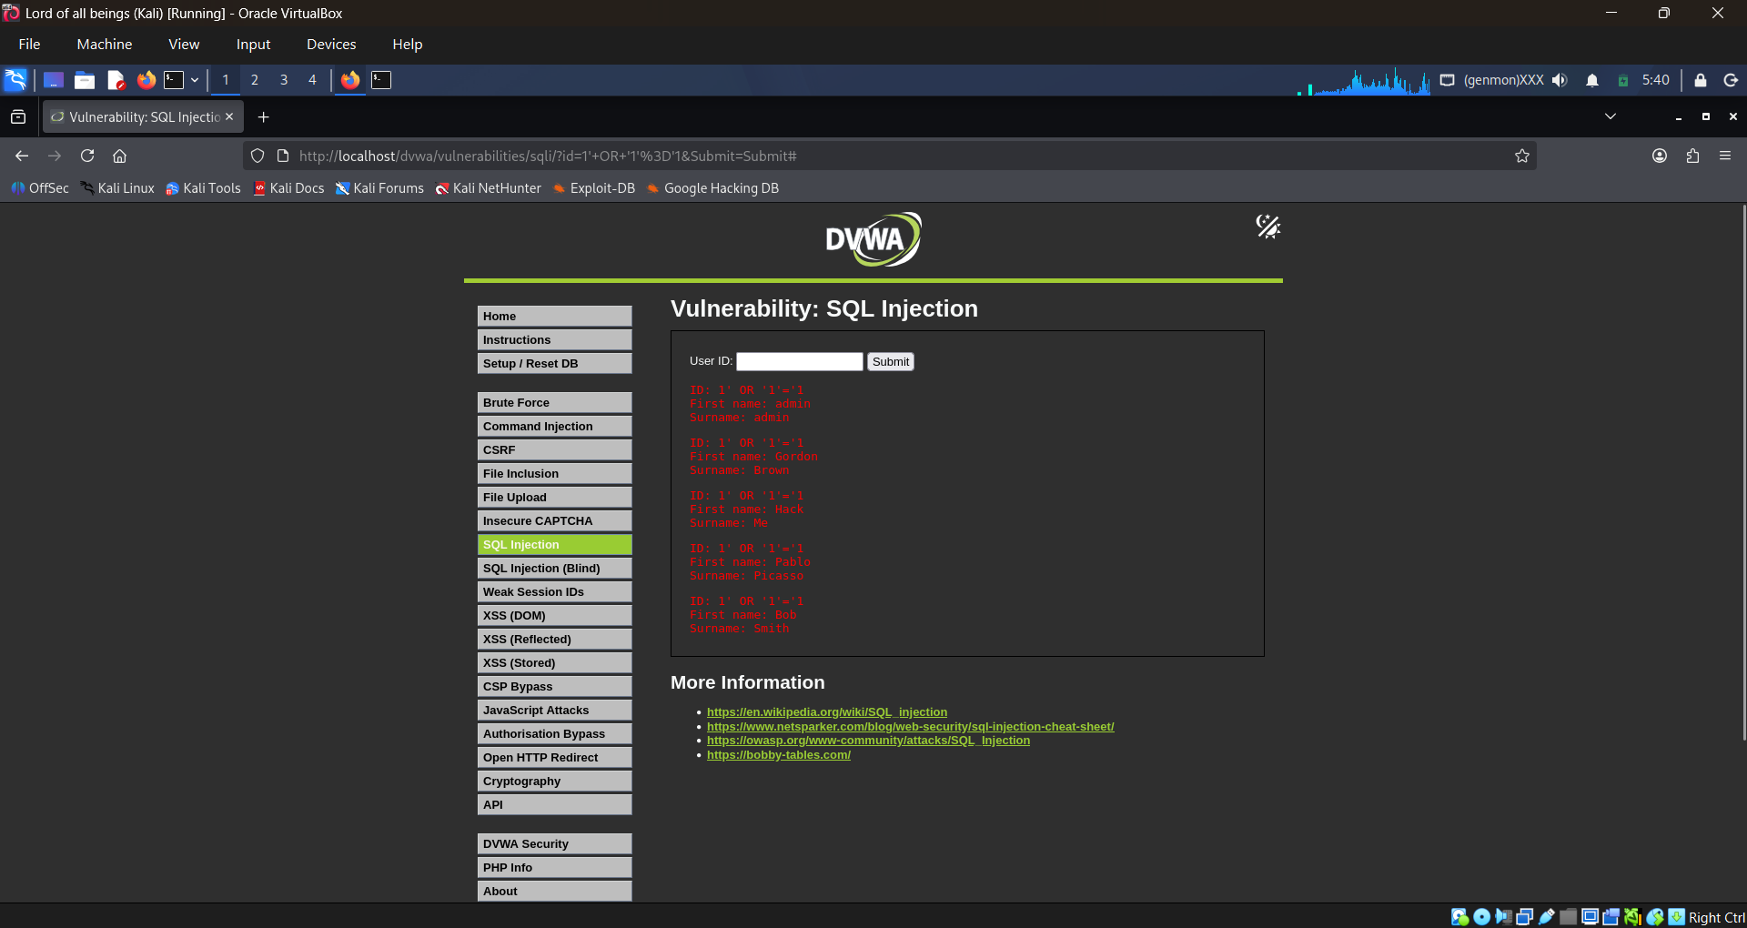

Remediation
- Use parameterized queries/prepared statements
- Implement input validation and sanitization
- Apply principle of least privilege to database accounts
- Use web application firewalls (WAF)

3.2 CROSS-SITE SCRIPTING (XSS)

Vulnerability Details
Vulnerability Type | Cross-Site Scripting (Reflected/Stored)
Severity | HIGH
CWE Reference | CWE-79
OWASP Top 10 | A03:2021 – Injection
Test Payload | <script>alert("XSS")</script>

Description
Cross-Site Scripting (XSS) vulnerabilities allow attackers to inject client-side scripts into web pages viewed by other users. The payload "<script>alert("XSS")</script>" demonstrates JavaScript code execution in the victim's browser context.

Impact
- Session hijacking
- Credential theft
- Malware distribution
- Defacement
- Phishing attacks

Proof of Concept
The JavaScript payload was successfully executed in the browser, displaying an alert dialog as proof of code execution capability.
Screenshots: dvwa xss.png, dvwa xss2.png
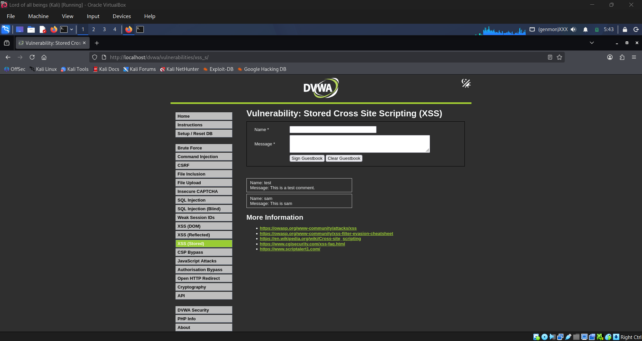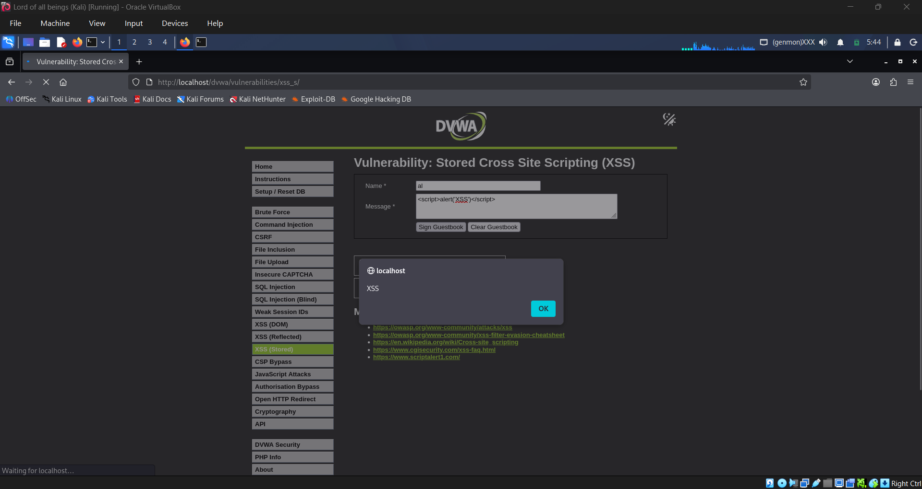

Remediation
- Implement context-aware output encoding
- Use Content Security Policy (CSP) headers
- Validate and sanitize all user inputs
- Use modern frameworks with built-in XSS protections

3.3 CROSS-SITE REQUEST FORGERY (CSRF)

Vulnerability Details
Vulnerability Type | Cross-Site Request Forgery
Severity | HIGH
CWE Reference | CWE-352
OWASP Top 10 | A01:2021 – Broken Access Control
Test Payload | ?password_new=hacked&password_conf=hacked

Description
CSRF attacks force an end user to execute unwanted actions on a web application in which they're currently authenticated. The tested payload demonstrates unauthorized password change functionality exploitation through crafted URLs or forms.

Impact
- Unauthorized account modifications
- Privilege escalation
- Data modification without consent
- Account takeover

Proof of Concept
The GET request parameters were successfully manipulated to change the user password without proper validation or token verification.
Screenshot: dvwa csrf.png
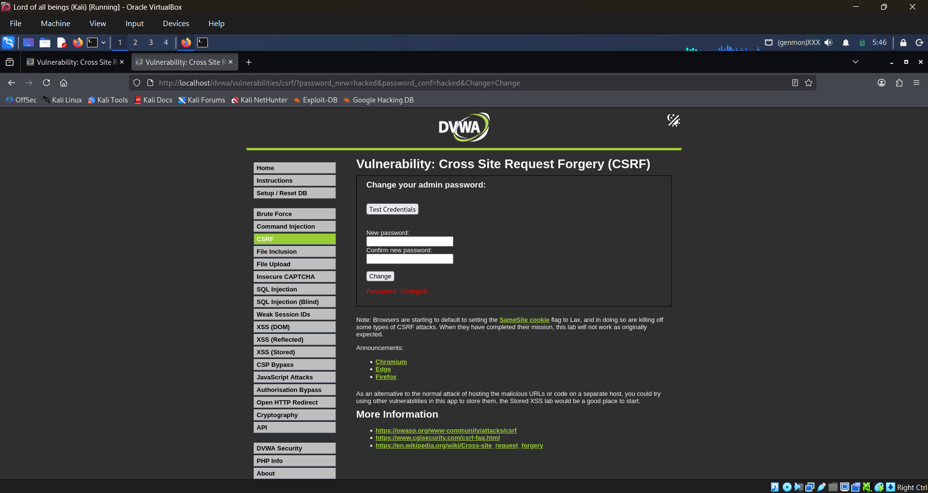

Remediation
- Implement CSRF tokens for state-changing operations
- Use SameSite cookie attributes
- Validate Referer and Origin headers
- Require re-authentication for sensitive actions

4. VULNERABILITY SUMMARY
# | Vulnerability | Severity | Status
1 | SQL Injection | Critical | Confirmed
2 | Cross-Site Scripting (XSS) | High | Confirmed
3 | Cross-Site Request Forgery (CSRF) | High | Confirmed

5. CONCLUSION
The security testing conducted on DVWA successfully identified and demonstrated three critical web application vulnerabilities. Each vulnerability was verified through manual testing with specific payloads designed to exploit the identified weaknesses.

Key Takeaways:
- Input validation is critical for application security
- Proper output encoding prevents XSS attacks
- CSRF protection mechanisms are essential for state-changing operations

Recommendations for Developers:
- Follow secure coding practices
- Implement defense-in-depth strategies
- Regular security testing and code reviews
- Keep security libraries and frameworks updated

6. APPENDIX

Screenshot References
- dvwa sqli.png - SQL Injection attack demonstration
- dvwa xss.png - XSS payload injection (Part 1)
- dvwa xss2.png - XSS payload injection (Part 2)
- dvwa csrf.png - CSRF attack demonstration

Report generated for internship documentation purposes

All tests conducted on authorized test environment (DVWA)

