JUNIOR FINANCIAL DATA ANALYST INTERNSHIP

Financial Data Collection
& Cleaning Process
TCS vs Infosys, HCLTech and Wipro
Week 2 Deliverable | Analysis-ready foundation for Weeks 3–4
Prepared by  Swarnadeep Dey | Scope  Q1 FY24–Q1 FY27 • 52 observations

Engagement context
A simulated analyst workflow for a hypothetical equity-research desk. The report documents how public financial data was identified, collected, standardized, validated and prepared for downstream visualization and forecasting. It is not an investment recommendation.
Source status: current Q1 FY27 operating/strategic KPIs are validated against issuer releases. The common 13-quarter historical financial panel uses a structured public-data extraction layer and is explicitly flagged where direct issuer reconciliation remains a follow-up control.

Executive Summary
Purpose. Week 2 converts the strategic questions defined in Week 1 into a controlled data workflow. The objective is not simply to assemble numbers, but to produce a dataset whose definitions, units, time periods and source lineage are sufficiently clear that an analyst can defend each subsequent calculation. The peer universe remains TCS, Infosys, HCLTech and Wipro, consistent with the Week 1 scope, and the working quarterly panel contains 13 common quarters from Q1 FY24 through Q1 FY27, giving 52 company-quarter observations. The earlier plan specified a 12+ quarter target and a primary-source-first approach. This report operationalizes that approach while making data-quality limitations visible rather than hiding them.
Collection architecture. The workflow uses issuer investor-relations releases, financial-statements pages and exchange filings as the source hierarchy for verification. A structured public-data extraction layer is retained for efficient historical backfill and cross-company panel construction. This is treated as a secondary layer, not as the final source of record. Current Q1 FY27 values are separately validated against the companies’ own releases so the most recent quarter is not allowed to inherit stale or mislabelled figures from an indexed summary.
Cleaning and standardization. Historical revenue, operating profit and net profit are standardized to INR crore. Fiscal-quarter labels are normalized, duplicates are checked, and derived metrics—quarter-on-quarter growth, year-on-year growth, operating margin and net margin—are formula-driven in the companion workbook. Source type, URL and data-status fields are retained alongside the financial observations. This creates an audit trail that separates hard financial inputs from analytical calculations.
Key findings from the data-quality pass. Coverage is complete for the common 13-quarter panel, with 52 rows across four issuers and no missing core revenue/profit observations in the working set. Four material controls are flagged for downstream work: Wipro’s margin basis must remain explicitly identified as IT services; small Q1 FY27 profit differences exist between the structured series and issuer-reported values for Infosys, HCLTech and Wipro; an exact current Wipro employee count was not captured and therefore must not be invented; and historical primary-source reconciliation should continue before final model sign-off.
Handoff. The dataset is suitable as a Week 3 visualization base and a Week 4 modelling base provided the source log and QA exceptions travel with it. The main analytical principle is therefore traceability: a clean-looking dataset is not treated as reliable merely because it has no blanks. Every exception has a named treatment, every derived metric has a defined formula, and the model stage will be required to respect the Q1 FY27 information cut-off to prevent look-ahead bias.

Report at a Glance
Control | Week 2 outcome
Companies | TCS, Infosys, HCLTech, Wipro
Common quarterly panel | Q1 FY24–Q1 FY27 (13 quarters each; 52 observations)
Core financial fields | Revenue, operating profit, net profit
Derived fields | QoQ growth, YoY growth, operating margin, net margin
Primary data principle | Issuer IR / filings are source of record for validation
Secondary layer | Structured public-data extraction used for historical backfill and reconciliation
Companion technical asset | Excel workbook + GitHub-ready Week 2 code/data structure
Downstream use | Week 3 visualization and Week 4 forecasting

1. Scope and Data Architecture
The Week 1 strategic plan established a simulated equity-research engagement focused on whether TCS’s growth and margin position among large Indian IT-services peers could be evaluated over the next two to four quarters. The Week 2 data architecture is designed to answer the information requirements without mixing incompatible measures.

1.1 Analytical universe
- TCS, Infosys, HCLTech and Wipro are retained as the four-company peer universe defined in Week 1.
- The common quarter-level comparison runs from Q1 FY24 through Q1 FY27. FY23 annual context may be referenced, but the common panel is kept at 13 quarters because that is the cleanest comparable window available across the four issuers in the working extraction.
- Wipro is explicitly treated on an IT-services operating-margin basis where that is how the issuer reports the metric; no silent conversion to a consolidated margin is permitted.

1.2 Dataset layers
Layer | Purpose | Examples | Control
Raw | Preserve extracted source observations | Revenue, operating profit, net profit, period, company, source URL | No analytical transformations
Cleaned | Create common units/labels and formula-driven metrics | INR crore, fiscal quarter, YoY/QoQ growth, margins | Validation and exception flags
Current KPI | Store Q1 FY27 issuer-validated operating/strategic indicators | TCV, AI revenue, headcount, attrition, CC growth | Source-of-record must be issuer
QA | Document data-quality decisions | Coverage, basis, reconciliations, missing/disclosed-threshold items | PASS/FLAG status
Handoff | Provide consistent inputs for later analysis | Revenue index, peer snapshots, forecast-ready series | No look-ahead

2. Data Collection Methodology
The collection process follows a source hierarchy rather than a single website. The objective is to combine the efficiency of a structured dataset with the governance of issuer-level evidence.
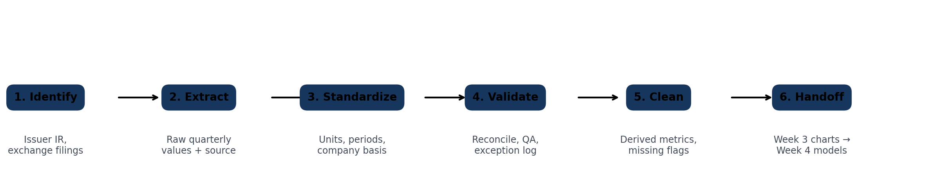
Figure 1. Week 2 data-control pipeline.

2.1 Source hierarchy
Priority | Source class | Use in this project | Governance rule
1 | Issuer investor relations / financial statements | Quarterly financials, official results, fact sheets, annual reports | Source of record; use for final validation
1 | Stock exchange filings | Filed financials and disclosures | Use to resolve reporting-basis or exceptional-item questions
2 | Structured public financial databases | Efficient historical extraction and cross-company panel construction | Secondary only; cross-check against issuer sources
2 | Financial press / analyst summaries | Locate figures, identify discrepancies and contextual issues | Never override an issuer figure without documented reason
Why this hierarchy matters. Financial data can appear identical while carrying different bases—for example, consolidated versus segment reporting, INR versus USD, or adjusted versus unadjusted profit. The source hierarchy therefore reduces the chance that a clean numerical table creates false comparability.

2.2 Step-by-step collection procedure
- Define the observation key as Company + Fiscal Quarter + Metric. This prevents a number from being stored without its time and company context.
- Locate the issuer result page or filing corresponding to the quarter. Record publication date, period end, units, reporting standard and whether the figure is consolidated or segment-level.
- Extract the core financial series—revenue, operating profit and net profit—into the raw layer. Preserve the original source URL and source type alongside the value.
- Use a structured public-data series only to accelerate historical panel construction. Mark these rows as secondary until issuer-level reconciliation is complete.
- Run unit checks. Convert INR million/lakh/crore conventions into INR crore using explicit factors; preserve source currency in the source log where conversion matters.
- Normalize fiscal-quarter labels so Q1 FY24 through Q1 FY27 are chronologically sortable and comparable across issuers.
- Calculate derived metrics only after the core financial inputs are stored and checked. This avoids hard-coding ratios that can become detached from their inputs.
- Complete the QA sheet and assign PASS or FLAG status. A flagged item is not deleted; it is carried forward with a documented treatment so downstream analysts can see the limitation.

3. Data Fields and Cleaning Rules
The companion workbook contains a formal data dictionary. The fields below are the minimum structure required for the four-company quarterly panel and the later analytical tasks.
Field | Definition / treatment | Downstream use
Company | Standard label: TCS, Infosys, HCLTech, Wipro | Peer grouping
Period End | Quarter-end label: Jun-23 through Jun-26 | Time ordering
Fiscal Quarter | Q1 FY24 through Q1 FY27 | Seasonality / back-testing
Revenue (INR Cr) | Standardized financial input | Growth and forecast target
Operating Profit (INR Cr) | Standardized operating profit input | Operating margin
Net Profit (INR Cr) | Standardized net profit input | Net margin / earnings quality
QoQ Revenue Growth | Current revenue / prior quarter revenue − 1 | Near-term trend
YoY Revenue Growth | Current revenue / same quarter prior year − 1 | Underlying trend / seasonality
Operating Margin | Operating profit / revenue | Profitability comparison
Net Margin | Net profit / revenue | Earnings quality
Source Type / URL | Evidence trail for each row | Auditability
Data Status | Historical secondary extraction vs current issuer cross-check | QA and handoff

3.1 Standardization rules
Issue | Rule applied | Rationale
Unit mismatch | Financial statements in the common panel are standardized to INR crore. | Allows direct ratio and trend calculations without scale errors.
Different period labels | Map all observations to a fiscal-quarter sequence. | Prevents a calendar label from being mistaken for a fiscal label.
Different reporting bases | Document segment/consolidated basis explicitly; do not silently mix them. | Protects peer comparability.
Currency effects | Keep constant-currency growth separate from reported INR growth when disclosed. | Prevents FX translation from being interpreted as demand growth.
Derived metrics | Calculate ratios in the cleaned layer rather than transcribing them from third-party pages. | Makes the logic reproducible.
Missing values | Use blank/NA only when the metric is genuinely undisclosed; never substitute zero. | Zero means “no value,” while blank means “not observed/disclosed.”
Conflicting values | Issuer value governs the current KPI snapshot; discrepancy is logged rather than overwritten silently. | Creates a visible reconciliation trail.

4. Q1 FY27 Current KPI Validation
Current-quarter metrics were checked against issuer releases because the latest quarter is especially vulnerable to stale summaries and inconsistent indexing. These strategic indicators complement the common financial panel; they are not all directly comparable across the four firms.
Company | Metric | Q1 FY27 value | Source treatment
TCS | Revenue / Operating margin | ₹72,275 Cr / 24.0% | Issuer release; USD revenue $7,624m
TCS | TCV / annualised AI revenue | $9.5bn / $2.6bn | Issuer release
TCS | Headcount / LTM attrition | 593,798 / 13.6% | Issuer release
Infosys | Revenue / Operating margin | ₹48,211 Cr / 21.1% | Issuer financial snapshot
Infosys | Net profit / headcount | ₹7,769 Cr / 328,062 | Issuer sources
HCLTech | Revenue / EBIT margin | ₹34,579 Cr / 16.9% | Issuer investor release
HCLTech | TCV / Advanced AI revenue | $2,407m / $171m | Issuer investor release
HCLTech | Net income | ₹4,624 Cr | Issuer investor release
Wipro | IT-services revenue / margin | $2,614.5m / 16.0% | Issuer Q1 FY27 release
Wipro | Bookings / large deals | $3,370m / $1,626m | Issuer Q1 FY27 release
Wipro | LTM attrition | 13.9% | Issuer Q1 FY27 release
Basis note: Wipro’s operating margin is for IT Services. Constant-currency definitions also differ slightly by issuer, so Week 3 should present the metric with its company-specific disclosure basis.
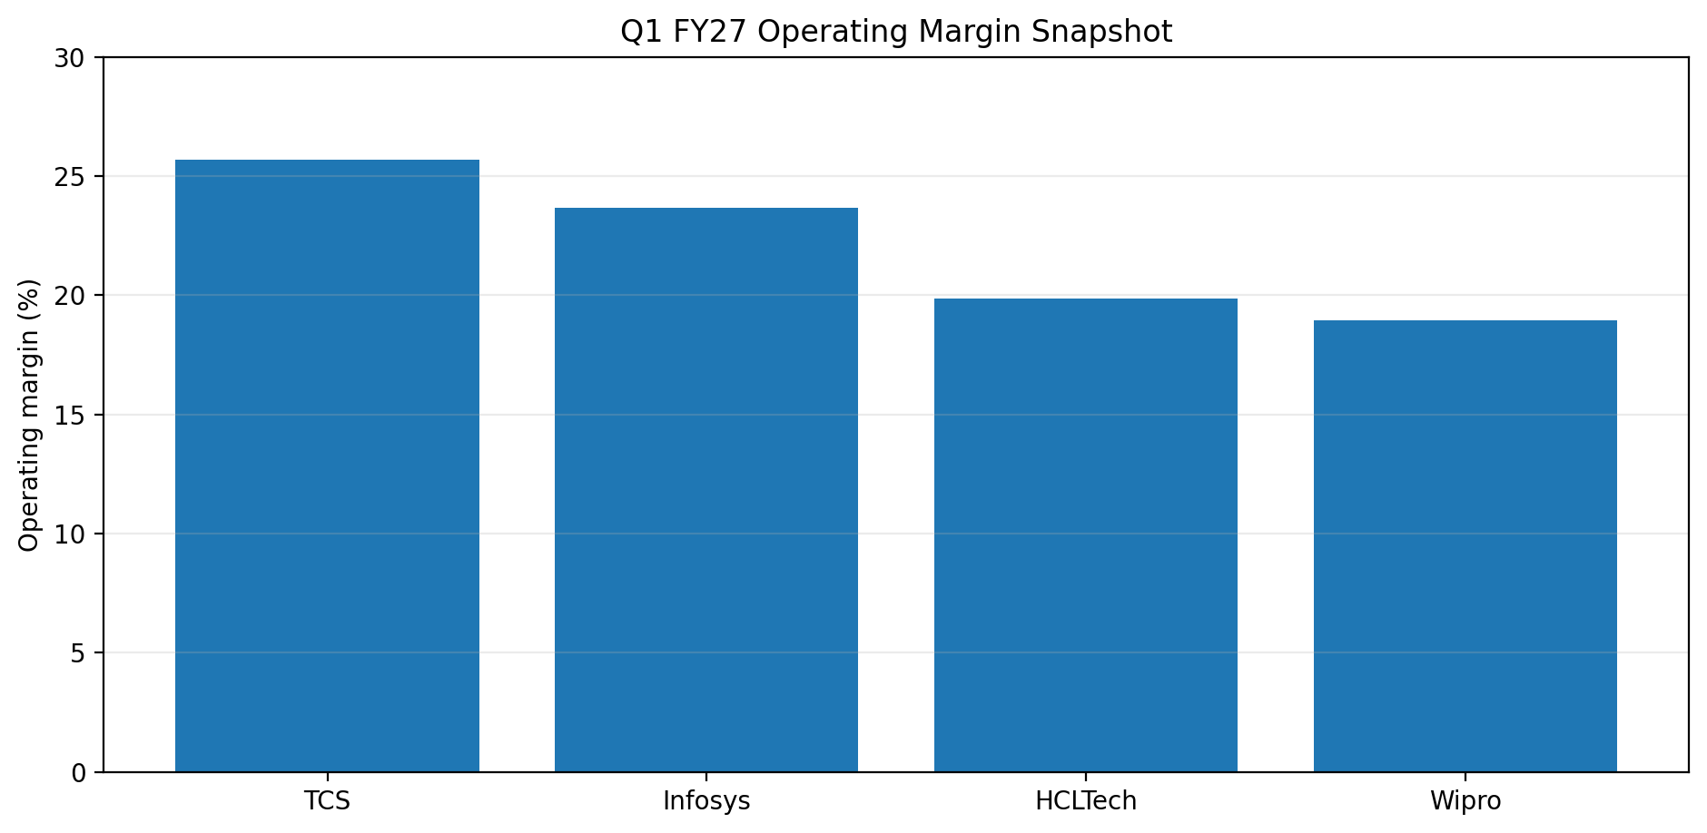
Figure 2. Q1 FY27 operating-margin snapshot using issuer-reported/current validation data.

5. Data Quality Assessment and Reconciliation
The objective of QA is to distinguish a genuine financial movement from a data problem. A reconciliation issue is therefore treated as a finding, not as an inconvenience to be hidden. The working panel passed coverage and unit checks, while several current-quarter items remain flagged for explicit treatment.
Control | Result | Status | Planned treatment
Coverage | 13 common quarters per company; 52 rows in total | PASS | Use the common panel for peer charts
Core financial completeness | Revenue, operating profit and net profit populated across the 52-row panel | PASS | Proceed to derived metrics
Unit standardization | Common financial fields stored in INR crore | PASS | No additional scaling before analysis
Wipro basis | Operating margin is IT-services basis | FLAG | Keep basis in chart/table labels
Infosys Q1 FY27 net profit | Issuer ₹7,769 Cr vs structured series ₹7,775 Cr | FLAG | Use issuer figure in current KPI tab; retain structured history with reconciliation note
HCLTech Q1 FY27 net income | Issuer ₹4,624 Cr vs structured series ₹4,626 Cr | FLAG | Use issuer figure in current KPI tab
Wipro Q1 FY27 net income | Issuer ₹3,360 Cr vs structured series ₹3,356 Cr | FLAG | Use issuer figure in current KPI tab
Wipro employee count | Exact number not captured; issuer communication gives a >230,000 threshold covering employees and business partners | FLAG | Do not infer a precise productivity denominator
Currency growth | Reported INR growth can diverge materially from constant-currency growth | PASS | Store both measures where disclosed
Look-ahead risk | Forecast cutoff retained at Q1 FY27 | PASS | Week 4 must use time-ordered training/test windows

5.1 Quality dimensions
Dimension | Assessment | Analyst implication
Accuracy | Current Q1 FY27 controls use issuer-reported figures. Historical structured extraction remains a reconciliation layer. | Do not present secondary values as independently audited facts.
Completeness | Core panel has complete revenue/profit observations for the chosen 13-quarter window. | Suitable for a consistent base series.
Consistency | Units and fiscal labels are normalized; reporting-basis caveats are retained. | Peer comparisons become more defensible.
Traceability | Source URLs and source-status fields accompany observations in the workbook. | Every material figure can be followed back to evidence.
Timeliness | Q1 FY27 values are current to the stated cut-off. | Supports later short-horizon analysis without mixing future information.

6. Challenges Encountered and Mitigation
Challenge | Observed issue | Mitigation / analyst decision
Conflicting figures | Small differences appear between structured summaries and issuer Q1 FY27 results. | Current issuer value governs the KPI snapshot; discrepancy remains visible in QA.
Different bases | Wipro’s margin is IT-services; other peers may present consolidated or segment metrics differently. | Basis is written into field names/notes and carried into visualization labels.
Historical source fragmentation | Issuer archives are spread across results pages, fact sheets and filings. | Use a source log and a secondary structured extraction layer for historical panel construction, then perform targeted primary reconciliation.
Undisclosed exact metric | Exact Wipro headcount not captured in the current source pass. | Use NA/threshold notation rather than an invented number.
Limited sample for forecasting | 13 common quarters is useful but not a large time-series sample. | Use simple models, back-testing and error reporting in Week 4.
Fast-changing AI disclosures | AI revenue definitions differ by issuer. | Retain issuer terminology and avoid combining non-identical AI metrics without a definition check.

7. Analytical Hand-off Readiness
A cleaned dataset is valuable only if its design supports the next questions. The Week 2 panel is therefore structured around the hypotheses from Week 1: growth must be separated from currency, profitability must be normalized, workforce measures must retain their definitions, and forward indicators such as TCV should not be treated as equivalent to recognized revenue.
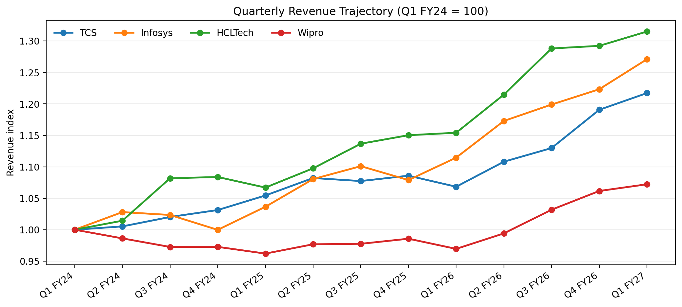
Figure 3. Revenue trajectory index, Q1 FY24 = 100. The index removes company scale so the four quarterly paths can be visually compared.
Week 3 / 4 requirement | Week 2 hand-off field | Control carried forward
Peer growth comparison | Revenue + QoQ/YoY growth | Check company basis and units
FX / constant-currency analysis | Current KPI CC growth + reported INR growth; source notes | Do not interpret INR growth alone
Profitability benchmarking | Operating margin + net margin | Calculate from standardized inputs
Productivity | Headcount where disclosed | No inferred or fabricated headcount
Forward indicators | TCV / bookings / AI metrics in Current_KPIs | Keep definitions company-specific
Forecasting | Revenue and margin time series | Use time-ordered split; compare against naive baseline

8. Critical Evaluation of the Data-Preparation Process
What worked. The strongest part of the process is that it creates a deliberate separation between raw inputs, derived calculations and QA exceptions. This matters in financial analysis because an error in a single unit or period label can propagate through a growth rate, a margin comparison and eventually a forecast. The use of a dedicated source log also means the analysis can be repeated or audited instead of relying on analyst memory.
What remains imperfect. The historical common panel is efficient and useful, but the structured extraction layer should not be mistaken for a substitute for issuer-level evidence. The next iteration should close the remaining primary-source reconciliation on older quarters before the Week 4 model is frozen. In addition, the peer set still contains reporting-basis differences and a limited observation count for forecasting. These are limitations of the information environment, not reasons to hide the uncertainty.
Analytical lesson. The central lesson from Week 2 is that “clean” means more than no missing cells. A financially clean dataset is one in which units, periods, definitions, source lineage and exceptions are explicit. That principle will determine how the Week 3 visualizations are labelled and how the Week 4 model is evaluated.

9. Conclusion and Recommendations for the Next Phase
Week 2 establishes a defensible working foundation for the remaining analytical stages. The four-company panel now has a common 13-quarter structure, standardized core financial fields, reproducible derived metrics, source metadata and a visible reconciliation log. The latest quarter is separately checked against issuer reporting, while known limitations are carried forward instead of being suppressed.
- Complete targeted primary-source reconciliation for the historical quarters used most heavily in Week 3 and Week 4.
- In Week 3, present reported INR growth beside constant-currency growth and clearly annotate company-specific reporting bases.
- In Week 4, keep the modelling sample small and transparent: benchmark against a naive method, use time-ordered back-testing and report forecast error rather than only a point estimate.
- Maintain the Week 2 source log and QA sheet as living controls so later changes do not silently alter the analytical record.

10. References and Source Register
[1] TCS Investor Relations – Financial Statements — https://www.tcs.com/investor-relations/financial-statements
[2] TCS – Q1 FY27 Financial Results (9 July 2026) — https://www.tcs.com/who-we-are/newsroom/press-release/tcs-financial-results-q1-fy-2027
[3] TCS Investor FAQs – financial and employee information — https://www.tcs.com/investor-relations/investor-faqs
[4] Infosys – Quarterly Results Archive — https://www.infosys.com/investors/reports-filings/quarterly-results/
[5] Infosys – Q1 FY27 Financial Information (23 July 2026) — https://www.infosys.com/investors/reports-filings/quarterly-results/2026-2027/q1.html
[6] Infosys – Financial Snapshot — https://www.infosys.com/about/last-quarter.html
[7] HCLTech – Investor Relations / Q1 FY27 Performance — https://www.hcltech.com/investor-relations
[8] HCLTech – Q1 FY27 Results (13 July 2026) — https://www.hcltech.com/en-us/press-releases/hcltech-delivers-robust-q1-led-record-deal-bookings-24-billion
[9] Wipro – Q1 FY27 Results (16 July 2026) — https://www.wipro.com/newsroom/press-releases/2026/wipro-announces-results-for-the-quarter-ended-june-30-2026/
[10] Wipro – Stock Exchange Filings Archive — https://www.wipro.com/investors/corporate-governance/stock-exchange-filings/
[11] Screener – TCS consolidated — https://www.screener.in/company/TCS/consolidated/
[12] Screener – Infosys consolidated — https://www.screener.in/company/INFY/consolidated/
[13] Screener – HCLTech consolidated — https://www.screener.in/company/HCLTECH/consolidated/
[14] Screener – Wipro consolidated — https://www.screener.in/company/WIPRO/consolidated/
Source convention: issuer releases/filings are treated as primary. Screener is retained only as a structured public-data extraction and reconciliation layer. All data should be re-verified before any investment decision; this report is an educational internship simulation.

Appendix A. Working Dataset Coverage
Company | Quarters | Revenue observations | Operating profit observations | Net profit observations | Historical source layer
TCS | 13 | 13 | 13 | 13 | Structured extraction + issuer current-quarter validation
Infosys | 13 | 13 | 13 | 13 | Structured extraction + issuer current-quarter validation
HCLTech | 13 | 13 | 13 | 13 | Structured extraction + issuer current-quarter validation
Wipro | 13 | 13 | 13 | 13 | Structured extraction + issuer current-quarter validation
Companion workbook: Week2_TCS_Financial_Data_Collection_Cleaning.xlsx. The workbook contains Raw_Quarterly, Cleaned_Quarterly, Current_KPIs, Data_Dictionary, Source_Log, QA_Checks, Trend_Index and Overview sheets.

