FINANCIAL DATA ANALYSIS
Financial Data
Visualization & Reporting
TCS vs Infosys, HCLTech and Wipro
ANALYSIS WINDOW  Q1 FY24–Q1 FY27  13 common quarters | PEER UNIVERSE  4 issuers  TCS • Infosys • HCLTech • Wipro | WORKING PANEL  52 observations  13 quarters × 4 companies | PRIMARY OUTPUT  8 visuals  Trend, growth, margin & QA views

Engagement context
A simulated equity-research workflow. Week 3 converts the Week 2 cleaned financial panel into decision-oriented visualizations and analytical commentary. It is an educational internship deliverable and is not investment advice.
Prepared for: Yuvaintern — Junior Financial Data Analyst Internship
Data cut-off: Q1 FY27 results (quarter ended 30 June 2026), with current issuer metrics cross-checked against company disclosures.

1. Executive Summary
Week 3 transforms the analysis-ready financial panel created in Week 2 into a structured visualization and reporting layer. The objective is to make the data easier to compare across companies and quarters while preserving the source, unit, and reporting-basis controls already established.
The common historical panel contains 13 quarters from Q1 FY24 through Q1 FY27 for TCS, Infosys, HCLTech and Wipro. The most useful views are an absolute revenue trend, an indexed revenue comparison, INR-reported year-on-year growth, standardized-panel margin trends, a current issuer-validated Q1 FY27 snapshot, and a quarter-to-quarter growth-volatility view.

Key observations from the visual review
- Relative revenue expansion is strongest for HCLTech and Infosys over the Q1 FY24–Q1 FY27 window, while Wipro shows materially lower cumulative expansion.
- TCS remains the largest revenue platform in the standardized Q1 FY27 panel, with ₹72,275 crore versus ₹48,211 crore for Infosys, ₹34,579 crore for HCLTech and ₹24,479 crore for Wipro.
- Latest INR-reported YoY growth in the historical panel is clustered at roughly 13.9% for TCS, Infosys and HCLTech, with Wipro at about 10.6%; this should not be read as constant-currency growth.
- The historical operating-margin series is useful for within-panel trend review but is not interchangeable with each issuer's current EBIT or IT-services margin definition. The report therefore separates the standardized historical panel from the issuer-validated Q1 FY27 margin snapshot.
- Growth-volatility is comparatively contained in the panel, but the level of volatility alone is not a quality signal; it should be interpreted alongside scale, trend, reporting basis and the source hierarchy.
Analyst discipline
Charts are treated as analytical instruments rather than decoration. Every figure has a defined metric, unit, time window, basis note and written interpretation. Where the underlying measure is not perfectly comparable, the limitation is made visible instead of being hidden by formatting.

2. Scope, Dataset and Visualization Framework

2.1 Data scope
The Week 2 cleaned dataset is the sole historical input for the visual analysis. It contains revenue, operating profit, net profit, quarter-on-quarter growth, year-on-year growth, operating margin and net margin. Financial statement fields are standardized to INR crore. Fiscal-quarter labels are normalized to a common sequence from Q1 FY24 to Q1 FY27.

2.2 Visualization metrics
Visualization | Definition | Purpose
Revenue trend | Reported revenue (₹ crore) | Shows absolute scale and quarterly direction.
Revenue index | Revenue ÷ Q1 FY24 revenue × 100 | Compares relative expansion from a common base.
YoY growth | Current quarter revenue ÷ revenue in prior-year quarter − 1 | Reduces seasonality from sequential comparisons; shown on INR basis.
Panel operating margin | Operating profit ÷ revenue × 100 | Tracks the standardized Week 2 profitability field.
Net margin | Net profit ÷ revenue × 100 | Shows bottom-line conversion in the standardized panel.
QoQ volatility | Std. deviation of quarterly QoQ revenue growth | Describes variation in sequential reported growth.

2.3 Source and basis controls
Issuer investor-relations releases and filings remain the source of record for current-quarter validation. The historical common panel uses the structured public-data extraction layer documented in Week 2. The distinction matters because a standardized field called “operating profit” can differ from an issuer's preferred EBIT or segment operating-margin definition.
For Wipro specifically, the current issuer-validated margin is the IT Services segment operating margin. It is therefore presented separately from the standardized historical panel margin. The same principle is applied wherever issuer definitions differ.

3. Visualization Analysis

3.1 Absolute Revenue Trend
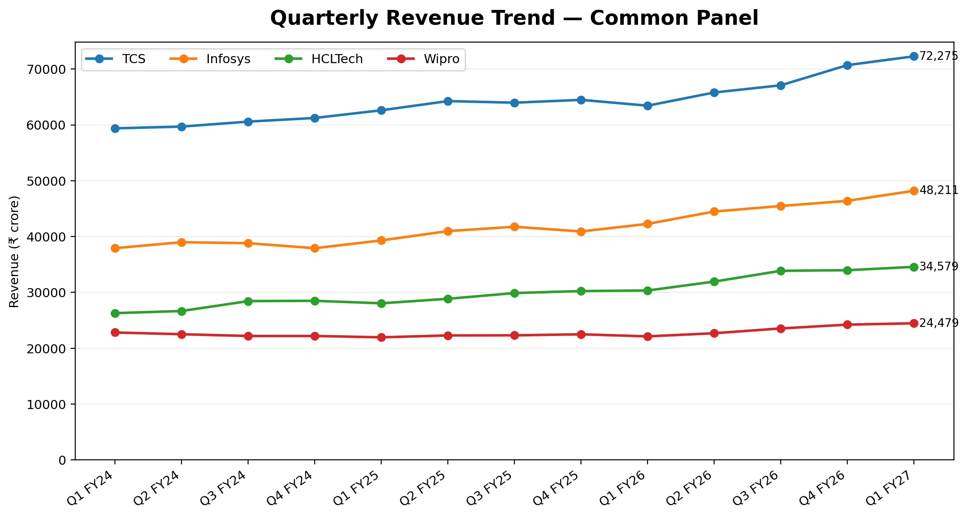
Figure 1. Quarterly revenue trend in the standardized Week 2 panel.
What the chart shows
All four issuers end the period above their Q1 FY24 revenue base. TCS has the highest absolute revenue throughout the panel, while HCLTech shows a strong upward trajectory relative to its starting scale. The chart is best used for scale and direction; relative expansion is clearer in the indexed view on the next page.

Analytical read-through
The absolute-scale chart establishes the peer hierarchy in rupee revenue without implying that a larger company automatically has a stronger growth profile. The separation between the lines is primarily a function of starting scale plus subsequent growth. That is why the next visualization resets each company to a common Q1 FY24 index.

3.2 Relative Revenue Expansion
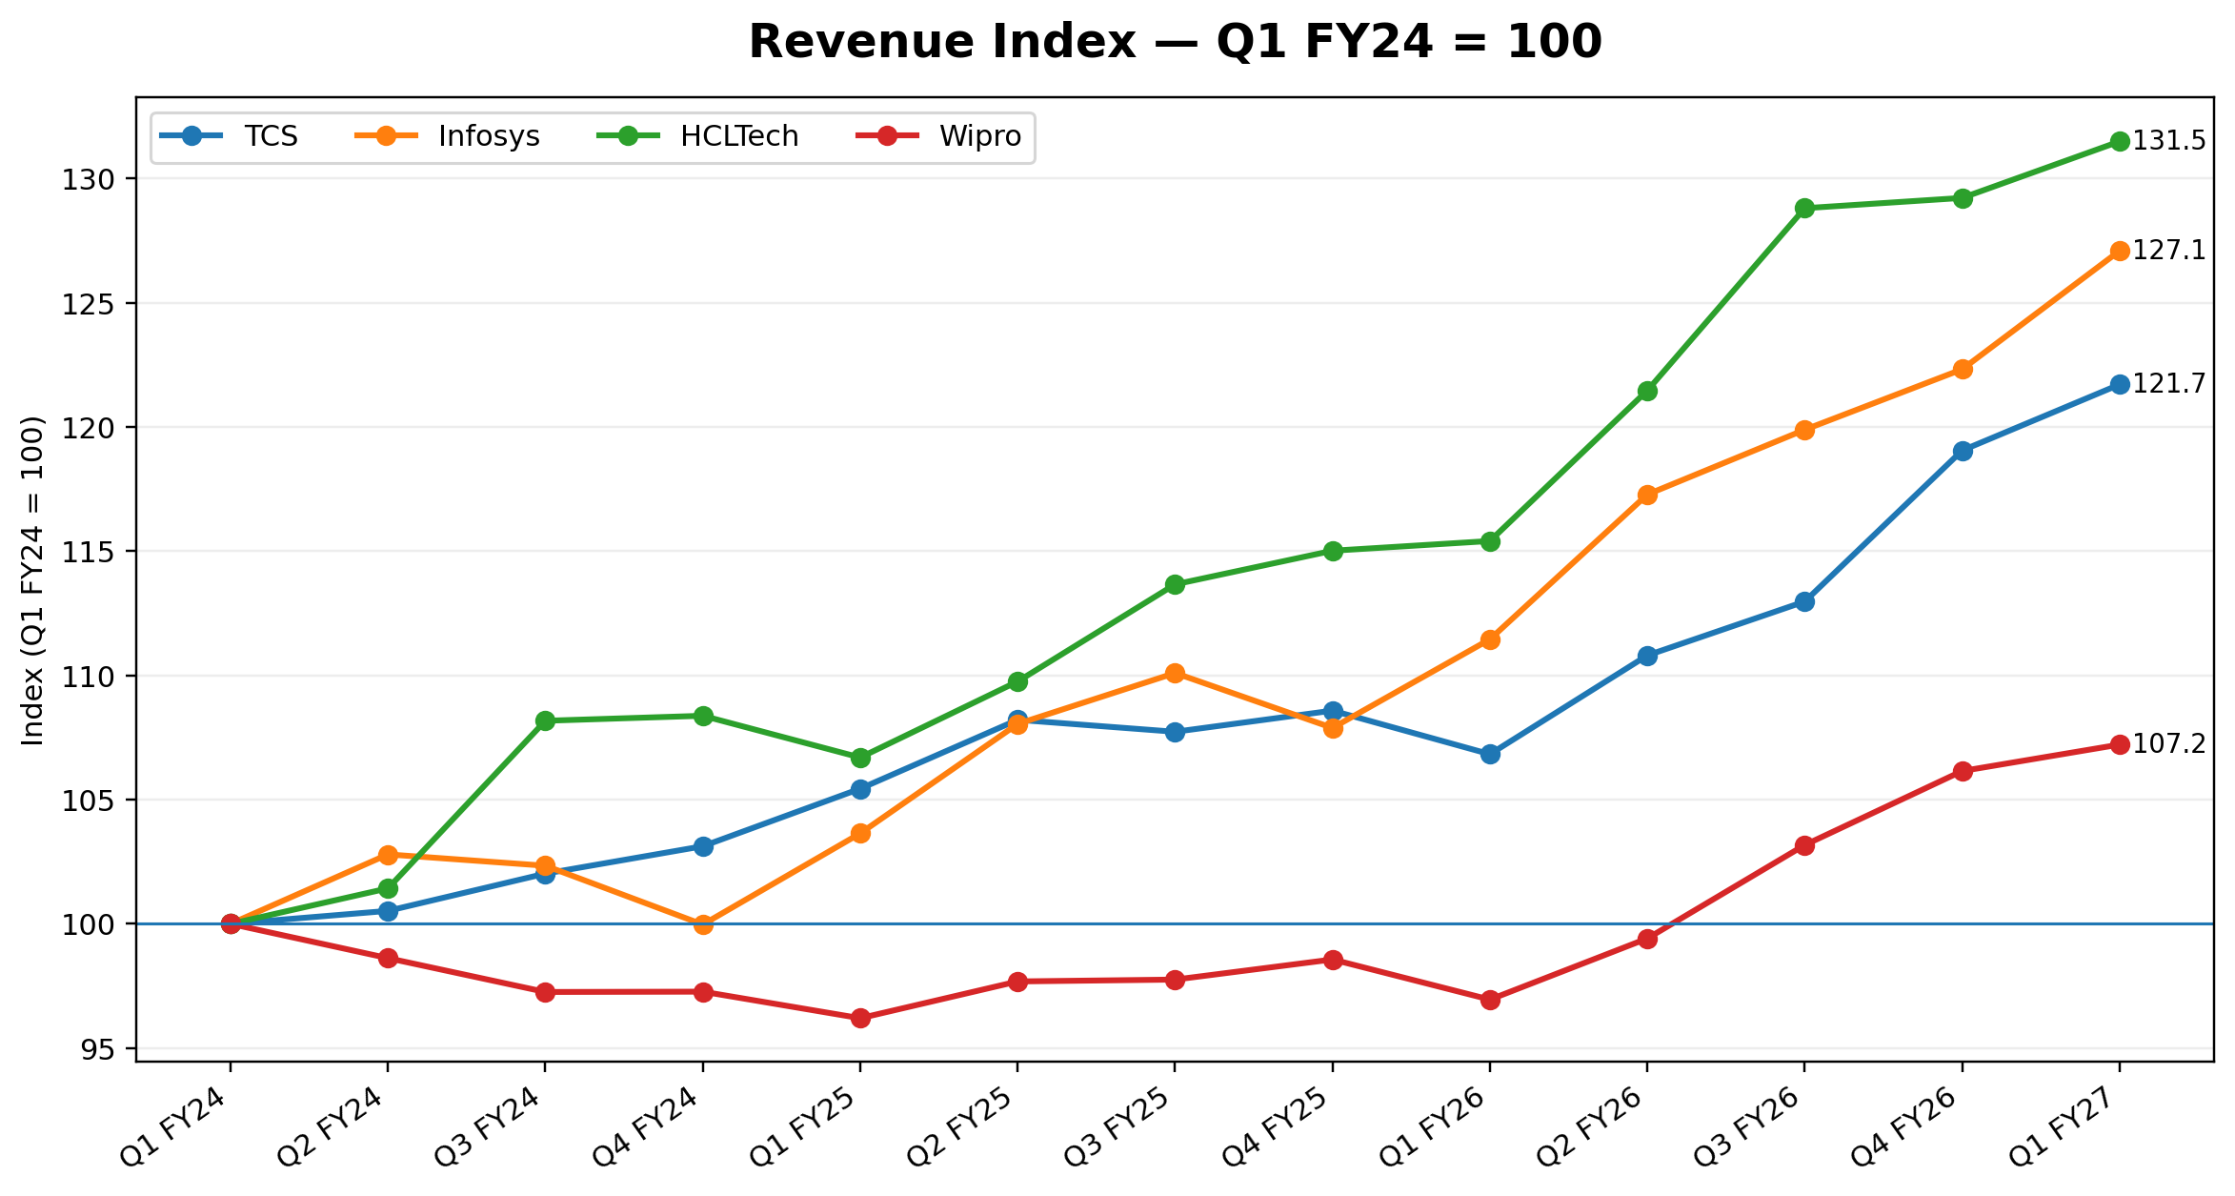
Figure 2. Revenue indexed to Q1 FY24 = 100.
TCS: revenue increased 21.7% between Q1 FY24 and Q1 FY27 in the standardized INR panel.
Infosys: revenue increased 27.1% between Q1 FY24 and Q1 FY27 in the standardized INR panel.
HCLTech: revenue increased 31.5% between Q1 FY24 and Q1 FY27 in the standardized INR panel.
Wipro: revenue increased 7.2% between Q1 FY24 and Q1 FY27 in the standardized INR panel.
Key pattern
The indexed chart changes the question from “who is larger?” to “who expanded more from the same base?” HCLTech and Infosys show stronger cumulative expansion than TCS over this window, while Wipro's indexed path is materially flatter.

3.3 Year-on-Year Revenue Growth
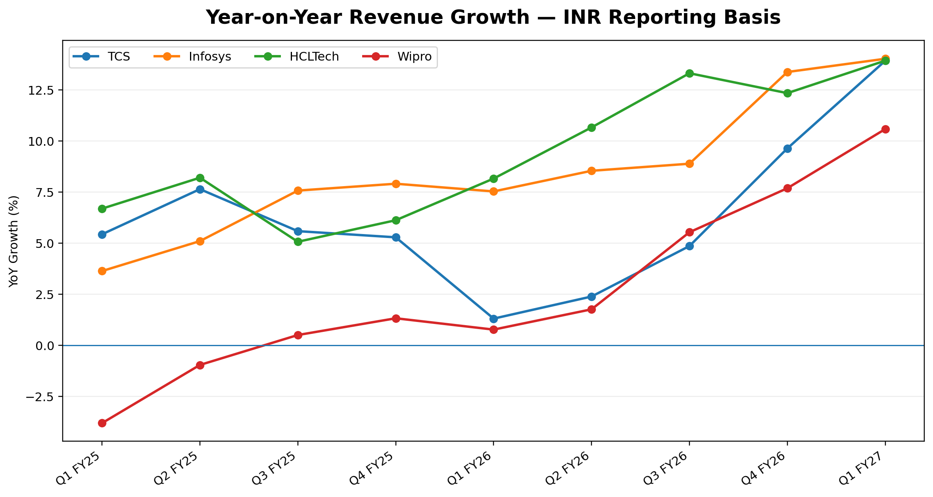
Figure 3. YoY revenue growth from Q1 FY25 to Q1 FY27, based on INR-reported revenue in the standardized panel.
- TCS: Q1 FY27 YoY revenue growth in the standardized INR panel = 13.9%.
- Infosys: Q1 FY27 YoY revenue growth in the standardized INR panel = 14.0%.
- HCLTech: Q1 FY27 YoY revenue growth in the standardized INR panel = 13.9%.
- Wipro: Q1 FY27 YoY revenue growth in the standardized INR panel = 10.6%.
Basis warning
The common-panel YoY view is intentionally labelled “INR reporting basis.” Exchange-rate movements can materially affect reported rupee growth for global IT-services companies, so this chart should not be substituted for company-specific constant-currency growth.

3.4 Operating Margin Trend — Standardized Panel
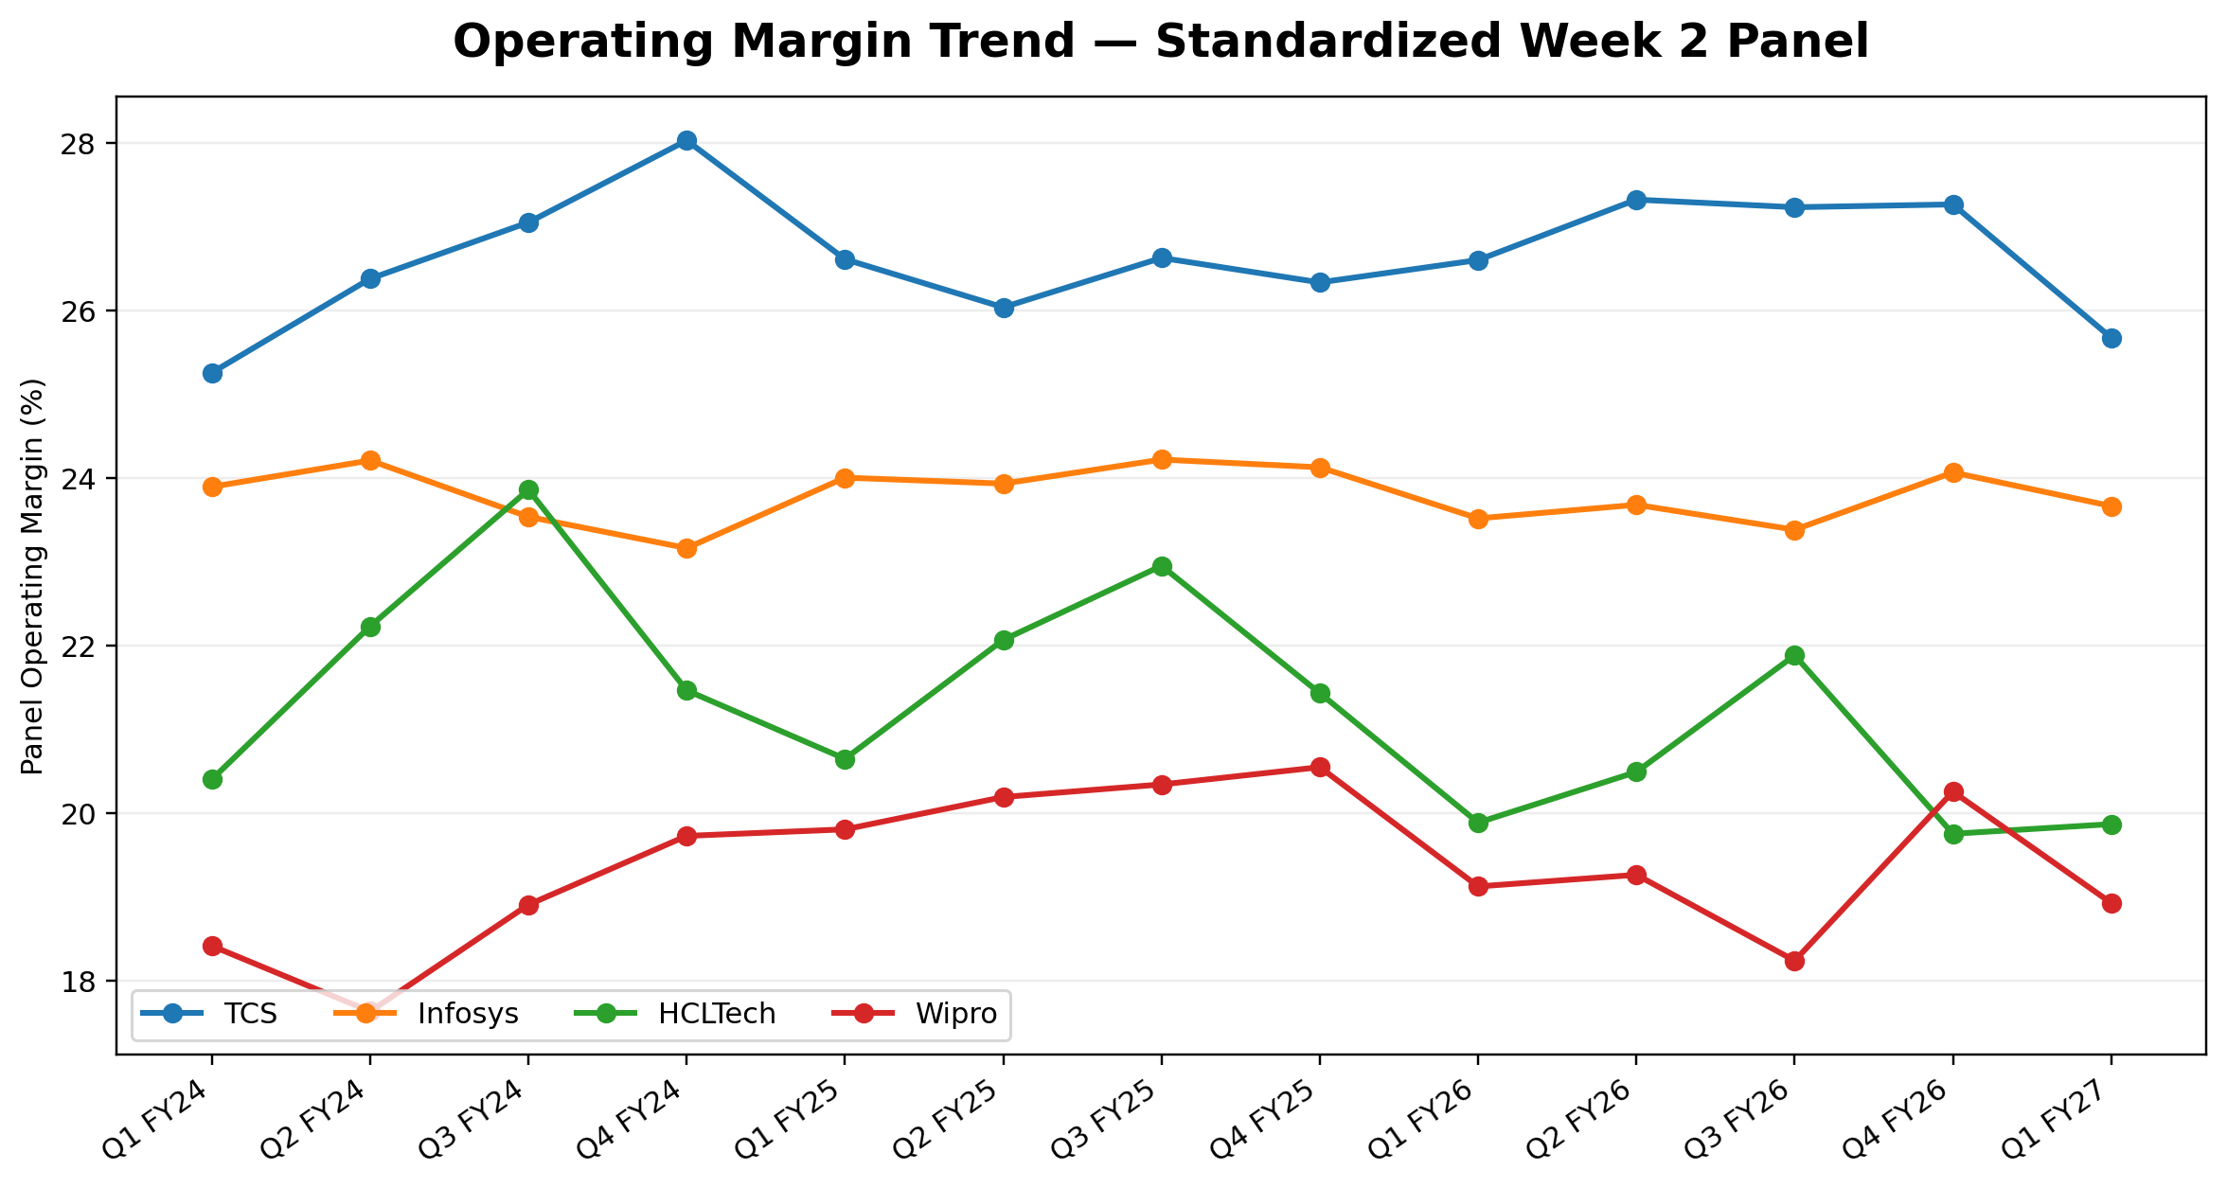
Figure 4. Operating margin derived from the standardized Week 2 operating-profit field.
- TCS: average standardized-panel operating margin across 13 quarters = 26.6%.
- Infosys: average standardized-panel operating margin across 13 quarters = 23.8%.
- HCLTech: average standardized-panel operating margin across 13 quarters = 21.3%.
- Wipro: average standardized-panel operating margin across 13 quarters = 19.3%.
Interpretation boundary
This chart is appropriate for trend inspection within the standardized dataset. It should not be used to directly reproduce the issuer-reported Q1 FY27 EBIT or IT Services margin snapshot because definitions and adjustments differ across reporting frameworks.

3.5 Net Margin Trend
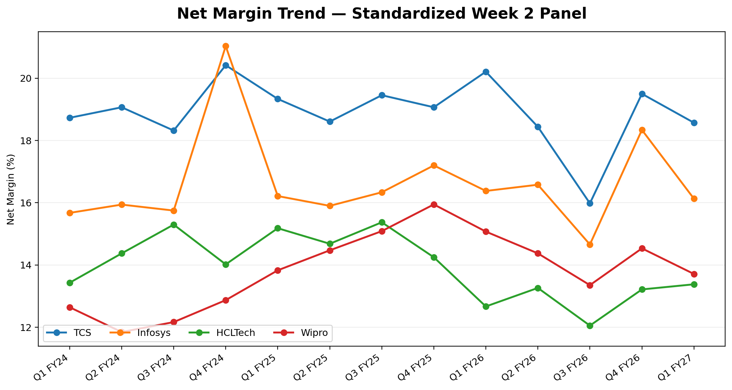
Figure 5. Net margin derived from the standardized Week 2 net-profit and revenue fields.
- TCS: average standardized-panel net margin across 13 quarters = 18.9%; Q1 FY27 = 18.6%.
- Infosys: average standardized-panel net margin across 13 quarters = 16.6%; Q1 FY27 = 16.1%.
- HCLTech: average standardized-panel net margin across 13 quarters = 13.9%; Q1 FY27 = 13.4%.
- Wipro: average standardized-panel net margin across 13 quarters = 13.8%; Q1 FY27 = 13.7%.
Analytical read-through
The net-margin series adds a bottom-line lens to the operating-margin analysis. Period-to-period movement can reflect factors beyond core delivery efficiency, including other income, exceptional items, tax effects and reporting adjustments; visual interpretation therefore remains descriptive rather than causal.

4. Q1 FY27 Current Issuer Snapshot
The historical panel is complemented by a separate current-quarter snapshot using issuer-validated Q1 FY27 disclosures. This prevents the current quarter from inheriting a secondary-series figure when the issuer has published a directly verifiable value.
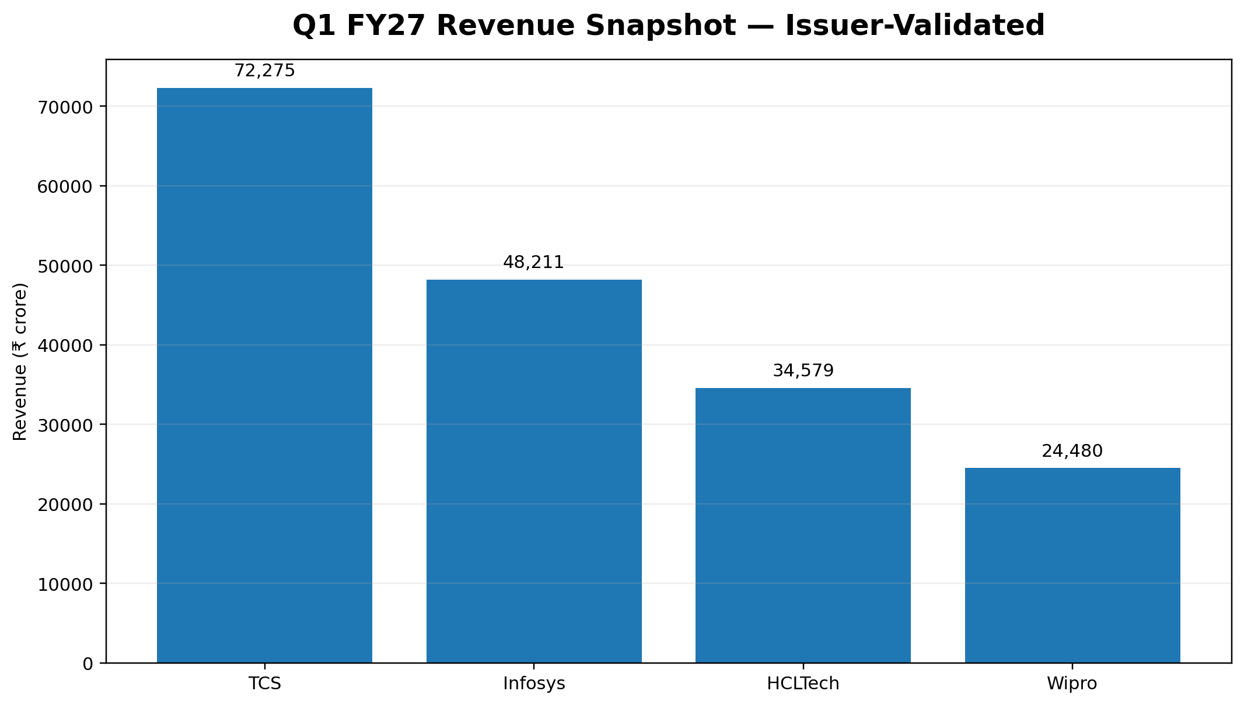
Figure 6. Q1 FY27 revenue snapshot from issuer-validated current data.
Company | Revenue (₹ Cr) | Growth / reporting basis | Margin | Margin basis
TCS | 72,275 | 3.2% YoY constant currency | 24.0% | Consolidated; excludes exceptional item
Infosys | 48,211 | 14.0% YoY INR | 21.1% | Issuer operating margin
HCLTech | 34,579 | 2.6% YoY constant currency | 16.9% | Issuer EBIT margin; includes restructuring impact
Wipro | 24,480 | 0.9% YoY constant currency (IT Services) | 16.0% | IT Services segment operating margin
Current-quarter read-through
Q1 FY27 issuer data confirms the scale ordering visible in the historical panel. The margin comparison is presented on issuer-defined bases: TCS consolidated operating margin, Infosys operating margin, HCLTech EBIT margin, and Wipro IT Services operating margin.

5. Current Margin View and Growth Volatility
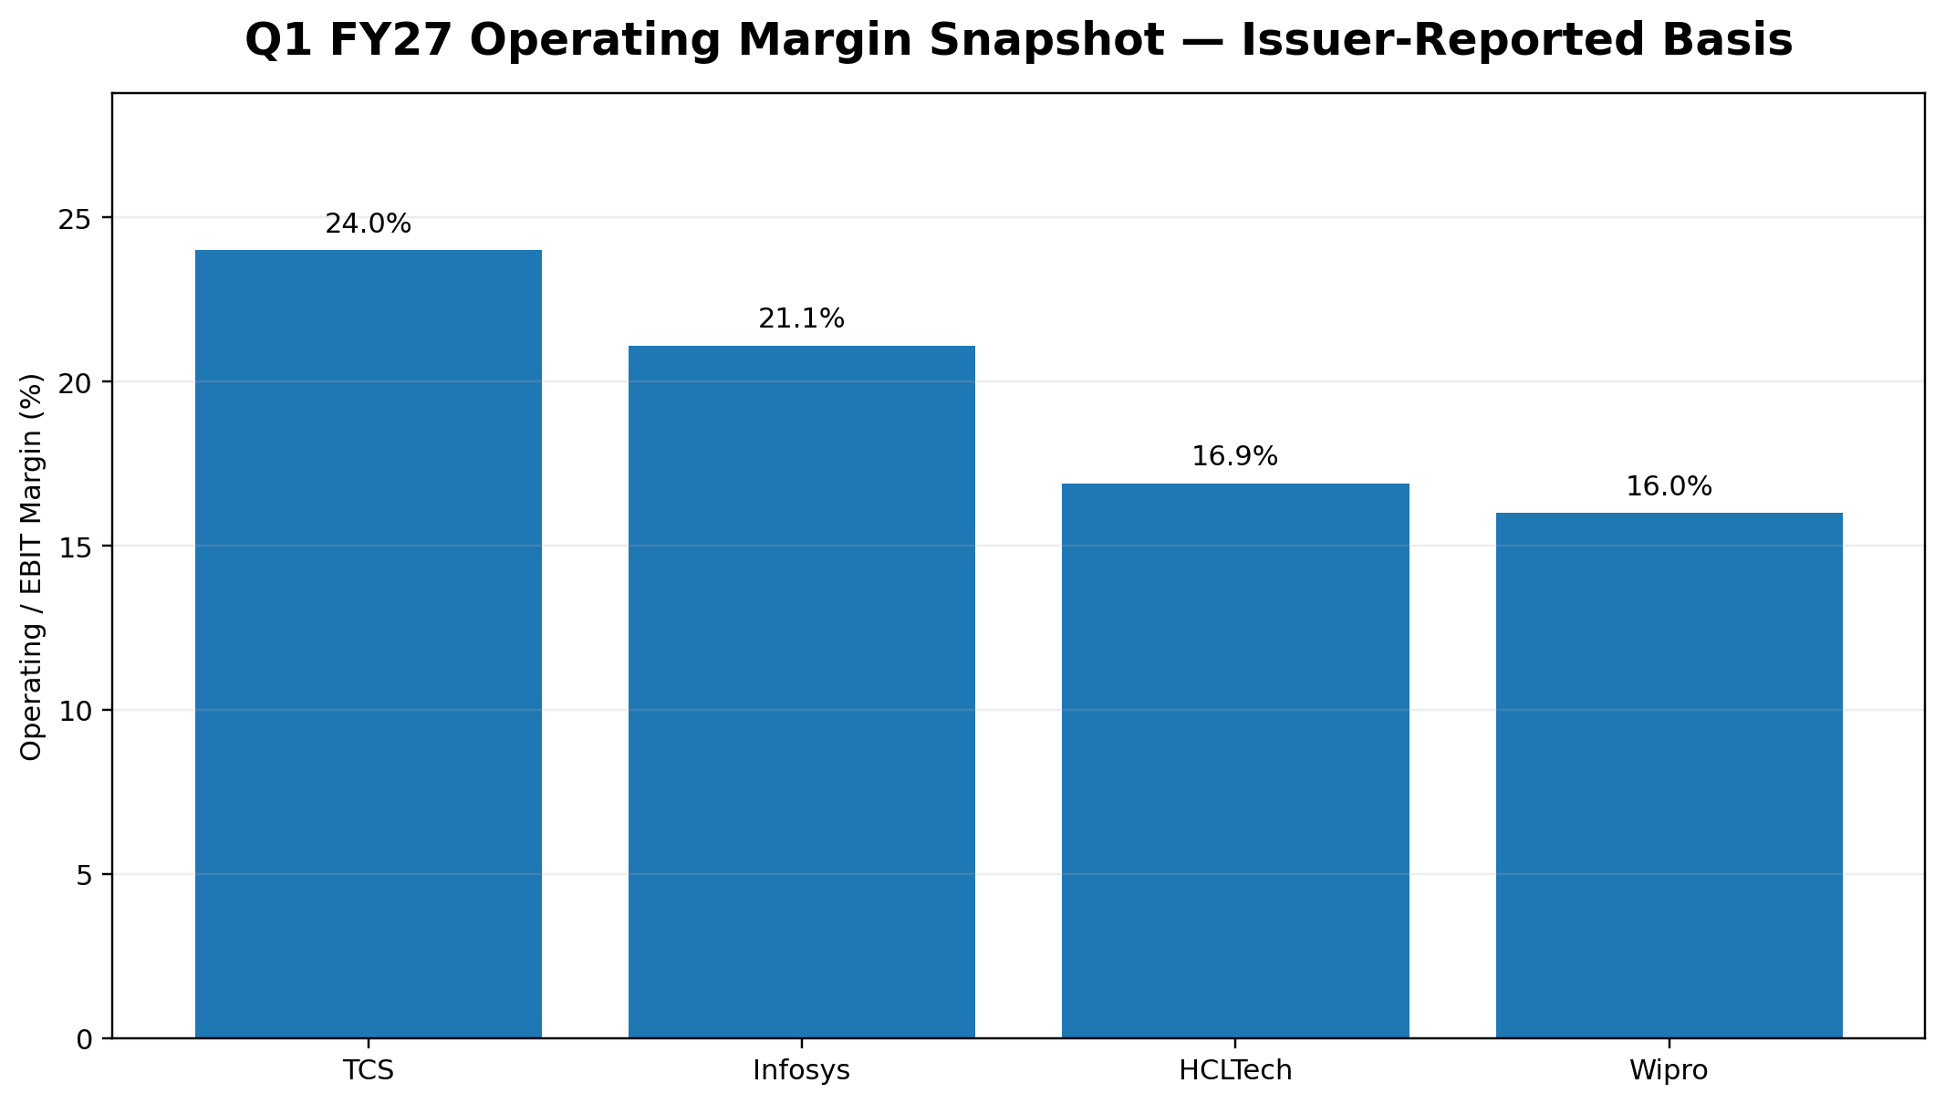
Figure 7. Q1 FY27 issuer-reported operating/EBIT margin snapshot; Wipro is IT Services.
The current issuer snapshot shows why basis labels matter. Wipro's 16.0% figure is specifically the IT Services segment operating margin; HCLTech's 16.9% is issuer-reported EBIT margin; TCS reports a 24.0% consolidated operating margin excluding the exceptional item; and Infosys reports a 21.1% operating margin.

5.1 Quarterly revenue-growth volatility
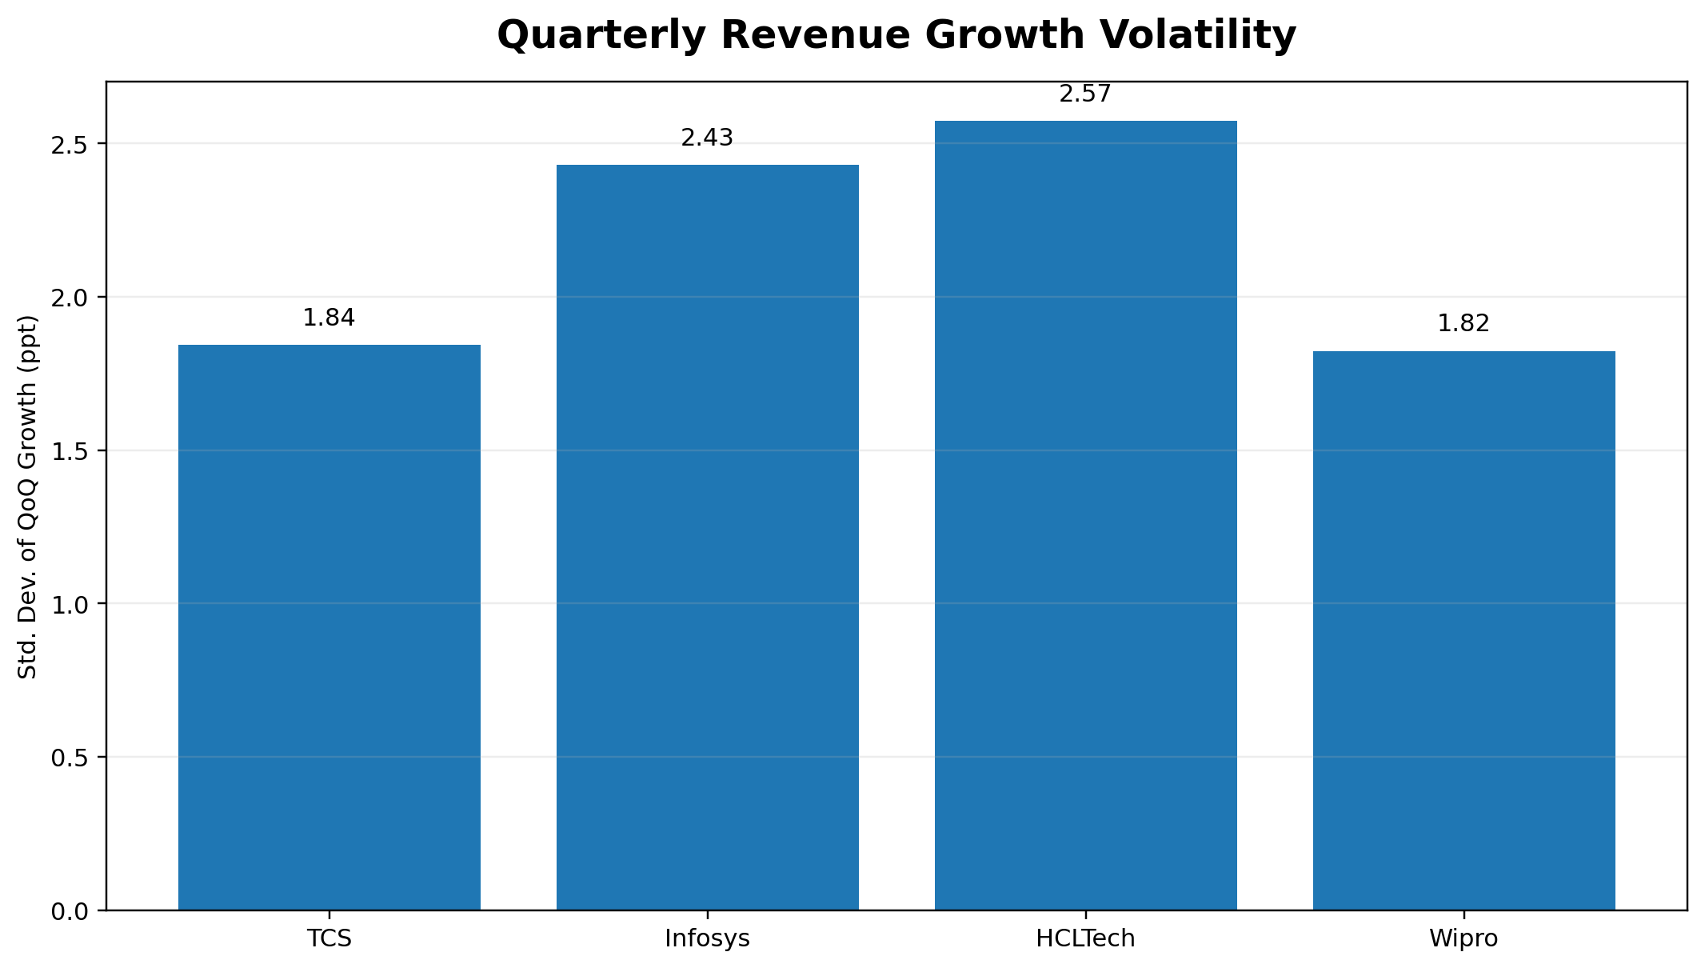
Figure 8. Standard deviation of QoQ revenue growth in the 13-quarter panel.
Company | Avg QoQ growth | Std. dev. | Min | Max
TCS | 1.67% | 1.84 ppt | -1.62% | 5.38%
Infosys | 2.04% | 2.43 ppt | -2.31% | 5.23%
HCLTech | 2.34% | 2.57 ppt | -1.55% | 6.65%
Wipro | 0.60% | 1.82 ppt | -1.64% | 3.78%
Volatility is a descriptive stability measure, not a standalone quality assessment. In this panel, HCLTech has the highest standard deviation of sequential growth, while Wipro has the lowest; the difference is small enough that the underlying business and reporting context should remain part of the interpretation.

6. Consolidated Analytical Findings
- 1. Scale and growth are different dimensions. TCS is the largest revenue platform in the panel, but HCLTech and Infosys show greater cumulative revenue expansion from the Q1 FY24 starting point.
- 2. The common INR growth view is useful for a consistent historical panel, but it embeds foreign-exchange effects. Current issuer disclosures therefore need to be retained when constant-currency growth is the relevant business question.
- 3. Margin analysis requires stronger metadata than revenue analysis. Standardized arithmetic creates a consistent series, but issuer-defined EBIT, operating margin and segment margin can differ materially.
- 4. Revenue volatility is comparatively stable across the four issuers, yet the lowest volatility should not be treated as inherently superior; volatility must be interpreted with scale, growth, seasonality and reporting definitions.
- 5. The visualization layer materially improves the usability of the Week 2 dataset by separating absolute scale, relative expansion, growth, profitability and quality-control dimensions into purpose-built views.

6.1 Selected comparison table
Company | Q1 FY24 Rev. | Q1 FY27 Rev. | Cumulative change | Latest YoY | Avg panel OPM | Avg net margin
TCS | 59,381 | 72,275 | 21.7% | 13.9% | 26.6% | 18.9%
Infosys | 37,933 | 48,211 | 27.1% | 14.0% | 23.8% | 16.6%
HCLTech | 26,296 | 34,579 | 31.5% | 13.9% | 21.3% | 13.9%
Wipro | 22,831 | 24,479 | 7.2% | 10.6% | 19.3% | 13.8%

7. Visualization Review and Refinement
A final review was performed after the first visualization pass to test whether each chart answered a distinct analyst question and whether any visual choice could create a misleading comparison.
Review item | Issue identified | Refinement applied
Absolute revenue trend | Scale became the primary story | Retained as a dedicated scale chart; added direct latest-point labels.
Indexed revenue | Direct scale comparison obscured relative expansion | Added Q1 FY24 = 100 indexing to make growth paths comparable.
YoY growth | Sequential movements could exaggerate seasonality | Used YoY growth for the main growth comparison and clearly labelled INR basis.
Margin comparison | Issuer and structured-series definitions differ | Separated standardized historical margin charts from current issuer-validated margin snapshot.
Chart readability | Too many labels can reduce signal | Limited labels to decision-useful points and used consistent quarter ordering.
Source transparency | A clean chart can hide data limitations | Basis notes and source hierarchy are carried into captions and interpretation boxes.
Quality-control principle
The final report does not attempt to make the dataset look more comparable than the underlying disclosure supports. Visual clarity is treated as part of analytical quality, not as a substitute for data validation.

8. Handoff to Week 4 — Forecasting & Predictive Modelling
The Week 3 visual layer identifies the variables and structural features that should inform the forecasting stage. The cleaned quarterly panel should remain the canonical input rather than being manually re-entered from charts.
Model element | Candidate input | Control
Target candidate | Quarterly revenue | Primary forecast target; maintain the 13-quarter time order.
Secondary target | Panel operating margin | Useful for a margin forecast, subject to definition caveat.
Predictors | Lagged revenue / growth, quarter position, prior-year revenue | Suitable for baseline time-series or regression specifications.
Validation design | Time-ordered train/test split | Prevents look-ahead and preserves temporal structure.
Evaluation | MAE / RMSE / MAPE where appropriate | Compare models on held-out observations rather than in-sample fit alone.
Risk control | Issuer basis and current-quarter cut-off | Do not use information published after the Q1 FY27 cut-off in model inputs.
Week 4 should test whether the visualized trends translate into stable predictive relationships. A model that fits historical data well but fails on held-out quarters should not be treated as reliable. The current-quarter issuer snapshot can be used for contextual checks, but the forecasting feature set should be time-consistent.

9. Limitations, Sources and Data Governance

9.1 Limitations
- The historical common panel is sourced from the structured public-data extraction layer retained in Week 2; primary-source reconciliation is a continuing control rather than a claim that every historical point is independently audited.
- The standardized operating-profit field is not identical to each issuer's current EBIT or segment operating-margin definition. Historical margin charts therefore require basis-aware interpretation.
- INR-reported growth can differ from constant-currency growth for globally exposed companies. The report does not collapse those measures into a single “true growth” figure.
- The project is a simulated internship workflow using public information and should be refreshed against the latest issuer filings before any real-world use.

9.2 Source hierarchy used
Priority | Source | Use | Reference
1 | TCS Investor Relations / Q1 FY27 Results | Issuer source of record | https://www.tcs.com/who-we-are/newsroom/press-release/tcs-financial-results-q1-fy-2027
1 | Infosys Q1 FY27 Financial Snapshot | Issuer source of record | https://www.infosys.com/about/last-quarter.html
1 | HCLTech Investor Relations / Q1 FY27 Performance | Issuer source of record | https://www.hcltech.com/investor-relations
1 | Wipro Q1 FY27 Results | Issuer source of record | https://www.wipro.com/newsroom/press-releases/2026/wipro-announces-results-for-the-quarter-ended-june-30-2026/
2 | Screener consolidated company pages | Structured historical extraction / reconciliation layer | https://www.screener.in/

9.3 Project files produced
- Week 3 DOCX report with embedded analytical figures and interpretation.
- Python visualization script for reproducible chart generation.
- Jupyter notebook for interactive review of the cleaned panel.
- Derived summary CSVs for growth, volatility and Q1 FY27 issuer snapshot.
- Portal description text for the Yuvaintern submission field.
Disclaimer
Educational internship simulation. This report is not investment advice, a research recommendation, or a substitute for current company filings.

Appendix A — Q1 FY27 Standardized Panel Values
Company | Revenue | Operating profit | Net profit | QoQ growth | YoY growth | Panel OPM | Net margin
TCS | 72,275 | 18,556 | 13,420 | 2.2% | 13.9% | 25.7% | 18.6%
Infosys | 48,211 | 11,409 | 7,775 | 3.9% | 14.0% | 23.7% | 16.1%
HCLTech | 34,579 | 6,870 | 4,626 | 1.8% | 13.9% | 19.9% | 13.4%
Wipro | 24,479 | 4,633 | 3,356 | 1.0% | 10.6% | 18.9% | 13.7%
Note: These values come from the standardized Week 2 historical panel. For current issuer-defined operating/EBIT margins, use the separate Q1 FY27 issuer snapshot in Section 4.

Appendix B — Figure Inventory
# | Figure | Analytical question | File
1 | Quarterly Revenue Trend | Absolute scale and direction | 01_revenue_trend.png
2 | Revenue Index — Q1 FY24 = 100 | Relative cumulative expansion | 02_revenue_index.png
3 | YoY Revenue Growth | Reported growth trajectory | 03_yoy_growth.png
4 | Operating Margin Trend | Standardized-panel profitability trend | 04_operating_margin.png
5 | Net Margin Trend | Standardized-panel bottom-line trend | 05_net_margin.png
6 | Q1 FY27 Revenue Snapshot | Current issuer-validated scale | 06_q1fy27_revenue.png
7 | Q1 FY27 Margin Snapshot | Current issuer-defined margin view | 07_q1fy27_margin.png
8 | Quarterly Revenue Growth Volatility | Sequential growth stability | 08_growth_volatility.png

