FINANCIAL DATA ANALYSIS
Financial Forecasting &
Predictive Modeling
TCS vs Infosys, HCLTech and Wipro
OBSERVED HISTORY  13 quarters  Q1 FY24–Q1 FY27 | FORECAST HORIZON  4 quarters  Q2 FY27–Q1 FY28 | TARGETS  2  Revenue + operating margin | CANDIDATE MODELS  5  Baseline to low-parameter TS

Engagement context
A simulated equity-research workflow extending the Week 2/3 data pipeline. The purpose is to test transparent, reproducible forecasting methods using only information available through Q1 FY27. It is not investment advice.
Prepared for: Yuvaintern — Junior Financial Data Analyst Internship
Data cut-off: Q1 FY27 results (quarter ended 30 June 2026). Historical panel: Q1 FY24–Q1 FY27.

1. Executive Summary
Week 4 converts the visual and analytical patterns identified in Week 3 into a reproducible forecasting exercise. The primary targets are quarterly revenue and standardized operating margin for TCS, Infosys, HCLTech and Wipro. The modelling objective is deliberately limited: produce a transparent four-quarter statistical baseline after Q1 FY27, measure how candidate methods perform on held-out historical observations, and document the risks that could make the forecast unreliable.
The main modelling constraint is sample size. Each company contributes only 13 quarterly observations. This is insufficient for a complex feature-rich machine-learning specification without a material risk of overfitting. Accordingly, the model set is concentrated on simple baselines and low-parameter time-series methods: Naive, Drift, damped Holt exponential smoothing, ARIMA(1,1,0), and AutoReg(1).

Headline findings
- For the revenue target, the holdout exercise selects ARIMA(1,1,0) for TCS, Infosys and HCLTech, while the Naive baseline is selected for Wipro under the primary MAE criterion.
- For operating margin, the selected specification is Naive for TCS, Infosys and HCLTech, while AutoReg(1) is selected for Wipro.
- The revenue model is used to extend the Q1 FY27 series through Q1 FY28, while margin forecasts are presented as a separate statistical baseline because margin definitions and dynamics differ from revenue.
- No external predictor is used. FX, contract wins/TCV, headcount, attrition, macro conditions and industry demand are treated as missing explanatory information rather than invented features.
- The forecasts should be interpreted as model-based scenarios. The short sample and absence of external drivers materially limit precision, especially beyond the first forecast quarter.
Model governance principle
Forecasting starts with temporal integrity: training data stop before the validation periods, the final forecast uses only observations through Q1 FY27, and model performance is measured on unseen quarters rather than on in-sample fit alone.

2. Forecasting Methodology — Literature Review
Forecasting literature commonly separates methods that emphasize level/trend/seasonality from methods that emphasize serial dependence. Hyndman and Athanasopoulos describe exponential smoothing as a family in which more recent observations receive greater weight, with extensions for trend and seasonality. Their ARIMA framework instead focuses on autocorrelation and differencing. These approaches are complementary rather than mutually exclusive.
In this project, quarterly seasonality is not estimated explicitly because the usable history contains only three complete annual cycles. A seasonal model would therefore have little repeated seasonal information to learn. The final candidate set focuses on level, trend and short-memory autoregressive structure, which is more consistent with the available sample size.

2.1 Candidate methods
Method | Concept | Role in this project
Naive baseline | Next quarter equals the latest observed value. | Benchmark that tests whether complexity adds value.
Drift | Extrapolates the average historical trend. | Simple direction-of-travel baseline.
Holt damped | Exponential smoothing with a trend that can flatten over time. | Balances recent level and trend without aggressive extrapolation.
ARIMA(1,1,0) | First-difference plus one autoregressive term. | Captures short-run dependence while allowing trend through differencing.
AutoReg(1) | Regression on one lag plus deterministic trend. | Low-parameter autoregressive model suitable for a short series.

2.2 Method-selection logic
- The naive model is retained as the minimum-complexity benchmark.
- Exponential smoothing is included because the series show persistent level and trend movements.
- ARIMA is included because differencing and autocorrelation provide a complementary time-series representation.
- AutoReg(1) is included as a compact autoregressive specification with one lag and deterministic trend.
- High-capacity machine-learning models are not used as the primary models because the sample is too small to create a defensible train/validation/test feature matrix without substantial overfitting risk.
Reference framework
Hyndman & Athanasopoulos, Forecasting: Principles and Practice; statsmodels documentation for Holt/ExponentialSmoothing and AutoReg; scikit-learn documentation for time-ordered validation. Full references are listed in Section 10.

3. Data, Variables and Forecasting Assumptions
The model consumes the Week 2 cleaned quarterly panel so that the forecasting stage cannot diverge from the data definitions used in Weeks 2 and 3. The common panel contains 52 observations: 13 quarters for each of the four companies. Revenue, operating profit, net profit, QoQ growth, YoY growth, operating margin and net margin are available.
Variable | Role | Definition / control
Revenue (₹ crore) | Primary forecast target | Absolute quarterly revenue in standardized INR crore.
Operating margin (%) | Secondary forecast target | Operating profit divided by revenue in the standardized panel.
Lagged revenue | Implicit AR feature | Previous-quarter revenue for the AutoReg(1) model.
Deterministic trend | Model component | Time index used in Drift/AutoReg specifications.
Quarter sequence | Temporal index | Ordered Q1 FY24 through Q1 FY27; forecast extends four additional quarters.

3.1 Key assumptions
- The historical dataset is correctly standardized as documented in Week 2.
- The relationship between recent observations and near-term values contains enough information to support a short-horizon statistical baseline, but not a precise long-term earnings model.
- No structural break is explicitly modelled. Major changes in demand, pricing, acquisitions, currency, utilization or reporting basis can reduce forecast accuracy.
- Q1 FY27 is the information cutoff. No later observations are permitted to enter model fitting or feature construction.
- Operating margin forecasts use the standardized historical margin field and are not presented as a direct forecast of every issuer’s own separately defined EBIT/IT-services margin.

3.2 Main risks to forecast interpretation
- Foreign-exchange movements may change INR revenue even if underlying demand is stable.
- Large contract wins/losses can create step changes not visible in a short univariate history.
- AI-led shifts in service mix and productivity can change the historical revenue/margin relationship.
- Wage cycles, utilization changes and restructuring can move margins abruptly.
- Issuer-specific reporting definitions can reduce cross-company comparability, especially for margin metrics.

4. Step-by-Step Model Building Process

Step 1 — Prepare the series
Sort each company by quarter and confirm 13 observations. Use only Week 2 cleaned revenue and operating-margin fields.

Step 2 — Define temporal holdout
Train on the first 10 quarters (Q1 FY24–Q2 FY26) and hold out the final three quarters (Q3 FY26–Q1 FY27).

Step 3 — Fit candidate models
Fit Naive, Drift, Holt damped, ARIMA(1,1,0) and AutoReg(1) separately for each target/company pair.

Step 4 — Calculate forecast errors
Compare predictions against the three unseen quarters using MAE, RMSE and MAPE.

Step 5 — Select specification
Use holdout MAE as the primary selection criterion; retain RMSE/MAPE as diagnostic context.

Step 6 — Refit to full history
Refit the selected model using all 13 observed quarters through Q1 FY27.

Step 7 — Forecast forward
Generate Q2 FY27, Q3 FY27, Q4 FY27 and Q1 FY28 point forecasts.

Step 8 — Review model risk
Inspect the forecast path against historical behaviour and record limitations rather than treating the point estimate as certainty.
Why this sequence matters
The procedure prevents look-ahead leakage. Model selection occurs before the full series is used. Only after a specification has been chosen is it refit through Q1 FY27 for the production forecast.

5. Validation Results and Model Selection
The holdout sample contains the last three observed quarters. MAE is the primary selection metric because it remains directly interpretable in the target’s native units and does not square large errors. RMSE is retained to show sensitivity to larger misses, while MAPE provides a percentage-based view but can become unstable when the denominator is small; this is less problematic for revenue and margin levels here because both remain well above zero.
Company | Selected revenue model | MAE (₹ Cr) | RMSE (₹ Cr) | MAPE
TCS | ARIMA(1,1,0) | 2,825 | 3,251 | 3.97%
Infosys | ARIMA(1,1,0) | 760 | 953 | 1.60%
HCLTech | ARIMA(1,1,0) | 985 | 1,017 | 2.89%
Wipro | Naive | 1,393 | 1,447 | 5.76%
Company | Selected margin model | MAE (ppt) | RMSE (ppt) | MAPE
TCS | Naive | 0.60 ppt | 0.95 ppt | 2.32%
Infosys | Naive | 0.23 ppt | 0.28 ppt | 0.98%
HCLTech | AutoReg(1) | 0.69 ppt | 0.97 ppt | 3.21%
Wipro | Naive | 0.78 ppt | 0.85 ppt | 4.10%

5.1 Revenue model findings
- TCS: ARIMA(1,1,0) produced holdout MAE of ₹2,825 crore; the next-best candidate on MAE had ₹3,011 crore MAE.
- Infosys: ARIMA(1,1,0) produced holdout MAE of ₹760 crore; the next-best candidate on MAE had ₹1,653 crore MAE.
- HCLTech: ARIMA(1,1,0) produced holdout MAE of ₹985 crore; the next-best candidate on MAE had ₹1,652 crore MAE.
- Wipro: Naive produced holdout MAE of ₹1,393 crore; the next-best candidate on MAE had ₹1,497 crore MAE.

5.2 Margin model findings
- TCS: Naive was selected for standardized operating margin with holdout MAE of 0.60 percentage points.
- Infosys: Naive was selected for standardized operating margin with holdout MAE of 0.23 percentage points.
- HCLTech: AutoReg(1) was selected for standardized operating margin with holdout MAE of 0.69 percentage points.
- Wipro: Naive was selected for standardized operating margin with holdout MAE of 0.78 percentage points.

6. Revenue Forecasts — Q2 FY27 to Q1 FY28
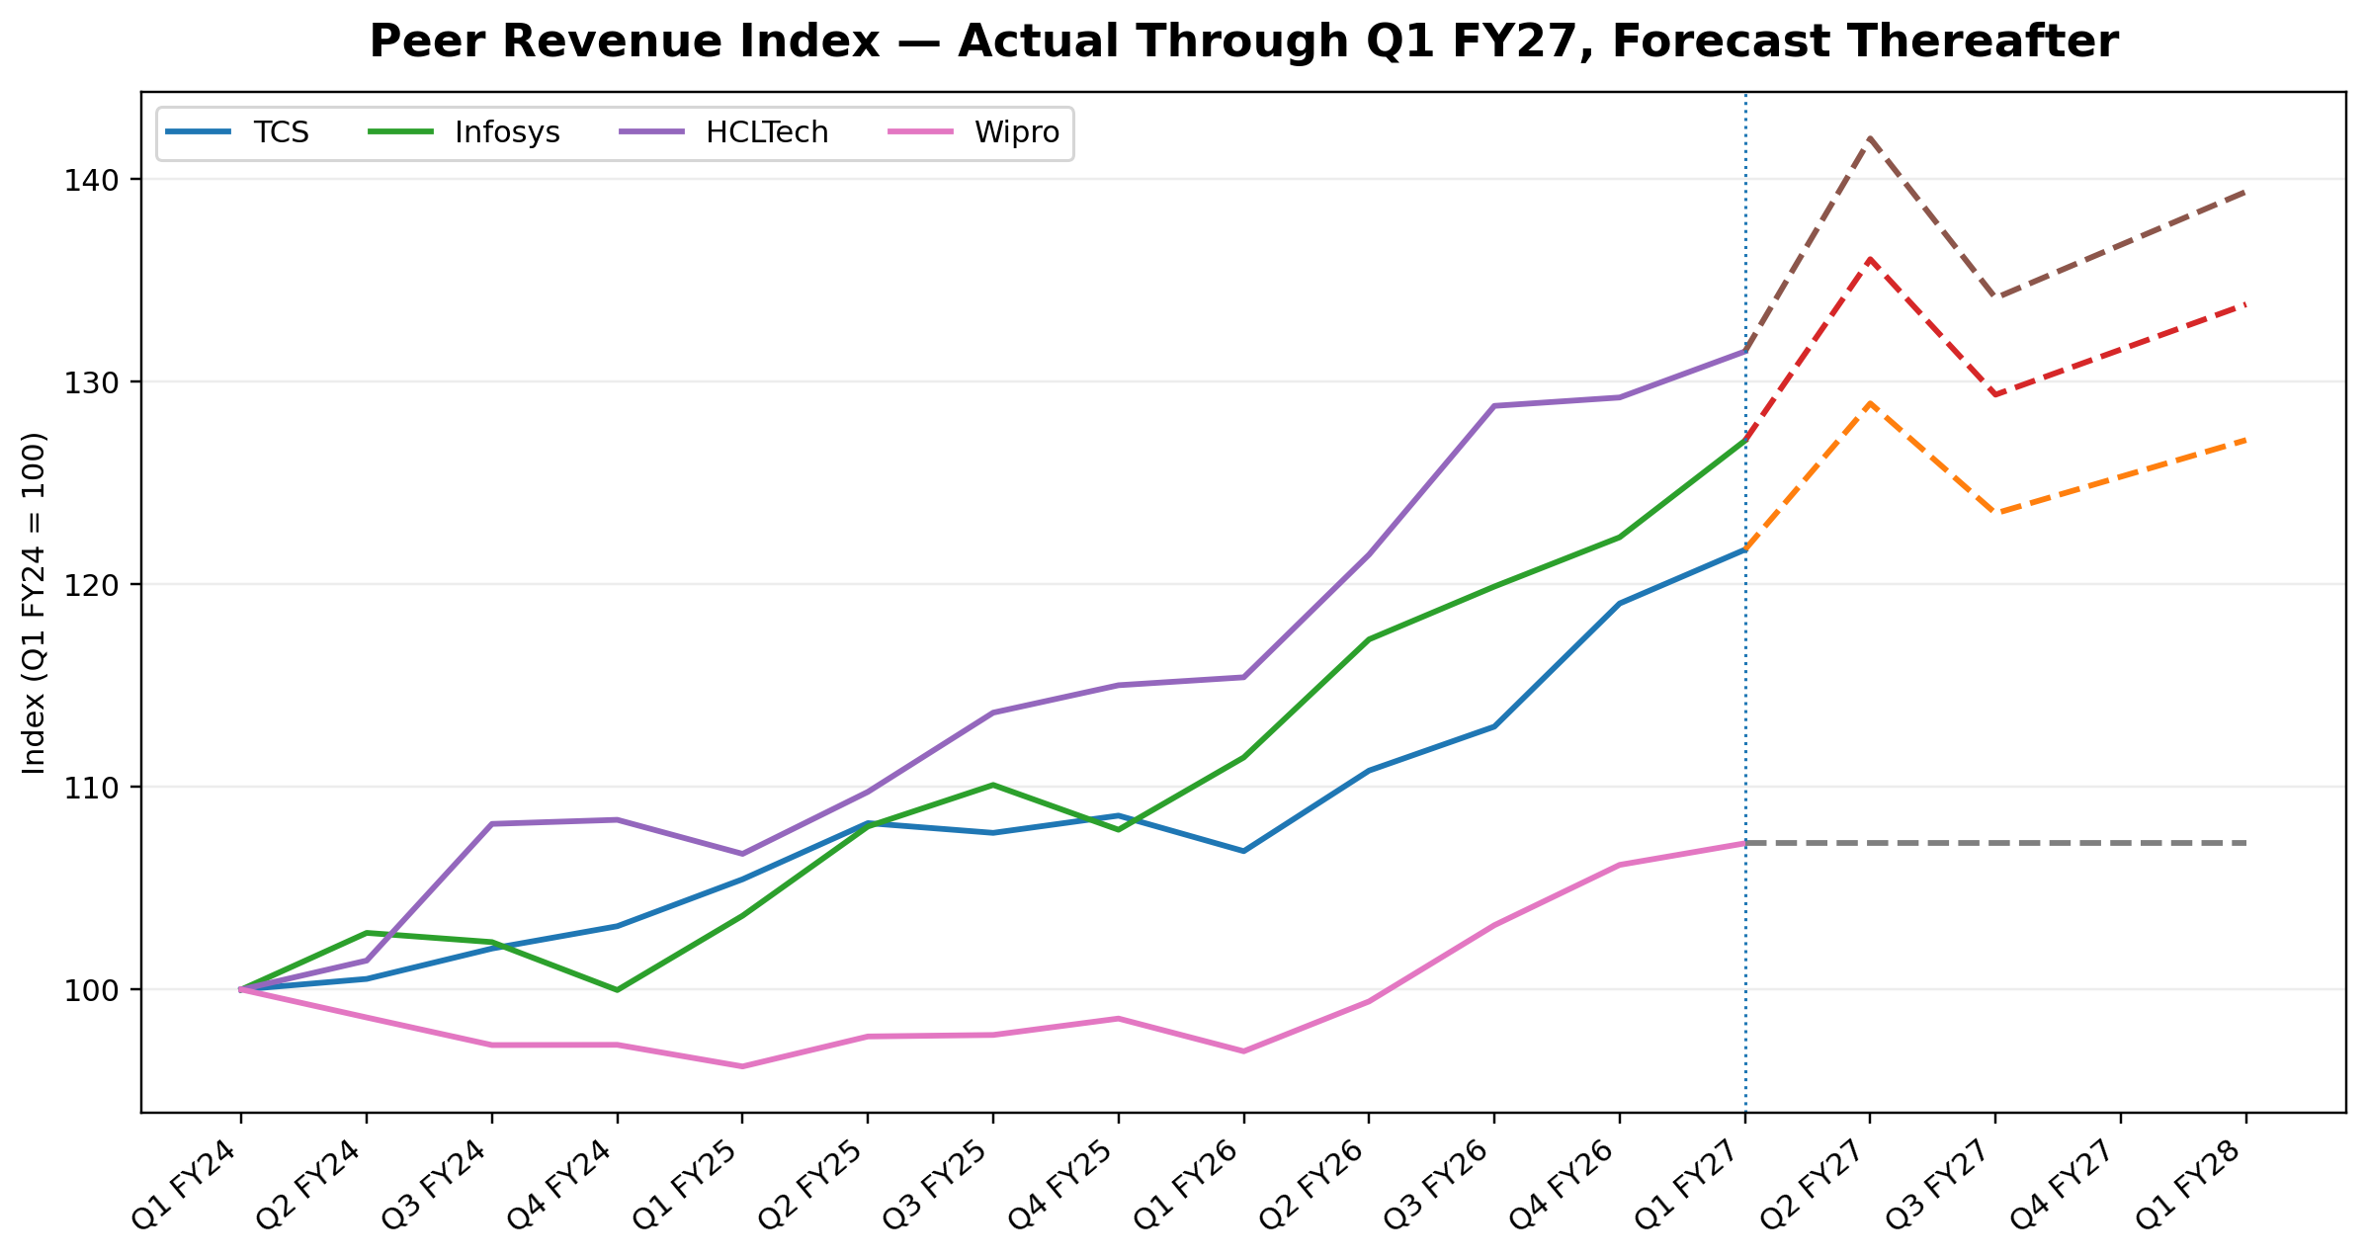
Figure 1. Actual standardized revenue through Q1 FY27; dashed lines show four-quarter model forecasts indexed to Q1 FY24 = 100.
The combined forecast view is intended to show the direction and relative scale of the model outputs, not to suggest that the four companies share identical business dynamics. Forecast paths reflect the selected model for each company and are anchored to the Q1 FY27 observation.
Company | Q2 FY27 | Q3 FY27 | Q4 FY27 | Q1 FY28
TCS | ₹73,339 | ₹74,414 | ₹75,488 | ₹76,563
Infosys | ₹49,072 | ₹49,917 | ₹50,763 | ₹51,608
HCLTech | ₹35,273 | ₹35,963 | ₹36,653 | ₹37,343
Wipro | ₹24,479 | ₹24,479 | ₹24,479 | ₹24,479

TCS — revenue forecast
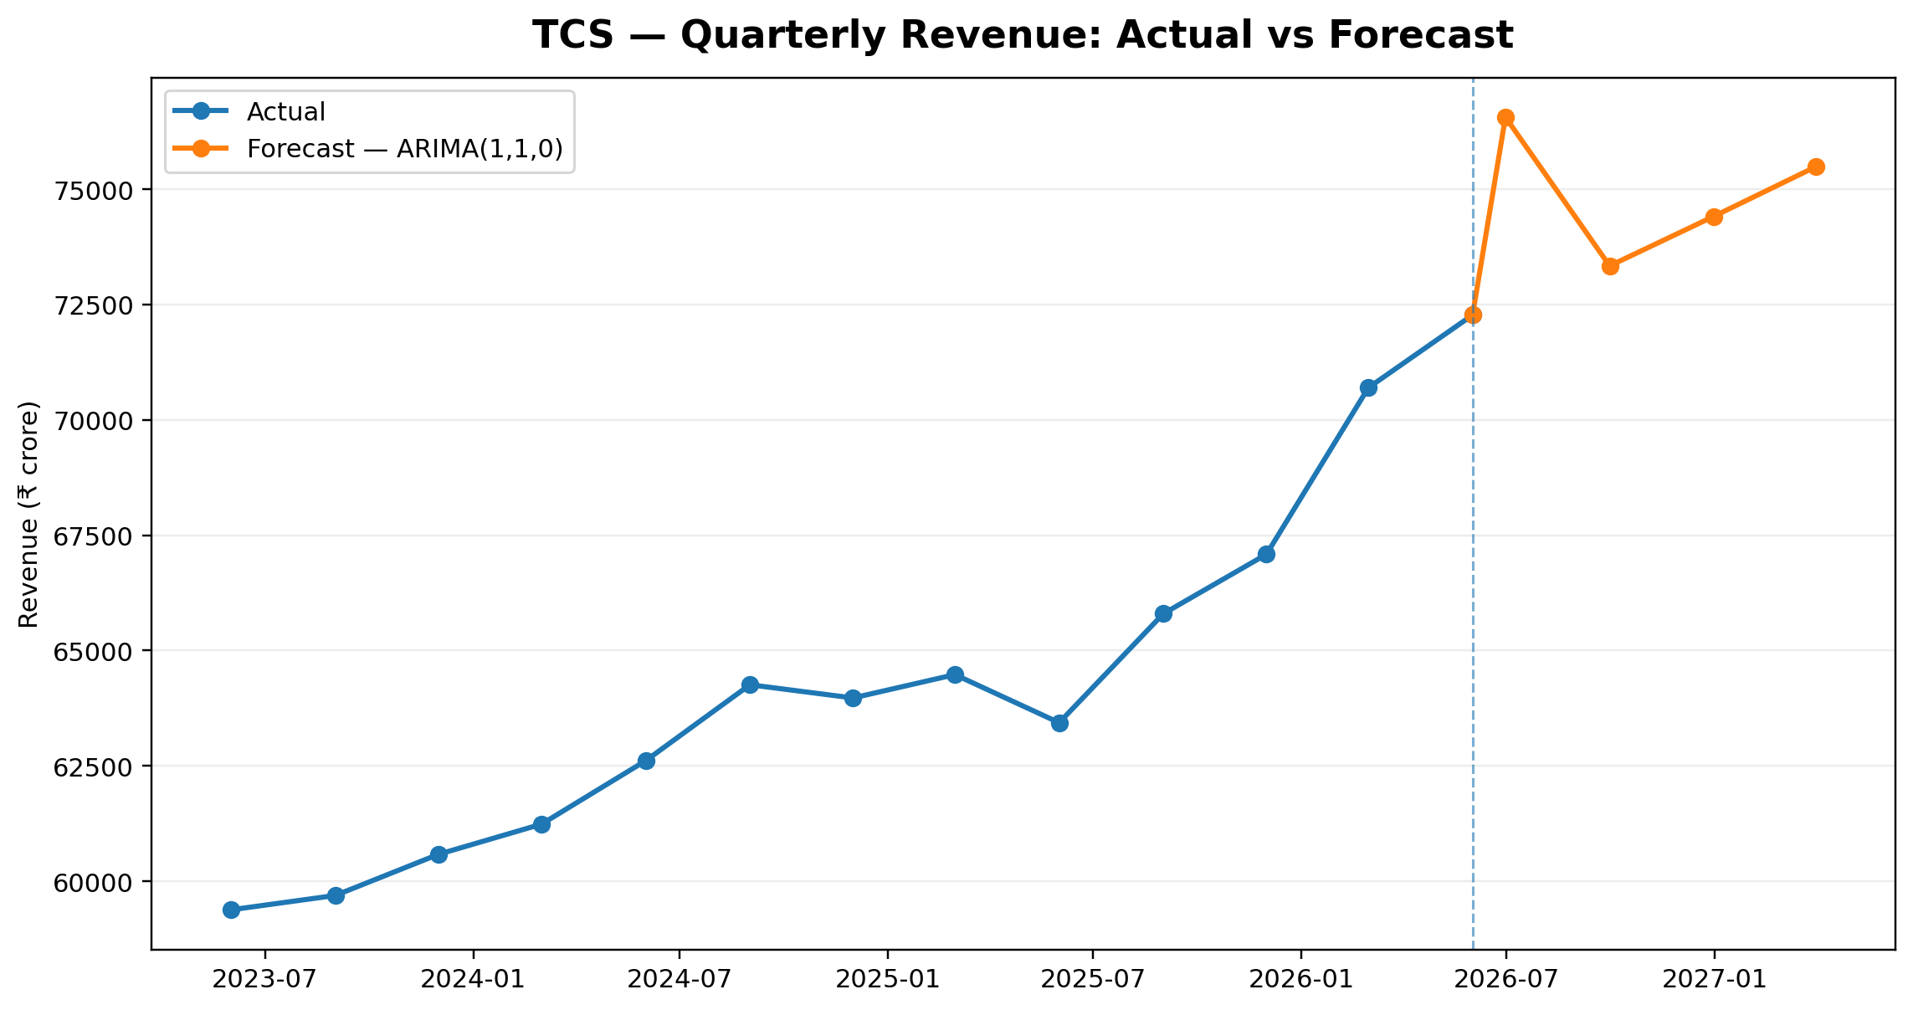
Figure. TCS revenue actuals and forecast using ARIMA(1,1,0).
The selected ARIMA(1,1,0) model projects revenue at ₹73,339 crore in Q2 FY27, ₹74,414 crore in Q3 FY27, ₹75,488 crore in Q4 FY27 and ₹76,563 crore in Q1 FY28. These are point estimates and should be read with the model-risk discussion in Section 8.

Infosys — revenue forecast
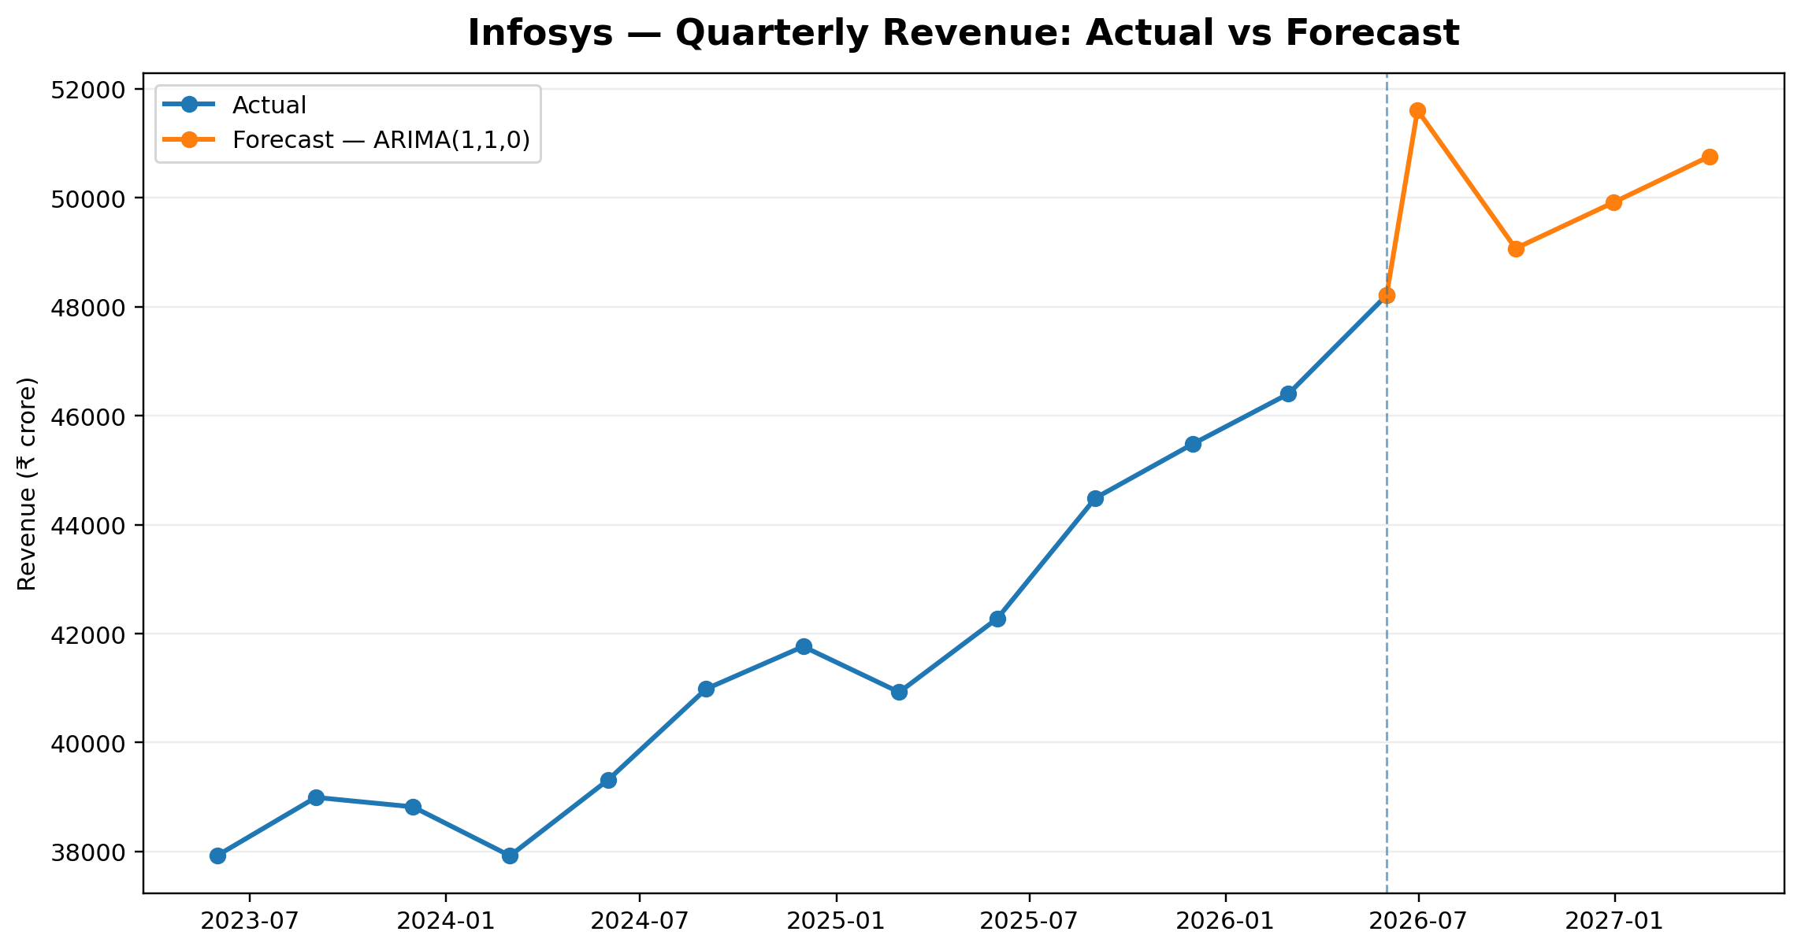
Figure. Infosys revenue actuals and forecast using ARIMA(1,1,0).
The selected ARIMA(1,1,0) model projects revenue at ₹49,072 crore in Q2 FY27, ₹49,917 crore in Q3 FY27, ₹50,763 crore in Q4 FY27 and ₹51,608 crore in Q1 FY28. These are point estimates and should be read with the model-risk discussion in Section 8.

HCLTech — revenue forecast
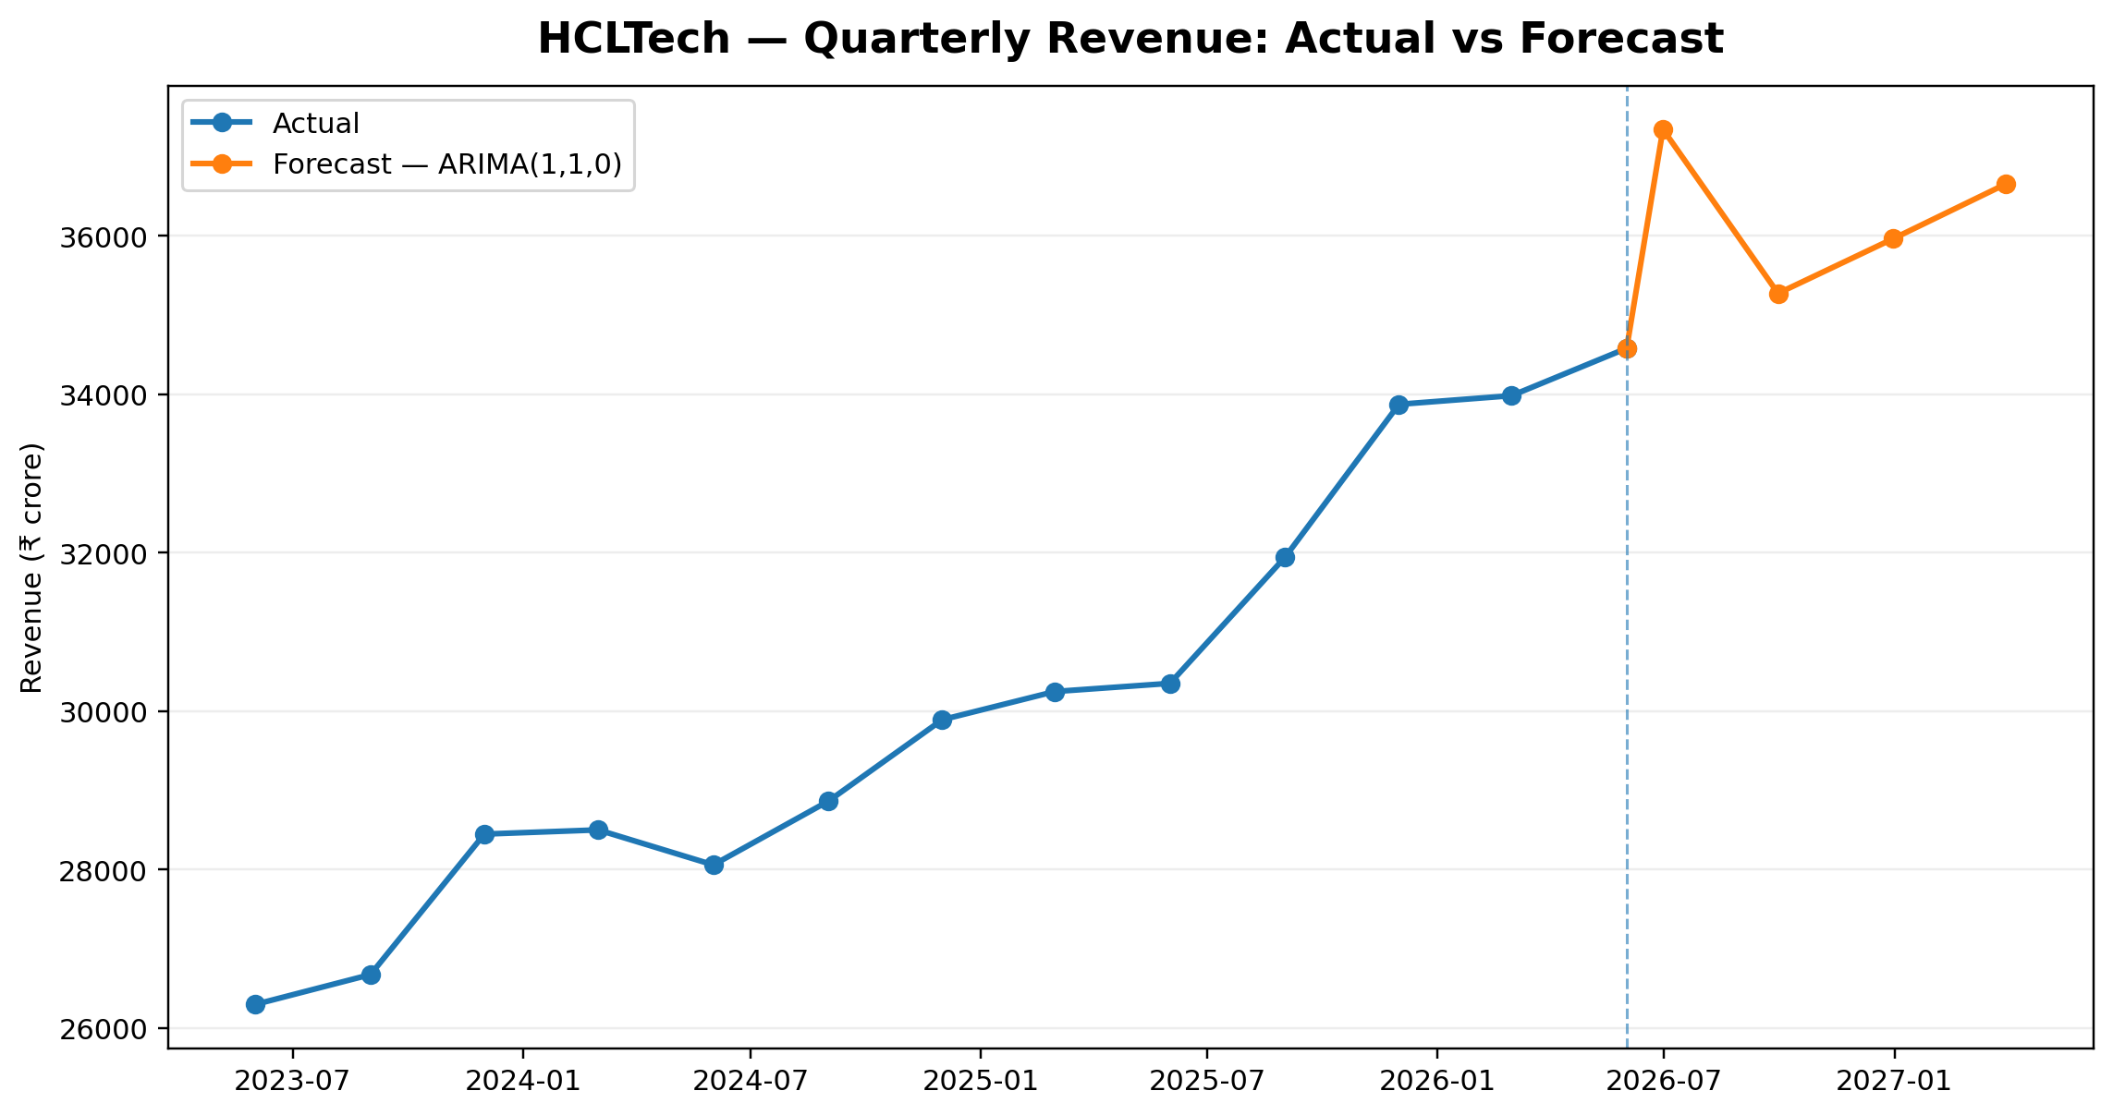
Figure. HCLTech revenue actuals and forecast using ARIMA(1,1,0).
The selected ARIMA(1,1,0) model projects revenue at ₹35,273 crore in Q2 FY27, ₹35,963 crore in Q3 FY27, ₹36,653 crore in Q4 FY27 and ₹37,343 crore in Q1 FY28. These are point estimates and should be read with the model-risk discussion in Section 8.

Wipro — revenue forecast
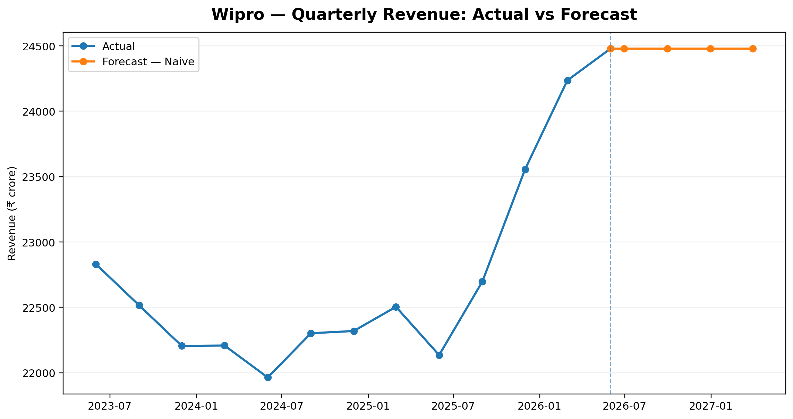
Figure. Wipro revenue actuals and forecast using Naive.
The selected Naive model projects revenue at ₹24,479 crore in Q2 FY27, ₹24,479 crore in Q3 FY27, ₹24,479 crore in Q4 FY27 and ₹24,479 crore in Q1 FY28. These are point estimates and should be read with the model-risk discussion in Section 8.

7. Operating Margin Forecasts
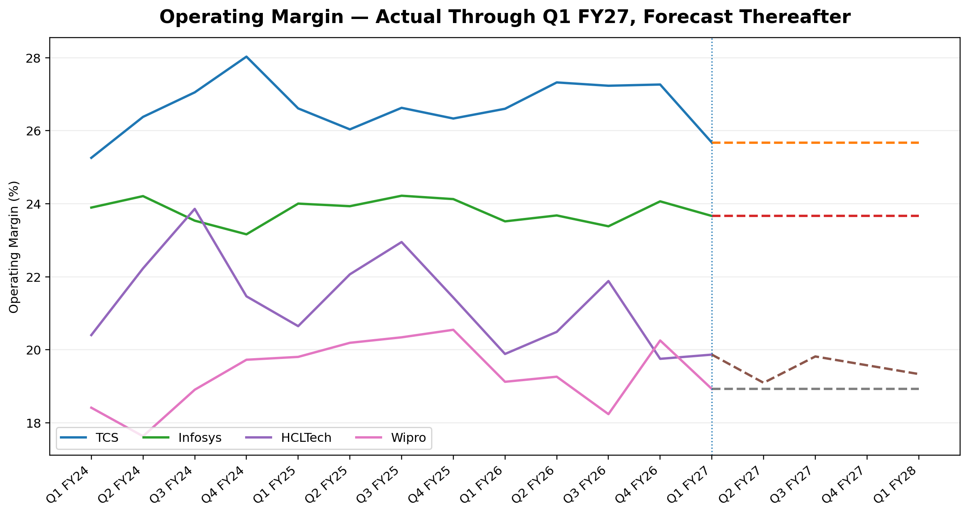
Figure 6. Standardized-panel operating margin actuals through Q1 FY27 and four-quarter model forecasts.
Company | Q2 FY27 | Q3 FY27 | Q4 FY27 | Q1 FY28
TCS | 25.67% | 25.67% | 25.67% | 25.67%
Infosys | 23.66% | 23.66% | 23.66% | 23.66%
HCLTech | 19.82% | 19.58% | 19.34% | 19.10%
Wipro | 18.93% | 18.93% | 18.93% | 18.93%
- TCS: selected margin model = Naive; forecast path = 25.67%, 25.67%, 25.67%, 25.67%.
- Infosys: selected margin model = Naive; forecast path = 23.66%, 23.66%, 23.66%, 23.66%.
- HCLTech: selected margin model = AutoReg(1); forecast path = 19.82%, 19.58%, 19.34%, 19.10%.
- Wipro: selected margin model = Naive; forecast path = 18.93%, 18.93%, 18.93%, 18.93%.
Margin forecasts are intentionally separated from current issuer-defined Q1 FY27 margin disclosures. The historical series is based on the Week 2 standardized operating-profit calculation. This prevents the forecast model from silently changing the dependent variable definition at the forecast boundary.
Margin-specific limitation
Operating margin is more vulnerable than revenue to one-off restructuring, wage revisions, utilization swings, pricing actions, acquisitions and exceptional items. A point forecast should therefore be treated as a central statistical path, not a guaranteed operating outcome.

8. Model Diagnostics, Strengths, Weaknesses and Improvements
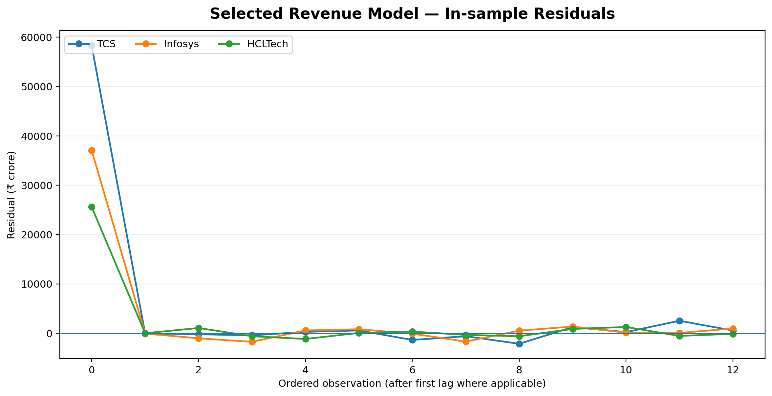
Figure 7. In-sample residuals for the selected revenue models. Residuals are shown only as a diagnostic, not as an assertion of randomness.

8.1 Strengths
- Time-order integrity is maintained from training through final forecasting.
- Model complexity is matched to the short quarterly sample.
- The naive benchmark makes incremental value from model structure visible.
- Forecast error is measured on unseen quarters rather than only in-sample.
- The workflow is reproducible in Python and tied directly to the Week 2 cleaned dataset.

8.2 Weaknesses
- Only 13 observations are available per company, limiting statistical power and the ability to detect stable seasonality.
- Univariate models cannot explicitly explain FX, demand, TCV, AI adoption, attrition, headcount or macroeconomic changes.
- A single three-quarter holdout is still a small validation sample and can make model selection sensitive to a few observations.
- Structural breaks can invalidate patterns learned from earlier quarters.
- The operating-margin target is a standardized analytical metric and does not perfectly match every issuer’s current reporting definition.

8.3 Recommended improvements
- Extend the dataset to additional quarters as they become available and repeat rolling-origin validation.
- Add exogenous variables with consistent definitions: constant-currency growth, TCV/bookings, headcount, attrition, wage inflation and FX.
- Test forecast combinations rather than relying on a single model.
- Introduce scenario analysis around FX, demand and margin assumptions.
- Compare against analyst consensus or issuer guidance only after ensuring date-consistent information sets and source traceability.

9. Forecast Risk Register and Critical Evaluation
Risk | Materiality | Potential effect | Mitigation
Short history | High | Model instability / wide uncertainty | Expand history; rolling validation
FX distortion | High | INR revenue may diverge from underlying demand | Add CC metrics and FX scenario
Contract timing | High | Large deal wins/losses can create step changes | Add TCV/bookings features
Margin shocks | High | Wage/restructuring/utilization changes can break trend | Model cost drivers and scenarios
Reporting basis | Medium | Comparability can change across firms | Lock target definition and source basis
Look-ahead leakage | High | Artificially optimistic validation | Enforce Q1 FY27 cutoff
Overfitting | High | Good historical fit but poor future performance | Prefer low-parameter models; hold out data
Model drift | Medium | Relationships may change after AI-led service shifts | Re-estimate regularly and monitor errors

9.1 Critical evaluation
The exercise demonstrates that a forecast can be technically reproducible without being inherently reliable. The strongest control is not model sophistication; it is a disciplined information set and a validation process that mimics the way the forecast would have been produced at the time. The next development stage should therefore focus on expanding the evidence base and adding economically meaningful predictors before increasing algorithmic complexity.
Analyst conclusion
The current models are suitable as transparent short-horizon baselines. Their main value is establishing a measurable starting point for future forecasting iterations, not eliminating uncertainty.

10. References and Reproducibility
Methodology references used for the literature-review section and implementation choices:
Hyndman, R. J. & Athanasopoulos, G. — Forecasting: Principles and Practice (3rd ed. online) — https://otexts.com/fpp3/
Hyndman & Athanasopoulos — Chapter 7: Exponential Smoothing — https://otexts.com/fpp2/expsmooth.html
Hyndman & Athanasopoulos — Chapter 9: ARIMA Models — https://otexts.com/fpp3/arima.html
statsmodels — AutoReg documentation — https://www.statsmodels.org/stable/generated/statsmodels.tsa.ar_model.AutoReg.html
statsmodels — Holt documentation — https://www.statsmodels.org/stable/generated/statsmodels.tsa.holtwinters.Holt.html
statsmodels — Exponential Smoothing documentation — https://www.statsmodels.org/stable/examples/notebooks/generated/exponential_smoothing.html
scikit-learn — TimeSeriesSplit documentation — https://scikit-learn.org/stable/modules/generated/sklearn.model_selection.TimeSeriesSplit.html

10.1 Reproducible project files
- src/week4_forecasting.py — reproducible model comparison and forecasting script.
- notebooks/week4_forecasting.ipynb — interactive modelling notebook.
- data/model_outputs/model_selection_validation.csv — all candidate validation results.
- data/model_outputs/selected_model_summary.csv — selected models and error metrics.
- data/model_outputs/forecast_outputs.csv — four-quarter point forecasts.
- reports/week4/figures/ — forecast charts and diagnostics.
- reports/week4/tables/ — forecast and model-selection tables.
- reports/week4/portal_description.txt — 200+ word submission description.
Disclaimer
Educational internship simulation using public financial data. Not investment advice. Forecasts are model outputs subject to data, specification and structural-break risk.

