Q1.Create a Database?

Create DataBase Company;

Q2.Create a table?

CREATE TABLE Employee(
emp_id int,
emp_name varchar(20),
phoneno int,
email_id varchar(25),
address varchar(30)
);

Q3.Perform CRUD operation?

1.Query to insert the values to the table.

INSERT INTO Employee VALUES(201801,'Gouri',965425423,'gouri@gmail.com','Belagavi');

INSERT INTO Employee VALUES(201802,'Sneha',965425424,'sneha@gmail.com','Belagavi');

INSERT INTO Employee VALUES(201803,'Suma',965425425,'suma@gmail.com','Dharwad');

INSERT INTO Employee VALUES(201804,'Rohit',965425426,'rohit@gmail.com','Banglore');

INSERT INTO Employee VALUES(201805,'Rohan',965425427,'rohan@gmail.com','Manglore');

INSERT INTO Employee VALUES(201806,'Rashmi',965625428,'rashmi@gmail.com','Mysore');

INSERT INTO Employee VALUES(201807,'pari',965622428,'pari@gmail.com','Hubli');

INSERT INTO Employee VALUES(201808,'Madhu',876622428,'madhu@gmail.com','Gokak');

INSERT INTO Employee VALUES(201809,'Gautam',876622654,'gautum@gmail.com','Manipal');

INSERT INTO Employee VALUES(201810,'Sana',876622876,'sana@gmail.com','Vijapur');

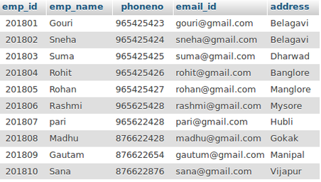

2.Query to delete the particular row from table.

DELETE from Employee WHERE emp_name='Sneha';

DELETE from Employee WHERE emp_id=201808;

DELETE from Employee WHERE address='Manipal';

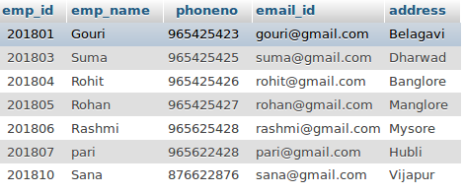

3.Query to read the data from table.

SELECT * FROM Employee WHERE address='Hubli';

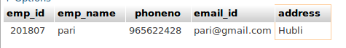

4.SQL Aliases.

SELECT emp_id as id,emp_name as name FROM Employee;

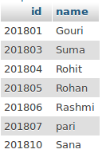

5.SQL Wildcard (% to compare zero or more charecters).

SELECT * FROM Employee WHERE address LIKE '%Vij';

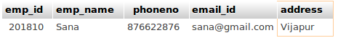

6.Query to Update the table.

UPDATE Employee SET emp_name='Meghan' WHERE emp_id=201810;

One row updated.

