**PERCENTILE**

**Overall report analysis:**

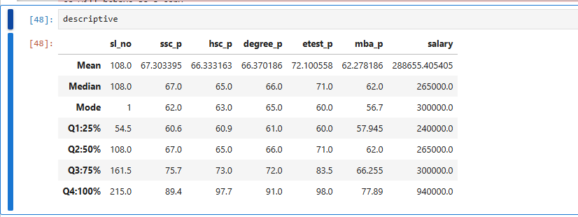

**Interpretation and Insights:**

1. **Academic Performance Insights:**
   * **SSC and HSC Percentiles:**  
     The academic scores, especially for SSC and HSC, show a good spread, with the majority of individuals falling between 60% and 75% in HSC, and a slightly lower spread in SSC. However, there are some anomalies in the dataset where values exceed 100%, particularly for SSC, which suggests data quality issues.
   * **Degree Percentiles:**  
     Degree scores generally increase as we move up the percentiles, with most individuals scoring between 60% and 73%. The top 25% achieved above 73%, with a few outliers reaching up to 97.7%.
   * **E-test Percentiles:**  
     E-test scores show a clearer pattern with the top 25% scoring above 72%, and the highest achieving individuals scoring around 91%.
   * **MBA Percentiles:**  
     The MBA scores show a more significant range, with 75% of individuals scoring below 83.5%, and the top achievers scoring close to 98%.
2. **Salary Distribution:**
   * + The **25th percentile** shows a salary of 240,000, indicating that 25% of individuals earn less than this amount.
     + The **50th percentile (Median)** salary is 265,000, implying that half the dataset earns less than this figure.
     + The **75th percentile** salary is 300,000, meaning 75% of individuals earn less than 300,000.
     + A **significant jump** is observed at the 100th percentile, where the highest salary recorded is 940,000. This suggests that there may be high-paying outliers or top earners in this dataset.