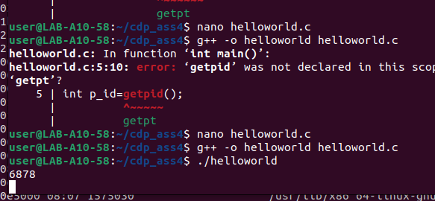
Q1.

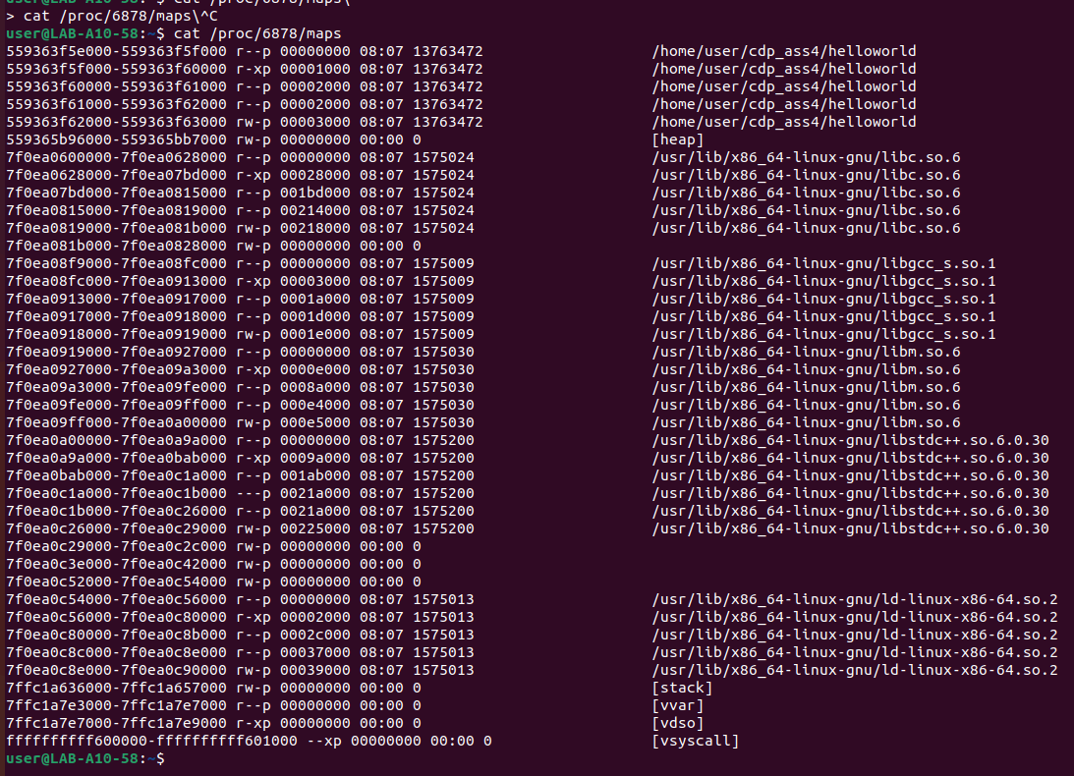
<address start>-<address end> <mode> <offset> <major id:minor id> <inode id> <file path>
559b8c418000-559b8c41a000 r--p 00000000 08:30 1708 /usr/bin/cat

Q2.
a)
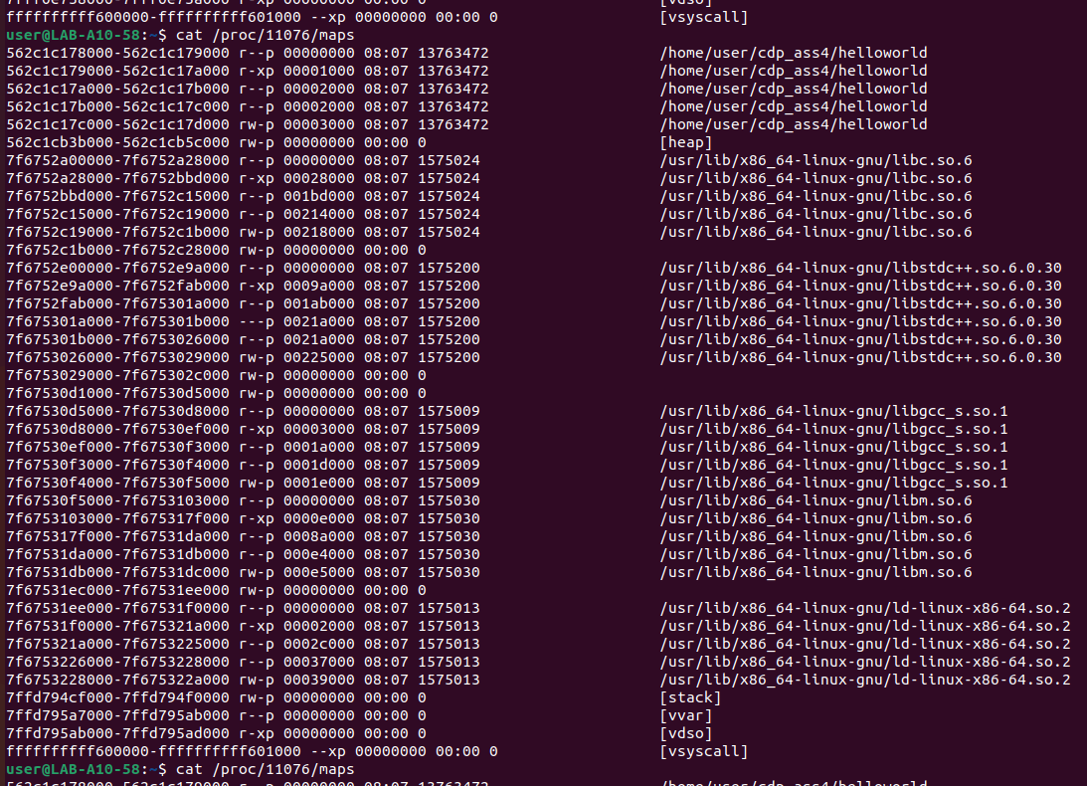

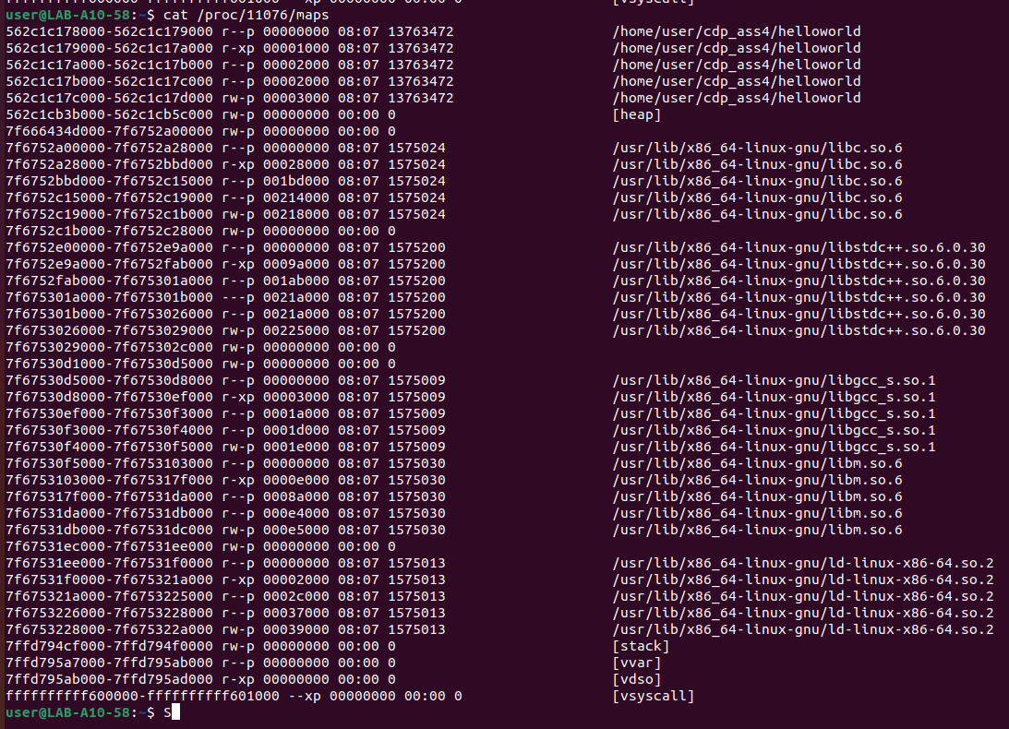

b)
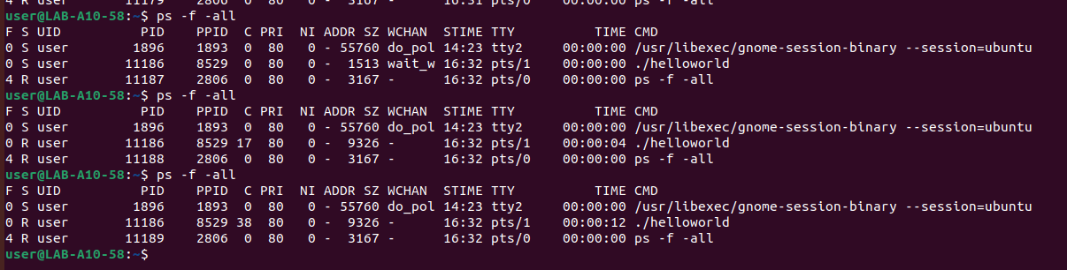
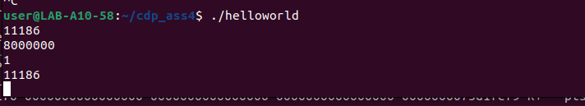
gdhmv,j.k
kjjk

