Assignment 5

B21140

Swarnarup Bhunia

Q1.

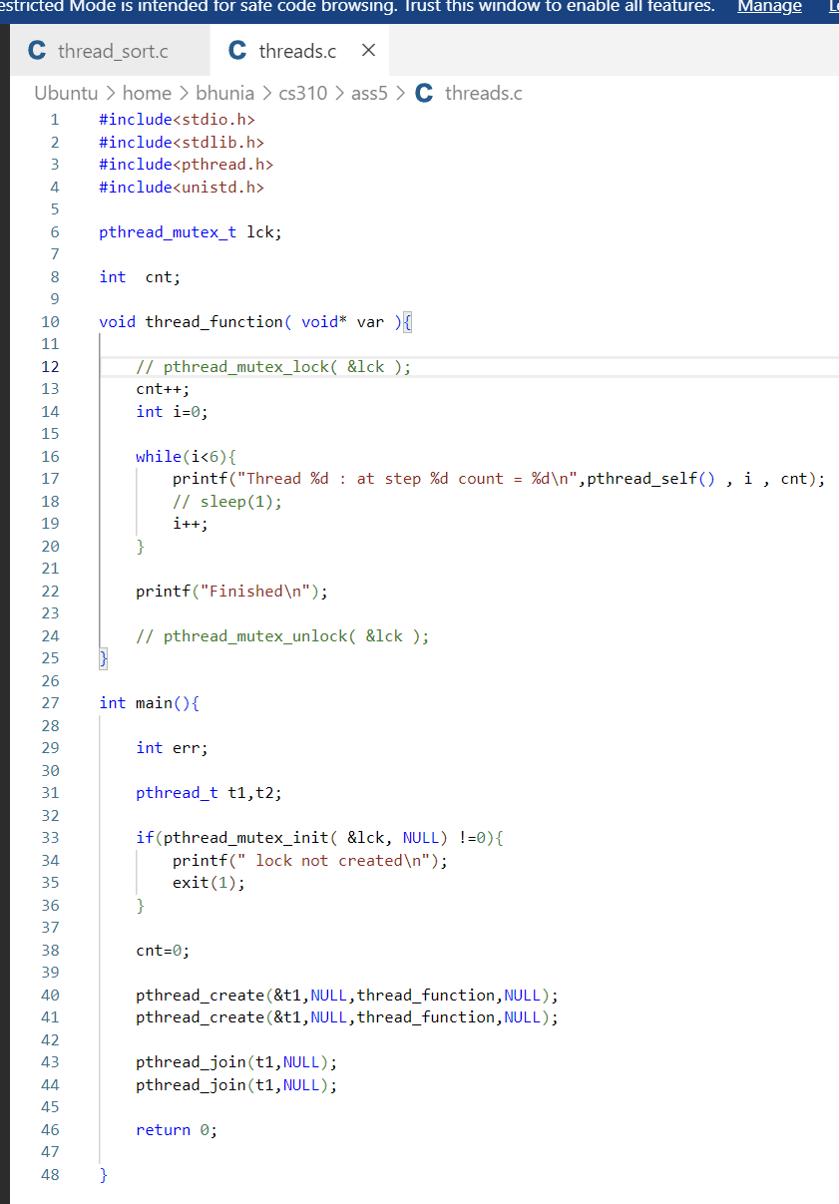

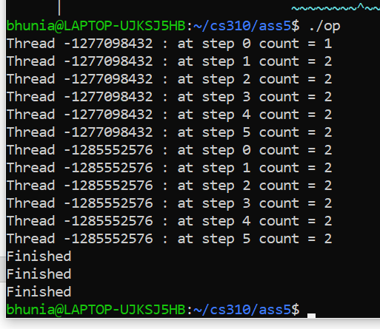

Q2.

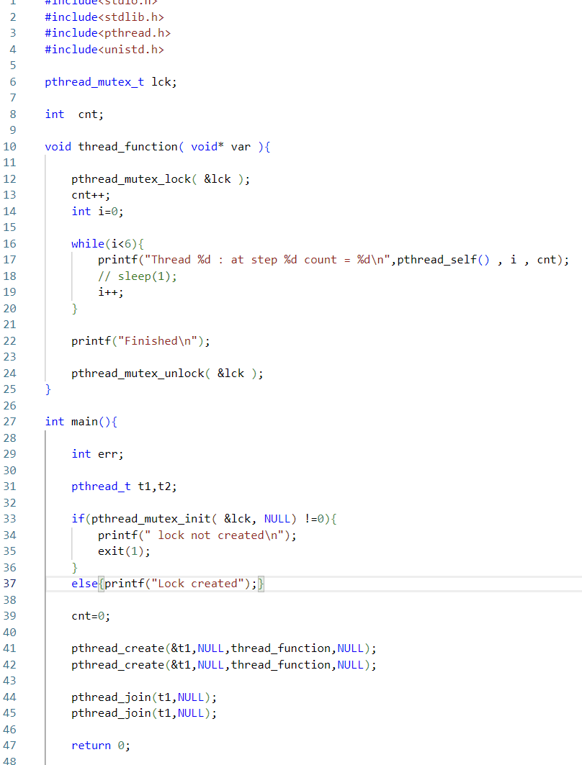

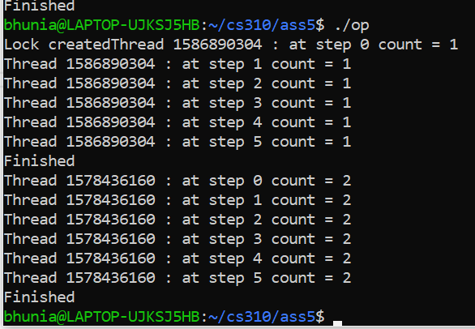

Q3.

Estimating how much time it’s taking to complete first iteration of all the threads; i.e n number of threads sorting 1^8/n size buckets and printing how much time it’s taking to do this.

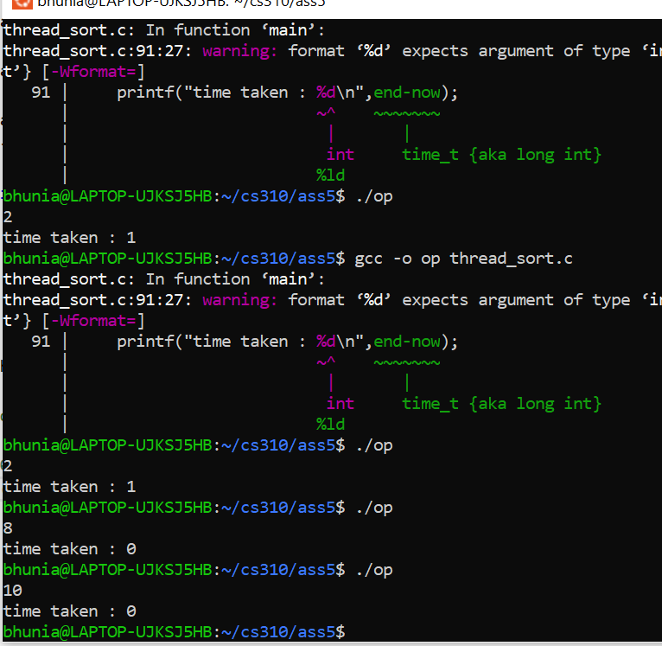

For number of threads 8 or 10 it’s instantaneous and threads number 2 it’s taking a second.