CDP Assignment 6: Socket programming

B21140 Swarnarup Bhunia

Q1.

Ip address: 10.0.2.15

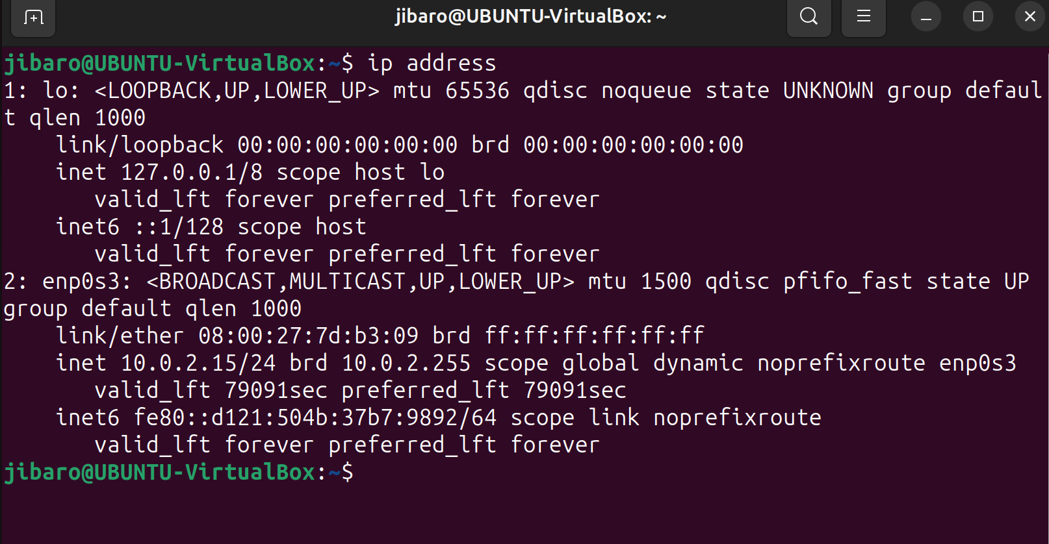

Default gateway: 10.0.2.2

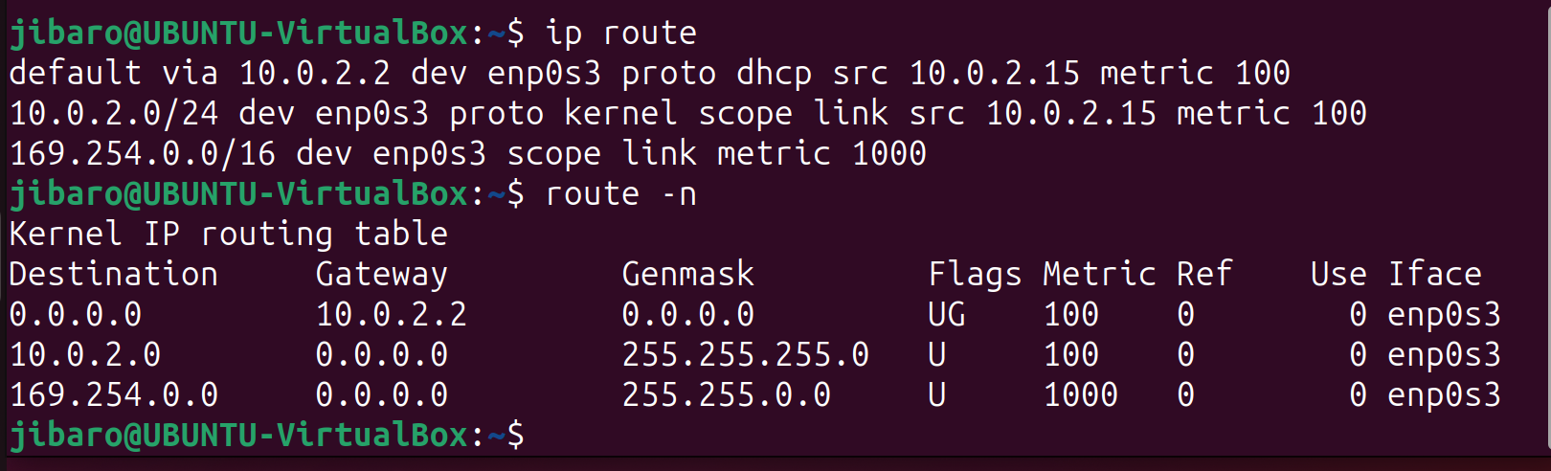

DNS of computer: 10.7.0.1

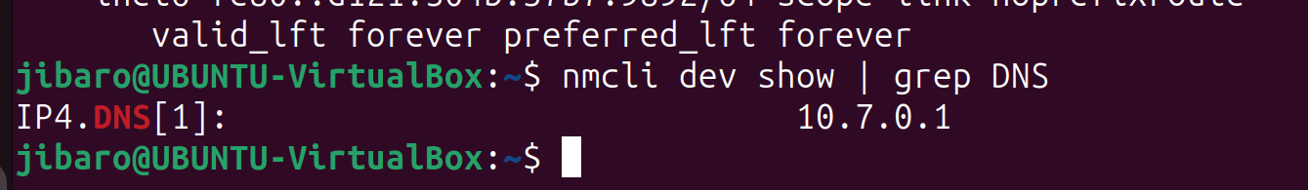

Q3.

Running the server on ubuntu Windows app with ip : 192.168.56.1 and running the client on virtual machine ubuntu.

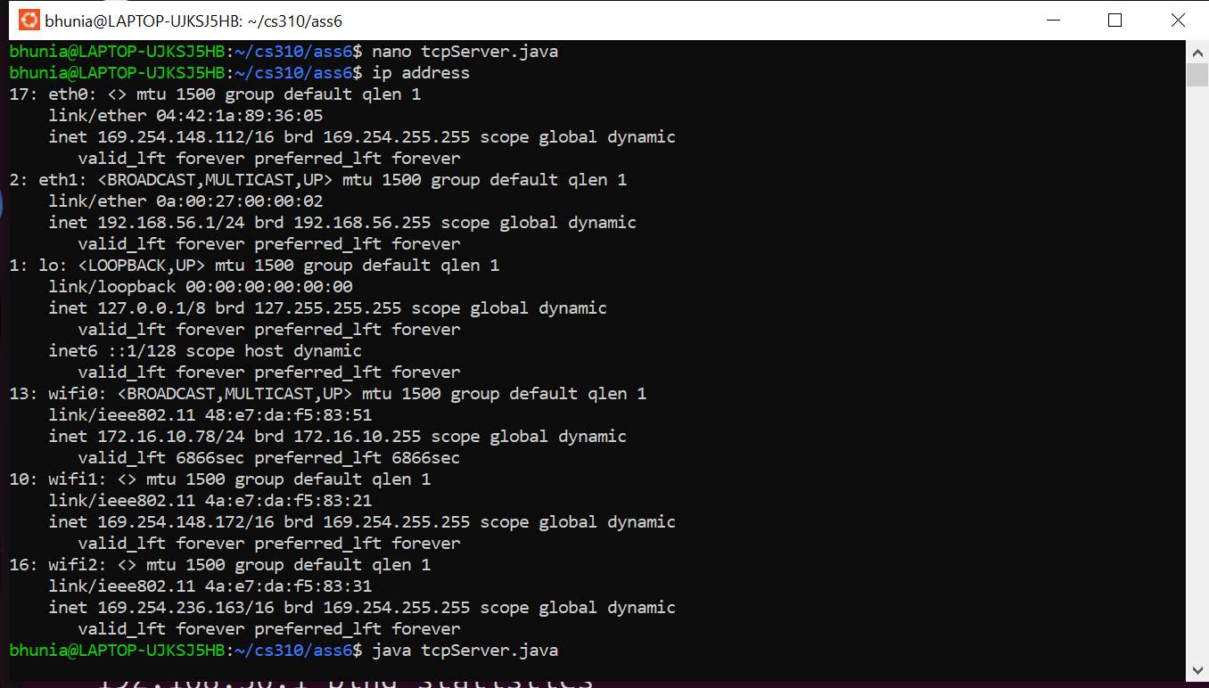

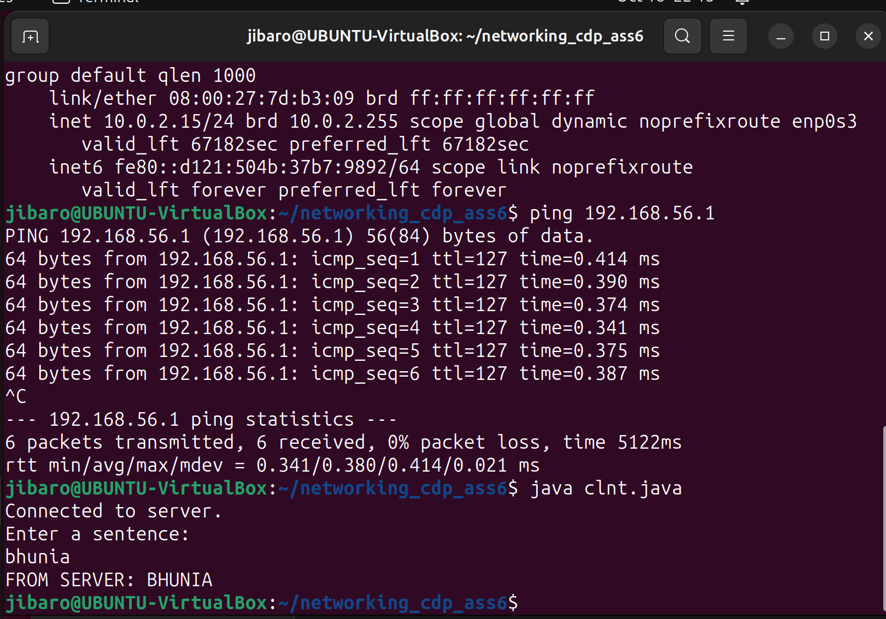

Q4.

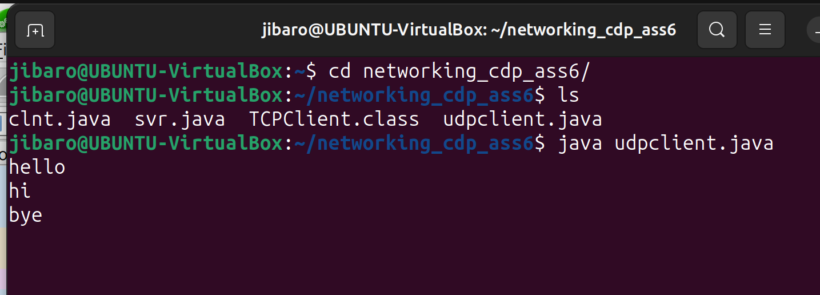

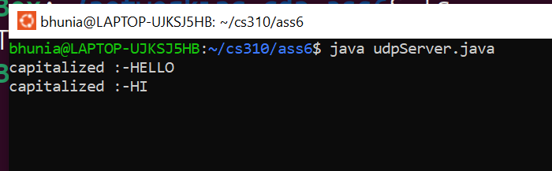

Q5.

TCP request :

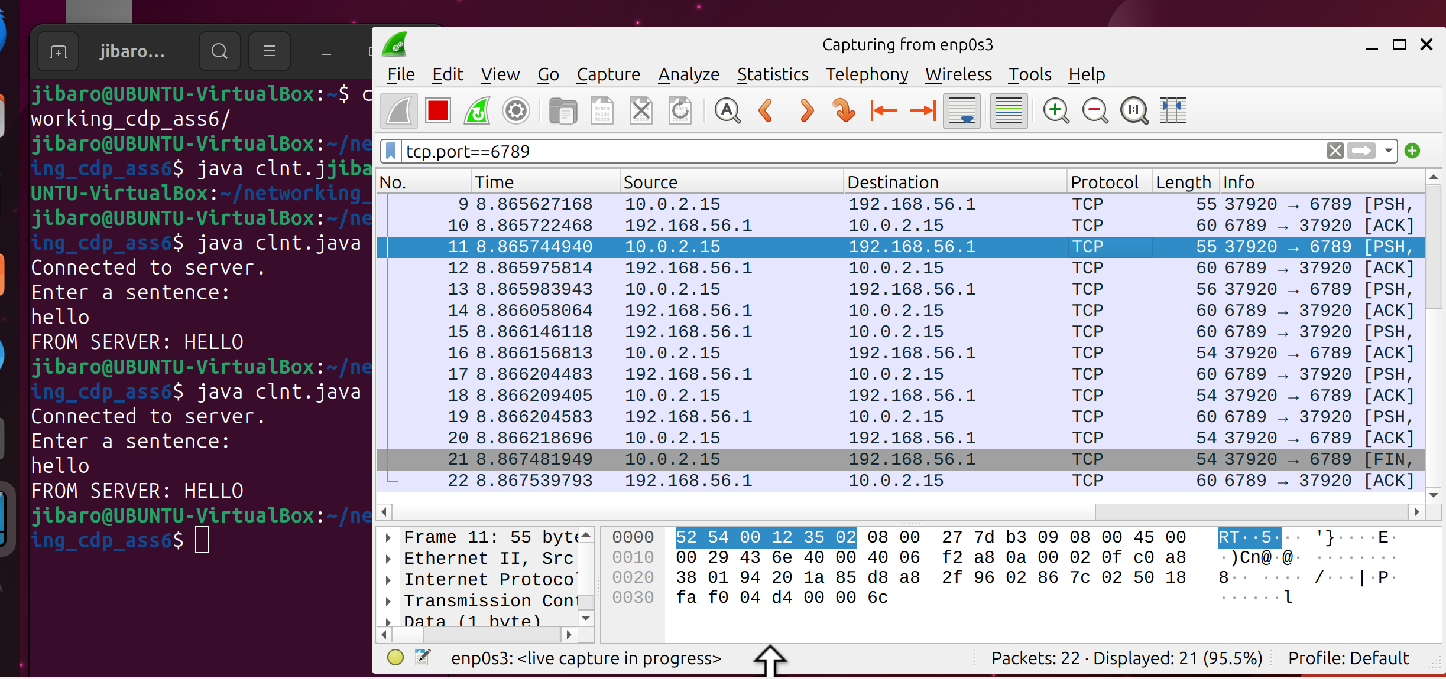

UDP request :

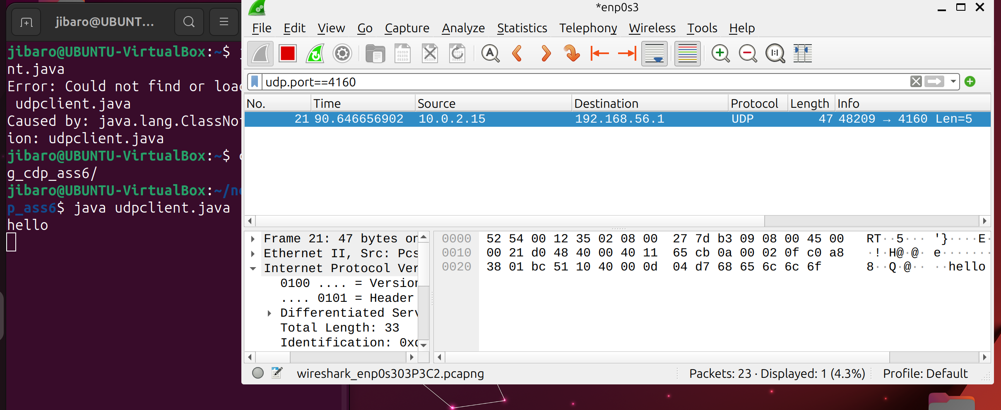

Q6. Cant know which files are hosted.

Q7.

Using wget command :

wget http://10.8.53.93/alloy/city.jpg

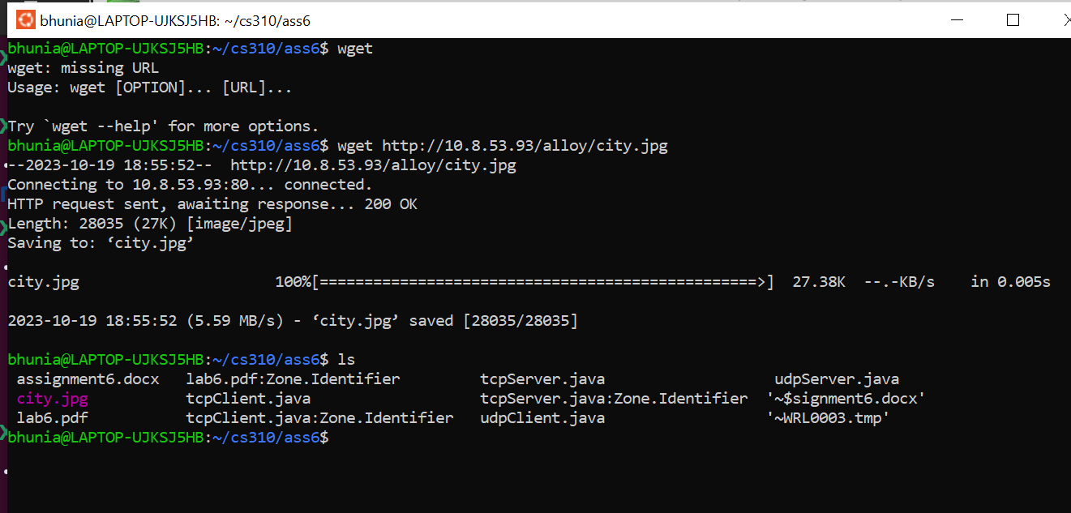

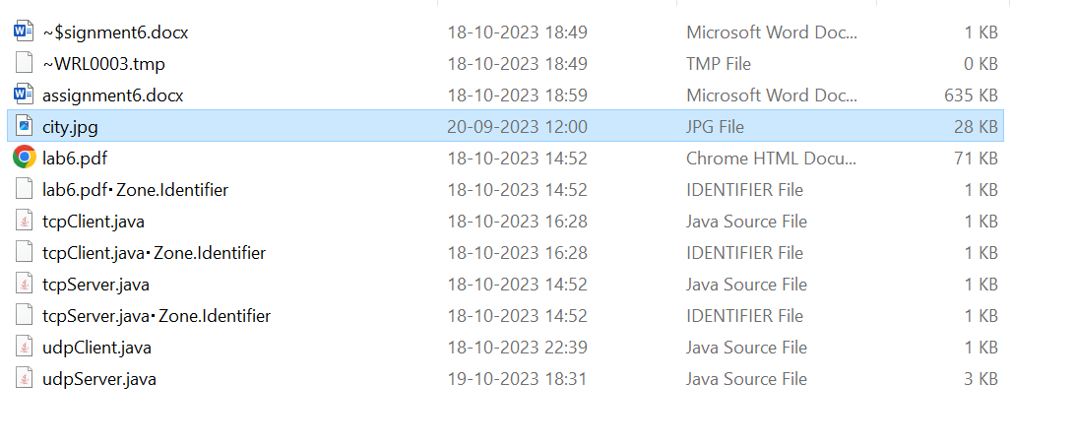

Q8.

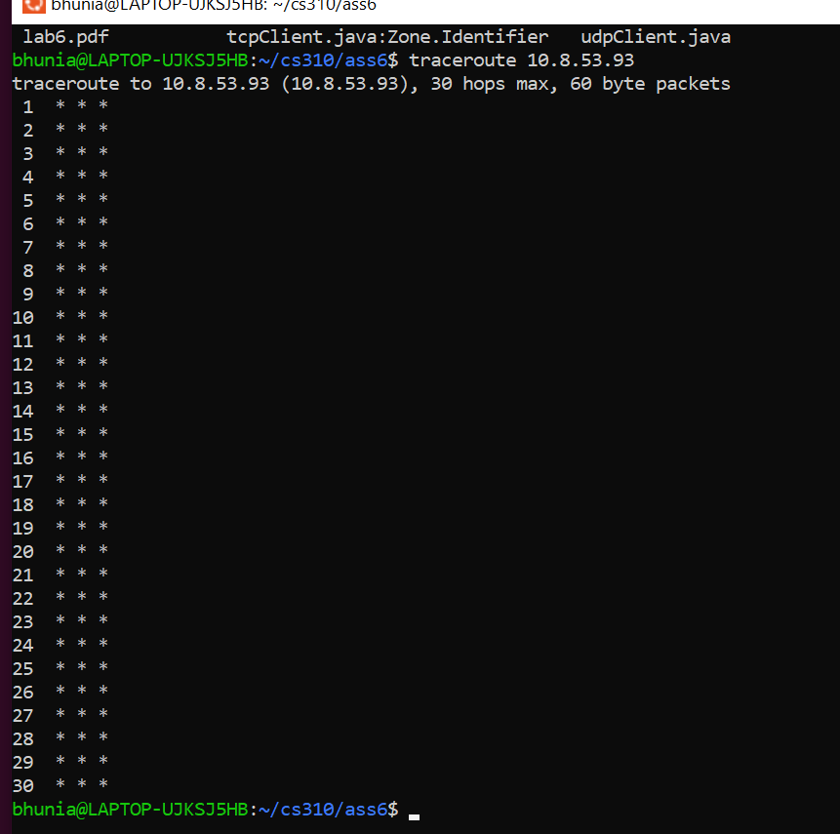

Q9.

After connecting to mobile hotspot, we are able to access the webpage and city.jpg.

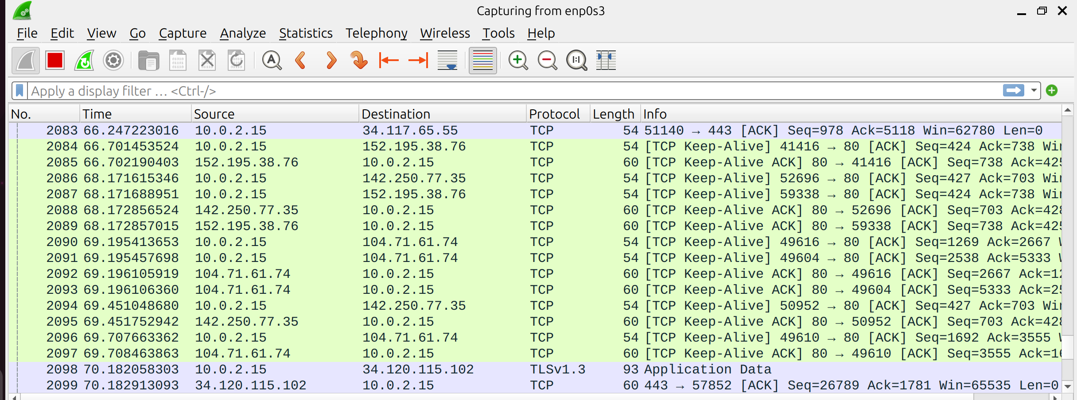

In these requests in destination or in source there is no ip of 10.8.53.93.

Most probably the web page content is cached somewhere in some server which is in-between the service provider of phone’s internet and rpi.

Q10.

dig +trace traces the DNS lookup path.

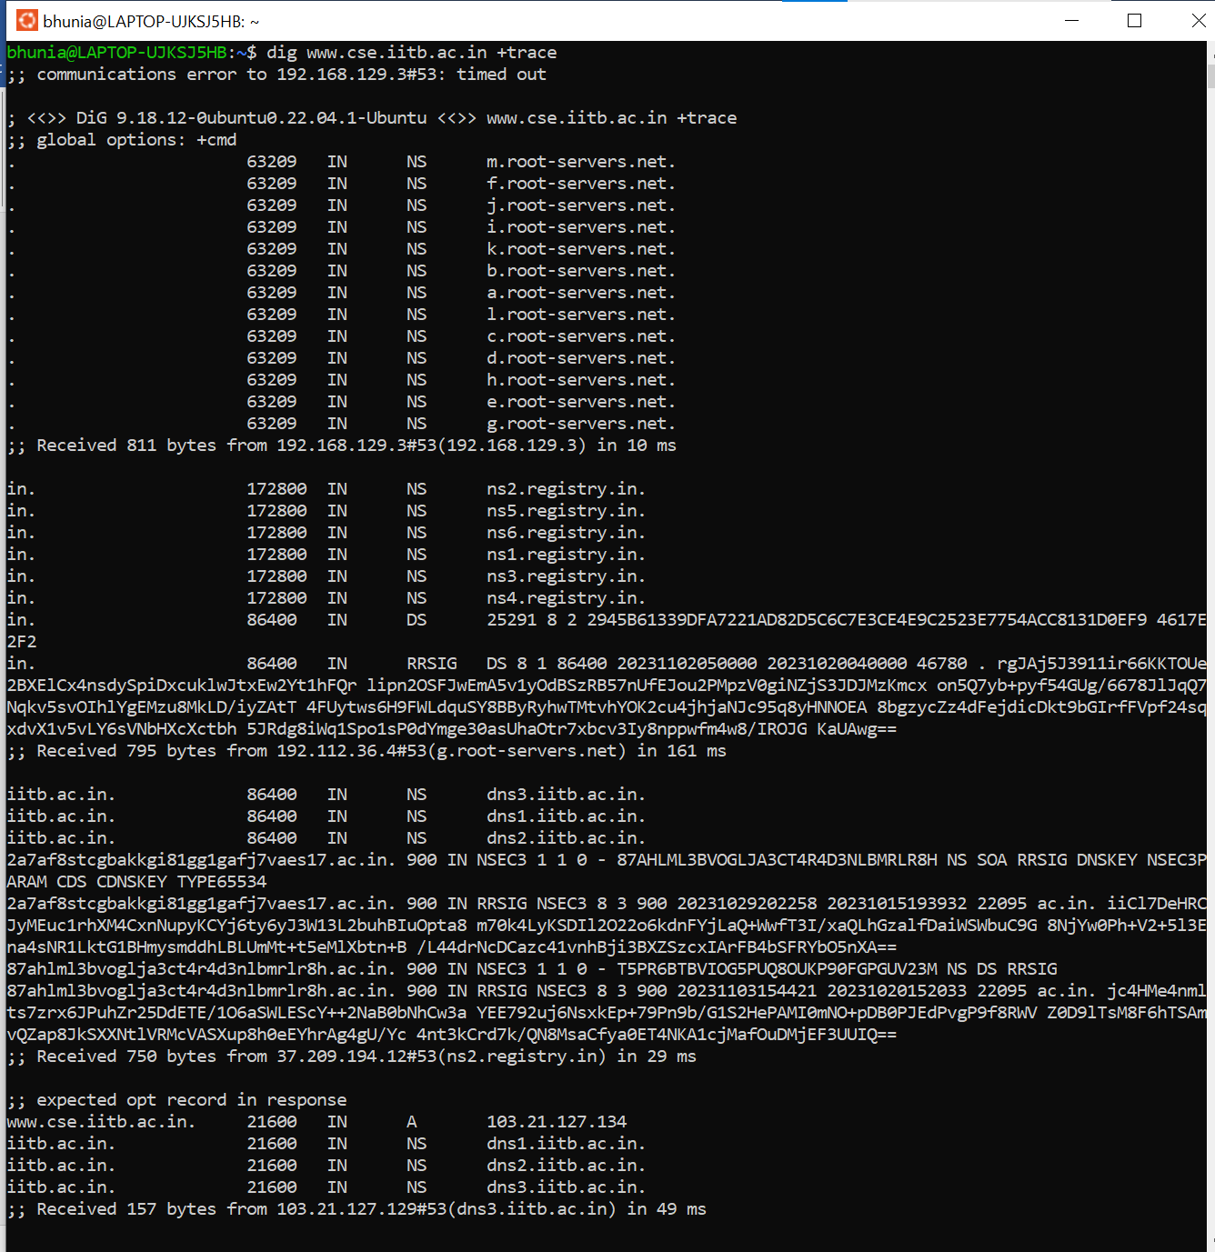

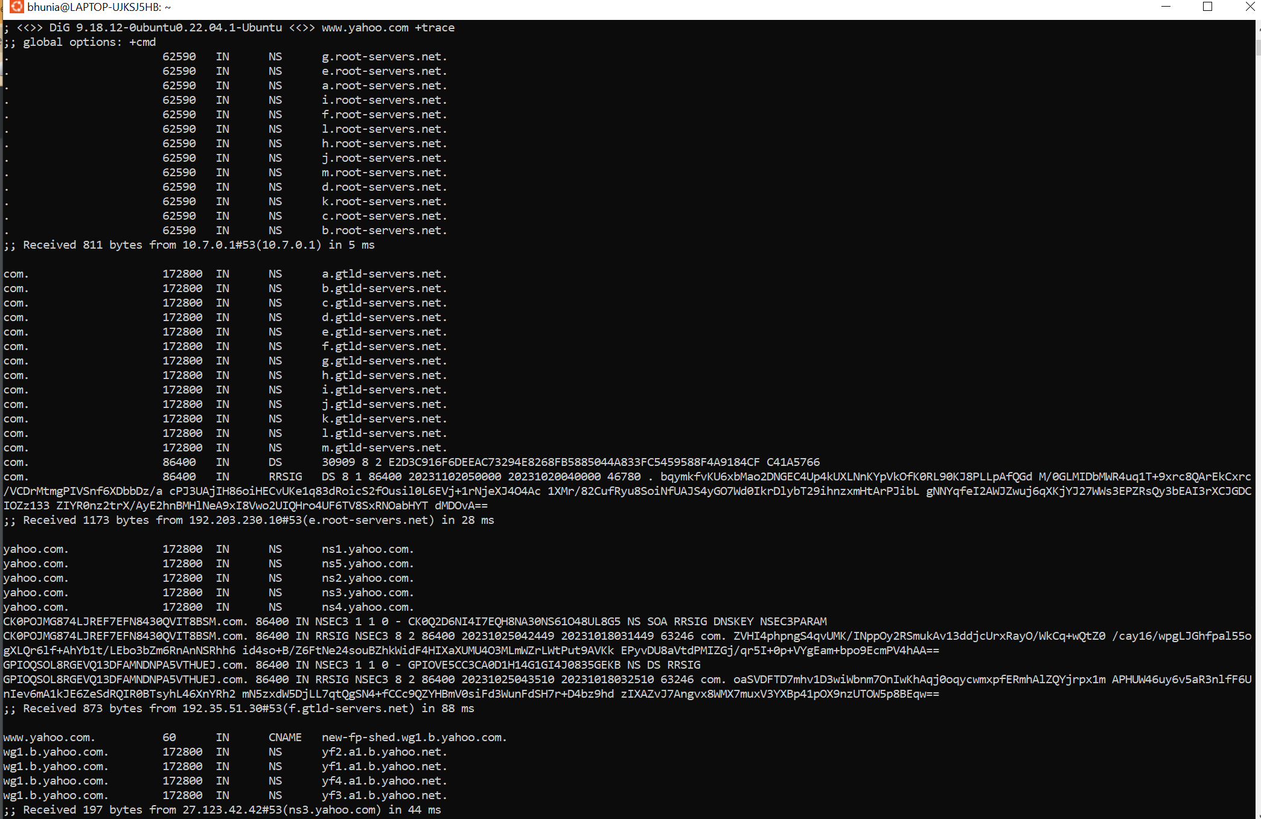

+trace goes to the root server and requests for nameservers, i.e it goes to .in domain then iitb.ac.in subdomain.

Similarly for yahoo it goes to .com then yahoo.com then wg1.b.yahoo.com

Q11.

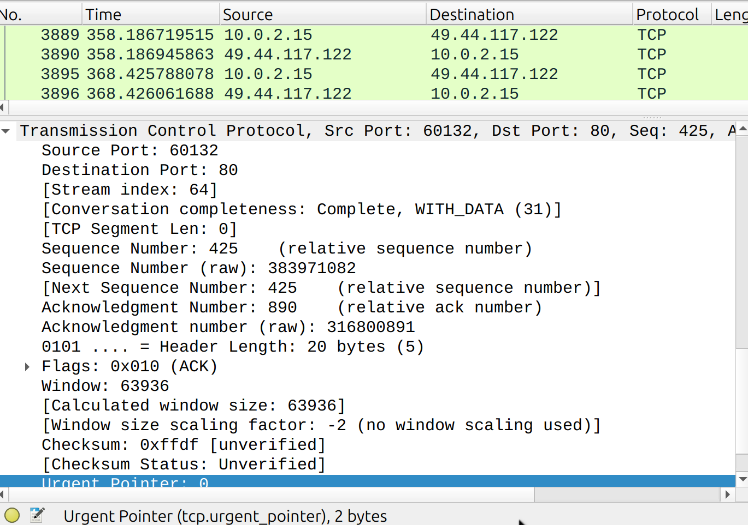

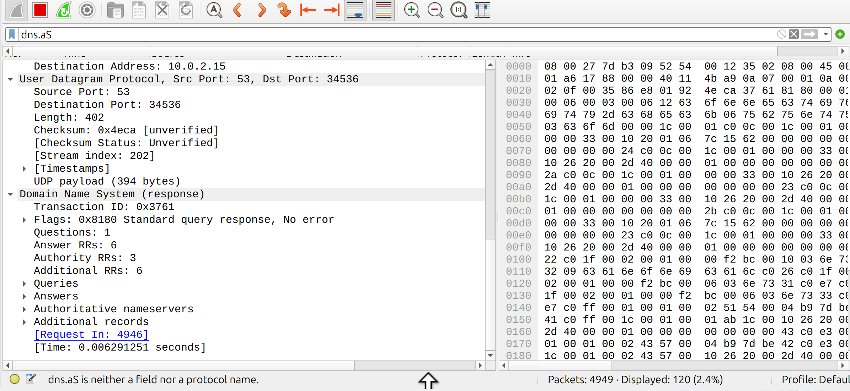

From here we can deduct the data that has reached the socket.