B21140/ Swarnarup Bhunia

Q2.

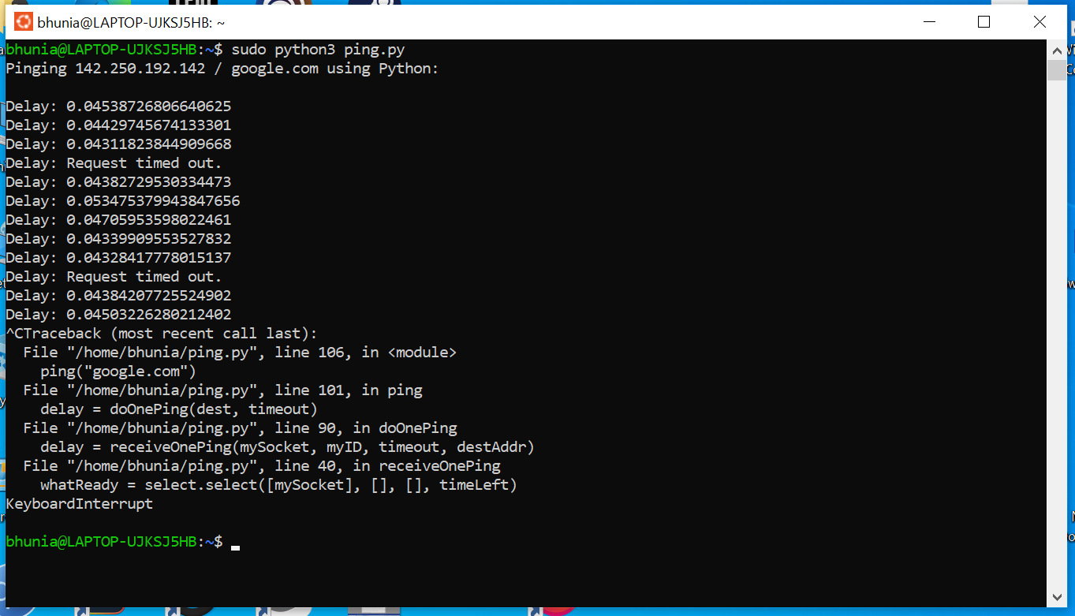

Q3.

Using tcpdump we can track filter package through the network

