Screenshots:

Q3.

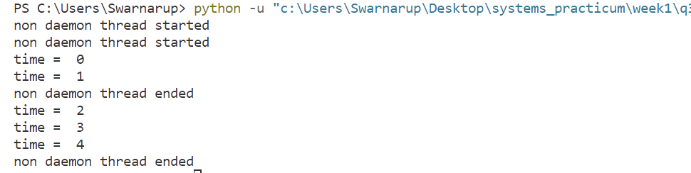

Q4.

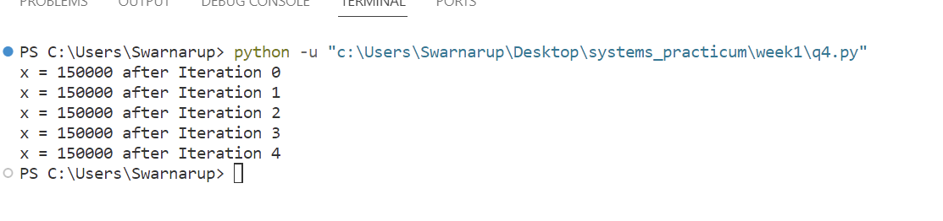

It does not suffer from Race condition. Python 3.11 has synchronization handler which eliminates race condition and always gives expected result.

For previous versions of python if the problem of race condition occurs the solution is using a lock.

