PROJECT REPORT

A Django-Based Data Mining and Machine Learning Portal

Bachelor of Computer Applications (BCA)
Chandigarh University

Submitted by: Swarnava Parial

University Roll Number: 24BCA10123

Submitted to: Mr. Ravi Raj

Subject: Data Mining Lab

Subject Code: 24CAP-308

FRONT MATTER
CERTIFICATE
Project completion certificate

This is to certify that the project report entitled “Data Analysis Project: A Django-Based Data Mining and Machine Learning Portal” has been prepared and submitted by Swarnava Parial, a student of the Bachelor of Computer Applications (BCA) programme at Chandigarh University.
The work describes the design and implementation of a web application that accepts tabular datasets, performs data cleaning and preprocessing, generates exploratory data analysis visualizations, trains a Random Forest model, reports evaluation metrics and provides an interactive prediction interface. The report has been prepared for academic evaluation and is based on the source code and test run of the submitted application.
To the best of my knowledge, the project work presented in this report is suitable for consideration as a BCA academic project, subject to the normal review and evaluation procedures of the University.
Project Guide / Supervisor
Signature: ___________________________________________

FRONT MATTER
DECLARATION
Statement of originality and academic responsibility

I, Swarnava Parial, hereby declare that the project report entitled “Data Analysis Project: A Django-Based Data Mining and Machine Learning Portal” is prepared by me for academic purposes as part of my Bachelor of Computer Applications programme at Chandigarh University.
I have based this report on the application source code, the project documentation included with the application, and the results produced during a local test run. The report explains the implemented functionality and identifies limitations observed in the current implementation. Dataset-related statistics and model metrics stated in the report are associated with the uploaded Telco Customer Churn CSV used for the demonstration run.
I understand that external datasets and software libraries must be acknowledged. The data source and technical documentation consulted for this work are listed in the References section. I have not represented the application as a production-ready service or claimed that the model provides guaranteed or decision-grade predictions.
I accept responsibility for the accuracy of the information presented and for making any corrections required by my project supervisor or the University.
Student Name: Swarnava Parial
Signature: ___________________________________________

FRONT MATTER
ACKNOWLEDGEMENT
Gratitude and project support

I would like to express my sincere gratitude to Chandigarh University for providing the academic environment and learning opportunities that supported the completion of this project. The coursework in programming, data analytics, databases and data mining provided the foundation required to understand the concepts used in the application.
I am thankful to my project guide and faculty members for their teaching, guidance and feedback during the development and documentation of the project. Their academic support helped me connect theoretical topics such as data preprocessing, exploratory analysis, classification and model evaluation with a practical software application.
I also acknowledge the maintainers of Python, Django, pandas, NumPy, scikit-learn and Plotly. These open-source technologies made it possible to build the application using a combination of web development and machine-learning tools. I acknowledge the public Telco Customer Churn dataset source cited in this report for the demonstration dataset.
Finally, I am grateful to my parents, family and friends for their encouragement and support throughout the project. Their patience and motivation helped me complete the implementation, testing and report preparation.
Swarnava Parial

FRONT MATTER
ABSTRACT
Project overview and demonstrated outcome

Data Analysis Project is a local web application developed with Django to bring common tabular-data analysis tasks into one guided workflow. The application allows a user to upload a CSV or XLSX file, choose the target column, inspect preprocessing results, explore charts, evaluate a machine-learning model and submit custom feature values for prediction. The project combines a browser-based interface with Python data-processing and machine-learning libraries.
The processing workflow includes blank-token normalization, duplicate removal, exclusion of identifier-like fields, missing-value auditing, numeric and categorical imputation, IQR-based clipping, numerical scaling and categorical one-hot encoding. The application builds a scikit-learn Pipeline and uses a Random Forest classifier or regressor according to the selected target. It reports classification metrics or regression errors on a held-out test set and generates Plotly charts for target distribution, feature distribution, box plots, scatter relationships, correlation, feature importance and the confusion matrix where applicable.
A demonstration run used an uploaded Telco Customer Churn CSV containing 7,043 records and 21 columns. The run identified 11 blank TotalCharges values, removed the customerID identifier from the predictors and retained 7,043 records after cleaning. The Random Forest classifier reported 77.2% accuracy, 75.8% weighted precision, 77.2% weighted recall and 76.1% weighted F1-score. A sample prediction using the form defaults returned “No” with a highest class probability of 0.763. These are dataset- and split-specific results, not a general performance guarantee.
KEYWORDS
Data analysis, data mining, Django, Python, pandas, NumPy, scikit-learn, Random Forest, preprocessing, exploratory data analysis, classification, customer churn, prediction.

REPORT NAVIGATION
TABLE OF CONTENTS
Main sections and appendices

Section | Page | Section | Page
Certificate | 2 | 9. Exploratory Data Analysis | 16
Declaration | 3 | 10. Random Forest Model Design | 17
Acknowledgement | 4 | 11. Model Evaluation and Results | 18
Abstract | 5 | 12. Interactive Prediction Module | 19
List of Figures, Tables and Abbreviations | 7 | 13. Technical Implementation | 20
1. Introduction | 8 | 14. Testing, Security and Limitations | 21
2. Problem, Objectives and Scope | 9 | 15. Conclusion and Future Work | 22
3. Requirements and Feasibility | 10 | References | 23
4. System Architecture | 11 | Appendix A: Upload and Preprocessing Screenshots | 24
5. Application Workflow | 12 | Appendix B: Dashboard and Prediction Screenshots | 25
6. Dataset and Data Understanding | 13
7. Data Preprocessing | 14
8. Model Input Pipeline | 15

Page numbers refer to the numbered pages in this report. The two appendix pages at the end contain screenshots captured from the locally running application.

REPORT NAVIGATION
LIST OF FIGURES, TABLES AND ABBREVIATIONS
Reference guide for diagrams and project terminology

List of figures
Figure | Description | Page
Figure 1 | System architecture | 11
Figure 2 | Application workflow | 12
Figure 3 | Data preprocessing sequence | 14
Figure 4 | Model input pipeline | 15
Figure 5 | Target distribution | 13
Figure 6 | Raw numeric-feature correlation | 13
Figure 7 | Random Forest classification concept | 17
Figure 8 | Top feature importances | 16
Figure 9 | Confusion matrix | 18
Figures A1-A2 | Upload and preprocessing interface | 24
Figures B1-B2 | Dashboard and prediction interface | 25

List of tables
Table 1. Functional requirements (page 10) | Table 2. Dataset field groups (page 13) | Table 3. Missing-value audit (page 14) | Table 4. Model metrics (page 18) | Table 5. Source files and routes (page 20) | Table 6. Test summary (page 21).
Abbreviations
Term | Meaning | Term | Meaning
CSV | Comma-Separated Values | EDA | Exploratory Data Analysis
IQR | Interquartile Range | ML | Machine Learning
RF | Random Forest | RMSE | Root Mean Squared Error
MAE | Mean Absolute Error | R² | Coefficient of determination
XLSX | Excel workbook format | UI | User Interface
URL | Uniform Resource Locator | ID | Identifier

CHAPTER 1
INTRODUCTION
Background, motivation and project overview

1.1 Background
Modern organisations and academic projects collect information in tables, spreadsheets and exported CSV files. A dataset may contain numerical measurements, category labels, blank cells, duplicate records and fields that identify a row but do not explain the behaviour being studied. Before a model can be trained, the data must be understood, checked and transformed into a consistent form. The same dataset may also need charts and summary statistics so that a user can identify patterns before interpreting a prediction.
Data analysis combines descriptive statistics, visual exploration and computational methods to turn raw records into useful information. Data mining focuses on discovering patterns or relationships, while machine learning uses examples to learn a function that can classify or estimate an outcome. In a supervised-learning workflow, the analyst selects a target column and uses the remaining relevant columns as predictors. The quality of the result depends on the suitability of the data, preprocessing choices, model design and evaluation method.
1.2 Project overview
The Data Analysis Project is a Django-based portal that packages several stages into a three-step interface. The first page accepts a CSV or XLSX dataset and a target-column name. The second page explains how the raw table was cleaned and displays a missing-value audit and a preview of processed rows. The third page shows exploratory charts, model metrics, feature importance and a form for testing new inputs. The user can clear the selected dataset and begin another analysis.
1.3 Why a web application?
A web interface makes the workflow easier to demonstrate than a collection of separate scripts. Users can interact with file selection, form fields, tables and charts without editing Python source code for each dataset. Django handles requests and page rendering, while the analytics module performs data operations and model training. The application is intended as an educational prototype that demonstrates how web development and data-mining libraries can work together.
PROJECT DELIVERABLE
A local, browser-based application that accepts tabular data and returns a cleaning summary, visual analysis, model evaluation and a user-triggered prediction.

CHAPTER 2
PROBLEM STATEMENT, OBJECTIVES AND SCOPE
What the application is designed to solve

2.1 Problem statement
Analysing an unfamiliar dataset often requires a sequence of separate tools and scripts. A learner may need to inspect file structure, convert blank strings into missing values, remove duplicates, decide how to treat missing fields, detect unusual numeric values, encode categories, train a model, calculate evaluation metrics and visualise the result. When these operations are performed manually in unrelated scripts, it becomes difficult to reproduce the same steps or explain what happened to the original records.
The project addresses this problem by providing a single guided interface for common tabular-data tasks. It does not attempt to replace a full enterprise analytics platform; instead, it gives a student a practical environment in which the stages of a supervised-learning workflow can be inspected and demonstrated.
2.2 Aim
To design and implement a Django web application that simplifies dataset upload, preprocessing, exploratory analysis, machine-learning evaluation and interactive prediction for tabular datasets.
2.3 Objectives
1. Accept CSV and XLSX datasets through a browser-based upload form.
2. Validate the file type, upload size and selected target-column name.
3. Identify blank or missing values, duplicate records, identifier-like columns and numeric outliers.
4. Apply suitable numerical and categorical transformations within a reusable preprocessing pipeline.
5. Generate visual summaries and train a Random Forest classifier or regressor.
6. Display evaluation metrics and provide a dynamic form for individual predictions.
2.4 Scope and boundaries
The current scope is limited to local, academic analysis of tabular CSV/XLSX files up to 15 MB. The user selects one target column per analysis. Classification is selected for non-numeric targets and numeric targets with up to 20 distinct values; otherwise, a numeric target is treated as a regression task. The application does not include login accounts, multi-user permissions, a permanent model registry, cloud storage, production deployment automation or a formal data-governance process.

CHAPTER 3
SYSTEM REQUIREMENTS AND FEASIBILITY
Functional and quality requirements

3.1 Functional requirements
ID | Requirement | Expected behaviour
FR-01 | Dataset upload | Accept CSV/XLSX files through a multipart form.
FR-02 | Target selection | Use the user-supplied target header; infer common target names where possible.
FR-03 | Input validation | Reject unsupported extensions and files larger than 15 MB.
FR-04 | Preprocessing | Clean blanks, remove duplicates and target-null rows, audit missing values and outliers.
FR-05 | Analysis | Generate target/feature charts, correlation and feature importance.
FR-06 | Model evaluation | Train Random Forest and report task-appropriate metrics.
FR-07 | Prediction | Build dynamic numerical/category inputs and return a model output.
FR-08 | Reset | Clear the selected dataset from the active session.

3.2 Non-functional requirements
- Usability: a three-step layout, clear labels, tables and chart panels should make the workflow understandable.
- Reliability: invalid files and unsupported target columns should produce useful messages instead of silent failure.
- Reproducibility: fixed random state 42 makes the train/test split and model run repeatable for an unchanged dataset and environment.
- Maintainability: view handling and reusable analytics logic are separated into different modules.
- Privacy: the project is designed for local execution; users should avoid uploading sensitive personal information to a shared or exposed server.
3.3 Environment and feasibility
The project uses Python and the packages listed in requirements.txt. Django provides the web framework; pandas and NumPy handle table operations; scikit-learn supplies preprocessing, modelling and metrics; Plotly creates interactive charts; and HTML/CSS/JavaScript provide the browser interface. A modern desktop browser and a Python environment compatible with the declared dependencies are required. The approach is technically and economically feasible for a student demonstration because it uses widely available open-source software and a local development server.

CHAPTER 4
SYSTEM ARCHITECTURE
Separation between interface, request handling and analytics

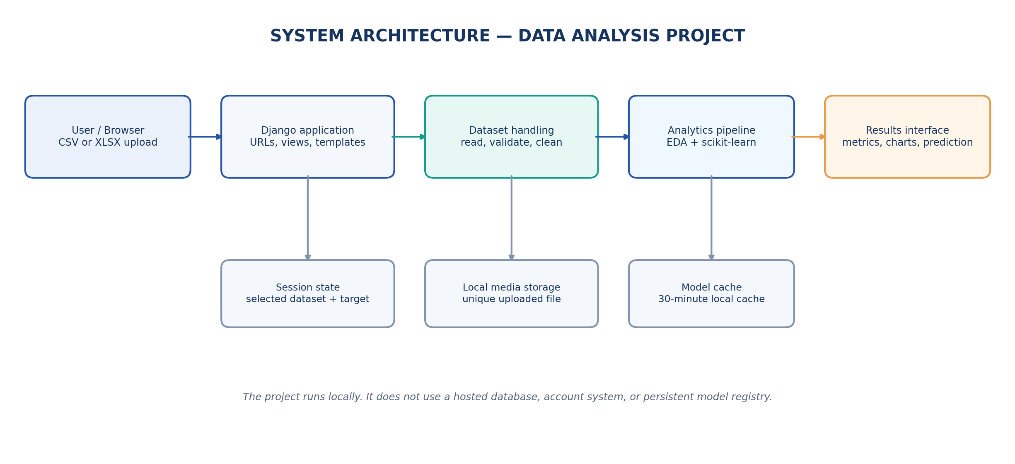
Figure 1. High-level architecture of the Data Analysis Project.
4.1 Architecture components
The browser is the user-facing layer. It displays the upload form, preprocessing summary, dashboard and prediction controls. The Django application layer maps URLs to views, validates uploaded files, stores the dataset under the local media directory and keeps the selected file path and target name in the session. The analytics layer reads the dataset and calls the reusable pipeline functions. It prepares the cleaned preview, computes summary counts, fits the model and builds the chart HTML. The results interface renders the report in Django templates.
The architecture keeps request orchestration in analytics/views.py and data science logic in analytics/pipeline.py. This separation makes it easier to test the pipeline independently from the pages. The local cache avoids repeating the full analysis for every page request during the cache period. The model object is part of the cached report; the application does not maintain a permanent model registry.

CHAPTER 5
APPLICATION WORKFLOW AND PAGE NAVIGATION
The complete analysis journey

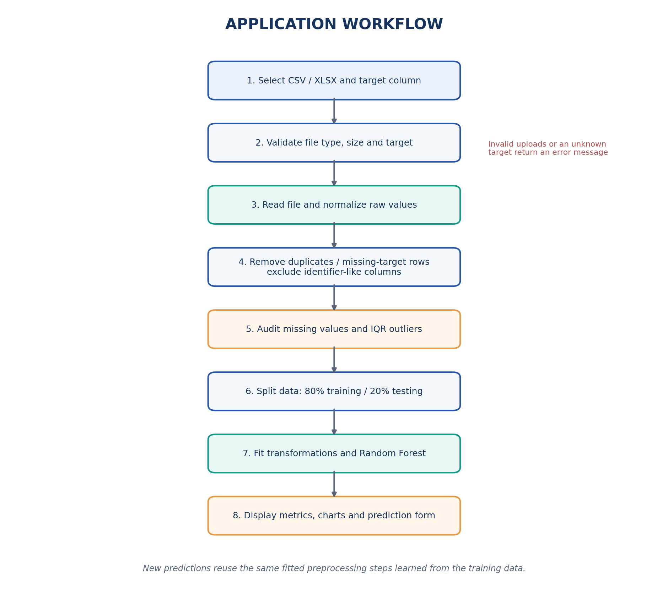
Figure 2. Main processing workflow from upload to prediction.
5.1 Three-step user journey
Step | Page / route | Purpose
1 | Upload & Select / | Choose a CSV/XLSX file and enter the target column.
2 | Data Preprocessing /preprocessing/ | Review missing values, cleaning changes, outlier counts and preview.
3 | EDA & Results /results/ | Inspect charts, metrics, feature importance and make predictions.

The /reset/ route clears the dataset selection from the current session and redirects the user to the upload page. If a dataset is missing from the session or the stored path is no longer valid, the application returns the user to the first step. Each page provides navigation to the next or previous stage so that the process can be reviewed without manually editing the URL.

CHAPTER 6
DATASET AND DATA UNDERSTANDING
Telco Customer Churn demonstration dataset

The tested demonstration file is named WA_Fn-UseC_-Telco-Customer-Churn.csv and was uploaded through the application interface. The dataset is commonly distributed as the IBM Telco Customer Churn dataset [1]. The uploaded file contains 7,043 records and 21 columns. The target column selected for the model is Churn, with two values: No and Yes.
Dataset property | Observed value
Rows / columns | 7,043 records / 21 columns
Target | Churn (No / Yes)
Identifier field | customerID (excluded from predictors)
Numeric predictors | SeniorCitizen, tenure, MonthlyCharges, TotalCharges
Categorical predictors | 15 columns including Contract, InternetService and PaymentMethod
Predictors used by the model | 19 columns after customerID is excluded
Class counts | No: 5,174 (73.46%); Yes: 1,869 (26.54%)

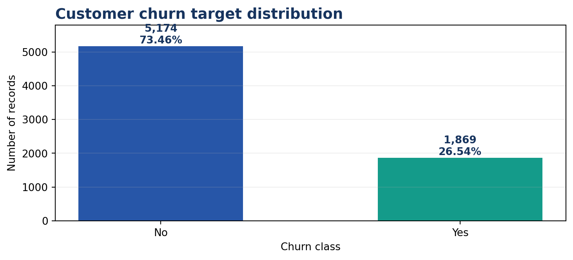 | 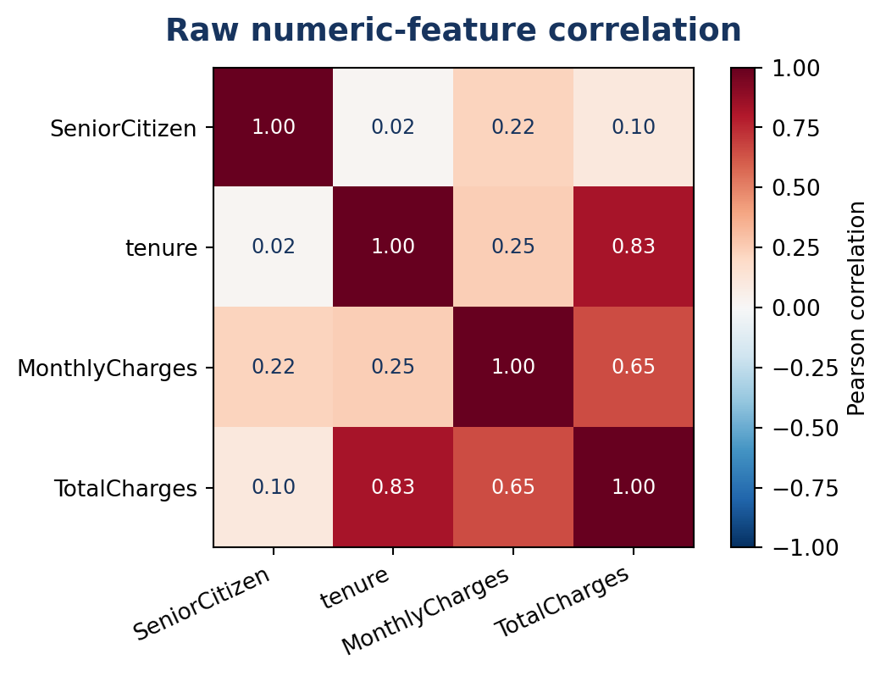
Figure 5. Distribution of the selected churn target. | Figure 6. Correlations among original numeric fields.
The target classes are imbalanced: approximately three quarters of the records are labelled No. This matters when interpreting model accuracy because a classifier can obtain a relatively high score by favouring the larger class. The raw numeric fields also show a strong positive association between tenure and TotalCharges (about 0.83) and a positive association between MonthlyCharges and TotalCharges (about 0.65). These relationships are descriptive and do not establish cause and effect.

CHAPTER 7
DATA PREPROCESSING AND CLEANING
How the uploaded table is prepared

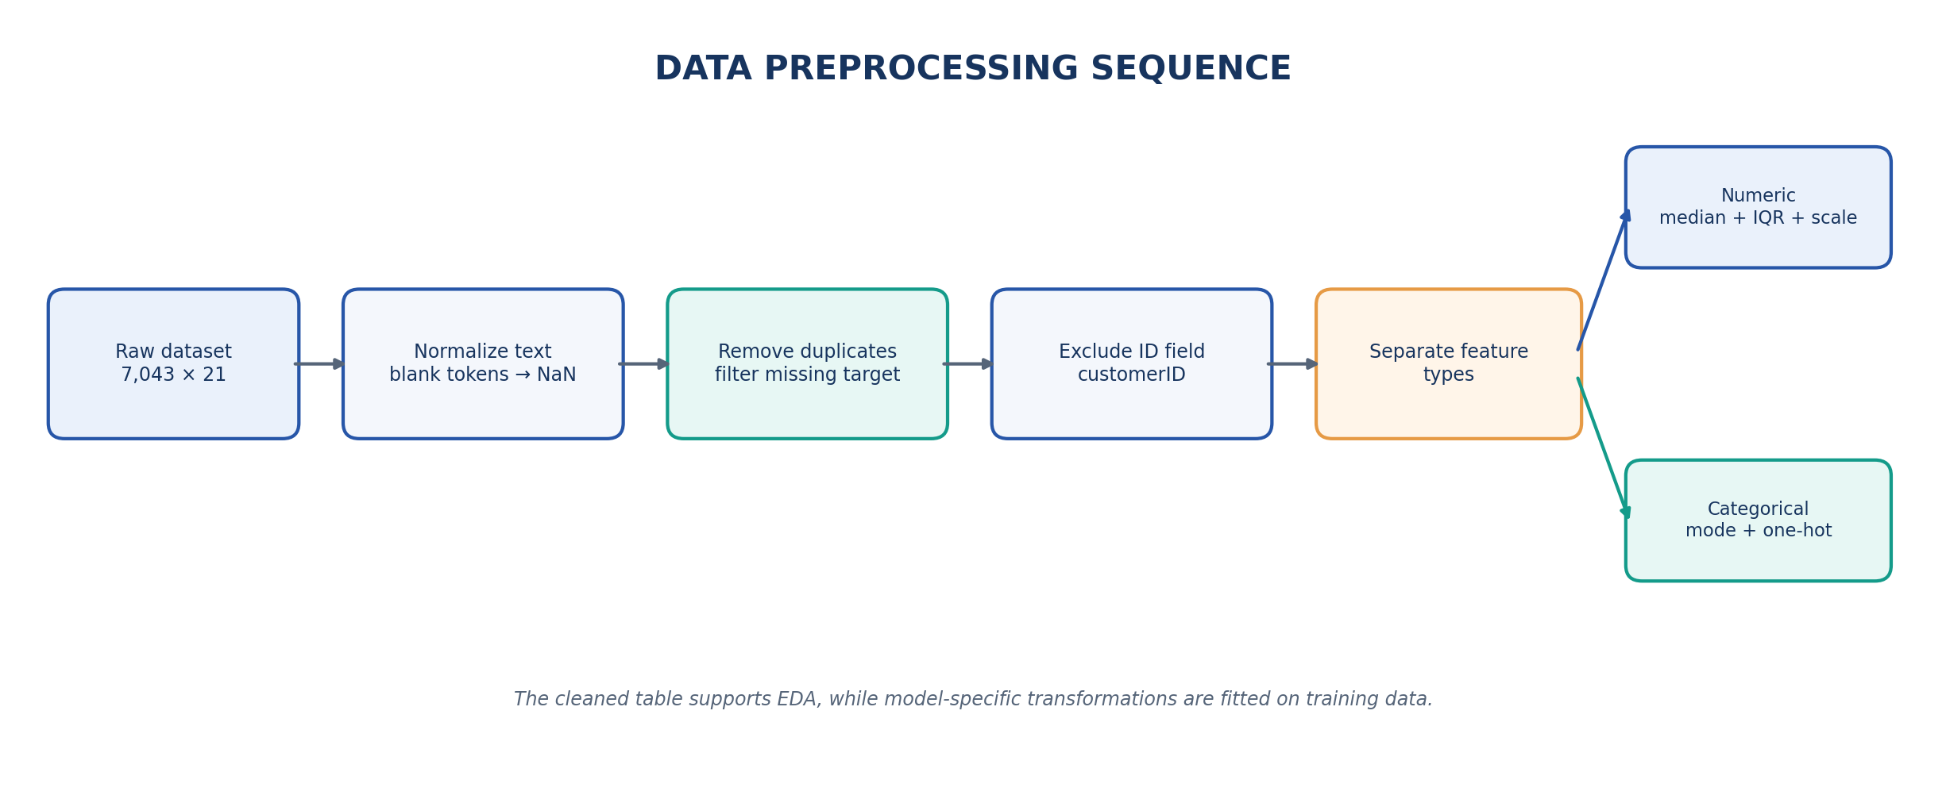
Figure 3. Cleaning sequence and numeric/categorical branches.
7.1 Observed cleaning summary
Check | Observed result | Interpretation
Blank / missing values | 11 in TotalCharges | Blank strings were converted to missing values.
Missing target rows | 0 | All target labels were available.
Exact duplicates | 0 | No complete duplicate records were removed.
Identifier columns | customerID | Identifier excluded from the feature matrix.
All-empty columns | 0 | No fully empty column was removed.
Post-imputation missing values | 0 | Feature preview has no remaining null values.
IQR flags | 1,142 in SeniorCitizen | Binary 1 values were flagged by the current IQR rule.

7.2 Missing-value and outlier methods
The code converts blank strings and common tokens such as ?, NA, N/A, null and None into missing values. Rows with a missing target are removed because supervised training requires a known label. Numeric predictor values are filled with the median; categorical predictor values are filled with the most frequent category. Exact duplicate rows and identifier-like columns are handled before model training.
For numeric fields, the Interquartile Range is defined as IQR = Q3 - Q1. The conventional lower and upper fences are Q1 - 1.5 × IQR and Q3 + 1.5 × IQR. Values outside the fences are counted and clipped. In this dataset, SeniorCitizen is a binary field and Q1 and Q3 are both zero. Its upper fence is therefore zero, so all 1,142 records with value 1 are flagged and clipped to zero. This is a limitation of the current generic rule, not evidence that those records are erroneous. Binary and discrete indicator columns should be excluded from IQR clipping in a corrected version.

CHAPTER 8
MODEL INPUT PIPELINE AND DATA TRANSFORMATION
Type-specific preparation inside scikit-learn

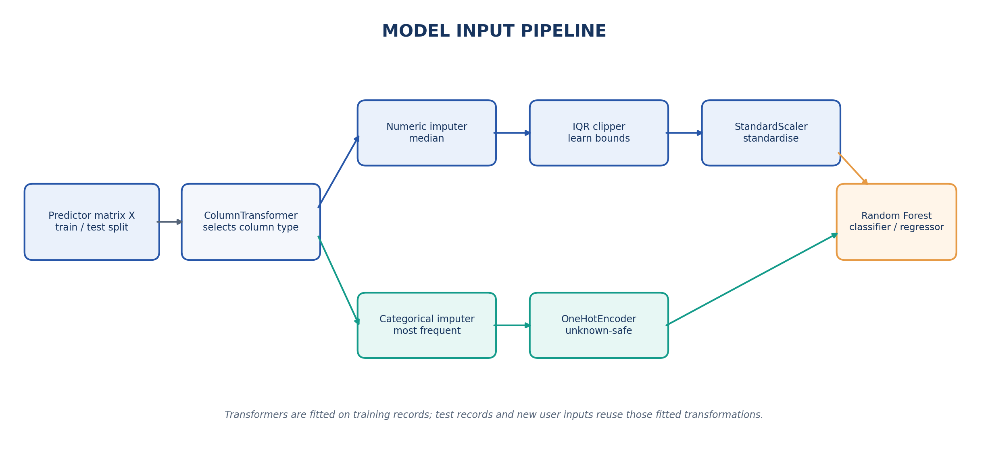
Figure 4. ColumnTransformer branches for numeric and categorical inputs.
8.1 Numerical branch
The numerical pipeline uses SimpleImputer(strategy="median"), the custom IQRClipper and StandardScaler. Median imputation is less sensitive to extreme values than mean imputation. IQRClipper learns lower and upper clipping limits from the training values. StandardScaler then centres each numeric feature and scales it using the training mean and standard deviation.
8.2 Categorical branch
Categorical columns use SimpleImputer(strategy="most_frequent") followed by OneHotEncoder(handle_unknown="ignore"). One-hot encoding converts each observed category into a machine-readable indicator column. The unknown-safe setting allows the transformer to handle a category that was not present while fitting without failing the whole request.
8.3 Training discipline
A ColumnTransformer applies the numerical and categorical steps to their corresponding columns. These transformations are placed in the same scikit-learn Pipeline as the model. The dataset is divided into 80% training and 20% testing data using random_state=42. For classification, the code uses stratification when each class has enough observations. Fitting transformations inside the model pipeline helps prevent information from the held-out test data from being used to learn preprocessing parameters. The current binary-field IQR issue remains a separate improvement item.

CHAPTER 9
EXPLORATORY DATA ANALYSIS
Visual summaries used to understand the selected dataset

Exploratory Data Analysis (EDA) is performed before interpreting the trained model. The dashboard creates charts from the uploaded dataset and the processed display frame. The target distribution chart shows how many records belong to each churn class. The feature histogram shows the spread of a selected numeric column. Box plots provide a compact view of the range and potential outlying values for numeric columns. A scatter plot explores the relationship between two numeric columns and can colour the points by the target class.
9.1 Correlation and feature relationships
The application computes a Pearson correlation heatmap for up to 12 numeric features. A correlation close to +1 indicates a strong positive linear association, a value close to -1 indicates a negative association, and a value near zero indicates little linear association. Correlation is not a measure of causation. The original numeric-field heatmap on page 13 was calculated before the application clipper was applied so that the binary SeniorCitizen relationship remains visible for discussion.
9.2 Dashboard chart set
- Target distribution: compares the number of No and Yes observations.
- Feature distribution and box plots: show the spread of selected numeric variables.
- Scatter plot: visualises a pair of numeric features and their target labels.
- Correlation heatmap: summarises pairwise linear correlations among numeric fields.
- Feature-importance chart and confusion matrix: connect model behaviour with held-out evaluation.
INTERPRETATION NOTE
The plots are exploratory aids. They should be interpreted with the data-cleaning rules in mind, especially where the current IQR clipping treats a binary numeric field as continuous.

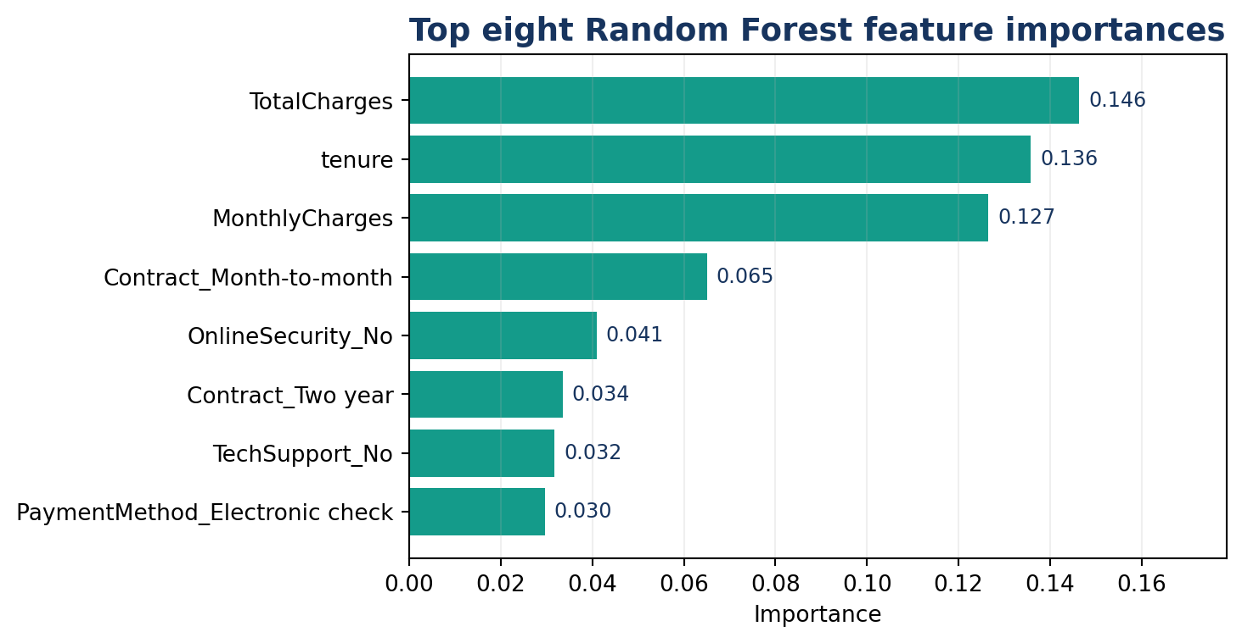
Figure 8. Highest-ranked transformed features in the demonstration model.

CHAPTER 10
RANDOM FOREST MODEL DESIGN
Learning a supervised prediction function

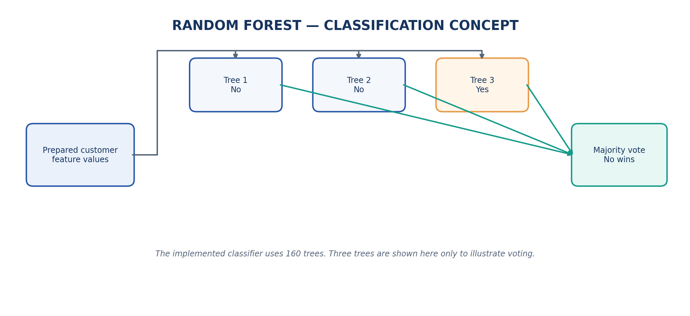
Figure 7. Conceptual voting process of a Random Forest classifier.
Random Forest is an ensemble learning method that combines predictions from multiple decision trees. Each tree is fitted using a randomised view of the training data and a subset of candidate features. For classification, the ensemble aggregates the individual tree outputs and predicts the class with the strongest vote. For regression, the ensemble combines numerical predictions. The approach can model nonlinear relationships and interactions without requiring the user to specify a linear equation.
10.1 Configuration in the application
Setting | Implementation
Classification estimator | RandomForestClassifier
Regression estimator | RandomForestRegressor
Number of trees | 160 estimators
Random seed | 42
Classification weighting | balanced_subsample
Parallel processing | n_jobs = -1
Model selection | Non-numeric or up to 20 numeric target labels → classification; otherwise regression

10.2 Feature importance
After fitting, the dashboard extracts the Random Forest feature_importances_ values and displays the leading transformed features. In the demonstration run, TotalCharges, tenure and MonthlyCharges ranked highest, followed by selected contract and service categories. Importance scores describe how the fitted forest used its splits; they are not causal effects and may change with the data and preprocessing.

CHAPTER 11
MODEL EVALUATION AND RESULTS
Observed performance on the held-out test partition

For the uploaded Telco Customer Churn file, the model used 5,634 training records and 1,409 held-out test records. The fixed 80/20 split and random seed make the run reproducible within the same software environment and data file. The values below are the metrics returned by the application for this run.
Metric | Observed value | Meaning
Accuracy | 77.2% | Correct predictions divided by all test predictions.
Weighted precision | 75.8% | Weighted proportion of predicted class labels that were correct.
Weighted recall | 77.2% | Weighted proportion of actual labels recovered.
Weighted F1-score | 76.1% | Weighted harmonic mean of precision and recall.

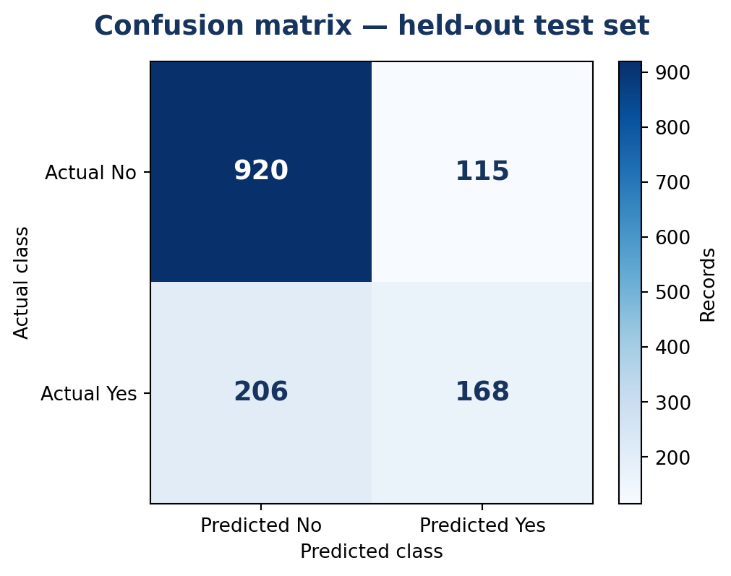
Figure 9. Confusion matrix for the 1,409-record test set (rows = actual class; columns = predicted class).
The matrix contains 920 correctly predicted No records, 115 false positives, 206 false negatives and 168 correctly predicted Yes records. For the churn class Yes, the recall derived from the matrix is 168 / (206 + 168), or approximately 44.9%. This means the overall accuracy should not be read as strong churn detection. The majority-class baseline (always predicting No) would be about 73.46%; the observed accuracy is approximately 3.7 percentage points higher. Class-specific metrics, threshold tuning and cross-validation should be examined before relying on the model for any operational use.

CHAPTER 12
INTERACTIVE PREDICTION MODULE
Testing a new record with the fitted model

The dashboard generates a prediction form from the predictor columns in the selected dataset. Numeric fields are displayed as number inputs. Categorical fields are displayed as drop-down lists containing observed values. For the Telco demonstration, the form includes 19 predictor fields because customerID is excluded. The user can enter a new combination of customer values and submit the form to the dashboard view.
12.1 Reusing the fitted pipeline
The prediction function converts the submitted form values into the data types expected by the model. It then calls the already-fitted scikit-learn Pipeline, so new inputs pass through the same median/mode imputation, clipping, scaling and one-hot encoding steps learned during training. For classification, the application displays the predicted class and, where probability estimation is available, the class probabilities.
12.2 Demonstration result
Input example | Default form value
gender / Partner / Dependents | Male / No / No
tenure | 29 months
InternetService / Contract | Fiber optic / Month-to-month
PaymentMethod | Electronic check
MonthlyCharges / TotalCharges | 70.35 / 1,397.475
SeniorCitizen | 0 (after current preprocessing rule)

OBSERVED MODEL OUTPUT
Predicted class: No. Highest class probability: 0.7625 (No). Probability for Yes: 0.2375. These values are the output for the form defaults in this demonstration run, not a prediction about a real identified customer.

The application includes a disclaimer that the model is intended for academic learning. A single prediction should not be used alone for consequential decisions about a customer.

CHAPTER 13
TECHNICAL IMPLEMENTATION
Project structure, request handling and routes

File / module | Responsibility
manage.py | Django command-line entry point for checks, migrations and server execution.
mining_portal/settings.py | Project configuration, middleware, templates, static/media paths and local cache.
mining_portal/urls.py | Maps URLs to upload, preprocessing, dashboard and reset views.
analytics/views.py | Validates uploads, reads session state, stores files and renders pages.
analytics/pipeline.py | Cleans the DataFrame, prepares previews, builds charts, fits the model and predicts.
templates/home.html | Upload and target selection form.
templates/preprocessing.html | Cleaning summary, missing-value audit and processed preview.
templates/dashboard.html | Metrics, Plotly charts, feature importance, confusion matrix and prediction form.
static/css/style.css / static/js/main.js | Visual styling, responsive layout and file-selection feedback.
data/sample_customer_churn.csv | Automated-test fixture; not automatically loaded by the web interface.

13.1 Request handling and storage
The upload view accepts only .csv and .xlsx extensions and checks the file size against a 15 MB limit. It sanitises the uploaded filename to its basename, adds a UUID prefix and saves the file in media/uploads. If the target field is omitted, the application tries to infer a common target label. The session stores the relative file path, selected target and original display name. A path-validation helper restricts later reads to the configured data and media upload directories.
13.2 URLs and page functions
URL | View | Purpose
/ | home | Upload and select target.
/preprocessing/ | preprocessing | Build and display the cleaning report.
/results/ | dashboard | Display model results and accept prediction input.
/reset/ | reset_dataset | Clear the selected dataset from session state.

CHAPTER 14
TESTING, SECURITY AND LIMITATIONS
Verification performed and remaining risks

14.1 Verification results
Test / check | Result | Evidence
Django system check | PASS | No system-check issues reported.
Classification report test | PASS | Task is classification; metrics and confusion chart are produced.
Missing-value handling test | PASS | Post-processing missing-value total is zero.
Default prediction test | PASS | Prediction is No/Yes and confidence is returned.
Live local workflow | PASS | CSV upload, preprocessing page, dashboard and prediction were exercised.
Unsupported file / wrong target | Guard implemented | Validation and user-facing error paths are present in views.py; not part of the two automated tests.

The automated Django test command completed with 2 tests passed and no failures. One test checks that the sample fixture builds a classification report and has no missing values after processing. The second test submits default feature values to the prediction function and checks that a class and confidence are returned. The live demonstration run used the uploaded Telco CSV rather than the bundled sample fixture.
14.2 Security and privacy considerations
- The app uses Django CSRF middleware for form submissions and checks supported file extensions and upload size.
- Uploaded filenames are reduced to a basename and prefixed with a UUID. Session file paths are resolved and checked against allowed local directories.
- The project is designed for local use. It does not implement user accounts, role-based access, encryption-at-rest policy, audit logging or production-grade hosting controls.
- The supplied settings use development-oriented defaults (DEBUG enabled and a development secret key). These must be replaced or overridden before any public deployment.
14.3 Current limitations
The model is evaluated using one held-out split rather than repeated cross-validation or a full hyperparameter search. Churn class imbalance is visible in the confusion matrix, and the derived recall for the Yes class is 44.9%. The 15 MB upload limit, local cache and lack of persistent model storage restrict the app to small demonstrations. Plotly is referenced from a CDN in the application, so a network connection may be required for charts in a normal browser. The current IQR clipper also treats the binary SeniorCitizen field as continuous, removing its variation; this should be corrected before model conclusions are relied on.

CHAPTER 15
CONCLUSION AND FUTURE WORK
Summary of the completed application

The Data Analysis Project demonstrates how web development, data preparation, visual analytics and supervised machine learning can be combined in one local application. It provides a guided sequence for uploading a CSV or Excel file, selecting a target, reviewing cleaning operations, exploring visual summaries, evaluating a Random Forest model and testing a prediction. The implementation separates Django request handling from reusable analytics logic and includes automated tests for report generation and prediction.
The Telco Customer Churn demonstration produced a 77.2% accuracy score on the 1,409-record held-out test set, with a weighted F1-score of 76.1%. The confusion matrix also revealed that recall for the churn class was only about 44.9%. This result illustrates why multiple evaluation measures are necessary and why model outputs must be interpreted in the context of class distribution and preprocessing choices. The report also identifies the binary-field IQR clipping behaviour as a concrete implementation issue.
15.1 Recommended improvements
1. Correct IQR clipping so that binary and low-cardinality discrete columns are not clipped as continuous measurements.
2. Add stratified cross-validation, hyperparameter tuning and class-specific precision/recall reporting.
3. Investigate class-weight and probability-threshold choices to improve detection of the minority churn class.
4. Bundle Plotly locally, add downloadable cleaned-data and analysis reports, and support saved model versions.
5. Introduce authentication, production settings, secure upload storage and a tested deployment configuration before exposing the service publicly.
FINAL REMARK
The project meets its academic demonstration goal: it shows a complete upload-to-prediction workflow while making the underlying data steps and current model limitations visible to the user.

BIBLIOGRAPHY
REFERENCES
Datasets, frameworks and technical documentation

[1] Blastchar / Kaggle. Telco Customer Churn dataset.
https://www.kaggle.com/datasets/blastchar/telco-customer-churn
[2] Django Software Foundation. Django documentation.
https://docs.djangoproject.com/
[3] The pandas development team. pandas documentation and user guide.
https://pandas.pydata.org/docs/
[4] NumPy Developers. NumPy reference documentation.
https://numpy.org/doc/
[5] scikit-learn developers. ColumnTransformer and Pipeline documentation.
https://scikit-learn.org/stable/modules/compose.html
[6] scikit-learn developers. RandomForestClassifier API reference.
https://scikit-learn.org/stable/modules/generated/sklearn.ensemble.RandomForestClassifier.html
[7] Plotly Technologies Inc. Plotly Python graphing library documentation.
https://plotly.com/python/
[8] Python Software Foundation. Python 3 documentation.
https://docs.python.org/3/
[9] OpenML. Telco Customer Churn dataset metadata.
https://www.openml.org/search?id=45568&sort=runs&type=data
The dataset source is cited for the public Telco Customer Churn file. The application code itself uses the bundled sample_customer_churn.csv only as an automated-test fixture; the web interface requires a dataset to be uploaded by the user.

APPENDIX A
APPLICATION SCREENSHOTS: UPLOAD AND PREPROCESSING
Captured from the locally running Django application

The screenshots below were captured during a test run using the uploaded Telco Customer Churn CSV and the target column Churn. They show the first two stages of the actual web interface.
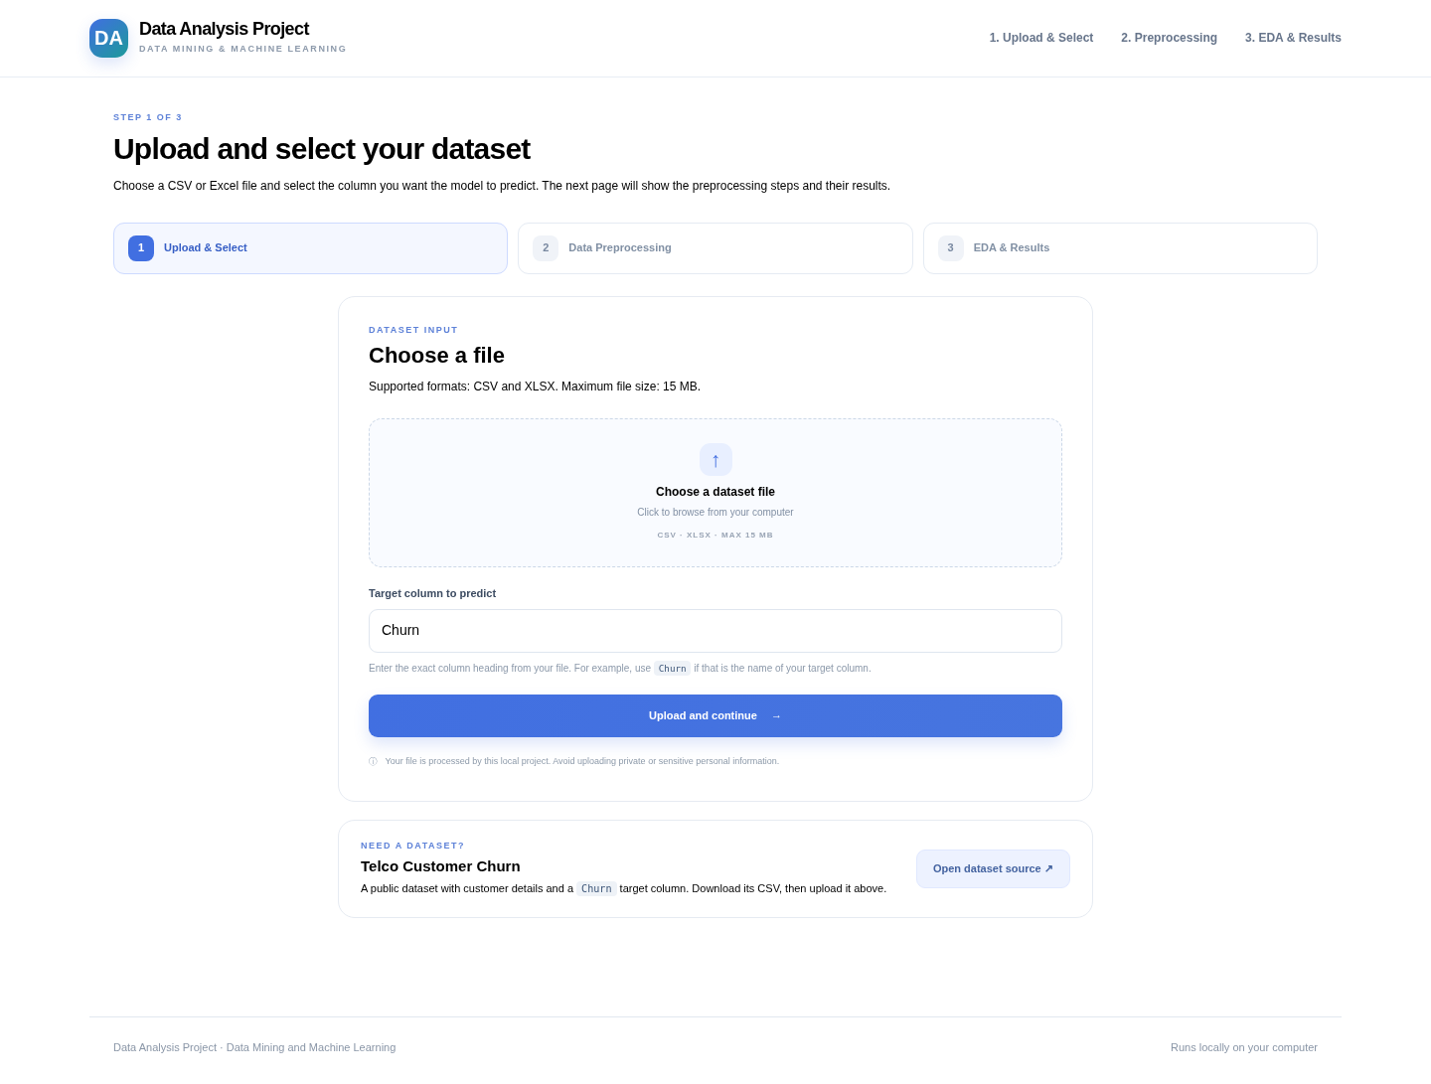
Figure A1. Upload and target-selection page. The interface accepts CSV/XLSX and displays the chosen target field.
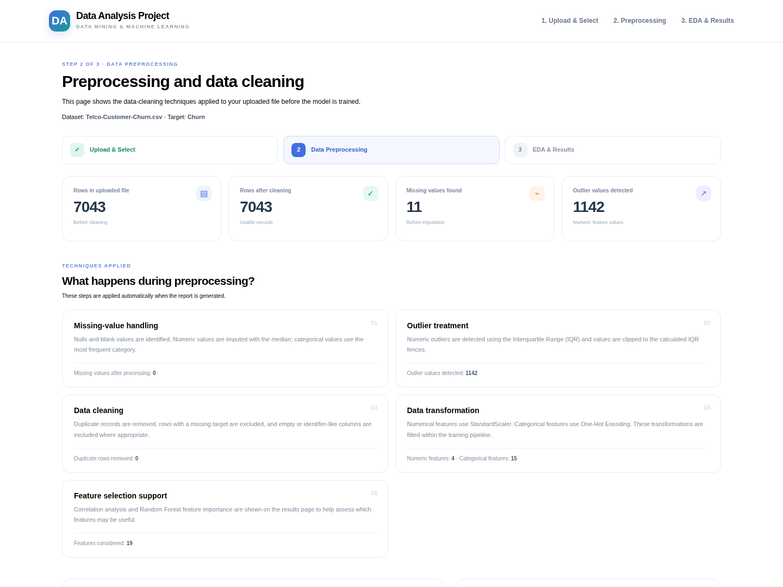
Figure A2. Preprocessing page showing row counts, missing-value count, outlier count and techniques applied.

APPENDIX B
APPLICATION SCREENSHOTS: RESULTS AND PREDICTION
Model metrics, charts and a submitted prediction

The results page displays model metrics and begins the visual-insight section. The prediction screenshot shows the response returned after submitting the default form values for the same fitted model.
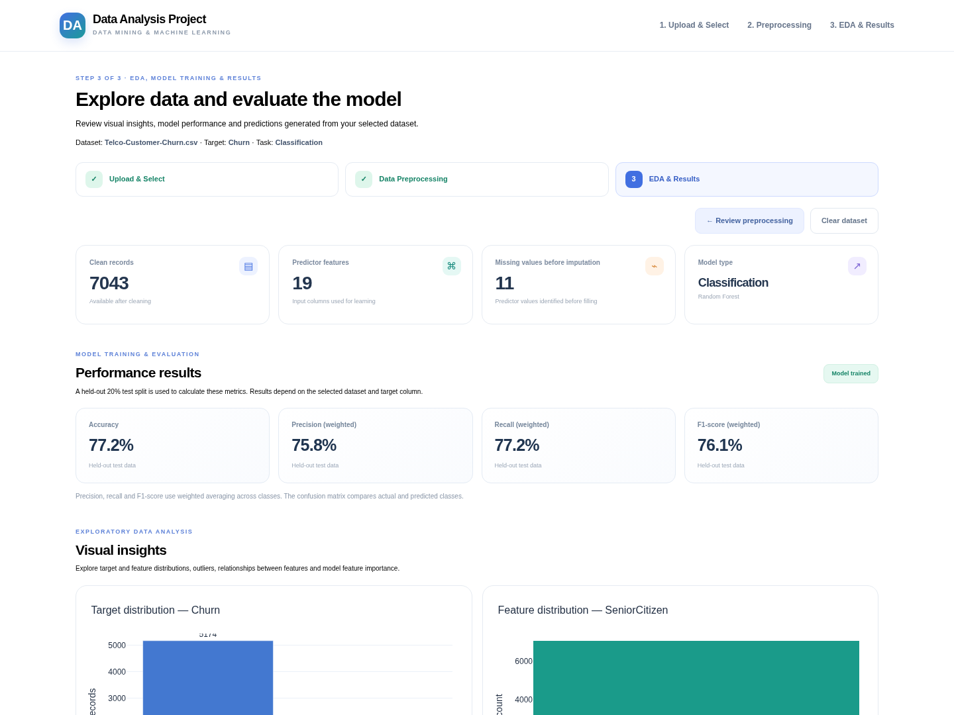
Figure B1. Dashboard showing 7,043 cleaned records, 19 predictors and the held-out classification metrics.
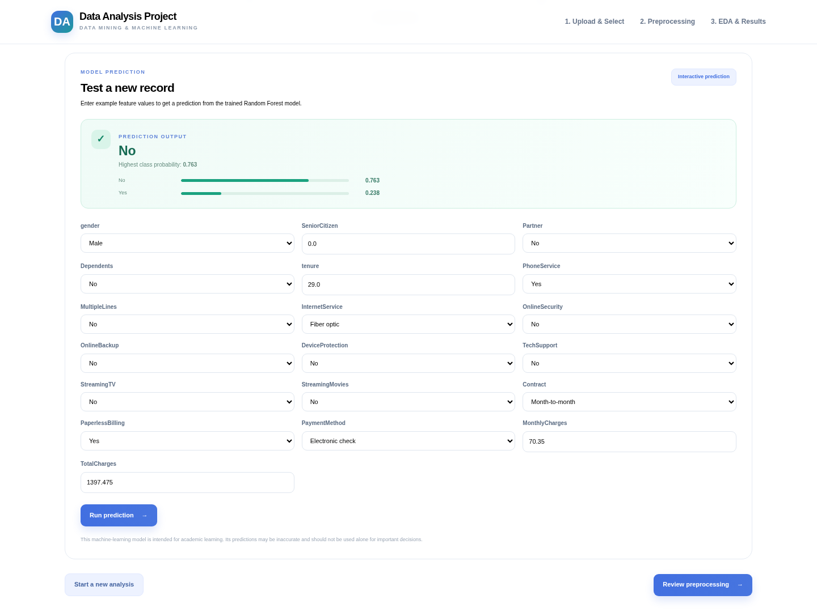
Figure B2. Prediction result: class No, with highest class probability 0.763.

