Experiment 2
Client–Server Communication Between Two Virtual Machines

Assign/check the IP address of both VMs.
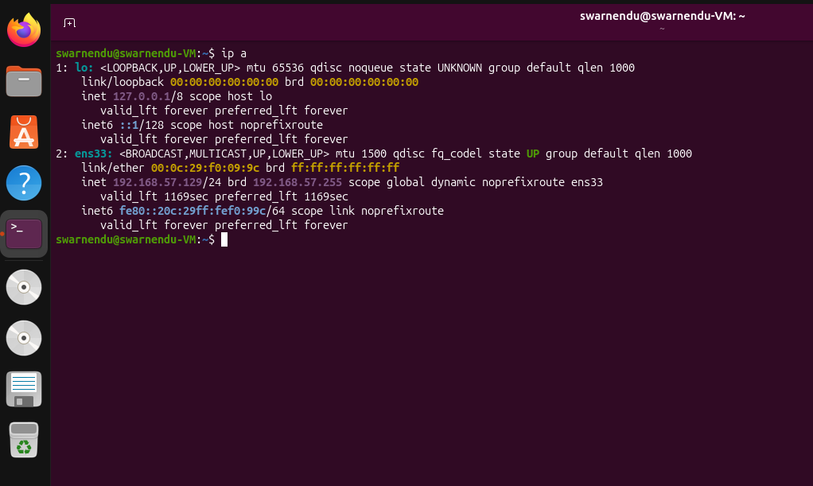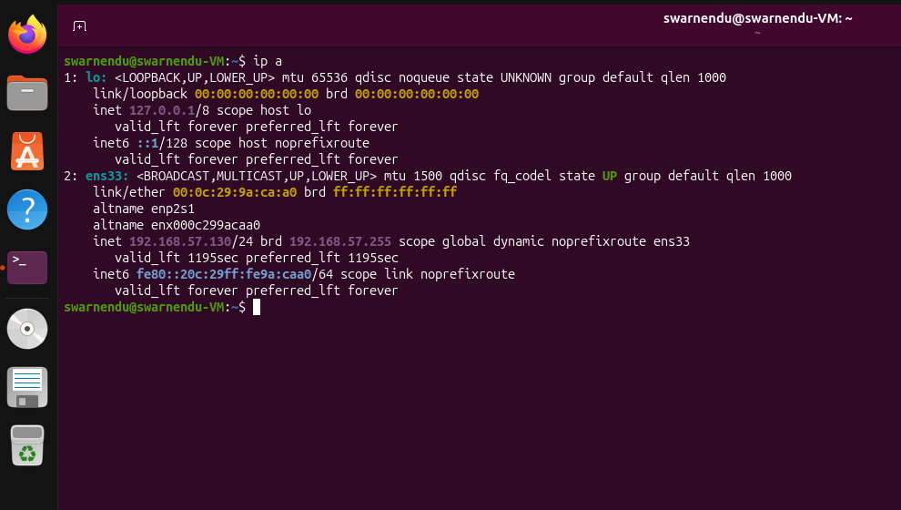

Configure both VMs on the same virtual network.

- Open Settings for the first VM (Ubuntu 26.04).
- Select Network from the left-side menu.
- Under Adapter 1, make sure Enable Network Adapter is enabled.
- Set Attached to as NAT.
- Click OK to save the network configuration.
- Open Settings for the second VM (Ubuntu 26.04 Server).
- Select Network → Adapter 1.
- Set Attached to as NAT Network.
- Select the NAT Network named Dummy from the Name field.
- Make sure Virtual Cable Connected is checked.
- Click OK to save the settings.
- These network configurations allow the virtual machines to be connected to a virtual network for further client-server communication and connectivity testing.

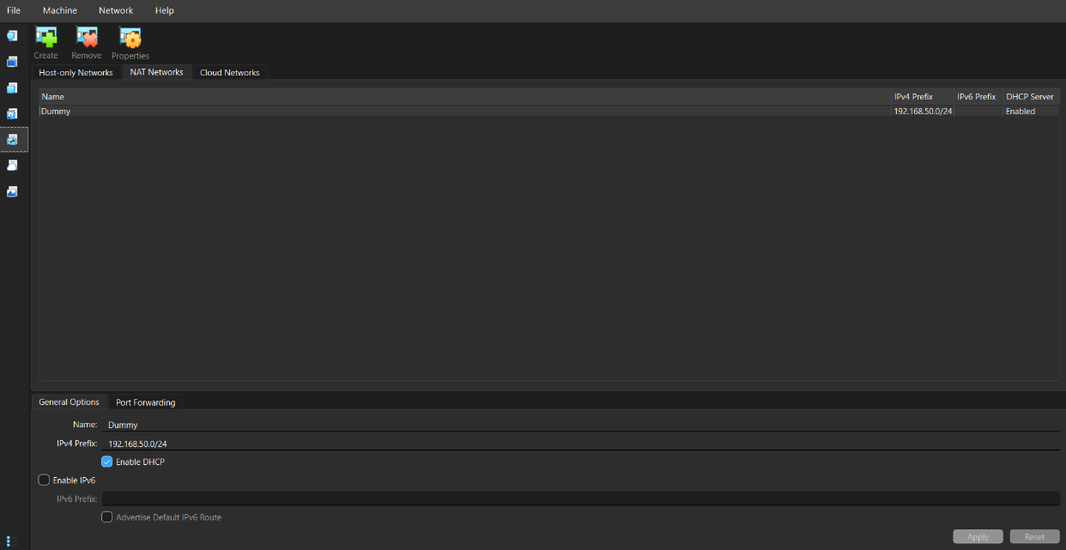

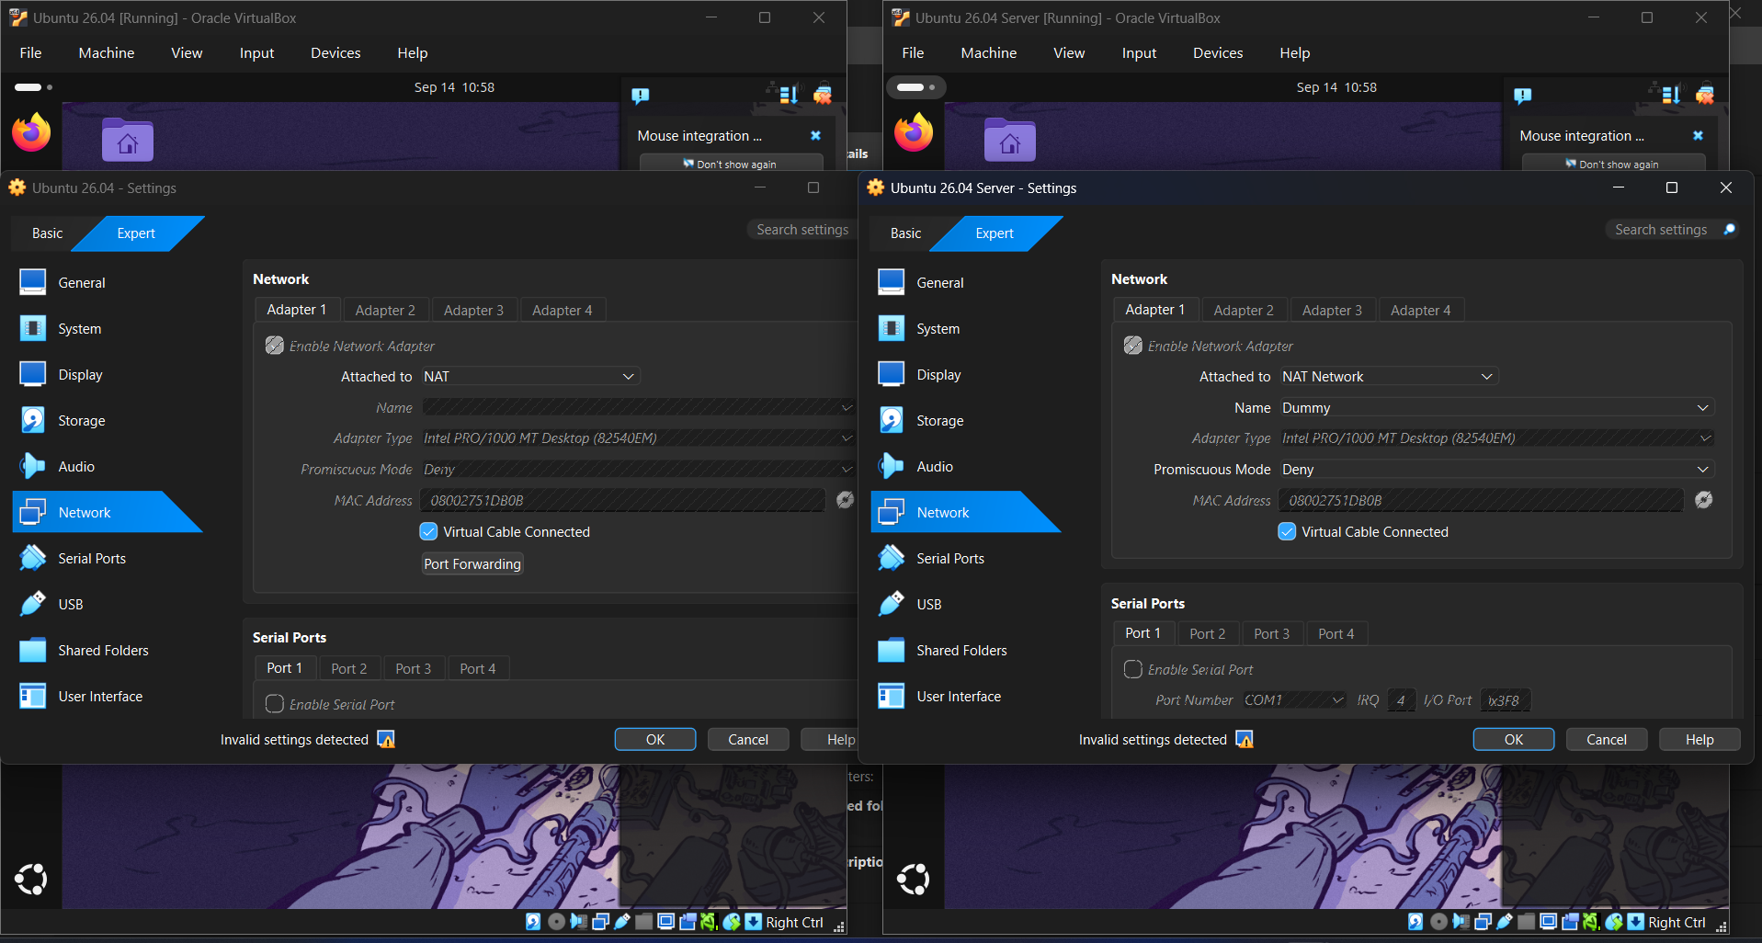

Test connectivity using the ping command.


