ASSIGNMENT-03
INSTALL MININET AND BUILD TOPOLOGIES.
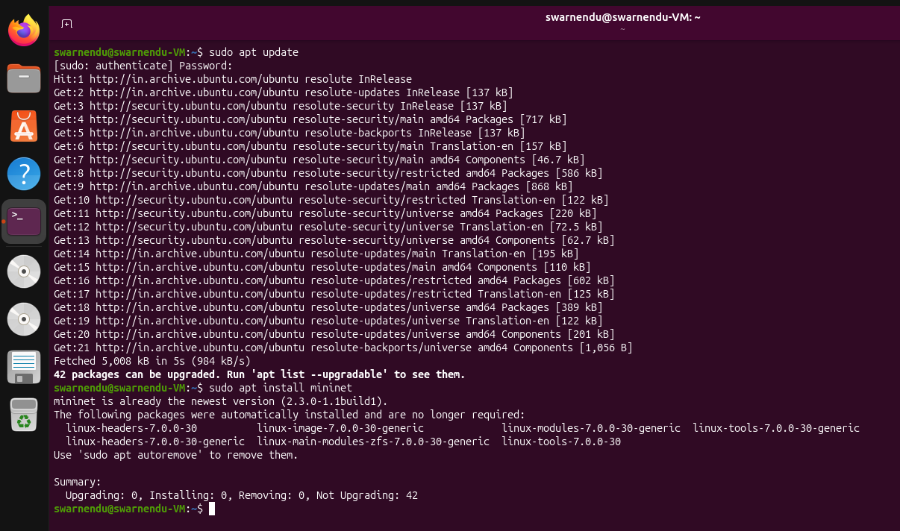

TOPOLOGIES-
1-SINGLE TOPOLOGY:
Sudo mn –topo single,2
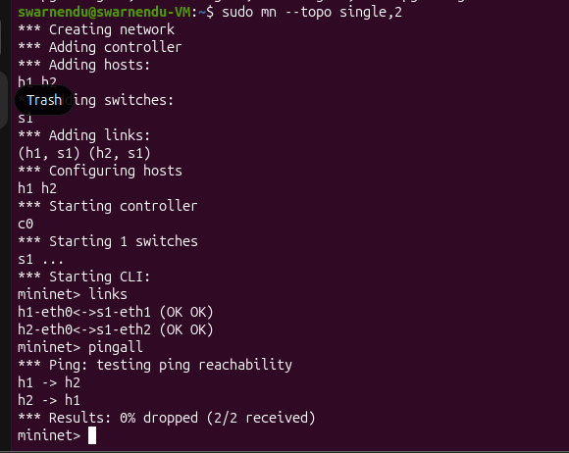
Diagram: S1

Switch

h1 h2

sudo mn –topo single,5
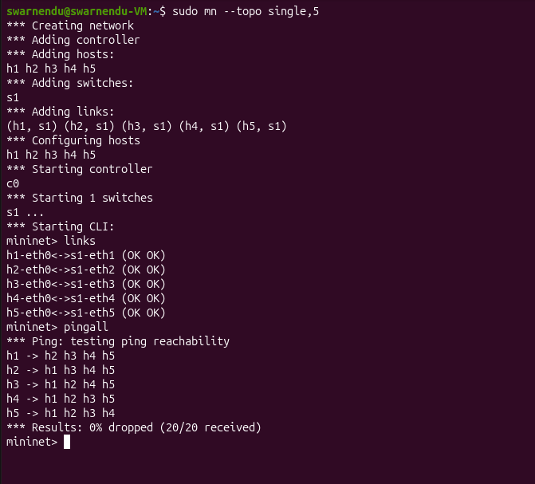
Diagram:

Switch

S1

H4

H1 H2 H3

H5
2-TREE TOPOLOGY :
Sudo mn –topo tree,depth=2,fanout=2
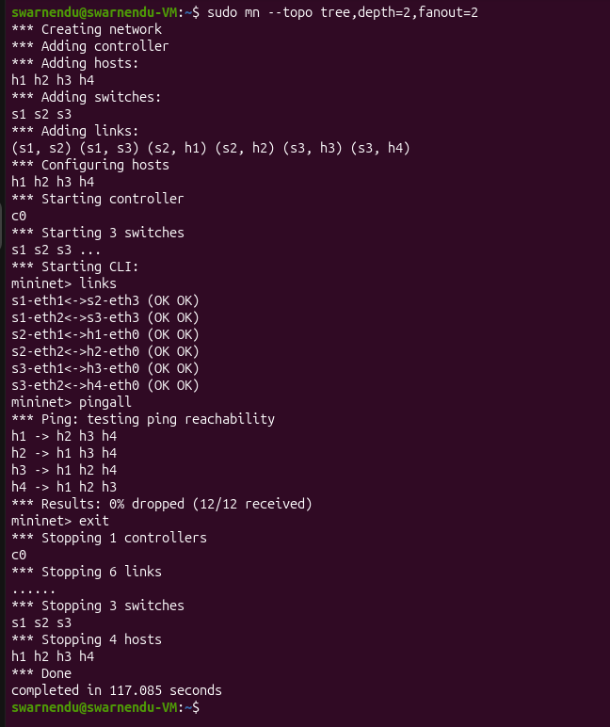

Diagram:
Switch 111
S1
Switch
Switch
S2 S3

h1 h2 h3 h4

Sudo mn –topo tree,depth=2,fanout=3
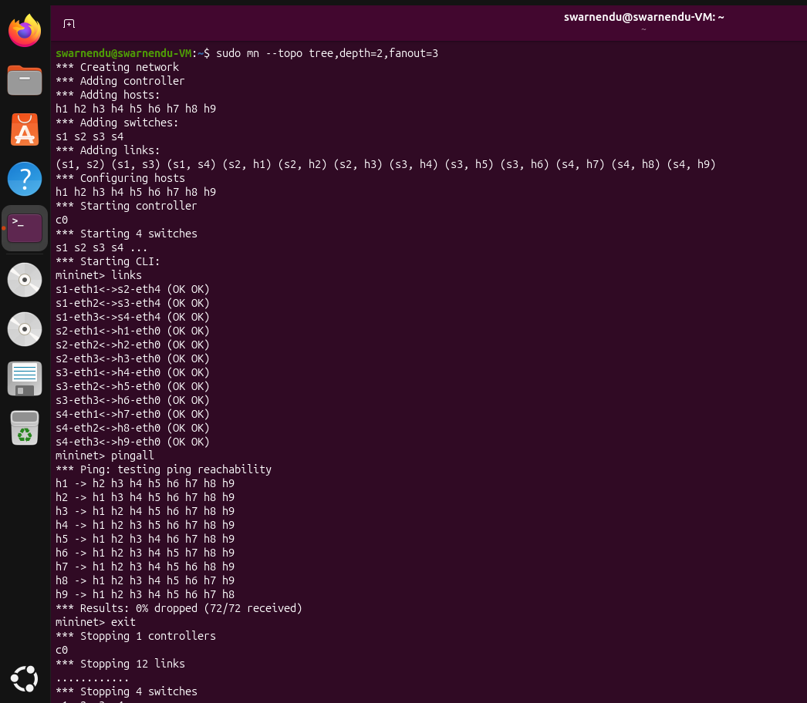

Diagram:
Switch 111
S1
Switch
Switch
Switch

S2 S3 S4

h1 h2 h3 h4 h5 h6 h7 h8 h9

3-LINEAR TOPOLOGY:
Sudo mn –topo linear,3
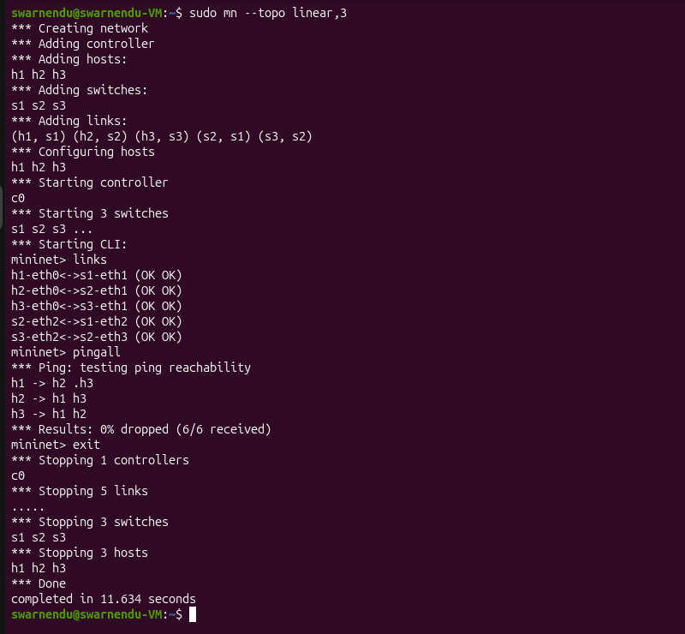
Diagram:
Switch 111
Switch 111

S1 S2 S3
Switch 111

h1 h2 h3

Sudo mn –topo linear,5
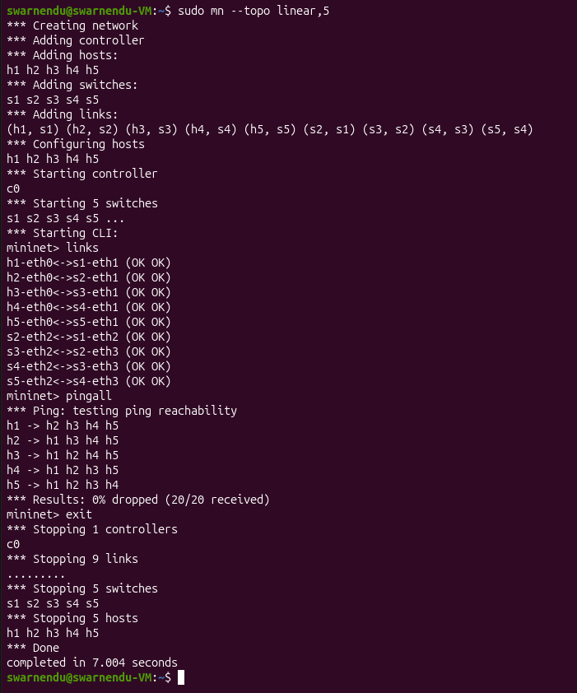

Diagram:
S1 S2 S3 S4 S5
Switch h1 h3 h4 h6 h7 h9 111
Switch h1 h3 h4 h6 h7 h9 111
Switch h1 h3 h4 h6 h7 h9 111
Switch h1 h3 h4 h6 h7 h9 111
Switch h1 h3 h4 h6 h7 h9 111

h1 h2 h3 h4 h5

