MaxHeap

Rule:
Parent ≥ Children

Example:
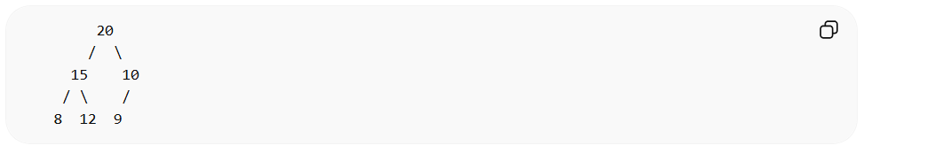
Largest element at root.
Used in:
• Top K problems
• Heap sort
• Task scheduling

Java PriorityQueue:
