MinHeap

A complete binary tree.
Rule:
Parent ≤ Children
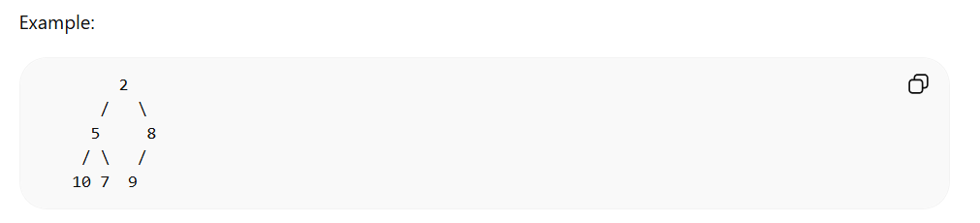
Smallest element always at root.
Used in:
• Priority Queue
• Dijkstra
• Scheduling systems

Operations:
Insert → heapify up
add node
compare with parent
swap if smaller
Remove → heapify down
remove root
replace with last node
push down
Time complexity:
Insert O(log n)
Remove O(log n)
Peek O(1)

Java PriorityQueue:
