Treemap & TreeSet

TreeMap is basically a Red-Black Tree implementation in Java.
Map<K,V>
Maintains sorted order of keys.
TreeMap<Integer,String> map = new TreeMap<>();
map.put(3,"C");
map.put(1,"A");
map.put(2,"B");
Stored as:
1=A
2=B
3=C

Time Complexity
Operation | Complexity
put | O(log n)
get | O(log n)
remove | O(log n)
Because internally → Red-Black Tree.
Special abilities:
firstKey() :
Returns the smallest key in the map.
Think of it as the leftmost node of the tree.
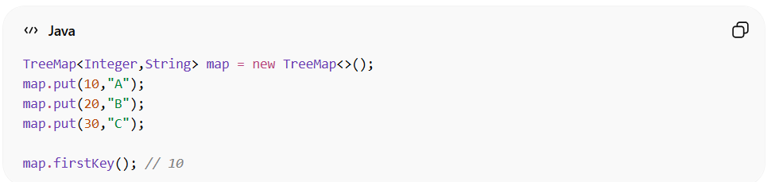
lastKey():
Meaning: Returns the largest key.
Think of it as the rightmost node in the tree.
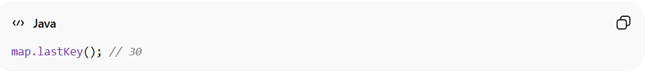
higherKey():
Returns the next strictly greater key than the given key.
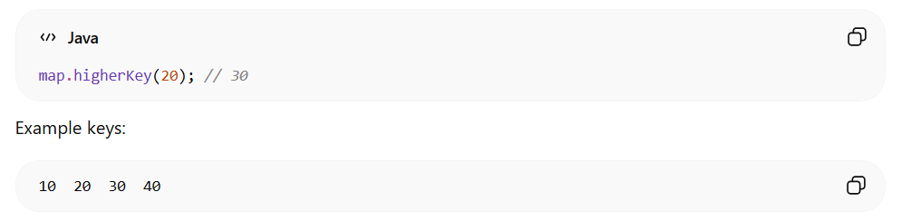
Input | Result
higherKey(20) | 30
higherKey(30) | 40
higherKey(40) | null
📌 Important
It does NOT include the given key.
lowerKey():
Returns the next strictly smaller key than the given key.
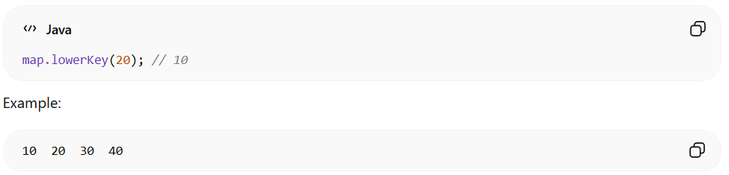

Input | Result
lowerKey(30) | 20
lowerKey(20) | 10
lowerKey(10) | null
📌 Again
The key itself is not included.
ceilingKey():
Meaning: Returns the smallest key ≥ given key
Think of ceiling = same OR next bigger.
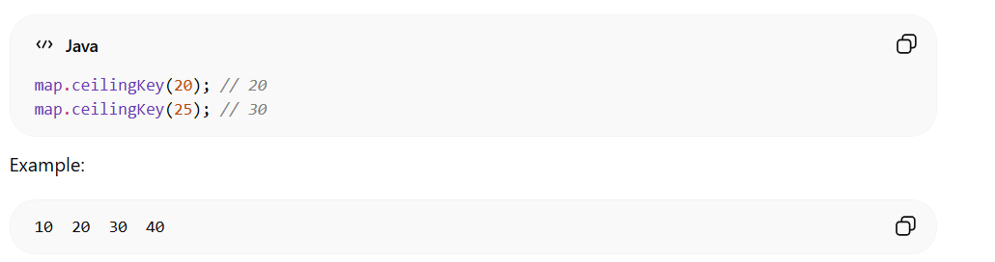
Input | Result
ceilingKey(20) | 20
ceilingKey(25) | 30
floorKey():
Meaning: Returns largest key ≤ given key
Think of floor = same OR next smaller.
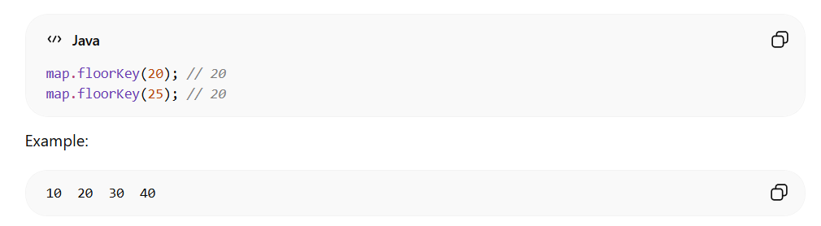
Input | Result
floorKey(20) | 20
floorKey(25) | 20

🧠 Easy Memory Trick
Method | Meaning
firstKey | smallest
lastKey | largest
higherKey | strictly greater
lowerKey | strictly smaller
ceilingKey | ≥ key
floorKey | ≤ key

