Treeset

TreeSet is also built on Red-Black Tree.
But it stores only values.
Internally it uses a TreeMap.
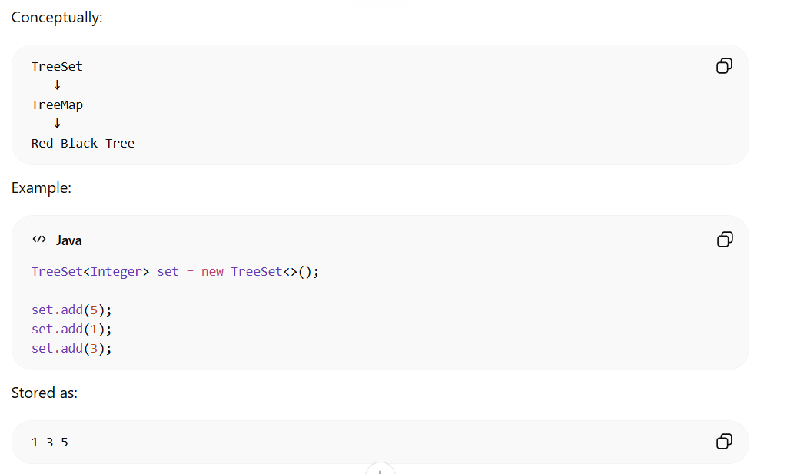

Properties
• Sorted
• No duplicates
• O(log n) operations

