Java

JVM architecture from Geeks for Geeks
Run time engine for java byte code.
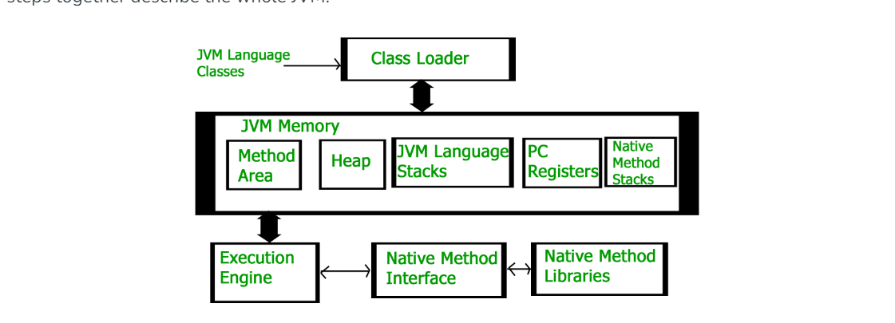
JVM Architecture:
Class Loader Subsystem:
Class Loader Subsystem is responsible for loading class files into memory. It follows a hierarchical delegation model consisting of three main class loaders.

Bootstrap Class loader:
- Responsible for loading core java libraries from rt.jar file (e.g.: java.lang, java.util etc).
- rt.jar file doesn’t exist from jdk 9. It is replaced by java platform module system(JPMS). So, now the core java files are available in module path which will be loaded by Bootstrap class loader.
Extension Class loader:
- Responsible for loading classes from ext directory (JAVA_HOME/lib/ext).
- These are the libraries that provide additional functionalities beyond core java API.
- Some of the libraries in ext directory are,
- javax.activation
- javax.annotation (contains classes like PostConstruct & PreDestroy)
- javax.net
- javax.mail
- javax.sql
- javax.swing ….etc
- So, it’s basically all classes from javax package.

Application (System) class loader
- Responsible for loading classes from the classpath.
- Classpath has all the maven dependencies and dependency jar files added to the application.
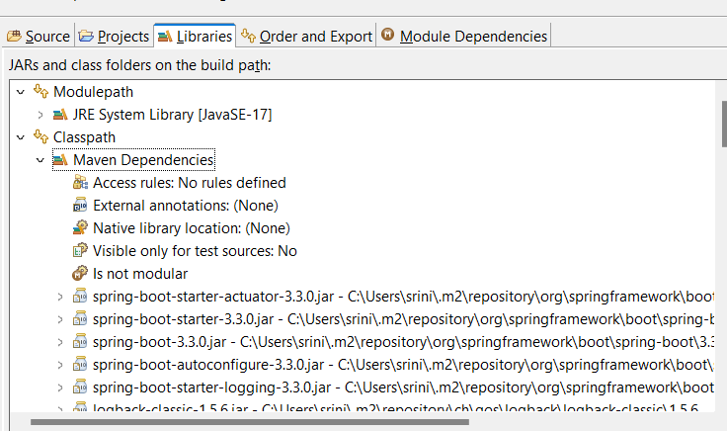

Class loading process:
It involves three steps
Loading:
--- Loading is the process of finding and importing the binary data(byte code) for a class.
--- The above-mentioned class loaders load all the class files in the application.
Linking:
Linking is a process of combining the binary representation of classes into runtime executable and preparing them for execution. Below are the steps,
Verification: This step ensures that the loaded classes are structurally correct and do not violate security constraints. It includes bytecode verification to check for potential security vulnerabilities.
Preparation: In this step, memory is allocated for static fields and variables of the class. Default values are assigned to these fields (e.g., 0 for integers, null for objects).
Resolution: References to other classes or methods are resolved. This involves replacing symbolic references in the bytecode with direct references to memory locations. This step ensures that all dependencies are resolved before execution.
Initialization:
In this phase, all static variables are assigned with their values defined in the code and static block(if any). This is executed from top to bottom in a class and from parent to child in the class hierarchy.
Memory areas in JVM :
Method Area: (Shared among all threads)
This stores the static variables, methods and static objects.
Method area is part of PermGen.
PermGen :
Permgen is the special heap space which is separated from main memory heap.
It stores class definitions :Information about loaded class, their names, super classes, interfaces, fields, and method descriptions.
Additionally, JVM stores all the static content in this memory section. This includes all the static methods, primitive variables and references to the static objects.
The default max size of Permgen in 32-bit system is 64mb and 82mb in 64bit system. However, we can change the default size with the JVM options by running some queries.
With its limited size, permgen is involved in generating the famous OutOfMemoryError.
String pool area is also part of permgen till java 7.
Heap area : (Shared among all threads)
All the objects that are created will be stored in heap area and is managed by garbage collector which automatically deallocates memory occupied by objects which are no longer referenced.
Heap area is divided into different generations,
young generation : Newly allocated objects are placed here
It is further divided into Eden space and survivor spaces.
Eden Space : Most new objects are allocated here.
Survivor Spaces (S0 and S1): Objects that survive a garbage collection in the Eden space are moved here.

Old generation (tenured generation) :
Objects that survive multiple garbage collection cycles in the Young Generation are promoted to the Old Generation. It typically contains long-lived objects.

Stack area: (Specific to each thread)
The stack area is a region of memory used for the execution of threads within a Java program. Each thread in a Java application has its own stack, which contains frames for each method invocation made by the thread.
It stores local variables, method parameters, and other method specific data required for method execution.
PC Registers (Specific to each thread):
The Program Counter register is a special-purpose register in the JVM that stores the address of the currently executing instruction.
It keeps track of the execution progress of the currently executing thread.
It points to the next instruction to be executed.
Native stacks (Specific to thread):
Native stacks refer to the memory used by native methods (methods written in languages like C or C++ and called from Java code using the Java Native Interface, or JNI).
Execution Engine:
Interpreter: Executes Java bytecode instructions sequentially.
Just-In-Time (JIT) Compiler: Compiles frequently executed bytecode into native machine code for faster execution.
Garbage Collector: Manages memory allocation and deallocation, reclaiming memory occupied by unused objects through garbage collection.

MetaSpace: Metaspace replaced Permgen area in java 8 because
Permgen has limitations with memory that a 64-bit OS has 82 mb of perm gen memory and 32-bit system has 68 mb and is part of Heap area/method area.
In Permgen we must manually increase the size by using some commands.
Metaspace is part of native memory (OS memory) and will automatically increases the memory if required and GC cleanups happen effectively in Metaspace.

Garbage Collector from Geeks for Geeks
To clean the heap memory from unreferenced objects.
It is a daemon thread which always runs in background.
An object can be made unreachable in 4 ways
Nullifying the reference
Reinitializing the reference
Object created inside method
Island of isolation
Two ways to request JVM to run GC
System.gc()
Runtime.getRuntime().gc()

Two activities in GC
Minor/ Incremental Garbage Collection
unreachable objects in the young generation heap memory are removed.
Major/ Full garbage Collection
It is said to have occurred when the objects that survived the minor garbage collection are copied into the old generation or permanent generation heap memory are removed.

Note: Just before destroying an object, GC calls the finalize() of an object.
finalize() :Deprecated from java 9 , now we have java.lang.ref.Cleaner class and java.lang.ref.PhantomReference which provides better ways to perform cleanup actions.

What is a memory leak in Java, and how can garbage collection help prevent it?
A memory leak occurs when objects that are no longer needed are still referenced, preventing their collection. While GC helps by automatically collecting unreferenced objects, preventing memory leaks requires careful coding practices to ensure references are properly managed.

How can you monitor garbage collection in Java?
Tools like JVisualVM, JConsole, and command-line options (-XX:+PrintGCDetails, -XX:+PrintGCTimeStamps) can be used to monitor GC activities and performance.

Generics in Java are a powerful feature introduced in Java 5 that allows you to define classes, interfaces, and methods with type parameters. These type parameters provide a way for you to specify the types of objects that a class, interface, or method can work with, which leads to stronger type-checking at compile-time, elimination of casting, and code reusability.
All the collection classes in Java are generic classes, that’s why we can use theses classes with any type of Objects.
List<E>, Set<E>, Map<K,V>.
Predicate, Supplier, Consumer and Function are generic interfaces.

Key Concepts of Generics
- Type Parameters: Generic types are defined with one or more type parameters inside angle brackets (<>). These parameters are placeholders for actual types.
- Parameterized Types: When you use a generic class, interface, or method, you specify the actual type arguments in place of the type parameters.

Optional class:
Optional class is introduced in java 8 and is a final class. It is a container class that helps us to handle with null values, avoid extra checks for null values and avoid potential NullPointerException.
Optional.empty();
Optional.ofNullable(Object o);
optional.isPresent();
optional.ifPresent(Consumer <T> action);
object creation in java:
- Using new keyword
Using the new keyword in java is the most basic way to create an object. This is the most common way to create an object in java. Almost 99% of objects are created in this way. By using this method, we can call any constructor we want to call (no argument or parameterized constructors).

- Using new instance
If we know the name of the class & if it has a public default constructor, we can create an object, Class.forName. We can use it to create the Object of a Class. Class.forName loads the Class in Java but doesn’t create any Object. To create an Object of the Class you must use the new Instance Method of the Class.

- Using clone() method
Whenever clone() is called on any object, the JVM creates a new object and copies all content of the previous object into it. Creating an object using the clone method does not invoke any constructor. In order to use the clone() method on an object we need to implement Cloneable and define the clone() method in it.

- Using deserialization
Whenever we serialize and then deserialize an object, JVM creates a separate object. In deserialization, JVM doesn’t use any constructor to create the object. To deserialize an object we need to implement the Serializable interface in the class.

- Using newInstance() method of Constructor class
This is similar to the newInstance() method of a class. There is one newInstance() method in the java.lang.reflect.Constructor class which we can use to create objects. It can also call the parameterized constructor, and private constructor by using this newInstance() method. Both newInstance() methods are known as reflective ways to create objects. In fact newInstance() method of Class internally uses newInstance() method of Constructor class.
Exceptions:
Exception in java is any event that disrupts the normal flow of a program during execution. Whenever an error occurs in a method the method will create an exception object and hands it over to runtime system. The runtime system will then find something to handle it.
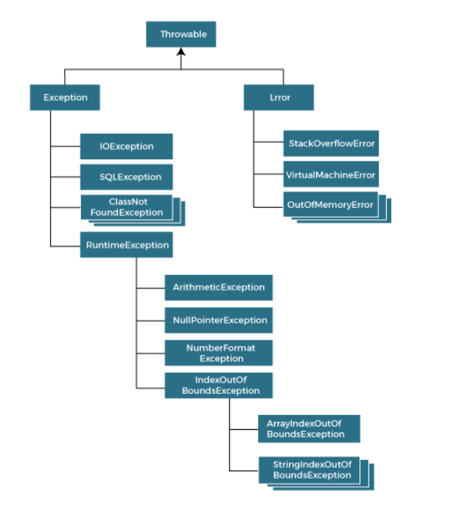

Checked exceptions:
These are exceptions that are checked at compile-time. If a method throws a checked exception, it must either handle the exception or declare it using the throws keyword.

Example: SQLException, ClassNotFoundException, IOException.

Unchecked Exceptions:
These are exceptions that are not checked at compile-time. They include RuntimeException and its subclasses.

Example: NullPointerException, ArrayIndexOutofBoundsException.

Errors:
These are serious problems that a reasonable application should not try to catch. Most errors are abnormal conditions.

Example: OutOfMemoryError, StackOverFlowError.

Handling Exceptions
Java uses a combination of try, catch, finally, and throw statements to handle exceptions.

try block: A block of code where exceptions can occur.
catch block: A block of code that handles the exception.
finally block: A block of code that is executed after the try and catch blocks, regardless of whether an exception was thrown or caught.
throw statement: Used to explicitly throw an exception.

Declaring Exceptions
When a method can throw a checked exception, it must declare it using the throws keyword.

Creating Custom Exceptions
You can create your own exception classes by extending the Exception class (for checked exceptions) or the RuntimeException class (for unchecked exceptions).

Exception Chaining
You can chain exceptions by passing one exception as the cause to another. This is useful for preserving the stack trace of the original exception.
try {
// Some code that throws SQLException
} catch (SQLException e) {
throw new MyCheckedException("Database error", e);}

Try-with-Resources: (from GFG)
In Java, the Try-with-resources statement is a try statement that declares one or more resources in it. A resource is an object that must be closed once your program is done using it. For example, a File resource or a Socket connection resource. The try-with-resources statement ensures that each resource is closed at the end of the statement execution. If we don’t close the resources, it may constitute a resource leak and also the program could exhaust the resources available to it.
Notes:
What are the differences between Exception and Error?
Exception is used for exceptional conditions that a program might want to catch, whereas Error represents serious issues that are typically not expected to be caught (e.g., OutOfMemoryError).

Can a finally block be skipped?
A finally block is generally executed even if a try or catch block contains a return statement. However, it can be skipped if the JVM exits (e.g., System.exit() is called) or the thread is interrupted/killed.

Can a try block be used without a catch block ?
Yes, a try block can be used without a catch block if it is followed by a finally block.

What happens if an exception is not caught ?
If an exception is not caught, it propagates up the call stack. If it reaches the top of the stack without being caught, the program terminates, and the stack trace is printed.

How can you handle multiple exceptions in a single catch block ?
You can handle multiple exceptions in a single catch block using multi-catch syntax introduced in Java 7.
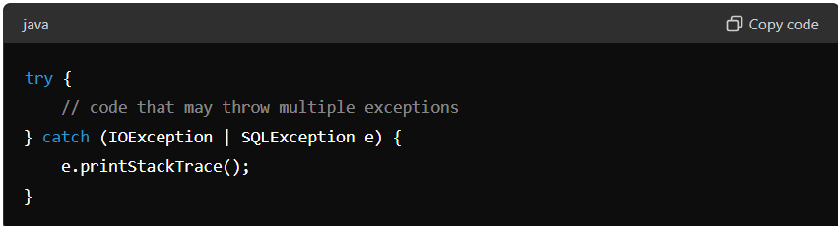

Can you catch more than one type of exception in a single catch block ?
Yes, you can use multi-catch syntax to catch multiple types of exceptions in a single catch block.

Is it possible to rethrow an exception ?
Yes, an exception can be rethrown in a catch block if you need to allow higher levels of the call stack to handle it.
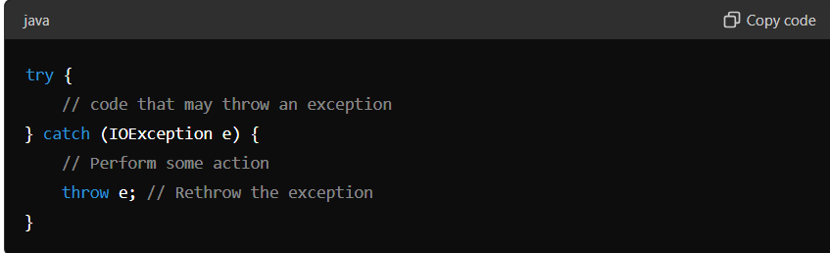

Collection Framework:

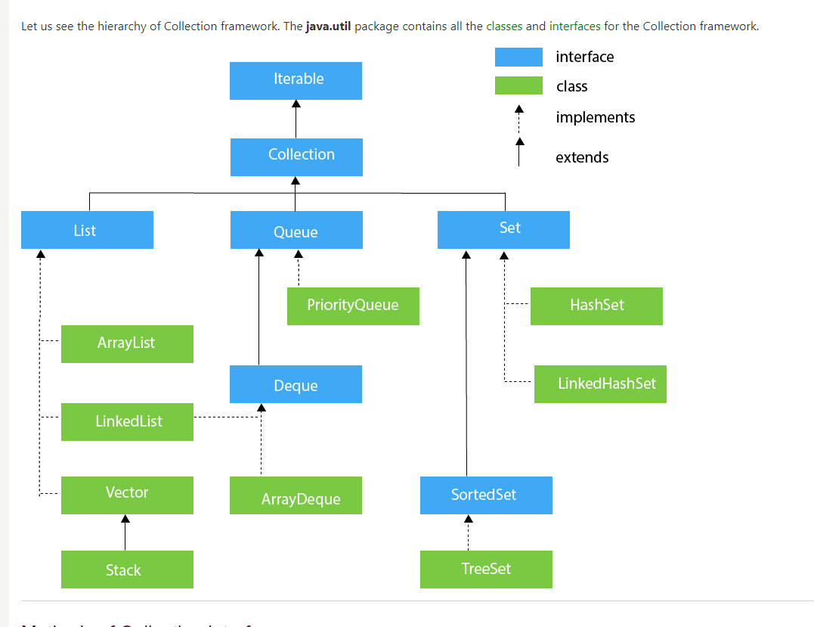

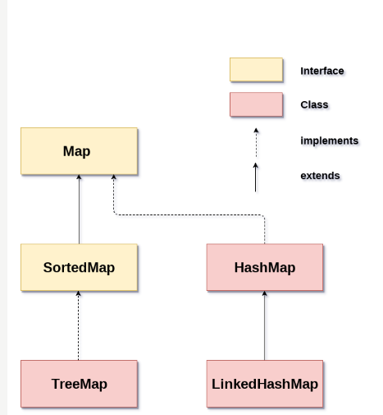

ArrayList :
ArrayList is an implementation class of List interface.
- It uses a dynamic array to store data.
- It maintains index. So, random access of elements is easy.
- ArrayList allows null and duplicate values.
- ArrayList` is not synchronized, which means it is not thread safe. If multiple threads access an `ArrayList` concurrently, proper synchronization is required.
- Generally, we can create an ArrayList<>(10) by sending capacity. If we don’t send any then by default the size will be 10.
- When the size of an ArrayList exceeds the capacity increases by 50%.

elements in an ArrayList in Java are stored in contiguous memory. This is because an ArrayList is backed by a dynamically resized array, which is a contiguous block of memory.

LinkedList:
A LinkedList in Java is an implementation of the List and Deque interfaces, part of the Java Collections Framework, and is found in the java.util package.
It represents a doubly linked list where each element (node) contains references to the previous and next element, allowing for efficient insertion and removal operations.
- Uses doubly linked nodes to store data.
- Each node stores data, link to prev node and link to next node.
- It doesn’t maintain index.
- Unlike arrays, the elements are not stored in contiguous memory locations.

• Efficient Insertion/Removal: Inserting or removing an element involves changing a few references, making these operations efficient (O(1) for adding/removing at the ends).
• Sequential Access: Accessing elements by index requires traversal from the beginning or end of the list, making random access operations slower (O(n)).
• Allows Nulls: LinkedList can store null values.
• Implements Deque Interface: Supports both stack and queue operations.

Arraylist vs Linkedlist:
In Java, ArrayList and LinkedList are both implementations of the List interface, but they have different underlying data structures and performance characteristics, making them suitable for different scenarios. Here’s a comparison:

ArrayList
- Underlying Data Structure: ArrayList uses a dynamically resizable array to store elements.
- Access Time: Provides O(1) time complexity for accessing elements by index. This is because it uses an array internally, so accessing an element is a direct operation.
- Insertion and Deletion:
  - End of List: Adding an element at the end is generally O(1). However, if the array is full, resizing it (which involves creating a new array and copying elements) makes it O(n).
  - Middle of List: Inserting or deleting elements in the middle of the list requires shifting elements, resulting in O(n) time complexity.
- Memory Usage: More memory efficient in terms of per-element overhead because it only stores the data elements without additional pointers.

LinkedList
- Underlying Data Structure: LinkedList uses a doubly linked list, where each element (node) contains a reference to both the next and previous elements in the list.
- Access Time: Accessing elements by index has O(n) time complexity because you must traverse the list from the beginning or the end to reach the desired index.
- Insertion and Deletion:
  - Anywhere in the List: Inserting or deleting elements is O(1) if you already have a reference to the node. However, finding the node takes O(n), making the overall operation O(n) in the general case.
- Memory Usage: Higher memory overhead per element due to the additional references (pointers) for the next and previous elements.
- LinkedList doesn’t have a capacity and load factor as it doesn’t pre-allocate memory like arrays. LinkedList dynamically allocates memory for each element.

When to Use Each
- Use ArrayList when:
  - You need fast random access to elements (i.e., retrieving elements by index frequently).
  - You mostly add or remove elements at the end of the list.
  - Memory overhead is a concern.
- Use LinkedList when:
  - You need to frequently add or remove elements from the beginning or the middle of the list.
  - You do not need to access elements by index frequently

Vector :
Vector is same as ArrayList except that vector has synchronized methods and increases size by 100%.
ArrayList vs Vector:

- Both use Dynamically resizable array for storing data
- ArrayList is non synchronized whereas Vector is Synchronized
- ArrayList resizes by 50%
- Vector resizes by 100%

Stack:
Stack implements List and extends Vector So, providing synchronized methods inherited from Vector.
It follows LIFO Structure.

Methods:
• Push and Pop Operations:
- push(E item): Pushes an item onto the top of the stack.
- pop(): Removes the object at the top of this stack and returns that object as the value of this function.
• Peek and Empty Check:
- peek(): Looks at the object at the top of this stack without removing it from the stack.
- empty(): Tests if this stack is empty.
• Search Operation:
- search(Object o): Searches for the specified object in this stack and returns its position relative to the top of the stack. The topmost item is considered to be at position 1.

Set :
Set is an interface which extends Collection interface. Properties of set are,
- It doesn’t allow duplicate values to be stored.
- It allows only one null element.
- It will not maintain any order and index for the elements.
Set is further implemented by classes HashSet, LinkedHashSet and TreeSet.
HashSet:
-HashSet uses HashMap to store elements, any element added to HashSet will be added as a key to HashMap with a constant dummy value.
-It doesn’t maintain any order and index and allows only one null element.
-Initial capacity is 16 and load factor is 0.75 i.e. increases the capacity by 100% when the size of HashSet is 75% of the capacity.
-HashSet is not thread safe.

LinkedHashSet:
  - It has features of HashSet and LinkedList. It stores only unique elements and maintains order of insertion.
  - LinkedHashSet uses LinkedHashMap to store the elements. All the elements added to a LinkedHashSet will be stored as a key in LinkedHashMap with a dummy object as value.
HashSet vs LinkedHashSet:
HashSet internally uses HashMap to store elements and LinkedHashSet uses LinkedHashMap to store elements.
HashSet doesn’t maintain order of insertion where as LinkedHashSet maintains the order of insertion.
Both HashSet and LinkedHashSet offers constant time performance for the basic operations (add, remove, contains, and size), assuming the hash function disperses the elements properly among the buckets.
LinkedHashMap uses more memory for storage as it maintains the links to previous and next nodes.
Both are not thread safe.
If we don’t care about order of insertion, then we can use HashSet.
HashMap :
- HashMap in java is an implementation of Map interface and is part of Collection framework
- Hashmap stores data in key value pairs.
- It allows only unique keys, one null key and values can be duplicate.
- It stores elements in array of buckets and each bucket is a LinkedList.
- By default, initial capacity of Hashmap is 16 and load factor is 0.75. doubles the size if threshold reaches.
Indexing in HashMap:
First the hash of key is calculated. Typically, this is done by calling hashcode(). Which returns the integer representation of the key object.
Using this hash and size of array, some calculation will be made to find out index.
General formula is hash% array length.
Hash Collision occurs when we get same calculated index for two elements. This is handled by using equals() method.
If the two elements are same then the new value overrides the existing value, otherwise the second element is stored in same index using a linked list.
Here the elements are stored as a Node object that implements Map.Entry interface.
Node has variables hash, key, value, next (next node within the same bucket).

LinkedHashMap:
- It maintains the insertion order of elements.
- Internally, LinkedHashMap uses a doubly linked list to keep track of the order of entries. Each entry keeps a reference to the previous and next entry.
Iteration Order: By default, LinkedHashMap maintains the insertion order. However, it can also be configured to maintain access order (from least-recently accessed to most-recently accessed), which is useful for creating LRU (Least Recently Used) caches.
HashMap vs LinkedHashMap:
- Hashmap doesn’t maintain any order whereas LinkedHashMap maintains order.
- For both, The time complexity for basic operations like insertion, deletion, and lookup is O(1) on average.
- HashMap typically need less memory as it only stores key and value pairs, whereas LinkedHashMap additionally stores a LinkedList to maintain insertion order.
- Iteration order is not guaranteed in hashmap. In LinkedList elements are iterated in insertion order.
• HashMap: Modification during iteration might cause ConcurrentModificationException unless done through iterator's remove() method.
• LinkedHashMap: Modification during iteration might cause ConcurrentModificationException unless done through iterator's remove() method.

In Java, HashMap and Hashtable are two distinct classes that provide similar functionality but have important differences. The HashMap class does not use Hashtable internally. Instead, both are separate implementations of a hash-based data structure.
Differences Between HashMap and Hashtable
Thread Safety:
Hashtable is synchronized, which means it is thread-safe and can be safely used by multiple threads concurrently without additional synchronization.
HashMap is not synchronized and is not thread-safe. If you need thread safety with HashMap, you can use Collections.synchronizedMap() or ConcurrentHashMap.
Null Values and Keys:
Hashtable does not allow null keys or values. If you try to insert a null key or value, it will throw a NullPointerException.
HashMap allows one null key and multiple null values.
Performance:
Because Hashtable is synchronized, it generally has slower performance compared to HashMap due to the overhead of synchronization.
HashMap is faster in a single-threaded environment because it does not have the synchronization overhead.
Inheritance:
Hashtable is a part of the legacy collection classes and is a subclass of the Dictionary class.
HashMap is part of the Java Collections Framework and implements the Map interface.
Initial Capacity and Load Factor:

Both classes allow you to specify the initial capacity and load factor, but their default values and resizing mechanisms are similar.
Hashmap vs ConcurrentHashmap:

- HashMap is not thread safe whereas concurrent hashmap is thread safe.
- Hashmap provides failfast iterators i.e if any modification is done after creating the iterator for the map, it will through ConcurrentModificationException.
- ConcurrenthashMap provides segment locking based on concurrency defined
- So, while manipulating the concurrenthashMap it provides lock over the segment for thread safety.

IO streams in java:
Java provides 3 standard streams which are commonly used,
System.out : This is a standard output stream provided by java used to produce output onto monitor.
System.out provides methods like,
Print() : prints the output on to the console and holds the cursor in same line.
Println() : prints the output on the console and moves cursor to next line.
Printf() : It’s like printf() in c/c++. printf() is used to print formatted Strings to the console. It provides more control on the output format.
Syntax: System.out.printf(String format, Object... args);
format : a string that specifies the desired format.
Args: arguments referenced by the format specifiers in format string
Example:
int num = 42;
System.out.printf("The number is: %d%n", num);
System.in is a standard input stream provided by java to take the input from keyboard or any other input device.
System.err is used to output error messages. By default, it outputs to the standard error stream, which is typically the console.
Can be redirected to different outputs using System.setErr.

Depending on the type of operations streams can be divided into two primary classes.
InputStream: Input Stream: These streams are used to read data that must be taken as an input from a source array or file or any peripheral device. For e.g., FileInputStream, BufferedInputStream, ByteArrayInputStream etc.
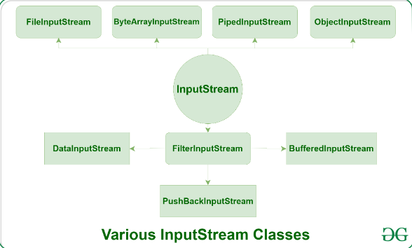

OutputStream:
These streams are used to write data as outputs into an array or file or any output peripheral device. For eg., FileOutputStream, BufferedOutputStream, ByteArrayOutputStream etc.
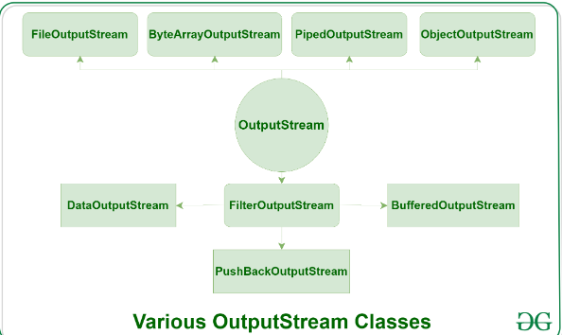
Depending on the types of files, Streams can be divided into two primary classes which can be further classes as shown in figure below,
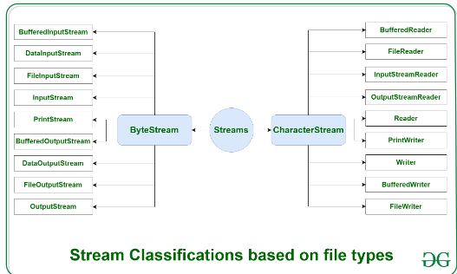
ByteStream: This is used to process data byte by byte (8 bits).FileInputStream and FileOutputStream are popular and most used classes.
CharacterStream: In Java, characters are stored using Unicode conventions (Refer this for details). Character stream automatically allows us to read/write data character by character. Though it has many classes, the FileReader and the FileWriter are the most popular ones.

Java NIO (New I/O) is a collection of APIs introduced in Java 1.4 to provide non-blocking I/O operations. Java NIO provides a different way to handle I/O compared to traditional I/O (java.io package), offering more scalability and better performance, especially for high-volume I/O operations. Here, we'll explore how to read from and write to files using Java NIO.
Need to learn more…..
Java 8:
Lambda Expression:
Before lambda expressions we used anonymous inner classes to provide the implementations for functional interface.
Example:
// Traditional way using anonymous inner class
Runnable r1 = new Runnable() {
@Override
public void run() {
System.out.println("Hello World!");
}
};

// Using lambda expression
Runnable r2 = () -> System.out.println("Hello World!");
Example functional interfaces:
Predicate, Supplier, Consumer, Function, BiFunction.
Can lambda expressions capture local variables from their enclosing scope?
Yes, lambda expressions can capture local variables from their enclosing scope. However, these local variables must be effectively final, meaning they cannot be modified after being assigned.
Can a lambda expression throw exceptions? If yes, how can they be handled?
- Yes, a lambda expression can throw exceptions. These exceptions must be handled appropriately. If the functional interface's method signature includes a throws clause, the lambda expression can also throw checked exceptions. Otherwise, you need to handle the exception within the lambda body.
Functional interfaces,
Stream API:
How do intermediate and terminal operations differ in the Stream API?
- Intermediate operations return a new stream and are lazy, meaning they do not process elements until a terminal operation is invoked. Examples include filter, map, and sorted. Terminal operations produce a result or a side-effect and trigger the processing of the stream, such as collect, forEach, and reduce.

What is the difference between map and flatMap?
- map transforms each element of the stream into another form, returning a stream of the same number of elements. flatMap is used when each element can be transformed into multiple elements, effectively flattening a stream of streams into a single stream.
Default Interface:
Purpose:
- Backward Compatibility: Allows interfaces to add new methods without breaking existing implementations.
- Code Reusability: Provides common functionality that can be shared across multiple classes.
Optional Class:
What is the difference between Optional.of() and Optional.ofNullable()?
- Optional.of() requires a non-null value and throws NullPointerException if the value is null, whereas Optional.ofNullable() can accept null and returns an empty Optional if the value is null.

BeanFactory vs ApplicationContext
ApplicationContext is indeed a derived from BeanFactory

Method Binding in java
Connecting method call to method implementation is called method binding. If this connection happens at compile time, it’s called static method binding. And if it happens at run time, it is called Dynamic binding.

Abstract classes can have constructors, but they cannot be instantiated directly. The constructors are used when a concrete subclass is created.

Difference Between Abstract classes and interfaces from Java 8 is that Abstract classes can have a constructor, but interfaces cannot.

Arrays.binarySearch(array, element); returns index of element in array or -1 if not present.
Object class is the super class for all the java classes and have methods,
getClass ()
hashCode ()
toString ()
equals ()
finalize () : Deprecated from java 9 , now we have java.lang.ref.Cleaner class and java.lang.ref.PhantomReference which provides better ways to perform cleanup actions.
clone ()
notify () & notifyAll ().

Cloneable is a marker Interface in java which enables the object. clone () of the implementing class.

Java String is immutable because the strings with same content share the same storage in single pool. (learn more from GFG)
String str = knowledge.
String s = str.
Str = str+” base”.
Now sysout(str) prints Knowledge base.
But string pool has two objects s(knowledge) and str (knowledge base)
String objects are immutable but not the references.
Serialization is a concept of representing an object’s state as a byte Stream.
Serialization is done using ObjectOutputStream & ObjectInputStream.
Serializable interface is implemented if the class wants its instances to be serialized or deserialized.
Ways to create an object in java,
new keyword
newInstance() of Class object
Class ob = Class.forName()
ob.newInstance();
clone() to enable this method, need to implement Cloneable interface.
It doesn’t invoke any constructor.
StringBuffer :
To create mutable string object.
It is synchronized i.e; thread safe.
StringBuilder:
To create mutable String object.
It is not synchronized i.e; not thread safe. So, faster than StringBuffer.
Custom Immutable Class:
It can be created by declaring the class as final, all variables as final and no setter methods.

Transient keyword:
Transient is a variable modifier which is used during serialization, to specify that the variable value shouldn’t be serialized.
Ex: private Transient String password;
Notes:
Using transient with static fields has no use as static fields are not part of object.
Final variables are directly serialized by their values so transient doesn’t work there.
Custom Immutable Class
Declare class as final
All datamembers as final
No setter methods.
Hashtable
HashMap and internal working
Hash Collision
Concurrent Hashmap
Notes:
Whenever we put an element into hashmap It will first get the hashcode of that key and then from hashcode it generates the index by formula as below
Index = Hashcode & (n-1) n being the size of hashmap.
For null, hashcode will be 0 So, null key will be stored at 0 index
When same index is generated for multiple entries, Hashcollision occurs, then,
It will be checked if both keys are same, if same ? new value will replace old value : It will internally create a linked list and stores the new entry there. Hence, storing multiple elements in single bucket.
Repositories in Spring
Repository
This is a base Interface and is a marker Interface.
CRUD Repository
This interface extends Reposoitory interface and provides basic methods like save, find & delete for crud operations.
Paging and Sorting repository
This interface extends CRUD Repository and provides utility methods for Pagination and Sorting.
JPA Repository
This interface extends Paging and Sorting interface and provides utility methods like findAll, flush, saveAndFlush, deleteInBatch.
NOTES
Hibernate is the default JPA provider for SpringBoot, All the JPA method implementations are given by Hibernate.
SpringDataJPA
SpringDataJPA is a part of Spring Data project and is an abstraction above JPA.
Spring Data simplifies the interaction with database using Java objects. It completely removes the implementation of JPA interfaces. It also removes the Broilerplate code for creating EntityManager and EntityManagerFactory beans and provides TransactionManagement.

Implementation:
We need to add Spring boot starter Data JPA dependency. Use @Repository on DAO interface and extend any JPARepositories.
@Component vs @Bean
Both are used to register a bean In Application Context
@Bean is method level annotation used on methods that return beans. Class that has @Bean Annotation methods, must be annotated with @Configuration.
@Component is class level annotation, all the classes with this annotation will be scanned to IOC.
BeanFactory post processor and BeanPostProcessor
Volatile is a keyword used with variables to state that the variable will not be cached as it will be updated by multiple threads at a time. So, the changes done to volatile variables are directly written to main memory and are visible to all the other threads.
@SpringBootApplication is a combination of @Configuration, @ComponentScan and @EnableAutoConfiguration
Transaction management:
A transaction is a sequence of pipelined actions performed in an application to complete an operation. If any of these actions is failed and operation got committed, then it would be an automicity breach.
To handle this situation, we use Transaction Management.
We make use of below 2 annotations,
@EnableTransactionManagement on starter class of Springboot application.
@Transactional can be used on Classes and Methods
If used on class, all the methods of that class are executed as a separate transaction each.
If used on method, a separate transaction is created for that method.
Transaction Propagation
Transaction Propagation means carrying forward a transaction to next level (service to repo)
Propagation.REQUIRED Spring checks if there is an active transaction exists, if not exists then creates a new transaction otherwise executes in the existing transaction.
Propagation.SUPPORTS If an active transaction exists then uses it otherwise executes non transactional.
Propagation.REQUIREDNEW always creates a new transaction.
application.properties file overrides application.yml files
Coupling and Cohesion
Generally, when we design an application, we design it in modules where each module has its own functionality.
Coupling means the degree to which these modules are dependent on each other. If the modules are tightly coupled the changes in one module will affect other modules as well.
Cohesion means the degree to which the elements within a module work together to serve a same purpose. High cohesion means the elements are closely related and work on same purpose.
A good software design would have high cohesion and loose coupling.
Put vs Patch HTTP request.
Spring Cloud:
Spring cloud is a collection of projects that are ready to be used for our applications. It provides Service Discovery(Netflix-Eureka), Load Balancing(Spring Cloud load balancing, Netflix ribbon), API Gateways (Spring Cloud gateway), Circuit breakers(Resilience4j). All these patterns can be used in our project by just adding the dependencies.
Equals() & hashcode() contract
Parellel Stream vs Sequential Stream
Stream uses a single thread on single core to execute the pipelined operations. Whereas parallel streams use multiple threads on multiple cores to execute the pipelined operations.
ParallelStream() from Collection framework can be used for Parellel streaming.
Map() vs FlatMap()
map() and flatMap() are two intermediate operations we use with streams, map takes each element of stream as input and returns one output element for each input element.
Map() takes function<T,R > as an argument, applies it to each element and returns a stream of type stream<R>. this is one to one mapping.
FlatMap() does both mapping and flattening, It processes stream of streams.
It takes Function<T, Stream<R>> as an argument and for each element produces a stream of type stream<R>. this is one to many mappings.
SpringBoot Actuator
Using this dependency, we can monitor and manage the spring web applications. Actuator makes the metrics of the application available through http endpoints and JMS.
We need to add spring-boot-starter-actuator dependency to our application and make some configurations.
Adding spring-boot-starter-actuator will enable the /actuator endpoint and provides some built-in endpoints like /actuator/beans, /actuator/health.
We can also write custom actuator endpoints for application related metrics by following the below steps.
- As we need new endpoints. obviously, we need to write @RestController class
- Along with @RestController class we also need to use @Endpoint(id = “custom”) to make it an actuator endpoint.
- Inside this class we write methods annotated with @ReadOperation, @Writeoperation, @DeleteOperation which are just like @Get/Put/DeleteMappings.
- @RestController
- @Endpoint(id="custom")
- public class CustomEndpoint {

- @ReadOperation
- public CustomEndpointResponse getResponse() {
- return new CustomEndpointResponse("message", 1234);
- }

- }
application.properties:
#exposes all default actuator endpopints
management.endpoints.web.exposure.include=*
# gives some extra details when we hit /actuator/health endpoint
management.endpoint.health.show-details=always
#enables custom endpoint
management.endpoint.custom.enabled=true

Prometheus
Prometheus is an open-source solution written in Go to collect data from various sources and store it in time series database.
Core components:
Data scraper to pull data periodically from various sources like Http endpoints.
A time series database to store all the metrics.
A simple user interface to visualize collected data.
Alerting functionality can also be used.
Grafana
Grafana is a visualization tool. It allows us to get data from various sources like Elastic search, Prometheus and Graphite and visualize them with beautiful graphs. It also allows us to set alert rules based on metrics data. It can notify over mail or slack channels.
Future and CompletableFuture
Future and CompletableFuture, both are abstractions to represent the result that will be available in future. Using these interfaces, we can execute the code on a separate thread.
CompletableFuture has methods like supplyAsync(), thenApply(), thenCombine() methods.
CompletableFuture is a class from java.util.concurrent and implements Future and CompletionStage interfaces.
2 DB connected in SpringBoot (From Baeldung)
We can do this in SpringBoot by,
write the Entities of each DB and put them in separate packages.
Write 2 Configuration classes to configure the EntityManagerFactoryBean that takes the DataSource of the DB.
@Bean method that return DataSource Bean.
@Bean method that returns EntityManagerFactoryBean.
@Bean method that returns TransactionManager.
For these two configuration classes add @EnableJPARepositories with parameters as below
@Configuration
@PropertySource({ "classpath:persistence-multiple-db.properties" }) @EnableJpaRepositories(
basePackages = "com.baeldung.multipledb.dao.user", entityManagerFactoryRef = "userEntityManager",
transactionManagerRef = "userTransactionManager")
Call by value and Call by reference in java.
https://www.prepbytes.com/blog/java/call-by-value-and-call-by-reference-in-java/

Git Rebase: https://git-scm.com/book/en/v2/Git-Branching-Rebasing
Git rebase is better way to merge your changes on to master.
Let’s say we pull from master and create our feature branch and making changes to our feature and committed the changes to feature.
But some other developers are also working on the same repository and while we were making our changes they have committed and pushed changes to master.
Now the last commit on remote master is different from the last commit on our local master.
Here if we use rebase (git rebase master) our local master get updated as remote master by rewriting the missing commits. So now it looks we have done the changes after the missing commits were also pulled to our local.

Drawbacks:
We need to be careful as rebase command rewrites the commits by changing the commitIds, there is a possibility for loss of commits.
//what will be the output here
public class Problem6 {
public static void main(String[] args) {
List<Integer> list = Arrays.asList(1,2,3,4);
list.stream().filter(a->{
System.out.print(a+"");
return a>2;
});
}

}

//Nothing is printed here, because there is no terminal operation.

//Without a terminal operation, the stream pipeline remains inactive, and no processing occurs.
//The intermediate operations are lazily evaluated, meaning they're only executed when a terminal operation is invoked.

Fail-fast and fail-safe iterators : (Summarized as notes for quick revision)
Generally, we use iterators to parse through Collections in Java. Fail fast iterators throw ConcurrentModification Exception if there is any structural modification to the collection.
ArrayList, HashMap and HashSet provide fail-fast iterators and Concurrenthashmap provides fail-safe iterator.
When you call list.remove() while iterating over a list using an enhanced for loop or an explicit iterator, the iterator or the enhanced for loop does not have a way to detect the modification made to the list during the iteration. This can lead to inconsistencies or unexpected behaviour.
Whenever we use an ArrayList and make a modification by parsing through it using an Iterator or enhanced for loop, below is what happen,
Enhanced for loop:
When you use an enhanced for loop (for-each loop) to iterate over a list, it internally uses an iterator. If the list is structurally modified (elements are added or removed) during the iteration using methods like list.remove(), it can lead to an inconsistency between the iterator's state and the list's state, causing ConcurrentModificationException to be thrown.
Iterator:
• When you use an iterator to iterate over a collection, it has an associated modification count that is used to detect concurrent modifications. Each time a structural modification is made to the list (such as adding or removing elements), the modification count of the list is incremented. When the iterator detects that the modification count has changed since the iterator was created, it throws ConcurrentModificationException to prevent inconsistent behaviour.
• iterator.remove() method, on the other hand, is designed to safely remove the current element from the underlying collection without causing a ConcurrentModificationException. It updates the iterator's internal state to reflect the removal of the element and the modification count of the underlying collection.

Notes:
AbstractList class has a variable modCount, which will be updated every time there is an addition or removal of an element from the list.
Iterator object returned by ArrayList also has a variable with name expectedModCount which will reflect ArrayList’s modCount.
While updating the list using list.remove() the modCount of list is updated but, the value for expectedModCount variable of iterator object is not updated.so, iterator while iterating identifies that there is a mismatch with modCount with expectedModCount, hence throws ConcurrentModificationException.
Refer to program in package FailFastIterators; in java_basics project.
Lazy loading:
Deferring the creation and initialization of objects as long as we can is called lazy loading.
Lazy and Eager loading of objects in hibernate :
When working with ORM frameworks, let’s say if there are objects with ‘HAS’ relationship, hibernate can load dependant objects by fetch = FetchType.lazy (loaded to memory when the getMethods to that objects are called) and can load fetch = FetchType.Eager(loaded along with the containing object).
By default, hibernate do lazy loading of objects to avoid loading unnecessary objects to memory.
https://www.baeldung.com/hibernate-lazy-eager-loading
Lazy and Eager loading of Spring beans:
Loading Spring beans can be done lazily or eagerly.
Lazy loading defers the creation of bean, So a bean is created only when we want to use it. This can be done by using @lazy on the bean definition and @lazy along with @Autowired.

By default, BeanFactory does lazy loading i.e. creates and initializes bean only when the bean is requested.
By default, ApplicationContext does Eager loading i.e. creates the beans at the time of container creation.

https://howtodoinjava.com/spring/spring-bean-eager-vs-lazy-init/

JVM Architecture:
Class Loader Subsystem:
Class Loader Subsystem is responsible for loading class files into memory. It follows a hierarchical delegation model consisting of three main class loaders.

Bootstrap Class loader:
- Responsible for loading core java libraries from rt.jar file (e.g.: java.lang, java.util etc).
Extension Class loader:
- Responsible for loading classes from ext directory (JAVA_HOME/lib/ext).
- These are the libraries that provide additional functionalities beyond core java API.
- Some of the libraries in ext directory are,
- javax.activation
- javax.annotation (contains classes like PostConstruct & PreDestroy)
- javax.net
- javax.mail
- javax.sql
- javax.swing ….etc
- So, it’s basically all classes from javax package.
Application (System) class loader
- Responsible for loading classes from the classpath.
- Classpath has all the maven dependencies and dependency jar files added to the application.

Class loading process:
It involves three steps
Loading:
--- Loading is the process of finding and importing the binary data(byte code) for a class.
--- The above mentioned class loaders load all the class files in the application.
Linking:
Linking is a process of combining the binary representation of classes into runtime executable and preparing them for execution. Below are the steps,
Verification: This step ensures that the loaded classes are structurally correct and do not violate security constraints. It includes bytecode verification to check for potential security vulnerabilities.
Preparation: In this step, memory is allocated for static fields and variables of the class. Default values are assigned to these fields (e.g., 0 for integers, null for objects).
Resolution: References to other classes or methods are resolved. This involves replacing symbolic references in the bytecode with direct references to memory locations. This step ensures that all dependencies are resolved before execution.
Initialization:
In this phase, all static variables are assigned with their values defined in the code and static block(if any). This is executed from top to bottom in a class and from parent to child in the class hierarchy.
Memory areas in JVM :
Method Area: (Shared among all threads)
Method area stores the class and interface definitions. For all the classes that are loaded by class loaders, memory is allocated in method area.
This stores the static variables, methods and static objects
PermGen :
Permgen which was used in HotSpot JVM part of method area till java 7 stores data like,
Class definitions :Information about loaded class, their names, super classes, interfaces, fields and method descriptions
Constants
String pool area is also part of permgen till java 7.
Heap area : (Shared among all threads)
All the objects that are created will be stored in heap area and is managed by garbage collector which automatically deallocates memory occupied by objects which are no longer referenced.
Heap area is divided into different generations,
young generation : Newly allocated objects are placed here
It is further divided into Eden space and survivor spaces.
Eden Space : Most new objects are allocated here.
Survivor Spaces (S0 and S1): Objects that survive a garbage collection in the Eden space are moved here.
Old generation (tenured generation) :
Objects that survive multiple garbage collection cycles in the Young Generation are promoted to the Old Generation. It typically contains long-lived objects.

Stack area: (Specific to each thread)
The stack area is a region of memory used for the execution of threads within a Java program. Each thread in a Java application has its own stack, which contains frames for each method invocation made by the thread.
It stores local variables, method parameters, and other method specific data required for method execution.
PC Registers (Specific to each thread):
The Program Counter register is a special-purpose register in the JVM that stores the address of the currently executing instruction.
It keeps track of the execution progress of the currently executing thread.
It points to the next instruction to be executed.
Native stacks (Specific to thread):

Execution Engine:
Interpreter: Executes Java bytecode instructions sequentially.
Just-In-Time (JIT) Compiler: Compiles frequently executed bytecode into native machine code for faster execution.
Garbage Collector: Manages memory allocation and deallocation, reclaiming memory occupied by unused objects through garbage collection.

MetaSpace: Metaspace replaced Permgen area in java 8 because
Permgen has limitations with memory that a 64 bit OS has 82 mb of perm gen memory and 32 bit system has 68 mb and is part of Heap area/method area.
In Permgen we must manually increase the size by using some commands.
Metaspace is part of native memory (OS memory) and will automatically increases the memory if required and GC cleanups happen effectively in Metaspace.

- Interpreter: Executes Java bytecode instructions sequentially.
- Just-In-Time (JIT) Compiler: Compiles frequently executed bytecode into native machine code for faster execution.
- Garbage Collector: Manages memory allocation and deallocation, reclaiming memory occupied by unused objects through garbage collection.

- The stack is primarily used for managing method invocation and execution context for each thread in a Java application.
- It stores local variables, method parameters, and other method-specific data required for method execution.

Detailed Architecture of the JVM

1. Class Loader Subsystem
The Class Loader Subsystem is responsible for loading class files into memory. It follows a hierarchical delegation model consisting of three main class loaders:
- Bootstrap Class Loader:
  - Loads the core Java libraries (e.g., java.lang, java.util) located in the JAVA_HOME/lib directory.
  - Implemented natively in the JVM.
- Extension Class Loader:
  - Loads classes from the ext directory (JAVA_HOME/lib/ext).
  - It is a child of the Bootstrap Class Loader.
- Application (System) Class Loader:
  - Loads classes from the application's classpath, which includes user-defined classes and libraries.
  - It is a child of the Extension Class Loader.

Class Loading Process
The class loading process involves three primary steps:
- Loading: The bytecode of a class is read from the file system or network.
- Linking:
  - Verification: Ensures the bytecode adheres to JVM specifications and does not violate security constraints.
  - Preparation: Allocates memory for class variables and sets them to default values.
  - Resolution: Converts symbolic references (e.g., class names) into actual references.
- Initialization: Executes static initializers and the initial values of static fields.

2. Runtime Data Areas
The JVM organizes memory into several runtime data areas that are used during the execution of a program.
- Method Area: Shared among all threads, this area stores class-level information such as the runtime constant pool, method data, and the code for methods.
- Heap: Shared among all threads, it is used for dynamic memory allocation for Java objects and JRE classes.
- Java Stack: Each thread has its own Java stack, which stores frames. Each frame holds local variables, the operand stack, and a reference to the constant pool of the current method's class.
- PC (Program Counter) Register: Each thread has its own PC register, which points to the next instruction to be executed.
- Native Method Stack: Each thread has its own native method stack, used for executing native (non-Java) methods via JNI (Java Native Interface).

3. Execution Engine
The Execution Engine is the heart of the JVM, responsible for executing the bytecode. It includes the following components:
- Interpreter: Reads and executes bytecode instructions one at a time. It is simple and effective for small applications but can be slower for large applications.
- Just-In-Time (JIT) Compiler: Translates bytecode into native machine code at runtime, significantly improving execution speed. It uses several optimization techniques:
  - Method Inlining: Replaces a method call with the actual method code.
  - Loop Unrolling: Reduces the overhead of loop control.
  - Dead Code Elimination: Removes code that is never executed.
- Garbage Collector (GC): Manages memory automatically, freeing up memory used by objects that are no longer reachable. The JVM supports several GC algorithms, each suited to different use cases.

4. Native Interface
The JNI (Java Native Interface) allows Java code running in the JVM to interoperate with applications and libraries written in other languages like C or C++. This interface provides the ability to:
- Call native methods from Java.
- Call Java methods from native code.
- Access Java objects and arrays from native code.

5. Native Method Libraries
These are libraries written in languages like C or C++ that the JVM uses to perform tasks such as interacting with the underlying operating system. The JVM loads these libraries when native methods are called.

Memory Management and Garbage Collection
The JVM memory management model includes several key components and processes to ensure efficient use of memory.

Heap Structure
The heap is divided into generations for efficient garbage collection:
- Young Generation: Where all new objects are allocated. It is further divided into:
  - Eden Space: Most new objects are allocated here.
  - Survivor Spaces (S0 and S1): Objects that survive a garbage collection in the Eden space are moved here.
- Old (Tenured) Generation: Holds objects that have survived multiple garbage collection cycles in the young generation.
- Permanent Generation (Metaspace in Java 8 and later): Stores metadata required by the JVM, such as class and method objects.

Garbage Collection Algorithms
The JVM employs several garbage collection algorithms, each with different characteristics:
- Serial GC: A single-threaded collector suitable for small applications with low memory footprints.
- Parallel GC (Throughput Collector): Uses multiple threads to perform minor garbage collections. It is designed for high throughput applications.
- CMS (Concurrent Mark-Sweep) GC: Aims to minimize pauses due to garbage collection, suitable for applications requiring low latency.
- G1 (Garbage-First) GC: Divides the heap into regions and prioritizes garbage collection based on regions with the most garbage first. It balances throughput and low pause times.

GC Phases
Garbage collection typically involves several phases:
- Marking: Identifies which objects are still in use.
- Sweeping: Deletes unused objects.
- Compacting: (Optional) Moves objects to reduce fragmentation.

Detailed JIT Compilation
The Just-In-Time (JIT) Compiler improves performance by translating bytecode into native machine code at runtime. The JIT compiler includes the following components:
- Client-Side Compiler (C1): Optimized for fast startup times and used in environments where applications need to start quickly.
- Server-Side Compiler (C2): Provides aggressive optimizations for long-running applications, enhancing performance by using techniques such as method inlining and loop unrolling.

Adaptive Optimization
The JIT compiler performs adaptive optimization by:
- Profiling the application to identify hot spots (frequently executed code paths).
- Applying optimizations only to these hot spots.
- Reverting to interpreted mode if necessary (e.g., when code deoptimizations are required).

Advanced Features

Bytecode Verification
Before executing bytecode, the JVM performs verification to ensure it adheres to security and integrity constraints. This process includes:
- Checking for valid instructions.
- Ensuring stack heights are consistent.
- Verifying access permissions.

Security
The JVM includes a security model that:
- Uses class loaders to define security boundaries.
- Implements a Security Manager to control access to system resources.
- Enforces a sandboxing mechanism to restrict what untrusted code can do.

Multithreading
The JVM provides built-in support for multithreading, allowing concurrent execution of threads. It includes:
- Thread Scheduling: Managed by the JVM and underlying OS.
- Synchronization: Using monitors (e.g., synchronized keyword) to manage access to shared resources.
- Memory Model: Ensures visibility and ordering of variables between threads, preventing issues such as race conditions.

JVM Tuning and Optimization
Developers and administrators can tune the JVM to optimize performance for specific applications by adjusting various parameters, such as:
- Heap Size: Configured using -Xms (initial heap size) and -Xmx (maximum heap size).
- Garbage Collector: Select the appropriate GC algorithm using options like -XX:+UseG1GC for G1 GC.
- JIT Compiler: Control compilation behavior with flags such as -XX:CompileThreshold.

Conclusion
The JVM is a sophisticated and highly optimized environment designed to execute Java applications efficiently. Its architecture, memory management, garbage collection, and Just-In-Time compilation mechanisms provide a robust platform for running Java applications across different hardware and operating systems. Understanding these components in detail helps developers write more efficient and performant Java code, making the most of the JVM's capabilities.

SOLID principles:
The SOLID principle was introduced by Robert C. Martin, also known as Uncle Bob and it is a coding standard in programming. This principle is an acronym of the five principles which are given below:
- Single Responsibility Principle (SRP)
- Open/Closed Principle
- Liskov’s Substitution Principle (LSP)
- Interface Segregation Principle (ISP)
- Dependency Inversion Principle (DIP)

Single Responsibility Principle (SRP):

It states that a class should have only one reason to change, meaning that a class should have only one job or responsibility. This makes the class easier to understand, maintain, and modify without affecting other parts of the system.

Open-Closed Principle (OCP):
It states that software entities (classes, modules, functions, etc.) should be open for extension but closed for modification. This means that you should be able to extend the behaviour of a module without modifying its source code.
• Open for Extension: This means that the behavior of a module can be extended. You should be able to add new functionality without changing the existing code.
• Closed for Modification: This means that once a module is written and tested, its implementation should be closed for any modification. This prevents introducing new bugs in the existing, working code.

Liskov Substitution Principle (LSP):
The Liskov Substitution Principle (LSP) is a fundamental principle in object-oriented programming, particularly in inheritance and polymorphism. It states that objects of a superclass should be replaceable with objects of its subclasses without affecting the correctness of the program.
In simpler terms, if S is a subtype of T, then objects of type T may be replaced with objects of type S without altering the correctness of the program.

Interface Segregation Principle (ISP):
It states that a client should not be forced to implement an interface that it doesn't use.
In other words, instead of having large interfaces that contain methods for every possible scenario, it's better to have smaller, more specific interfaces that are tailored to the needs of the clients.
Dependency Inversion Principle (DIP):
It states two essential things:
- High-level modules should not depend on low-level modules. Both should depend on abstractions.
- Abstractions should not depend on details. Details should depend on abstractions.
In simpler terms, this principle encourages decoupling between components by introducing an abstraction layer. This helps to reduce dependencies and make the system more flexible and easier to maintain.

