Apache Kafka is an open-source distributed event streaming platform used by thousands of companies for high-performance data pipelines, streaming analytics, data integration, and mission-critical applications.
Getting started:
- Download and extract Kafka from official website.
- Open cmd in the path where we have bin folder.
- Start zookeeper server by providing properties using command as below,
bin\windows\zookeeper-server-start.bat config\zookeeper.properties
- open another cmd console and start Kafka server using below command.
bin\windows\kafka-server-start.bat config\server.properties

Now creating a topic, producer, and consumer by using kafka-console
- Create topic by below command.
- Run command bin\windows\kafka-console-producer.bat --topic user-topic --bootstrap-server localhost:9092
Above command will create a producer for topic user-topic.
above command will create consumer on same topic.
From ChatGPT,
Kafka architecture refers to the design and components of Apache Kafka, an open-source distributed event streaming platform. Kafka is commonly used for building real-time data pipelines and streaming applications due to its high throughput, fault tolerance, and scalability. Here's an overview of the key components and concepts in Kafka architecture:

Topics
Topics are the core abstraction in Kafka. They represent a feed of messages or events categorized by a unique name. Producers publish records to topics, and consumers subscribe to topics to read records.

Partitions
Each topic is divided into one or more partitions. Partitions allow data to be distributed across multiple brokers (servers) in a Kafka cluster. Each partition is an ordered, immutable sequence of records.

Brokers
Kafka brokers are individual instances of Kafka servers responsible for storing and serving data. Brokers manage partitions, handle read and write requests, and replicate data across the cluster for fault tolerance.

Producers
Producers are applications that publish records to Kafka topics. Producers determine which topic and partition to publish to and can optionally specify a key for partitioning.

Consumers
Consumers are applications that subscribe to Kafka topics and read records from partitions. Consumers can be part of a consumer group, where each consumer within the group reads from a subset of partitions to achieve parallel processing.

Consumer Groups
A consumer group consists of one or more consumers that jointly consume a topic. Each consumer within a group reads from a unique subset of partitions, allowing for parallel processing and load balancing.

Zookeeper
Zookeeper is a service responsible for managing brokers.
Zookeeper maintains metadata of Kafka brokers, Including the information about which brokers are part of cluster and their status.
Zookeeper maintains list of brokers and conducts leader elections.
Zookeeper handles the election of partition leader within the Kafka cluster. Each partition in Kafka cluster has a lead
Zookeeper sends notifications to Kafka in case of changes like new topic, broker dies, broker comes up, delete topics etc.
The Apache Kafka community has deprecated the usage of Zookeeper to store the cluster metadata and it will be completely removed in the version 4.0 release. This means that users should soon consider moving to using KRaft-based clusters.

Replication
Kafka provides built-in replication for fault tolerance. Each partition can have multiple replicas, with one designated as the leader and the rest as followers. Leaders handle read and write requests, while followers replicate data from leaders for redundancy.

Retention
Kafka retains published records for a configurable period or until a certain size threshold is reached. This retention period allows consumers to catch up on missed data and replay events if needed.

Connectors and Streams
Kafka Connect is a framework for building and running connectors that integrate Kafka with external systems.
Streams ??

Kafka Controller
Kafka controller is a special broker in the cluster that is responsible for overseeing state of cluster and managing critical tasks, including ISR management.
Leader Election: The controller monitors the health of brokers and partitions. If a leader replica fails, the controller triggers a leader election to select a new leader from the ISR.
ISR Management:
- The leader replica of a partition keeps track of the progress of its follower replicas.
- If a follower falls behind (e.g., it is unable to keep up with the leader due to network issues or slow performance), the leader detects this based on the replication lag.
- The leader communicates the follower's lag status to the controller.
- The controller then removes the lagging follower from the ISR.
- The follower is re-added to the ISR once it catches up with the leader.
Zookeeper Coordination: The controller uses Apache Zookeeper for coordination. Zookeeper maintains the metadata of the Kafka cluster, including the ISR information. The controller updates the ISR information in Zookeeper whenever there is a change.
Overall, Kafka's architecture is designed for horizontal scalability, fault tolerance, and high throughput, making it well-suited for use cases involving real-time data processing, event-driven architectures, and data integration.

Messages and batches (from eBook : page 27 -> messages & Batches):
The unit of data within kafka is called message. A message is generally array of bytes in kafka. The data within the message does not have a specific format or meaning to kafka.
In kafka message can have an optional bit for metadata. It is also an array of byte. This bit is called key. The key is also a byte array and has no meaning to kafka.
Keys are used when messages are to be written to partitions in more controlled manner.
The simplest such schema is to generate consistent hash of the key and then select the partition number for that message by taking the result of hash modulo, the total number of partitions in the topic. This ensures that the messages with the same key are always written to the same partition.

Kafka messages anatomy: (source : https://www.youtube.com/watch?v=EG3P3AhiSnc&list=PLYmXYyXCMsfMMhiKPw4k1FF7KWxOEajsA&index=9)
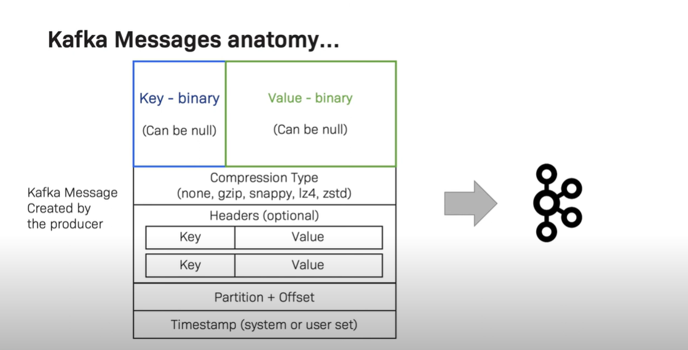
Generally, we send key and values in form of an object/String/Integer or any high-level type. But on Kafka topics it should be binary. To achieve this we make use of producer serializers and consumer deserializers.
Serializers indicate how to transfer data/object into bytes.
Serializers are used on value and keys.

Schema :
Though a message in kafka is a byte array, It is recommended to use additional structure for these messages such as Java Script Object Notation(JSON) or XML which are user friendly. Generally, Kafka developers prefer to use Apache avro which is a framework for serialization and deserialization.
Topics and Partitions :
Topics in kafka is category of messages. It determines what data can be expected from the topic. Each Topic is further divided into partitions. Messages are written to partitions in append-only fashion and are read by consumers in order.
Note: Kafka allows all the ASCII characters and ‘ . ’, ‘ _ ’, ‘ - ’. But it is important to name a topic carefully as Kafka doesn’t provide any option to rename a topic.
recommended format is <message type>.<dataset name>.<data name>
Partitions is the way of achieving scalability in Kafka. If there are multiple partitions in a topic all these partitions can be distributed over servers(Kafka Brokers). And can be replicated across the servers(Kafka Brokers)..

Partitions have offset which increases sequentially for each message. This is like an index in partition.
Producer:
Producer is a kafka client who writes data on to a topic. By default producer doesn’t care to what partition a specific message is written to and will balance the messages over all partitions.
In some cases producer will direct messages to specific partitions by using a key.
So, whenever there is a need for ordering the messages, we make use of key in the message.
If a key is sent, then all the messages with same key will always be sent to same partition.
For Example : we need to send location updates of a truck to topic. In that case we need to send the data to same partition.
If no key is sent, then the key=null and the messages will be sent to partitions in round robin.
Consumer:
Consumer is a Kafka client who reads the messages from partitions.
Brokers and Clusters:
Each Kafka server that accommodates partitions is called a broker. It stores the data from producers on partitions and provides offset. It also services consumers with the fetch requests.
A Cluster is a group of brokers or Kafka servers that are working together to manage and store stream of messages.
Spring boot Kafka:
We can create Spring boot applications to write messages to Topic (producers) and to read messages from topic (Consumers). To achieve this, we make use of following…
KafkaTemplate : KafkaTemplate is a class from Springframework.kafka.core that provides methods to send messages on to topic. Kafka template constructor takes ProducerFactory and creates a KafkaTemplate with configurations mentioned in ProducerFactory
kafkaTemplate.send();
@kafkaListener : is a method level annotation used along with parameters like topic name and groupid so that the method triggers everytime there is a message on topic.
We can pass ConcurrentKafkaListenerContainerFactory for configuration.
ConsumerFactory : It is an interface used to configure the Kafka Consumer. DefaultKafkaConsumerFactory is an implementation for this class which has all the configuration for a Kafka consumer.

ProducerFactory : It is an interface used to configure the Kafka Producer. DefaultKafkaProducerFactory is an implementation for this class which has all the configuration for a Kafka producer.

ConcurrentKafkaListenerContainerFactory:
The ConcurrentKafkaListenerContainerFactory in Spring Kafka is a factory class that allows you to create and configure instances of ConcurrentMessageListenerContainer. These containers are responsible for concurrently consuming messages from Kafka topics.
https://stackoverflow.com/questions/55023240/when-to-use-concurrentkafkalistenercontainerfactory
With this configuration, you can now use @KafkaListener annotations in your Spring Boot application to define methods that consume messages from Kafka topics, and Spring will use the ConcurrentKafkaListenerContainerFactory configured above to create the necessary listener containers.

Refer to programs in Kafka-clone workspace

Acknowledgement in Kafka
Producer Acknowledgement :
Message acknowledgment in Apache Kafka is crucial for ensuring the reliability of message delivery between Kafka brokers (servers) and clients (producers and consumers). Here’s how message acknowledgment works in Kafka
- A Kafka producer sends a message or a batch of messages to a Kafka topic. The producer specifies the topic to which it wants to send the message.
Acknowledgement Settings.
Producers can configure the level of acknowledgement it requires from Kafka brokers regarding the sent messages.
There are 3 modes
acks=0: (No acknowledgement) producer doesn’t wait for an acknowledgement, it sends the messages and doesn’t care if its received.
Note: High possibility for data loss
acks=1: (Leader acknowledgement) producer waits for an acknowledgement from the leader broker if it has received the message.
Note: Data loss when broker leader is down.
acks=all: (replica acknowledgement) producer waits for acknowledgement from all the in-sync replicas. This ensures high reliability and has high latency.
Note : No data loss.
acks=all is used along with min.insync.replicas this is to specify from how many replicas we need the acknowledgement from.
Example : min.insync.replicas=2

That means that at least two brokers that are insync replicas, including the leader, must respond that they have the data. Otherwise, you’ll get an error message. So, that means that if you use replication.factor=3, min.insync.replica=2, and acks=all, you can only tolerate one broker going down. Otherwise, the producer will receive an exception on Send. Here is a diagram to understand this concept.
Acknowledgement from consumers:
Consumers receive data from Kafka brokers based on the offset which is like an index number on partitions.
In Consumers we use configuration for setting up ack mode to determine when the broker updates the consumer offset.
There are 3 acknowledgement categories, under which there are some modes,
auto-commit: The consumer sends an acknowledgement to the broker as soon as it receives the message.
after-processing: The consumer sends an acknowledgement to broker only after processing the message.
manual: Consumer waits until it receives specific instructions before sending an acknowledgement.

Modes that we can configure are,
AckMode.Record : In this after-processing mode, the consumer sends an acknowledgment for each message it processes.
AckMode.BATCH: In this manual mode, the consumer sends an acknowledgment for a batch of messages, rather than for each message.
AckMode.COUNT: In this manual mode, the consumer sends an acknowledgment after it has processed a specific number of messages.
AckMode.MANUAL: In this manual mode, the consumer doesn’t send an acknowledgment for the messages it processes.
AckMode.TIME: In this manual mode, the consumer sends an acknowledgment after a certain amount of time has passed.
Popular Kafka providers are,

- Apache Kafka,
- Confluent Kafka,
- RedPanda
Apache kafka is free open source. And provides core capabilities like,
- Data ingestion from variety of sources,
- Data storage and retrieval,
- Data processing and streaming.
Apache kafka has a throughput of upto 100,000 messages/second

Confluent has a free version under community license and a fee based paid version as well.

- Confluent provides additional features like,
A GUI that makes it easy to manage and monitor Kafka clusters.
- A management console that provides a centralised view of all Kafka activity.
- Provides numerous connectors which can be used to connect Kafka to wide range of data sources and sinks.

Confluent Kafka has a throughput of upto 200,000 messages/second.

RedPanda is a high performant Kafka provider. It has a throughput of 500,000 messages/second.

It is new and doesn’t provide as many features as other providers.

But Redpanda provides high performance and scalability.

https://medium.com/@bijit211987/distributed-messaging-apache-kafka-vs-confluent-vs-redpanda-3c99288b77f8

Kafka Connect:
Kafka Connect is a tool to stream data between External systems and Kafka clusters.
We generally pull data from same set of sources and put the data on same set of sinks. Here the sources and sinks are external systems like Relational databases, NoSQL databases, key-value store, file systems etc.
We have many connectors like JDBC Connector, ElasticSearch connnector, S3 Connector, MongoDB Connector, Twitter Connector etc which are already available.
Source Connectors : Source connector is a connector which will be pulling the data from external systems on to the topic.
Sink Connectors : Sink connector is which will write data to external systems from topic.
Kafka Connect Cluster Components :
Connectors: Connectors are plugins (jar files) that define how to move data between Kafka and external systems.
Each connector is responsible for either reading data from an external source (source connector) or writing data to an external sink (sink connector).
Tasks:
Tasks are actual connector instances that run within Kafka cluster.
Connector + user configuration = Tasks
Each connector can have one or more tasks associated with it.
Tasks are responsible for the actual data movement between Kafka and the external system.
For example, if you have a JDBC source connector configured to read data from a database, it might have multiple tasks to parallelize the data retrieval process.
Workers:
Workers are the processes that run the connectors and tasks.
A Kafka Connect cluster typically consists of one or more worker processes.
Workers are responsible for coordinating the execution of tasks, managing configuration, and distributing the workload across the cluster.
They handle the lifecycle of connectors and tasks, such as starting, stopping, and rebalancing.
In summary, connectors define the integration with external systems, tasks are the instances of connectors responsible for data movement, and workers manage the execution of connectors and tasks within a Kafka Connect cluster. This architecture allows Kafka Connect to scale horizontally and handle large-scale data integration scenarios effectively.

Kafka KSQL:

