Microservices

Synchronous communication :
RestTemplate is from org.springframework.web.client package so we need Spring-Web dependency in our project.
RestTemplate is deprecated in Spring 5 and they have introduced WebClient in Spring webflux module that provides the fluent functional style API for sending http requests and handling responses.
WebClient :
- we need to add Springboot-starter-webflux dependency to our project.
- Create the WebClient index using the WebClient.create() orWebClient.builder().
- WebClient provides retrieve() and exchange() methods to make http requests.\
- retrieve() primarily used to retrieve data from a web service. It is a simpler, higher-level method focused on fetching data.
- It is often used when you need to make a GET request to a web service to retrieve data.
- exchange() method is more versatile and lower level compared to retrieve(). It is used for more complex interactions with a web service, allowing for more control over the request and response.
- exchange() provides full http response including headers and status codes.

Feign client: (declarative web service client)
We need to add Spring-cloud-open-feign dependency in our project.
we need to enable Feign Clients using @EnableFeignClients annotation that enables component scanning for all interfaces annotated with @FeignClient.
Interfaces can be declared as Feign Clients using the @FeignClient annotation.
Asynchronous communication :
KafkaMQ, RabbitMQ.

Service Discovery :
As in microservices we have a numerous microservices deployed at different network locations. We need to know the location of a service to send a request. For this we use service discovery where all the services in the application are registered. There are two types in this pattern, Client-side service discovery and server-side service discovery.

Client-side service discovery :
- The locations of the Service Provider instances are added to the Service Registry (Self Registration Pattern).
- When the Service Consumer wants to request for a particular service, the service discovery mechanism will query the Service Registry to obtain a list of available Service Provider instance locations.
- The location list will be sent back to the Service Consumer after fetching it from the Service Registry.
- Finally, the Service Consumer will route the service request to one of the Service Provider instances.
Eg: Netflix Eureka, zookeeper, consul

Self Registration Pattern
In the Self Registration Pattern, a service instance registers itself with the Service Registry (See Figure 01 — Step 01). This happens with the Service Registry on startup and unregistered on shutdown.
The service instance may invoke Service Registry’s registration API to register its network location. In addition to that, Service Registry invokes an API to the Service Provider instance for a health check.

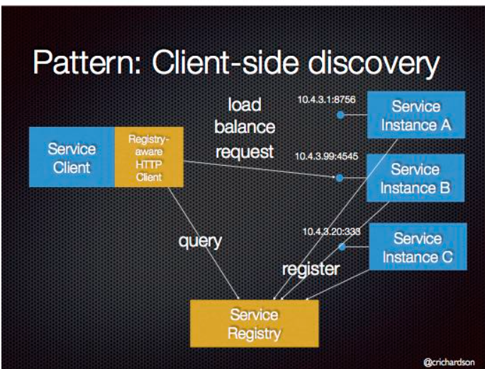

Server-side service discovery :
It allows services to discover other services through a router or Load balancer
Eg : NGINX, AWS ELB.

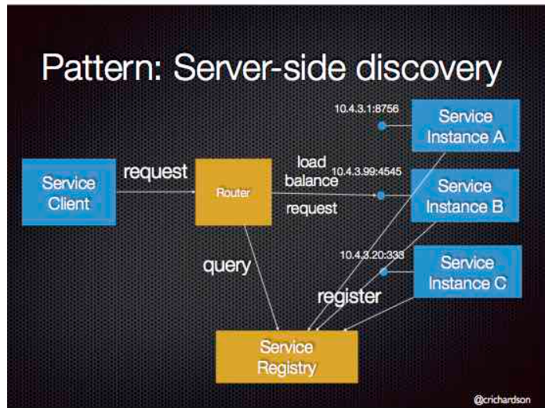
Implementing Eureka Server :
Create a new springboot project
Add the dependencies spring cloud netflix eureka server
Use @EnableDiscoveryServer( takes the implementation on classpath) or @EnableEurekaServer annotation for enable the service registry
Make the configuration server.register.with.eureka = false

Implementing Eureka client:
Add dependency Spring-cloud-netflix-eureka-client to the service to be registered
Use @EnableDiscoveryClient or @EnableEurekaClient to register the service in Eureka.
Make the configuration server.register.with.eureka = true.

What is Microservices Load Balancing?
SOURCE
At its core, load balancing for microservices aims to distribute incoming network traffic across multiple instances of a service to ensure no single instance is overwhelmed with too much traffic. This results in:
- Optimal Resource Utilization: Traffic distribution ensures that all service instances are used effectively.
- Enhanced Application Availability: In the event that a service instance fails, traffic is rerouted to healthy instances.
- Reduced Latency: Requests are directed to the nearest or quickest service instance, minimizing response times.

Why is Load Balancing Critical in a Microservices Architecture?
Microservices often thrive in environments with dynamic instance scaling, where services can be scaled up or down based on the traffic demands. In such environments:
- Instances are Ephemeral: Service instances might be short-lived, often replaced, or new instances might be spun up to handle the load.
- Services are Distributed: Microservices might be scattered across various servers, data centers, or even geographical regions.
- Traffic is Unpredictable: Traffic patterns can change rapidly, requiring the infrastructure to adapt swiftly.
Given this nature of microservices, traditional load balancers that rely on manual configuration or static lists of servers can't keep up. Modern load balancers must be adaptive, recognizing the dynamic nature of the environment in which microservices operate.

Strategies for Microservices Load Balancing
Here are some common strategies employed:
- Round Robin (static): This is the simplest method where each request is forwarded to the next service instance in line.
- Least Connections (Dynamic): Directs traffic to the service instance with the fewest active connections.
- IP Hash (static): The source or destination IP address is used to determine which service instance will handle the request, ensuring a user always connects to the same service instance.
- Latency-Based(Dynamic): Directs traffic to the service instance with the lowest latency.
- Geographic(static): Based on the geographical location of the user, the request is directed to the nearest service instance.

Tools and Solutions for Load Balancing Microservices
Several tools cater to the needs of load balancing in microservices ecosystems:
- Hardware Load Balancers: Traditional hardware-based solutions like F5's BIG-IP are powerful but might lack the agility required for ephemeral microservices.
- Cloud Load Balancers: Cloud providers like AWS (with its Elastic Load Balancer) or Google Cloud (with its Global Load Balancer) offer managed load balancing solutions that integrate well with their respective ecosystems.
- Software Load Balancers: Can be installed at a server or added to client application.

Client-side load balancing :
If you are keeping the load balancer on the client side and giving the load balancing responsibility to the client, then it’s called Client-Side Load Balancing.
Client-side load balancers are typically integrated within Java applications, often in microservices architectures.
Ribbon obtains the service registration information list from the eureka registration centre server, caches it locally, and then implements the polling load balancing strategy locally.
Eg: Spring cloud load balancer, Netflix Ribbon library.
Advantages : (from chat GPT)
Flexibility
Reduced Server Load:
Geographic Load Distribution
Fault Tolerance

Server-side load balancing:
If you are keeping the load balancer on the server side and giving the load balancing responsibility to the server, then it’s called Server-Side Load Balancing.
Server-side load balancers are typically deployed on servers to manage and distribute incoming client requests to multiple backend servers.
nginx transfers all client requests to nginx, and nginx forwards load balancing requests, which belongs to server-side load balancing.
Eg: Nginx server, AWS Elastic Load Balancer (ELB), Google Cloud Load Balancing.
Advantages : (from chat GPT)s
Centralized control
Efficiency
Scalability
Security
Note: Ultimately, the choice between server-side and client-side load balancing should be based on careful consideration of your application requirements, infrastructure, and operational constraints. In many cases, a combination of both approaches may be used to achieve the desired performance, scalability, and fault tolerance characteristics.
Load balancer can be single point of failure, But we can have a backup load balancer which is called passive load balancer.

API Gateway: (from Chat GPT)
In a Spring Boot microservices architecture, an API Gateway serves as a single-entry point for clients to interact with various microservices. It's responsible for routing requests, authentication, authorization, caching, ratelimiting, logging and monitoring. Here's how you can implement an API Gateway using Spring Boot:
𝐀𝐏𝐈 𝐆𝐚𝐭𝐞𝐰𝐚𝐲: 𝐀 𝐏𝐫𝐨𝐛𝐥𝐞𝐦 𝐒𝐨𝐥𝐯𝐞𝐫
𝐀𝐏𝐈 𝐆𝐚𝐭𝐞𝐰𝐚𝐲 𝐢𝐬 𝐚 𝐯𝐞𝐫𝐲 𝐮𝐬𝐞𝐟𝐮𝐥 𝐭𝐨𝐨𝐥 𝐢𝐧 𝐦𝐚𝐧𝐚𝐠𝐢𝐧𝐠 𝐚𝐧𝐝 𝐦𝐚𝐤𝐢𝐧𝐠 𝐜𝐥𝐢𝐞𝐧𝐭 𝐚𝐧𝐝 𝐦𝐢𝐜𝐫𝐨𝐬𝐞𝐫𝐯𝐢𝐜𝐞𝐬 𝐢𝐧𝐭𝐞𝐫𝐚𝐜𝐭𝐢𝐨𝐧𝐬 𝐬𝐢𝐦𝐩𝐥𝐞𝐫.
Here are a few problems that it helps to solve:
𝟏. 𝐒𝐢𝐧𝐠𝐥𝐞 𝐏𝐨𝐢𝐧𝐭 𝐨𝐟 𝐈𝐧𝐭𝐞𝐫𝐚𝐜𝐭𝐢𝐨𝐧
Problem: In a microservices architecture, there are many services talking to each other. If each service communicates with all the others directly, it can get very complex, very fast.
API Gateway Solution: The API Gateway simplifies this by being the central point of communication. Services or clients talk to the Gateway, and the Gateway talks to other services.
𝟐. 𝐋𝐨𝐚𝐝 𝐁𝐚𝐥𝐚𝐧𝐜𝐢𝐧𝐠
Problem: Some services might get more traffic than others, and you need to manage this traffic efficiently.
API Gateway Solution: It can distribute the incoming traffic evenly across services, ensuring no single service is overwhelmed.
𝟑. 𝐀𝐠𝐠𝐫𝐞𝐠𝐚𝐭𝐢𝐨𝐧 𝐨𝐟 𝐑𝐞𝐬𝐮𝐥𝐭𝐬
Problem: A client might need information that is spread across multiple services. Getting this info could require multiple network calls, which can be inefficient.
API Gateway Solution: The Gateway can aggregate results from multiple services and send a consolidated response back to the client.
𝟒. 𝐒𝐞𝐜𝐮𝐫𝐢𝐭𝐲 𝐚𝐧𝐝 𝐀𝐮𝐭𝐡𝐞𝐧𝐭𝐢𝐜𝐚𝐭𝐢𝐨𝐧
Problem: Handling security for each service individually can be a nightmare. You need to make sure each service is secure, and that’s a lot of work.
API Gateway Solution: It can handle authentication and authorization centrally. Clients authenticate with the Gateway, and then the Gateway ensures that the clients are who they say they are.
𝟓. 𝐏𝐞𝐫𝐟𝐨𝐫𝐦𝐚𝐧𝐜𝐞 𝐎𝐩𝐭𝐢𝐦𝐢𝐳𝐚𝐭𝐢𝐨𝐧
Problem: Services might be spread out, and network calls between services can add delays.
API Gateway Solution: It can cache responses from services, reducing the need for repeated calls and improving performance.
𝟔. 𝐂𝐞𝐧𝐭𝐫𝐚𝐥𝐢𝐳𝐞𝐝 𝐋𝐨𝐠𝐠𝐢𝐧𝐠 𝐚𝐧𝐝 𝐌𝐨𝐧𝐢𝐭𝐨𝐫𝐢𝐧𝐠
Problem: Collecting logs and monitoring data from all services in a distributed system can be challenging.
API Gateway Solution: The Gateway can collect logs and monitoring data, providing a centralized point for observability.

Popular API Gateway Solutions
• Kong: An open-source API gateway that provides a range of features such as traffic control, authentication, and analytics.
• NGINX: Known for its high performance and reliability, it can be configured as an API gateway.
• Amazon API Gateway: A managed service by AWS that offers easy setup and scaling.
• Apigee: Google Cloud's full-lifecycle API management platform.
• Zuul: Netflix’s API gateway that provides dynamic routing, monitoring, resiliency, security, and more.
Remember, while API Gateways provide various benefits, they also introduce a single point of failure. Therefore, ensure high availability and fault tolerance measures are in place to mitigate risks.

Hystrix library:
Hystrix is a library developed by Netflix for implementing fault tolerance and latency tolerance in distributed systems. It is designed to handle the issues that arise when different parts of a system (e.g., microservices) communicate with each other over networks, where failures and latency spikes can occur.
Here are some key features and concepts of Hystrix:
Circuit Breaker Pattern: Hystrix implements the Circuit Breaker pattern, which monitors for failures in remote service calls. When the failure rate exceeds a certain threshold, Hystrix "trips" the circuit breaker, preventing further requests from being sent to the failing service. This helps to prevent cascading failures and conserves resources.
Fallback Mechanism: Hystrix provides the ability to define fallback logic that gets executed when a circuit is open or when a request times out. This allows applications to gracefully degrade functionality when dependent services are unavailable.
Command Execution and Asynchronous Execution: Hystrix allows you to wrap remote service calls or any code that may fail into a HystrixCommand or HystrixObservableCommand, respectively. These commands are executed asynchronously and can be configured with various properties such as timeouts, thread pools, and circuit breaker settings.
Metrics and Monitoring: Hystrix collects and exposes metrics about command execution, thread pool usage, circuit breaker state, and more. These metrics can be monitored in real-time using tools like Hystrix Dashboard or integrated with monitoring systems such as Graphite, Prometheus, or CloudWatch.
Configuration: Hystrix provides extensive configuration options to tune its behavior based on application requirements. You can configure properties such as circuit breaker thresholds, timeouts, thread pool sizes, and error thresholds.
Integration: Hystrix can be easily integrated into Java applications using its provided libraries and annotations. It also integrates seamlessly with other Netflix OSS components such as Ribbon for client-side load balancing and Eureka for service discovery.
Hystrix has been widely used in building resilient and scalable microservices architectures. However, as of my last update, Netflix announced that they have put Hystrix into maintenance mode and recommended users to migrate to other resilience libraries such as Resilience4j or implement circuit breaker patterns directly with libraries like Hystrix's circuit breaker pattern is a fundamental part of many distributed systems.

Implementation
Add the dependency for Hystrix library in pom.xml
Annotate main class with @EnableCercuitBreaker or @EnableHystrix
Annotate the methods that we want to wrap in a hystrixcommand with @HystrixCommand
We can give properties like Fallbackmethod to be called if the method is failing

@Service
public class YourService {
private final RestTemplate restTemplate;
public YourService(RestTemplate restTemplate) {
this.restTemplate = restTemplate;
}
@HystrixCommand(fallbackMethod = "fallbackMethod")
public String callExternalService() {
// Make a remote call using restTemplate or any other method
return restTemplate.getForObject("http://external-service/api/endpoint", String.class);
}
public String fallbackMethod() {
// Fallback logic in case the call to external service fails
return "Fallback Response";
}
}
Timeout and Circuit Breaker:
You can configure additional Hystrix behaviours such as timeouts, circuit breakers, thread pools, and more by setting attributes in the @HystrixCommand annotation.

Spring Cloud: (source)
Building and deploying microservices distributed across the network brings up new challenges like,
- We need to maintain the list of all the available applications and the instances with their network address.
- We need to load balance the services so that we make optimal use of resources.
- We need to provide fault tolerance.
- We need to have the configuration of all the services stored and managed externally at a single place.
- We need a single point of contact between clients and microservices.
- Debugging distributed services to identify where the error is.
Spring Cloud provides many libraries and services which are ready to use to mitigate above challenges.
- Service registries like Eureka server, Zookeeper and Consul.
- Netflix Ribbbon, Spring Cloud load balancer.
- Hystrix, Resilience4j libraries for fault tolerance.
- Spring cloud config server.
- Spring cloud API gateway.
- Spring cloud Sleuth and Zipkin for tracing.

Spring cloud config server
As we will be having multiple services deployed, we can store the configuration properties of all the services at one place.
Spring cloud config supports file systems, git, AWS CodeCommit, and Google Cloud Store.
Implementation :
- Create a project for config-server
- Add Spring-cloud-config-server dependency
- Add @EnableConfigServer annotation on main class.
- Create a git repository and create files for dev, qa & prod properties.
- Point to Git repo from config server by creating a file bootstrap.properties and add value for git uri.

Now on client side (microservices)
- Add Spring-cloud-starter-config dependency
- Create a file bootstrap.properties and add properties like,
active profile & config server url.

Spring Cloud Sleuth
-Let’s say we are working with eCommerce site built on microservices architecture, and the services are order-service, payment-service, bank-service, user-service and notification-service. All these services communicate with each other to process an order.
-we have multiple instances of all these services running.
-In this case of any failure in order processing we need to know which instance has failed.
-By using Hystrix(circuit breaker) we will just know which service has failed but cannot know which instance.
-For this problem Spring-cloud-sleuth provides the solution.
For every request in microservices environment it will add a TraceId & SpanId.
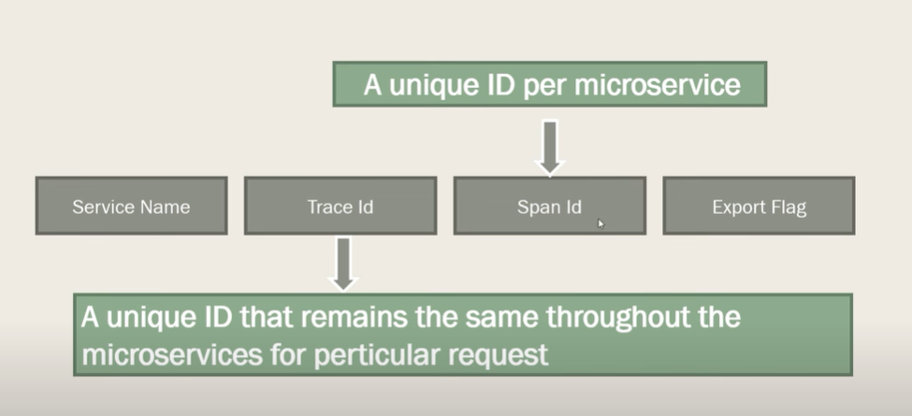
This data follows the format of:
[application name, traceId, spanId, export]
- Application name – This is the name we set in the properties file and can be used to aggregate logs from multiple instances of the same application.
- TraceId – This is an id that’s assigned to a single request, job, or action. Something like each unique user initiated web request will have its own traceId.
- SpanId – Tracks a unit of work. Think of a request that consists of multiple steps. Each step could have its own spanId and be tracked individually. By default, any application flow will start with the same TraceId and SpanId.
- Export – This property is a boolean that indicates whether or not this log was exported to an aggregator like Zipkin.
Manually adding a span:
We can start a span manually by using Tracer object.
Tracer instance is created by Spring sleuth during startup.
We can start a span as, tracer.nextSpan().name(“new span”).start();
Spring cloud when integrated with Slf4j, enriches all the logs with trace-id and span-id.
Using this trace id and span ids we can track each and every request in the microservices environment.

Spring Cloud Zipkin:
Spring Cloud Zipkin is used to collect, store, and visualize traces created by Sleuth (or other tracing tools). Zipkin provides a user interface to search and analyse traces.

Implementation:
First, we need to start zipkin server. We can download the jar and run it.
Add Spring-cloud-sleuth dependency to the applications. So that all the logs will be added with trace-id and span-ids.
Now add spring-cloud-zipkin dependency to all the applications and give a property for spring.cloud.zipkin.base.url in .properties/.yml file. So that the services register with the zipkin server.

CORS:
Cross Origin Resource Sharing is accessing the resources that belongs to a different origin.
Same Origin Policy is followed by web browsers to allow the communication only when the origins of both the client and server are same.
CORS mechanism comes into picture when a cross-origin request must be made. Hence it comes as a boon in catering towards microservice-based architecture where the resources may be housed in different locations.

In code we use @CrossOrigin(origins = “*”) to allow a cross-origin request.

Saga pattern: source
You have applied the Database per Service pattern. Each service has its own database. Some business transactions, however, span multiple service so you need a mechanism to implement transactions that span services. For example, let’s imagine that you are building an e-commerce store where customers have a credit limit. The application must ensure that a new order will not exceed the customer’s credit limit. Since Orders and Customers are in different databases owned by different services the application cannot simply use a local ACID transaction.

Solution
Implement each business transaction that spans multiple services as a saga. A saga is a series of local transactions. Each local transaction updates the database and publishes a message/event to the next local transaction in the saga. If a local transaction fails, then the saga will initiate compensating transactions to undo the changes that were made by preceding local transactions.

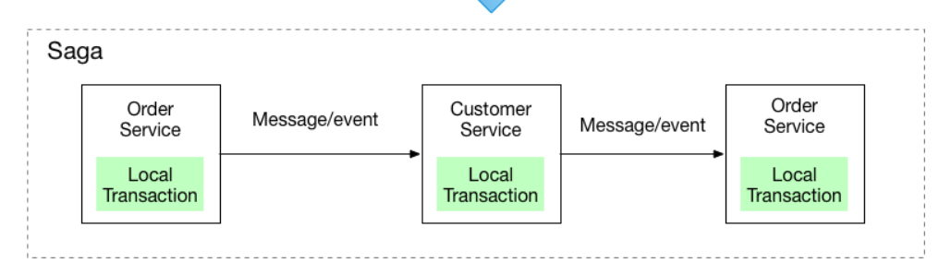
There are two ways of coordination sagas:
- Choreography - each local transaction publishes domain events that trigger local transactions in other services
Here are a few frameworks available to implement the choreography pattern:
- Axon Saga – a lightweight framework and widely used with Spring Boot-based microservices
- Eclipse MicroProfile LRA – implementation of distributed transactions in Saga for HTTP transport based on REST principles
- Eventuate Tram Saga – Saga orchestration framework for Spring Boot and Micronaut-based microservices
- Seata – open-source distributed transaction framework with high-performance and easy-to-use distributed transaction services

- Orchestration - an orchestrator (object) tells the participants what local transactions to execute
Here are a few frameworks available to implement the orchestrator pattern:
- Camunda is a Java-based framework that supports Business Process Model and Notation (BPMN) standard for workflow and process automation.
- Apache Camel provides the implementation for Saga Enterprise Integration Pattern (EIP).

2PC: 2 phase commit
source
2 Phase commit protocol is a widely used pattern to implement distributed transactions.
In this protocol there is a coordinator component that is responsible for controlling the transaction and contains the logic to manage the transaction.
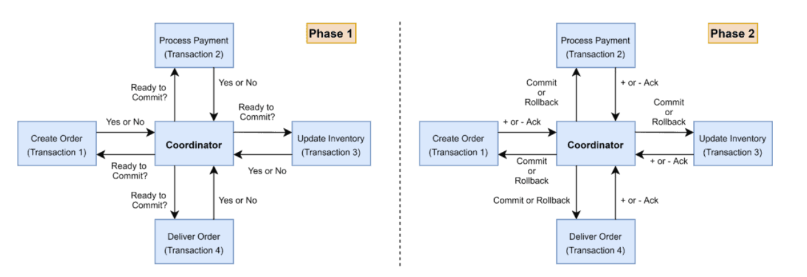
As the name indicates, 2PC protocol runs a distributed transaction in 2 phases,
Prepare Phase: The coordinator asks the participating nodes if all the nodes are ready to commit the transaction. The participants return with a yes or no.
Commit phase : If all the participant nodes respond affirmatively in phase 1, The coordinator asks all of them to commit. If at least one node returns negative, the coordinator asks all the nodes to roll back their local transactions.
Problems with 2PC:
- The onus of the transaction is on the coordinator node, and it can become the single point of failure.
- All other services need to wait until the slowest service finishes its confirmation. So, the overall performance of the transaction is bound by the slowest service.
- Two-phase commit protocol is not supported in NoSQL databases. Therefore, in a microservice architecture where one or more services use NoSQL databases, we can’t apply a two-phase commit.

What deployment strategies are commonly employed in the domain of Microservices?

Blue-Green Deployment
- In this deployment strategy we will have 2 identical instances deployed on servers. One is called Blue instance, and the other is Green instance.
- One instance let’s say blue will be serving the business purpose/ client requests and the other instance will be idle.
- Let’s say Blue is the active one(version v1) serving the requests and Green is the idle instance with all the changes in blue.
- Now if we want to release a new version v2 we will be making the changes to the idle instance (Green in this case). We make all the testing for this instance.
- Once the testing is done and the green instance is ready to serve the production requests, we will just route all the requests to Green now. And Blue will be updated later and put to idle state.
- If anything goes wrong with the new version, However we have the older version at Blue instance so we will just route back the requests to Blue instance.
Benefits:
- Reduced Downtime: Since the switch between environments is almost instantaneous, downtime is minimized.
- Risk Mitigation: If something goes wrong with the new deployment, rolling back to the previous version is straightforward.
- Seamless Updates: Users experience a seamless transition as the switch between environments is typically instantaneous.

Canary Deployment
Canary Release is a deployment strategy that involves gradually rolling out new software updates or features to a subset of users or systems before deploying it to the entire user base. The approach is named after the practice of using canaries in coal mines to detect dangerous gases before miners are exposed to them.
This can be done by releases and deployments,
Canary Releases:
Often companies publish canary versions(beta) of their products, hoping that tech-savvy or power users want to download and try them out.
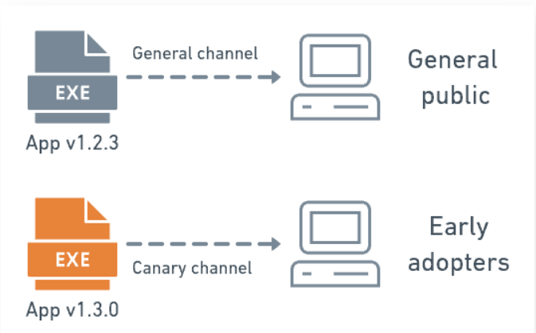

Canary Deployments
In a canary deployment, on the other hand, we install the update in our systems and split the users into two groups. A small percentage of them will go to the canary while the rest stay on the old version, as a control.
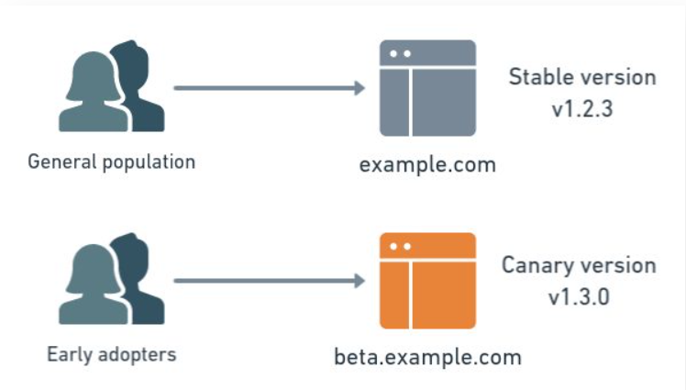
Later, once we have taken the time to evaluate the canary version, we can decide to migrate the rest of the users to the canary or roll everyone back to the old version.
Learn more at here

Rolling Deployments/ Ramped Deployments
Incremental updates, where new versions are gradually deployed across servers or instances, reducing downtime.
Learn more here

Shadow Deployment
In this strategy we will be creating a replica for actual live environment and will be configuring the load balancer to route requests to this shadow application as well.
Requests handled by shadow application are processed same as that of the actual production live application. But the responses are not returned to the end user.
Learn more here

Design Patterns

Observer pattern:
- Observer pattern is a behavioral design pattern, here an object (called subject) will maintain the list of its dependent objects (called observers) and notifies them of any state changes usually by calling one of their methods.
- Here the Subject and observer has a one to many relationship. Observers are directly related to the subject.
- Observers register themselves to the subject to receive updates. The Subject will directly call the method on each observer when change occurs.
- Typically used in environments where change in one object needs to be reflected in dependent objects.

Pub-Sub pattern:
- In Pub-Sub pattern, Publishers will be sending the messages to a central broker which then will distribute the messages to all the subscribers who are interested in those messages.
- In this architecture the Publishers and Subscribers are completely decoupled with an event bus or broker.
- Publisher sends messages to the broker and the broker delivers these messages to all the subscribers that are interested in this type of messages.
- Typically used in Distributed systems and event driven architectures where decoupling the producers and subscribers is beneficial.
Key Differences
- Decoupling:
  - Observer Pattern: Observers are tightly coupled with the subject. The subject maintains direct references to the observers.
  - Pub-Sub Pattern: Publishers and subscribers are completely decoupled. They interact only through the broker or event bus.
- Scalability:
  - Observer Pattern: Limited by the subject’s ability to manage and notify observers, making it less suitable for highly scalable systems.
  - Pub-Sub Pattern: More scalable due to the decoupling and the use of an intermediary broker.
- Flexibility:
  - Observer Pattern: Less flexible because adding or removing observers usually requires changes to the subject.
  - Pub-Sub Pattern: More flexible as publishers and subscribers can be added or removed without affecting each other.

