PRACTICAL – 11

- Develop a multithreaded counter application using POSIX threads (pthread_create, pthread_join). Demonstrate race conditions by allowing multiple threads to update a shared variable concurrently.
Modify the previous program using mutex locks (pthread_mutex_lock, pthread_mutex_unlock) and compare the outputs with the race-condition version. Analyze the impact of synchronization

11A Code:
#include <stdio.h>
#include <pthread.h>

#define NUM_THREADS 5
#define ITERATIONS 100000

int counter = 0;

void *increment(void *arg)
{
for (int i = 0; i < ITERATIONS; i++)
{
counter++;
}

return NULL;
}

int main()
{
pthread_t threads[NUM_THREADS];

// Create threads
for (int i = 0; i < NUM_THREADS; i++)
{
pthread_create(&threads[i], NULL, increment, NULL);
}

// Wait for all threads
for (int i = 0; i < NUM_THREADS; i++)
{
pthread_join(threads[i], NULL);
}

printf("Expected counter value: %d\n",
NUM_THREADS * ITERATIONS);

printf("Actual counter value: %d\n", counter);

return 0;
}
Output:
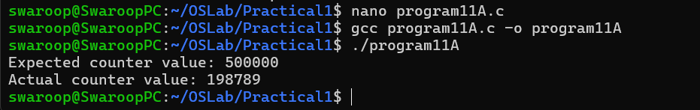

PART_B :

Code: (11B):

#include <stdio.h>
#include <pthread.h>

#define NUM_THREADS 5
#define ITERATIONS 100000

int counter = 0;

pthread_mutex_t lock;

void *increment(void *arg)
{
for (int i = 0; i < ITERATIONS; i++)
{
pthread_mutex_lock(&lock);

counter++;

pthread_mutex_unlock(&lock);
}

return NULL;
}

int main()
{
pthread_t threads[NUM_THREADS];

// Initialize mutex
pthread_mutex_init(&lock, NULL);

// Create threads
for (int i = 0; i < NUM_THREADS; i++)
{
pthread_create(&threads[i], NULL, increment, NULL);
}

// Wait for all threads
for (int i = 0; i < NUM_THREADS; i++)
{
pthread_join(threads[i], NULL);
}

printf("Expected counter value: %d\n",
NUM_THREADS * ITERATIONS);

printf("Actual counter value: %d\n", counter);

// Destroy mutex
pthread_mutex_destroy(&lock);

return 0;
}

Output:

