PRACTICAL – 12

- Implement the Producer-Consumer problem using counting semaphores and POSIX threads. Evaluate synchronization correctness and system throughput under different buffer sizes.

Design a deadlock scenario involving multiple threads competing for shared resources. Demonstrate deadlock occurrence, identify the four necessary conditions for deadlock, and implement a deadlock prevention strategy using resource ordering.

12A Code:

#include <stdio.h>
#include <stdlib.h>
#include <pthread.h>
#include <semaphore.h>
#include <unistd.h>

#define BUFFER_SIZE 5
#define ITEMS 20

int buffer[BUFFER_SIZE];

int in = 0;
int out = 0;

sem_t empty;
sem_t full;
pthread_mutex_t mutex;

void *producer(void *arg)
{
for (int i = 1; i <= ITEMS; i++)
{
sem_wait(&empty);

pthread_mutex_lock(&mutex);

buffer[in] = i;
printf("Producer produced: %d\n", i);

in = (in + 1) % BUFFER_SIZE;

pthread_mutex_unlock(&mutex);

sem_post(&full);

usleep(100000);
}

return NULL;
}

void *consumer(void *arg)
{
for (int i = 1; i <= ITEMS; i++)
{
sem_wait(&full);

pthread_mutex_lock(&mutex);

int item = buffer[out];

printf("Consumer consumed: %d\n", item);

out = (out + 1) % BUFFER_SIZE;

pthread_mutex_unlock(&mutex);

sem_post(&empty);

usleep(150000);
}

return NULL;
}

int main()
{
pthread_t producer_thread;
pthread_t consumer_thread;

// Initialize semaphores
sem_init(&empty, 0, BUFFER_SIZE);
sem_init(&full, 0, 0);

// Initialize mutex
pthread_mutex_init(&mutex, NULL);

// Create threads
pthread_create(&producer_thread, NULL, producer, NULL);
pthread_create(&consumer_thread, NULL, consumer, NULL);

// Wait for threads
pthread_join(producer_thread, NULL);
pthread_join(consumer_thread, NULL);

// Destroy synchronization objects
sem_destroy(&empty);
sem_destroy(&full);
pthread_mutex_destroy(&mutex);

printf("\nProducer-Consumer execution completed.\n");

return 0;
}

Output:
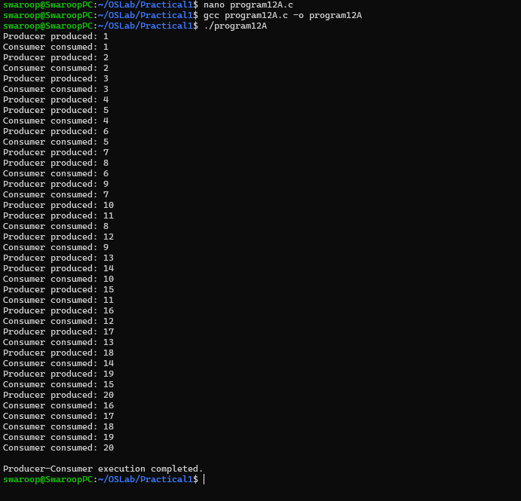

PART_B :

Code: (12B):

#include <stdio.h>
#include <pthread.h>
#include <unistd.h>

pthread_mutex_t resource1;
pthread_mutex_t resource2;

void *thread1(void *arg)
{
printf("Thread 1: Trying to lock Resource 1\n");
pthread_mutex_lock(&resource1);

printf("Thread 1: Locked Resource 1\n");

sleep(1);

printf("Thread 1: Trying to lock Resource 2\n");
pthread_mutex_lock(&resource2);

printf("Thread 1: Locked Resource 2\n");

pthread_mutex_unlock(&resource2);
pthread_mutex_unlock(&resource1);

return NULL;
}

void *thread2(void *arg)
{
printf("Thread 2: Trying to lock Resource 2\n");
pthread_mutex_lock(&resource2);

printf("Thread 2: Locked Resource 2\n");

sleep(1);

printf("Thread 2: Trying to lock Resource 1\n");
pthread_mutex_lock(&resource1);

printf("Thread 2: Locked Resource 1\n");

pthread_mutex_unlock(&resource1);
pthread_mutex_unlock(&resource2);

return NULL;
}

int main()
{
pthread_t t1, t2;

pthread_mutex_init(&resource1, NULL);
pthread_mutex_init(&resource2, NULL);

pthread_create(&t1, NULL, thread1, NULL);
pthread_create(&t2, NULL, thread2, NULL);

pthread_join(t1, NULL);
pthread_join(t2, NULL);

pthread_mutex_destroy(&resource1);
pthread_mutex_destroy(&resource2);

return 0;
}

Output:



PART_C :

12C Code:

#include <stdio.h>
#include <pthread.h>
#include <unistd.h>

pthread_mutex_t resource1;
pthread_mutex_t resource2;

void *thread1(void *arg)
{
printf("Thread 1: Locking Resource 1\n");
pthread_mutex_lock(&resource1);

printf("Thread 1: Resource 1 locked\n");

sleep(1);

printf("Thread 1: Locking Resource 2\n");
pthread_mutex_lock(&resource2);

printf("Thread 1: Resource 2 locked\n");

printf("Thread 1: Using both resources\n");

pthread_mutex_unlock(&resource2);
pthread_mutex_unlock(&resource1);

printf("Thread 1: Resources released\n");

return NULL;
}

void *thread2(void *arg)
{
// Resource ordering:
// Always lock Resource 1 before Resource 2

printf("Thread 2: Locking Resource 1\n");
pthread_mutex_lock(&resource1);

printf("Thread 2: Resource 1 locked\n");

sleep(1);

printf("Thread 2: Locking Resource 2\n");
pthread_mutex_lock(&resource2);

printf("Thread 2: Resource 2 locked\n");

printf("Thread 2: Using both resources\n");

pthread_mutex_unlock(&resource2);
pthread_mutex_unlock(&resource1);

printf("Thread 2: Resources released\n");

return NULL;
}

int main()
{
pthread_t t1, t2;

pthread_mutex_init(&resource1, NULL);
pthread_mutex_init(&resource2, NULL);

pthread_create(&t1, NULL, thread1, NULL);
pthread_create(&t2, NULL, thread2, NULL);

pthread_join(t1, NULL);
pthread_join(t2, NULL);

pthread_mutex_destroy(&resource1);
pthread_mutex_destroy(&resource2);

printf("\nDeadlock prevented using resource ordering.\n");

return 0;
}

Output :

