Skill – 10

- To Retrieve Current Directory, Display Path, Process Exit Requests, Cleanup Resources, Save State, Verify Correct Behavior.

To Parse Export Syntax, Update Environment Variables, Validate Names, Handle Existing Variables, Export to Child Processes, Test Functionality

Code(10A) :

#include <stdio.h>
#include <stdlib.h>
#include <string.h>
#include <unistd.h>
#include <limits.h>

#define INPUT_BUFFER 500

int main()
{
char input[INPUT_BUFFER];
char current_dir[PATH_MAX];
char saved_dir[PATH_MAX];

/* Get and save the initial directory */
if (getcwd(saved_dir, sizeof(saved_dir)) == NULL)
{
perror("getcwd");
return 1;
}

printf("Simple Directory Shell\n");
printf("Commands: pwd, exit\n\n");

while (1)
{
/* Retrieve current directory */
if (getcwd(current_dir, sizeof(current_dir)) == NULL)
{
perror("getcwd");
break;
}

/* Display current path */
printf("%s> ", current_dir);
fflush(stdout);

/* Read command */
if (fgets(input, sizeof(input), stdin) == NULL)
{
break;
}

input[strcspn(input, "\n")] = '\0';

/* Ignore empty input */
if (strlen(input) == 0)
{
continue;
}

/* pwd command */
if (strcmp(input, "pwd") == 0)
{
printf("%s\n", current_dir);
}

/* exit command */
else if (strcmp(input, "exit") == 0)
{
printf("Saving state...\n");
printf("Initial directory: %s\n", saved_dir);
printf("Cleaning up resources...\n");
printf("Exiting shell.\n");

break;
}

/* Invalid command */
else
{
printf("Unknown command: %s\n", input);
printf("Available commands: pwd, exit\n");
}
}

return 0;
}

OUTPUT :
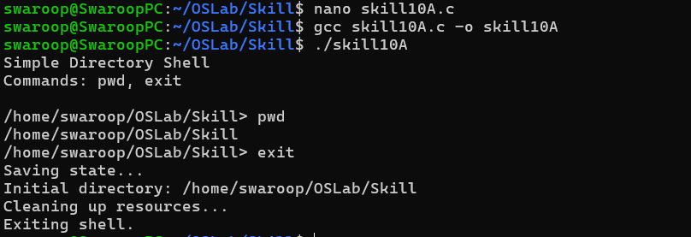

Part-B :

Code (8B) :

#include <stdio.h>
#include <stdlib.h>
#include <string.h>
#include <ctype.h>
#include <unistd.h>
#include <sys/wait.h>

#define INPUT_BUFFER 500

/* Validate environment variable name */
int valid_name(const char *name)
{
int i;

if (name == NULL || name[0] == '\0')
return 0;

/* First character must be letter or underscore */
if (!isalpha((unsigned char)name[0]) && name[0] != '_')
return 0;

/* Remaining characters */
for (i = 1; name[i] != '\0'; i++)
{
if (!isalnum((unsigned char)name[i]) && name[i] != '_')
return 0;
}

return 1;
}

int main()
{
char input[INPUT_BUFFER];

printf("Environment Variable Shell\n");
printf("Use: export NAME=value\n");
printf("Use: show NAME\n");
printf("Use: test NAME\n");
printf("Use: exit\n\n");

while (1)
{
printf("myshell> ");
fflush(stdout);

if (fgets(input, sizeof(input), stdin) == NULL)
break;

input[strcspn(input, "\n")] = '\0';

/* Exit */
if (strcmp(input, "exit") == 0)
{
printf("Exiting shell...\n");
break;
}

/* Empty input */
if (strlen(input) == 0)
continue;

/* export command */
if (strncmp(input, "export ", 7) == 0)
{
char *assignment = input + 7;
char *equal = strchr(assignment, '=');

if (equal == NULL)
{
printf("Error: Use export NAME=value\n");
continue;
}

/* Separate name and value */
*equal = '\0';

char *name = assignment;
char *value = equal + 1;

/* Validate variable name */
if (!valid_name(name))
{
printf("Error: Invalid variable name: %s\n", name);
continue;
}

/* Set environment variable */
if (setenv(name, value, 1) != 0)
{
perror("setenv");
continue;
}

printf("Exported: %s=%s\n", name, value);
}

/* show command */
else if (strncmp(input, "show ", 5) == 0)
{
char *name = input + 5;
char *value = getenv(name);

if (value != NULL)
{
printf("%s=%s\n", name, value);
}
else
{
printf("Variable '%s' is not defined.\n", name);
}
}

/* Test child process */
else if (strncmp(input, "test ", 5) == 0)
{
char *name = input + 5;
pid_t pid = fork();

if (pid < 0)
{
perror("fork");
continue;
}

if (pid == 0)
{
/* Child process */
char *value = getenv(name);

if (value != NULL)
{
printf("Child process: %s=%s\n", name, value);
}
else
{
printf("Child process: %s is not defined.\n", name);
}

exit(0);
}
else
{
/* Parent waits for child */
waitpid(pid, NULL, 0);
}
}

else
{
printf("Unknown command.\n");
printf("Available commands:\n");
printf(" export NAME=value\n");
printf(" show NAME\n");
printf(" test NAME\n");
printf(" exit\n");
}
}

return 0;
}
Output :

