Skill – 11

- To Store Commands, Maintain History Buffer, Handle Capacity Limits, Retrieve Entries, Display History, Validate Consistency.

To Create Pipeline Structures, Store Commands, Maintain Execution Order, Connect Processes, Validate Pipeline Layout, Test Configurations

Code(11A) :

#include <stdio.h>
#include <stdlib.h>
#include <string.h>

#define HISTORY_SIZE 5
#define COMMAND_SIZE 100

char history[HISTORY_SIZE][COMMAND_SIZE];
int history_count = 0;
int total_commands = 0;

/* Add command to history */
void add_history(const char *command)
{
int index;

if (history_count < HISTORY_SIZE)
{
index = history_count;
history_count++;
}
else
{
/* Buffer full: remove oldest command */
for (int i = 1; i < HISTORY_SIZE; i++)
{
strcpy(history[i - 1], history[i]);
}

index = HISTORY_SIZE - 1;
}

strcpy(history[index], command);
total_commands++;
}

/* Display history */
void display_history()
{
if (history_count == 0)
{
printf("History is empty.\n");
return;
}

printf("\nCommand History:\n");

for (int i = 0; i < history_count; i++)
{
printf("%d %s\n", i + 1, history[i]);
}
}

/* Retrieve a history entry */
void retrieve_history(int number)
{
if (number < 1 || number > history_count)
{
printf("Invalid history number.\n");
return;
}

printf("History %d: %s\n",
number, history[number - 1]);
}

/* Validate history */
void validate_history()
{
int valid = 1;

if (history_count < 0 || history_count > HISTORY_SIZE)
{
valid = 0;
}

for (int i = 0; i < history_count; i++)
{
if (strlen(history[i]) == 0)
{
valid = 0;
}
}

if (valid)
printf("History consistency: VALID\n");
else
printf("History consistency: INVALID\n");
}

int main()
{
char command[COMMAND_SIZE];
int number;

printf("Command History Manager\n");
printf("-----------------------\n");
printf("Commands:\n");
printf(" history - Display history\n");
printf(" get <number> - Retrieve an entry\n");
printf(" check - Validate history\n");
printf(" exit - Exit program\n\n");

while (1)
{
printf("shell> ");
fflush(stdout);

if (fgets(command, sizeof(command), stdin) == NULL)
break;

command[strcspn(command, "\n")] = '\0';

if (strlen(command) == 0)
continue;

/* Exit */
if (strcmp(command, "exit") == 0)
{
printf("Exiting...\n");
break;
}

/* Display history */
if (strcmp(command, "history") == 0)
{
display_history();
continue;
}

/* Validate history */
if (strcmp(command, "check") == 0)
{
validate_history();
continue;
}

/* Retrieve history entry */
if (sscanf(command, "get %d", &number) == 1)
{
retrieve_history(number);
continue;
}

/* Store normal command */
add_history(command);

printf("Command stored: %s\n", command);
}

return 0;
}

OUTPUT :
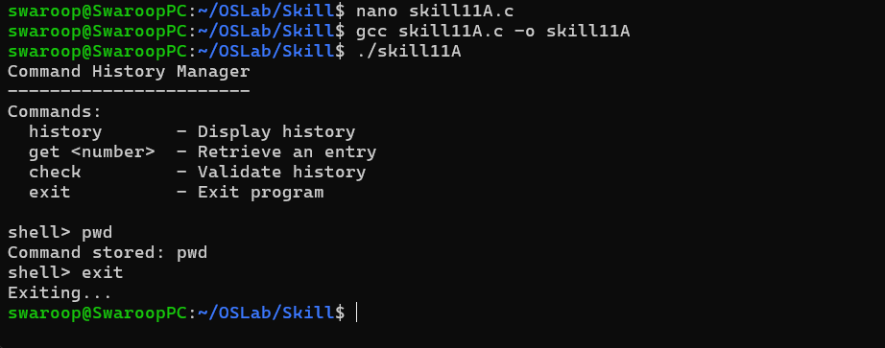

Part-B :

Code (11B) :

#include <stdio.h>
#include <stdlib.h>
#include <string.h>
#include <unistd.h>
#include <sys/wait.h>

#define MAX_COMMANDS 5
#define MAX_ARGS 10
#define INPUT_SIZE 500

typedef struct
{
char command[100];
char *args[MAX_ARGS];
} Command;

/* Parse one command */
int parse_command(char *text, Command *cmd)
{
int count = 0;

char *token = strtok(text, " \t");

if (token == NULL)
return 0;

strcpy(cmd->command, token);
cmd->args[count++] = token;

while (count < MAX_ARGS - 1)
{
token = strtok(NULL, " \t");

if (token == NULL)
break;

cmd->args[count++] = token;
}

cmd->args[count] = NULL;

return count;
}

/* Display pipeline structure */
void display_pipeline(Command commands[], int count)
{
printf("\nPipeline Layout:\n");

for (int i = 0; i < count; i++)
{
printf("[%d] %s", i + 1, commands[i].command);

if (i < count - 1)
printf(" | ");
}

printf("\n");
}

/* Validate pipeline */
int validate_pipeline(Command commands[], int count)
{
if (count < 2 || count > MAX_COMMANDS)
{
printf("Invalid number of commands.\n");
return 0;
}

for (int i = 0; i < count; i++)
{
if (strlen(commands[i].command) == 0)
{
printf("Invalid command at position %d.\n", i + 1);
return 0;
}
}

printf("Pipeline layout: VALID\n");
return 1;
}

/* Execute pipeline */
void execute_pipeline(Command commands[], int count)
{
int pipes[MAX_COMMANDS - 1][2];
pid_t pids[MAX_COMMANDS];

/* Create pipes */
for (int i = 0; i < count - 1; i++)
{
if (pipe(pipes[i]) == -1)
{
perror("pipe");
return;
}
}

/* Create processes */
for (int i = 0; i < count; i++)
{
pids[i] = fork();

if (pids[i] < 0)
{
perror("fork");
return;
}

if (pids[i] == 0)
{
/* Connect input from previous pipe */
if (i > 0)
{
dup2(pipes[i - 1][0], STDIN_FILENO);
}

/* Connect output to next pipe */
if (i < count - 1)
{
dup2(pipes[i][1], STDOUT_FILENO);
}

/* Close all pipe descriptors */
for (int j = 0; j < count - 1; j++)
{
close(pipes[j][0]);
close(pipes[j][1]);
}

/* Execute command */
execvp(commands[i].command, commands[i].args);

perror(commands[i].command);
exit(1);
}
}

/* Parent closes pipes */
for (int i = 0; i < count - 1; i++)
{
close(pipes[i][0]);
close(pipes[i][1]);
}

/* Wait for all children */
for (int i = 0; i < count; i++)
{
waitpid(pids[i], NULL, 0);
}
}

int main()
{
char input[INPUT_SIZE];
char *parts[MAX_COMMANDS];
Command commands[MAX_COMMANDS];

printf("Pipeline Manager\n");
printf("----------------\n");
printf("Enter pipelines such as:\n");
printf(" ls | grep .c\n");
printf(" ls | wc -l\n");
printf(" ls | grep .c | wc -l\n");
printf("Type exit to quit.\n\n");

while (1)
{
printf("pipeline> ");
fflush(stdout);

if (fgets(input, sizeof(input), stdin) == NULL)
break;

input[strcspn(input, "\n")] = '\0';

if (strcmp(input, "exit") == 0)
break;

if (strlen(input) == 0)
continue;

/* Split pipeline using | */
int count = 0;

char *part = strtok(input, "|");

while (part != NULL && count < MAX_COMMANDS)
{
while (*part == ' ')
part++;

parts[count++] = part;

part = strtok(NULL, "|");
}

/* Parse each command */
int valid = 1;

for (int i = 0; i < count; i++)
{
if (parse_command(parts[i], &commands[i]) == 0)
{
valid = 0;
break;
}
}

if (!valid)
{
printf("Invalid pipeline.\n");
continue;
}

display_pipeline(commands, count);

if (validate_pipeline(commands, count))
{
printf("Executing pipeline...\n");
execute_pipeline(commands, count);
}
}

printf("Pipeline manager terminated.\n");

return 0;
}

Output :

