Skill – 12

- To Create Pipes, Redirect Streams, Execute Connected Commands, Close Descriptors, Synchronize Processes, Test Data Flow.

To Support Multiple Pipes, Manage Descriptor Arrays, Launch Multiple Processes, Coordinate Execution, Cleanup Resources, Test Long Pipelines

Code(12A) :

#include <stdio.h>
#include <stdlib.h>
#include <unistd.h>
#include <sys/wait.h>

int main()
{
int pipefd[2];
pid_t p1, p2;

if (pipe(pipefd) == -1)
{
perror("pipe");
return 1;
}

/* First child */
p1 = fork();

if (p1 < 0)
{
perror("fork");
return 1;
}

if (p1 == 0)
{
/* Redirect stdout to pipe */
dup2(pipefd[1], STDOUT_FILENO);

close(pipefd[0]);
close(pipefd[1]);

/* Execute ls */
execlp("ls", "ls", NULL);

perror("execlp ls");
exit(1);
}

/* Second child */
p2 = fork();

if (p2 < 0)
{
perror("fork");
return 1;
}

if (p2 == 0)
{
/* Redirect stdin from pipe */
dup2(pipefd[0], STDIN_FILENO);

close(pipefd[0]);
close(pipefd[1]);

/* Execute wc -l */
execlp("wc", "wc", "-l", NULL);

perror("execlp wc");
exit(1);
}

/* Parent closes both ends */
close(pipefd[0]);
close(pipefd[1]);

/* Wait for both children */
waitpid(p1, NULL, 0);
waitpid(p2, NULL, 0);

printf("Pipeline execution completed.\n");

return 0;
}

OUTPUT :
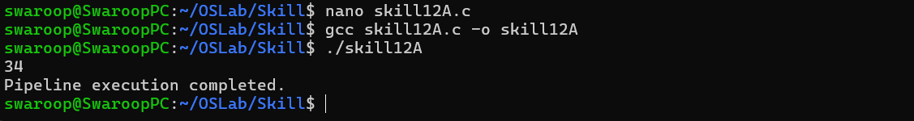

Part-B :

Code (12B) :

#include <stdio.h>
#include <stdlib.h>
#include <unistd.h>
#include <sys/wait.h>

#define MAX_COMMANDS 5

int main()
{
int num_commands;

char *commands[MAX_COMMANDS][4] =
{
{"ls", NULL},
{"grep", ".c", NULL},
{"sort", NULL},
{"wc", "-l", NULL},
{NULL}
};

/*
* Number of commands:
*
* ls | grep .c | sort | wc -l
*
* = 4 commands
*/
num_commands = 4;

int pipes[MAX_COMMANDS - 1][2];
pid_t pids[MAX_COMMANDS];

/* Create all required pipes */
for (int i = 0; i < num_commands - 1; i++)
{
if (pipe(pipes[i]) == -1)
{
perror("pipe");
return 1;
}
}

/* Create child processes */
for (int i = 0; i < num_commands; i++)
{
pids[i] = fork();

if (pids[i] < 0)
{
perror("fork");
return 1;
}

if (pids[i] == 0)
{
/*
* If this is not the first command,
* connect stdin to previous pipe.
*/
if (i > 0)
{
if (dup2(pipes[i - 1][0], STDIN_FILENO) == -1)
{
perror("dup2 stdin");
exit(1);
}
}

/*
* If this is not the last command,
* connect stdout to next pipe.
*/
if (i < num_commands - 1)
{
if (dup2(pipes[i][1], STDOUT_FILENO) == -1)
{
perror("dup2 stdout");
exit(1);
}
}

/* Close all pipe descriptors in child */
for (int j = 0; j < num_commands - 1; j++)
{
close(pipes[j][0]);
close(pipes[j][1]);
}

/* Execute command */
execvp(commands[i][0], commands[i]);

perror("execvp");
exit(1);
}
}

/* Parent closes all pipe descriptors */
for (int i = 0; i < num_commands - 1; i++)
{
close(pipes[i][0]);
close(pipes[i][1]);
}

/* Wait for all children */
for (int i = 0; i < num_commands; i++)
{
waitpid(pids[i], NULL, 0);
}

printf("Long pipeline execution completed.\n");

return 0;
}

Output :

