Skill – 13

- To Parse Input Redirection, Open Files, Redirect stdin, Handle Missing Files, Restore Streams, Test File Inputs.

To Parse Output Redirection, Create Output Files, Redirect stdout, Handle Permissions, Verify Output Data, Test Redirection

Code(13A) :

#include <stdio.h>
#include <stdlib.h>
#include <string.h>
#include <unistd.h>
#include <fcntl.h>
#include <sys/wait.h>

#define INPUT_SIZE 500
#define ARG_SIZE 50

int main()
{
char input[INPUT_SIZE];
char *args[ARG_SIZE];
char *filename;
int argc;

printf("Input Redirection Program\n");
printf("Example: cat < input.txt\n");
printf("Type exit to quit.\n\n");

while (1)
{
printf("shell> ");
fflush(stdout);

if (fgets(input, sizeof(input), stdin) == NULL)
break;

input[strcspn(input, "\n")] = '\0';

if (strcmp(input, "exit") == 0)
break;

if (strlen(input) == 0)
continue;

/* Find input redirection symbol */
char *redirect = strchr(input, '<');

if (redirect == NULL)
{
printf("Error: Use input redirection with '<'\n");
continue;
}

/* Separate command and filename */
*redirect = '\0';
filename = redirect + 1;

/* Remove leading spaces from filename */
while (*filename == ' ')
filename++;

if (*filename == '\0')
{
printf("Error: Input file not specified.\n");
continue;
}

/* Parse command */
argc = 0;

char *token = strtok(input, " \t");

while (token != NULL && argc < ARG_SIZE - 1)
{
args[argc++] = token;
token = strtok(NULL, " \t");
}

args[argc] = NULL;

if (argc == 0)
{
printf("Error: Command not specified.\n");
continue;
}

/* Create child process */
pid_t pid = fork();

if (pid < 0)
{
perror("fork");
continue;
}

if (pid == 0)
{
/* Open input file */
int fd = open(filename, O_RDONLY);

if (fd == -1)
{
perror("Input file");
exit(1);
}

/* Redirect stdin to file */
if (dup2(fd, STDIN_FILENO) == -1)
{
perror("dup2");
close(fd);
exit(1);
}

close(fd);

/* Execute command */
execvp(args[0], args);

perror("execvp");
exit(1);
}
else
{
/* Parent waits */
waitpid(pid, NULL, 0);

printf("Input redirection completed.\n");
}
}

return 0;
}

OUTPUT :
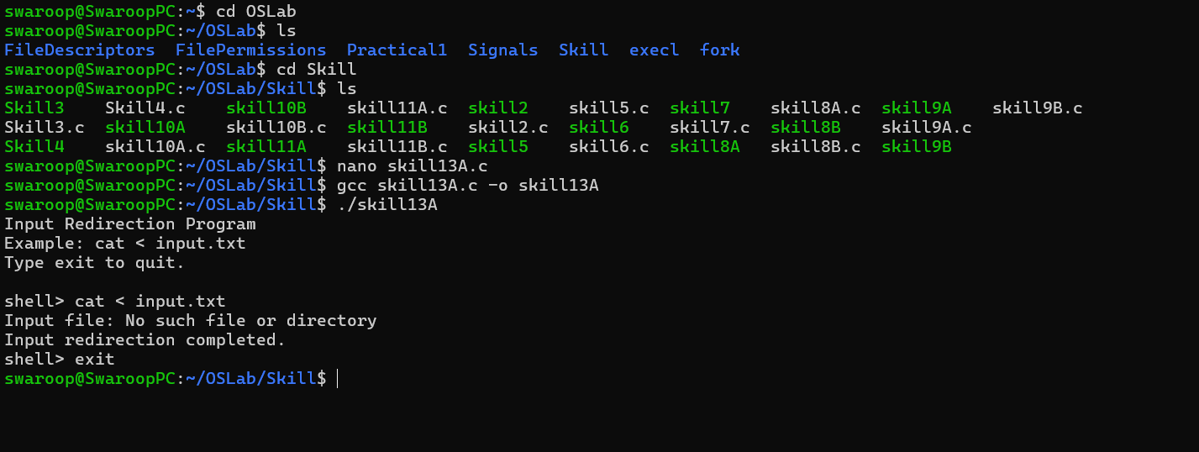

Part-B :

Code (13B) :

#include <stdio.h>
#include <stdlib.h>
#include <string.h>
#include <unistd.h>
#include <fcntl.h>
#include <sys/wait.h>

#define INPUT_SIZE 500
#define ARG_SIZE 50

int main()
{
char input[INPUT_SIZE];
char *args[ARG_SIZE];
char *filename;
int argc;

printf("Output Redirection Program\n");
printf("Example: ls > output.txt\n");
printf("Type exit to quit.\n\n");

while (1)
{
printf("shell> ");
fflush(stdout);

if (fgets(input, sizeof(input), stdin) == NULL)
break;

input[strcspn(input, "\n")] = '\0';

if (strcmp(input, "exit") == 0)
break;

if (strlen(input) == 0)
continue;

/* Find output redirection symbol */
char *redirect = strchr(input, '>');

if (redirect == NULL)
{
printf("Error: Use output redirection with '>'\n");
continue;
}

/* Separate command and filename */
*redirect = '\0';
filename = redirect + 1;

/* Remove leading spaces */
while (*filename == ' ')
filename++;

if (*filename == '\0')
{
printf("Error: Output file not specified.\n");
continue;
}

/* Parse command */
argc = 0;

char *token = strtok(input, " \t");

while (token != NULL && argc < ARG_SIZE - 1)
{
args[argc++] = token;
token = strtok(NULL, " \t");
}

args[argc] = NULL;

if (argc == 0)
{
printf("Error: Command not specified.\n");
continue;
}

/* Create child */
pid_t pid = fork();

if (pid < 0)
{
perror("fork");
continue;
}

if (pid == 0)
{
/* Open/create output file */
int fd = open(filename,
O_WRONLY | O_CREAT | O_TRUNC,
0644);

if (fd == -1)
{
perror("Output file");
exit(1);
}

/* Redirect stdout to file */
if (dup2(fd, STDOUT_FILENO) == -1)
{
perror("dup2");
close(fd);
exit(1);
}

close(fd);

/* Execute command */
execvp(args[0], args);

perror("execvp");
exit(1);
}
else
{
/* Parent waits */
int status;

waitpid(pid, &status, 0);

if (WIFEXITED(status) &&
WEXITSTATUS(status) == 0)
{
printf("Output redirection completed.\n");
}
else
{
printf("Command execution failed.\n");
}
}
}

return 0;
}

Output :

